Summer raffle July 2022

The Alderley Edge Community Primary School (AECPS) PTA is running a summer raffle with the proceeds being used to update the school playground, which is in need of both remedial work and new equipment. The playground improvements will enable our children the chance to play in an enriching environment, whilst developing independent, social, emotional, physical, and creative skills that will last a lifetime.

Previously the Summer raffle has been a huge success and connects with the whole village. We are contacting local businesses to see if they are willing to contribute prizes for the raffle. If you are able or, If you run, work for, or have close links with any business that may be able to contribute a prize, be it a product, voucher, or service, we would be extremely grateful. Your prize and support would be publicised on our website and social media pages.

The raffle will take place on the 2nd July 2022 at the AECPS summer fair. We will let you know details of prizes and how to buy tickets shortly.

If you can help in any way, please get in touch with us on email at PTA@aecps.org before 12th June 2022

Save the dates

Please add the following dates to your diary for our upcoming PTA events. We look forward to a busy but fun summer for our children and the school community which will see the return of the Summer Fair and the Bales Race will include spectators again this year.
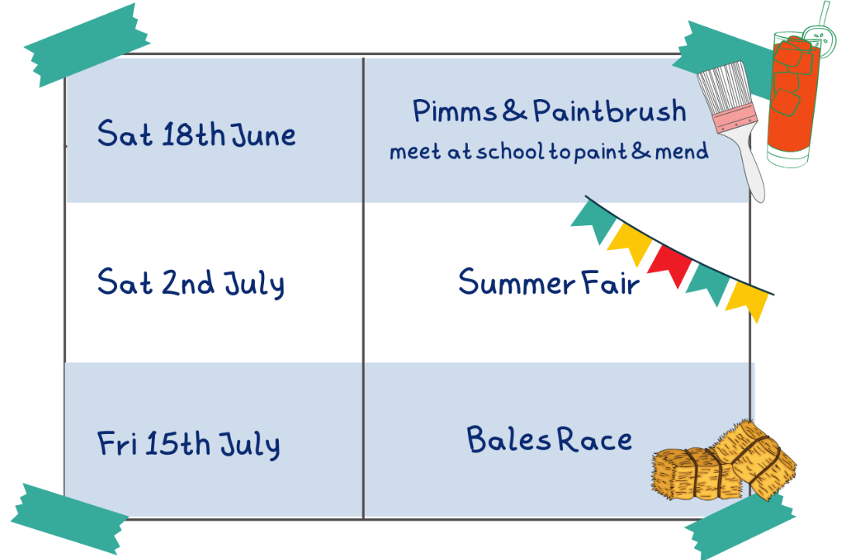
More information to follow. We look forward to seeing you there.
The PTA Committee

