
Supporting young people in Secondary Education
with independence skills, career and education options

Passport to Success



Passport 2 Success 

What is it?
Passport to Success is a development programme to support the young people in Secondary Education with their career and education options.
By working through this programme, The Virtual School and your own school will support you in putting together your Passport 2 Success folder, which will help you when applying for college, apprenticeships and employment opportunities.
The programme includes;
- Post 16 options including colleges, sixth forms, basic apprenticeship info
- Apprenticeships
- CVs - What they are and how to produce one
- Interview techniques
- Life skills




Essential Life Skills for All Teens

Personal Appearance Skills
Basic clothing repair (Buttons, hems)
Iron garments
Fold, put away clothes
Laundry – follow care labels, treat stains
Maintain personal appearance

Food Skills
Plan, shop for healthy diet
Prepare, store food
Cook balanced meals
Use kitchen appliances
Home Skills
Research housing options
Arrange rent, utilities, phone
Basic routine maintenance
Clean, vacuum, dust
Find a circuit breaker/use it
Locate, use water stop tap
Fix basic plumbing

Independent Living Skills

Drive/Maintain Car and Driving Licence
Buy car, buy insurance
Vehicle registration
Pump fuel
Maintain vehicle oil, fluids
Maintain, change tyres
Follow traffic laws/safety

Community Access
Know options
Read a map/use GPS
Know landmarks
Community Orientation

Use Public Transportation
Know timetables
Know routes, pick up points
Know options (Bus, Taxi, Train)

Transportation and Community Access
Financial
Understand gross/net pay, deductions
Make a budget – stick to it
Use a bank/ATM/on-line banking
Open, use and balance check an account
Apply for credit cards – use wisely
Benefits planning
Savings account
Keep track of documents file taxes

Health and Wellness
Basic First Aid
Maintain healthy diet
Use medication safely
Routine exercise
Making healthy lifestyle choices
Maintain hygiene/grooming
Be aware of personal safety
Make appointments if needed

Citizenship
Register to vote, vote
Comply with laws/regulations
Be environmentally responsive
Participate in community activities
Volunteer

Post 16 Options
Explore Post 16 education options
Apply decision-making skills
Access Information, advice and guidance
Develop CV
Submit applications/CV on-line
Interview skills

Use Technology at Work, Home and Socially
Use social media responsibly
Know cyber presence
Validate sources of information
Maintain safe identity
Know current technology applications, programs and hardware

Be a Lifelong Learner: Be curious & interested to learn new things or apply old info in new ways
Seek opportunities to learn – in classroom, with computers, with books, with people
Learn from and with others – share what you learn – recognise you are not “the expert”
Take in information – Analyse it, join it with other information, then apply it

Social / Recreation
Explore social/recreational opportunities
Pursue hobbies, recreational interests
Develop, maintain healthy friendships
Develop, maintain healthy family relationships

Self Determination/Self-Management
Know yourself – your strengths, limitations
Manage your time
Set priorities
Monitor your performance
Balance your responsibilities and priorities
Adapt and accept change
Advocate for yourself to meet your needs
Learn from mistakes
BELIEVE IN YOURSELF

Find the job that is right for YOU!
Prepare: Learn skills
Test the waters: Gain experience
ADVOCATE FOR YOURSELF!
Learn about talents, self, interests, skills, personality
Develop your personal career plan
Reflect on insights gained
Investigate, research/
explore career & education/training options

Employability Skills
Communication skills (listen, speak, customer service)
Interpersonal skills (leadership, social skills, teamwork)
Personal qualities/work ethic
Thinking skills (analyse, prioritise, visualise, problem solve)
Application of core academic skills
Use of technology
Manage resources, time
Understand value of lifelong learning
Be adaptable

Essential Life Skills for All Teens

Independent Living Skills
Personal Appearance Skills | Done | Date
Basic clothing repair (Buttons, hems)
Iron garments
Fold, put away clothes
Laundry – follow care labels, treat stains
Maintain personal appearance
Home Skills | Done | Date
Research housing options
Arrange rent, utilities, phone
Basic routine maintenance
Clean, vacuum, dust
Find a circuit breaker/use it
Locate, use water stop tap
Fix basic plumbing
Food Skills | Done | Date
Plan, shop for healthy diet
Prepare, store food
Cook balanced meals
Use kitchen appliances
Transportation and Community Access
Drive/Maintain Car and Driving Licence | Done | Date
Buy car, buy insurance
Vehicle registration
Pump fuel
Maintain vehicle oil, fluids
Maintain, change tyres
Follow traffic laws/safety
Use Public Transportation | Done | Date
Know timetables
Know routes, pick up points
Know options (Bus, Taxi, Train)
Community Access | Done | Date
Read a map/use GPS
Know landmarks
Community Orientation
Know options

Health and Wellness | Done | Date
Basic First Aid
Maintain healthy diet
Use medication safely
Routine exercise
Making healthy lifestyle choices
Maintain hygiene/grooming
Be aware of personal safety
Make appointments if needed
Financial | Done | Date
Understand gross/net pay, deductions
Make a budget – stick to it
Use a bank/ATM/on-line banking
Open, use and balance check an account
Apply for credit cards – use wisely
Benefits planning
Savings account
Keep track of documents file taxes
Post 16 Options | Done | Date
Explore Post 16 education options
Apply decision-making skills
Access Information, advice and guidance
Develop CV
Submit applications/CV on-line
Interview skills
Citizenship | Done | Date
Register to vote, vote
Comply with laws/regulations
Be environmentally responsive
Participate in community activities
Volunteer
Use Technology at Work, Home and Socially | Done | Date
Use social media responsibly
Know cyber presence
Validate sources of information
Maintain safe identity
Know current technology applications, programs and hardware
Be a Lifelong Learner: Be curious & interested to learn new things or apply old info in new ways | Done | Date
Seek opportunities to learn – in classroom, with computers, with books, with people
Take in information – Analyse it, join it with other information, then apply it
Learn from and with others – share what you learn – recognise you are not “the expert”
Social / Recreation | Done | Date
Develop, maintain healthy family relationships
Explore social/recreational opportunities
Pursue hobbies, recreational interests
Develop, maintain healthy friendships
Self Determination/Self-Management | Done | Date
Know yourself – your strengths, limitations
Manage your time
Set priorities
Monitor your performance
Balance your responsibilities and priorities
Adapt and accept change
Advocate for yourself to meet your needs
Learn from mistakes
BELIEVE IN YOURSELF
Employability Skills | Done | Date
Communication skills (listen, speak, customer service)
Interpersonal skills (leadership, social skills, teamwork)
Personal qualities/work ethic
Thinking skills (analyse, prioritise, visualise, problem solve)
Application of core academic skills
Use of technology
Manage resources, time
Understand value of lifelong learning
Be adaptable

One-page profiles
We believe that one-page profiles are the foundation of personalisation, and can lead to positive change for people, whatever their age or circumstances. They provide us with an at-a-glance way of knowing what really matters to people, that can be taken with them as they move through services and come into contact with people.

What is a One Page Profile?
A One Page Profile captures all the important information about a person on a single sheet of paper under three simple headings: what people appreciate about me, what’s important to me and how best to support me.
You can look at or download free One Page Profile templates here.

How can they help us to support people better?
One Page Profiles are deceptively simple, and in this simplicity lies their strength. They help us to support people better by:
- Helping us build better relationships by truly understanding what really matters to the person in their life and the way they are supported to live it
- Providing a record that can move with the person as they transition from service to service or use multiple services
- Being regularly updated to reflect people’s changing circumstances and aspirations
- When staff have One Page Profiles, the people being supported feel like they get to know the person, rather than just the job title
- When used at work, they can contribute to more person-centred teams, where individual strengths are recognised and different ways of working are taken into account

One-page profile of a child in secondary school – Jordan


What others like and admire about me
- Kind and caring
- Good friend
- Good with children
- Determined
- Good morals
- A leader

What’s important to me

• Getting to know the school quickly
• Knowing where to go if I need help
• Having time to just be with friends and relax
• Access to a telephone when stressed
• Taking classes that are fun but also help me to work toward a career in child care
• Getting through compulsory courses
• Help with math when I need it
• Staying away from situations where I may be influenced to make poor choices
• That both of my parents are involved in my education
• I have a consistent person to go to for emotional, stress management
• Learning good study habits

How best to support me
• I don’t like to ask for help; please offer it if you feel I need it
• After a visit to my dad’s house, it takes me some time to get into the swing of things, be patient and offer your support
• If I get overwhelmed I tend to give up, please help me to stay on track
• I like to write stories or in my journal when I am frustrated or sad, sometimes I need the freedom to do this
• I like to be a leader but sometimes get caught up in the drama of a situation; I might need a motivational reminder
• In elementary schools I did not have a lot of homework or studying, I had mostly one on one due to small class size. This will be a huge adjustment to me, please support me developing good strategies
• Stress is not my friend. My anxiety raises and I need reassurance or comfort from someone I love or am comfortable with
• Public speaking makes me physically ill, my anxiety level rises until I am physically sick and cannot function. Please limit that where possible.


Good listener Team player
Think of others Determined
Sense of humour
Organised
- Spending time with my family, especially my daughter as she lives in Abu Dhabi so visits are limited
- Sunday trips out with my close friends Liz and Sue involving lunch or coffee and cake
- Time spent in the garden, especially in the sunshine
- Holidays in warm places
- Returning home after a stressful day and putting on music, drawing the curtains and lighting candles
- My weekend bottle of wine
- Long country walks either on cold, frosty days or warm, sunny ones
- Shopping for clothes especially shoes
- Reading, something light at night to get me to sleep but a more challenging read during the holidays
- Working with people who have the same values as me
- To be part of a supportive, motivated, enthusiastic team who value each other
- To show people around me that I care about them and value them
- To laugh every day
- Wearing nice clothes, perfume and make up

- When you think I’m stressed give me time to myself
- I like to feel in control so if you think I’m losing my way keep me solution focussed
- Be clear about what you want from me
- I like to be on time so if you are meeting with me stick to our planned time
- I am very organised, if you want me to do something prepare me well in advance
- I’m a list person so please don’t remove my post its!
- I hate being the centre of attention so please don’t draw attention to me

Chris

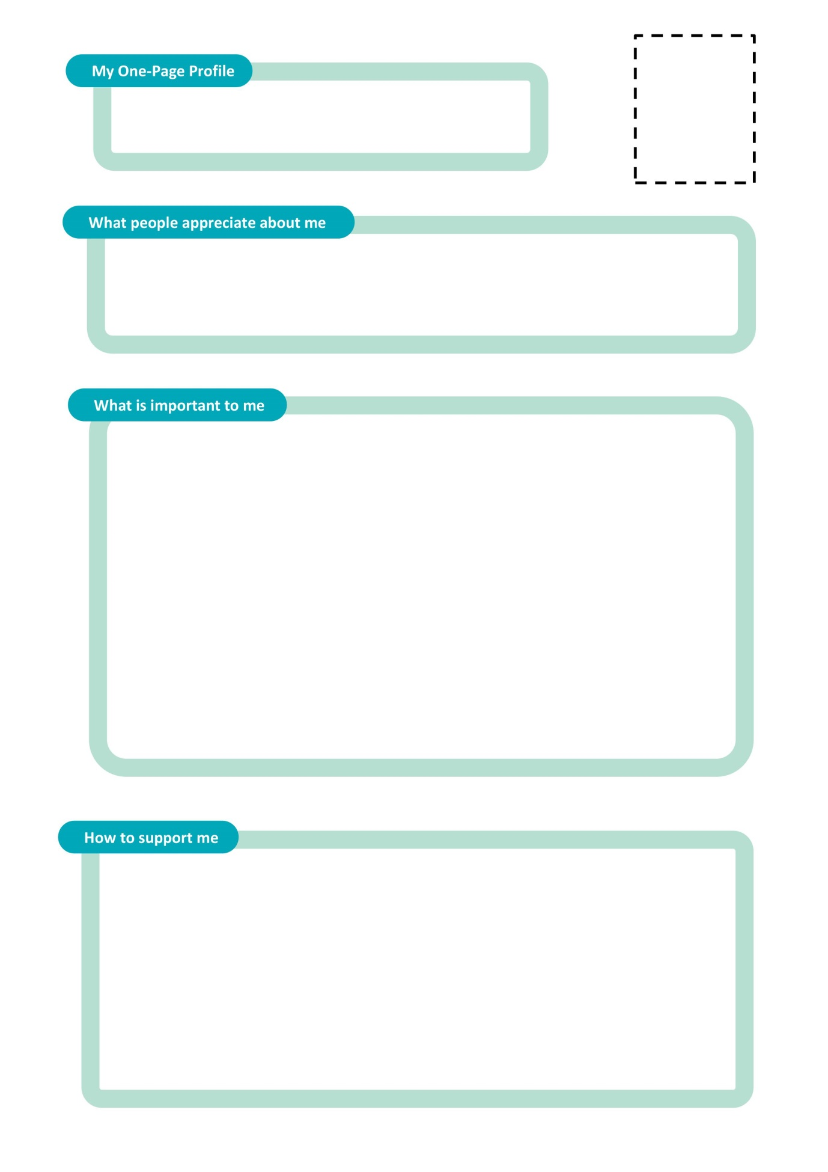

These are the things I am proud of

These are the things I enjoy doing


These are my hopes and dreams for the future

Post 16
Options

Year 9 and Beyond
Yr9 Summer Term Options (if not chosen in Yr8)
Summer PEP
Spring PEP
Autumn PEP
Year 9
Year 11
Year 10
Autumn PEP
Spring PEP
Jun–Jul - Work Experience (If not put in place by the school contact The Virtual School to see if it could be arranged.)
Summer College Visits with Carers
Summer PEP
Sept-Oct – YPS visit schools offering individual career advice
Autumn PEP
College Visits
Training Providers
Oct-Dec – Applications Deadline
Dec-Feb – Pre Public Examinations
Spring PEP (Transition PEP) – Future destinations should be invited to attend including YPS.
Jan-Mar – Interventions for College/Employment/ Apprenticeships
Summer PEP Transition to Post 16. Kelly to attend when required.
May –Jun - Exams
June – Leave school
August – Results
Kelly Jackson to complete One Page Profile if required

Young People’s Services – Information, Advice and Guidance

PEP (Personal Education Plan)
The Process

- PEP is initiated by the Social Worker on Liquid Logic. PEP is populated with basic information. This is then sent by the Business Support Officer (BSO) to school 3 weeks before the meeting date

- First draft of PEP is then filled out by school and sent back to BSO. This is put on Liquid Logic. (Should be done 3 days before the meeting.)

- This is then printed off and taken to the PEP meeting by the Social Worker. At the meeting, any amendments are made

- PEP then given back to BSO who types up any changes onto Liquid Logic

- PEP is then finalised by the Social Worker and forwarded to the relevant people/school.

Personal Education Plans

All young people in care have a care plan, and the PEP makes up part of this.

The Personal Education Plan (PEP) is the tool which is used to ensure that everyone is actively prioritising your education by carefully tracking your progress and supporting you to achieve your goals.

It can be difficult to decide what path to take when you finish your GCSEs, so the PEP helps you to get advice and the right support in making the best decision for you.

Because of all this it’s really important that you continue to have, and attend, PEP meetings when you’ve finished at school. That way you can be involved in any decisions that are about you!

What is a Personal Education Plan (PEP) and why are they important for you?

Who should come to the meeting?

- You
- Your Personal Adviser/Social Worker
- Anyone involved in your education or future goals
- Your carer (if applicable)

Who and what can help with my future?

- Your Personal Adviser/Social Worker
- Your careers adviser
- The Virtual School (Kelly Jackson)

Cheshire West & Chester Virtual School
Tarvin Meadow Professional Centre
Meadow Close
Tarvin
Chester
CH3 8LY
Phone: 01244 976172
Email: Virtual.School@cheshirewestandchester.gov.uk
Website: https://cheshirewestvirtual.school/

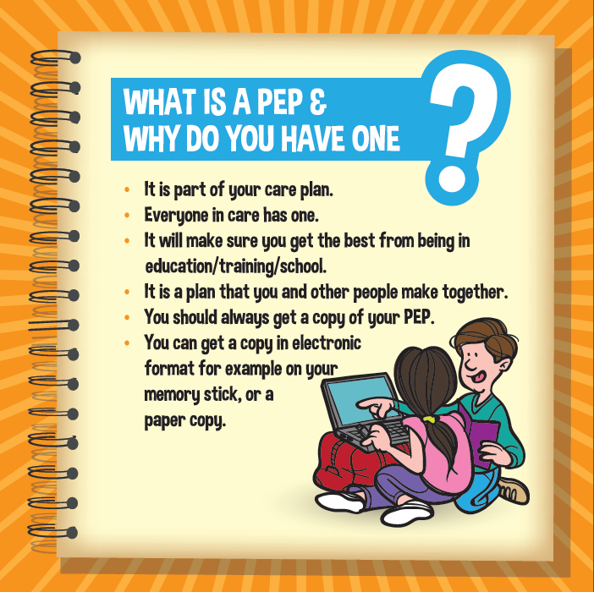
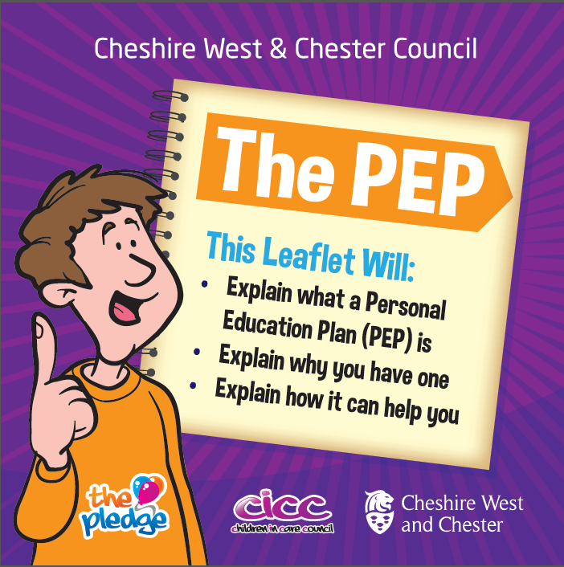

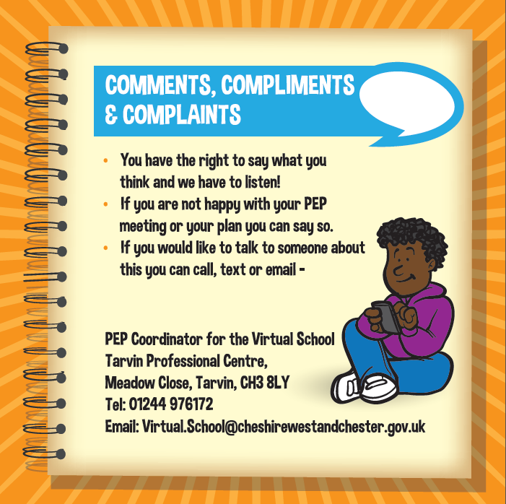
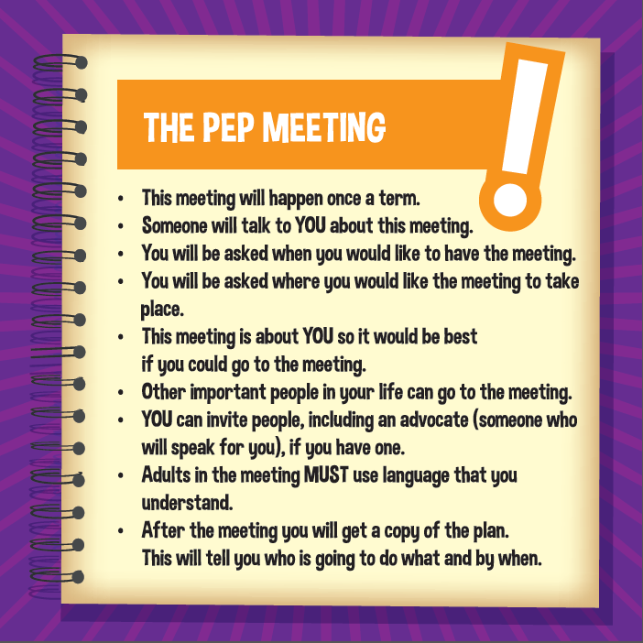

RPA (Raising the Participation Age)

Due to the introduction of “Raising the Participation Age” which is now in place, the Government has increased the age to 18 which all young people in England must continue in education or training. This is what RPA means.
It does not mean you must stay in school; you can choose one of the following options:
- Full-time education, such as school, college or learning provider
- Work-based learning, such as an apprenticeship or traineeship
- Part-time education or training if you are employed, self-employed or volunteering for 20 hours or more a week
Why have these changes taken place?
You deserve the best opportunities to achieve your potential; it has been proven that remaining in education or training for longer:
- helps develop the skills needed for adult life;
- encourages achievement of full potential;
- raises aspirations and expectations;
- reduces the likelihood of unemployment;
- increases income earning potential; and
- encourages positive attitudes towards lifelong learning.
If you would like to discuss your options in more detail then please book an appointment to speak to a careers advisor so you can explore your choices in further detail.

Post 16 Options

There are many options available to young people when they reach the end of year 11 and it can be a very daunting time for them. We suggest looking at all the options as soon as you can, most settings will start having open days and events around October and November.
All young people should be given independent and impartial careers advice and guidance on the full range of post 16 options.
Young people and their parents or carers must think about progression and where their course or training might lead to. It is worth asking schools or colleges what the next step is if the young person succeeds on the level of course or training that they have applied for.

Apprenticeships

Apprenticeships combine practical training in a job with study. As an apprentice you will:
- work alongside experienced staff
- gain job-specific skills
- study towards a related qualification (usually one day a week)
- earn a wage and get holiday pay
Apprenticeships take 1 to 4 years to complete depending on their level.
Who can apply
You can apply for an apprenticeship while you’re still at school. To start one, you need to be:
- 16 or over
- living in England
- not in full-time education

Traineeships

A traineeship is an education and training programme with work experience that unlocks the great potential of young people and prepares them for their future careers by helping them to become ‘work ready’.
Designed to help young people aged 16 to 24 who don’t yet have the appropriate skills or experience, traineeships provide the essential work preparation training, English, maths, and work experience needed to secure an apprenticeship or employment.
Traineeships are an ideal opportunity for young people who are motivated to get a job but lack the skills and experience that employers are looking for.
Those who have been unsuccessful when applying for an apprenticeship or other job due to a lack of skills and experience would most likely be good candidates for a traineeship.

Colleges

College is classed as Further Education. You may think that college is just school continued, however it’s so much more then that! College can open doors for you that school cannot.
Unlock Opportunities
Thanks to all the knowledge, skills and experience you’ll gain in college, you’ll be able to adapt to a greater variety of jobs and careers. It is proven that people who qualify from college are better equipped to:
- Get a job
- Make more money
- Become more independent
During your time at college, you will:
- Explore subjects in greater depth than you did in school
- Choose your own courses following the direction of your chosen career
- Decide which extracurricular activities you’ll focus on — and how much time you give them
Although college requires you to be a lot more independent then school you’re not entirely on your own: colleges offer students many kinds of help making this transition, such as tutoring and academic advising as well as counselling and other support.

Sixth Form Colleges

All over the country there are schools with their own sixth forms offering courses which are designed to follow on from GCSEs.
Most sixth forms will have a small range of courses available, unlike an FE college, which will have a much wider choice of subjects and levels.
A sixth form learning environment is often a lot like school with a uniform policy and calling teachers ‘Mr’ and ‘Miss’. However there will still be some emphasis put on independence and maturity.
A sixth form timetable will normally follow that of a school with independent study sessions put in throughout the week.

Employment

Due to the introduction of “Raising the Participating Age” which is now in place, the Government has increased the age to 18 which all young people in England must continue in education or training.

It does not mean you must stay in school; you can choose one of the following options:
- Full-time education, such as school, college or learning provider
- Work-based learning, such as apprenticeship or traineeship
- Part-time education or training of you are employed, self-employed or volunteering for 20 hours or more a week

Why have these changes taken place?
You deserve the best opportunity to achieve your potential; it has been proven that remaining in education or training for longer:
- Helps develop the skills needed for adult life
- Encourages achievement of full potential
- Raises aspirations and expectations
- Reduces the likelihood of unemployment
- Increase income learning potential
- Encourages positive attitudes towards lifelong learning

If you would like to discuss your options in more detail please book an appointment to speak to your careers adviser so you can explore these further.


CVs

Curriculum Vitae

What is a CV?
Your CV, short for Curriculum Vitae, is a personal marketing document used to sell yourself to prospective employers. It should tell them about you, your professional history and your skills, abilities and achievements. It should highlight why you’re the best person for the job.
In addition to your CV, employers may also require a cover letter and a completed application form.

What to include in your CV
While the structure of a CV is flexible, bending to your unique skill set and experiences, there are particular sections that employers expect to see on your CV regardless.
Here are the sections you must include in your CV:

Name, professional title and contact details
The first part of your CV, positioned at the top of the page, should contain your name, professional title and contact details. Do not title your CV with ‘curriculum vitae’ or ‘CV’ as it’s a waste of valuable space. Treat your name as the title instead.
When it comes to your contact details, your email address and phone number(s) are essential. Once upon a time, it was customary to include your full address on your CV. Today, you simply need to list your town and county.

Personal profile
A personal profile, also known as a personal statement, career objective and professional profile, is one of the most important aspects of your CV. It’s a short paragraph that sits just underneath your name and contact details giving prospective employers an overview of who you are and what you’re all about.
You should tailor your profile to every job you apply for, highlighting specific qualities that match you to the role. Aim to keep your personal statement short and sweet, and no longer than a few sentences. To make the most of this section, you should try to address the following:
- Who are you?
- What can you offer the company?
- What are your career goals?

Experience and employment history
Your employment history section gives you a chance to outline your previous jobs and work experience.
List your experience in reverse chronological order as your recent role is the most relevant to the employer.
When listing each position of employment, state your job title, the employer, the dates you worked and a line that summarises the role. Then bullet point your key responsibilities, skills and achievements.
It helps to choose the duties most relevant to the job you’re applying for, especially if it’s a long list.

Education and qualifications
Like your experience section, your education should be listed in reverse chronological order. Include the name of the settings and the dates you were there, followed by the qualifications and grades you achieved.

Additional sections
There is a range of additional sections that may strengthen your CV and highlight your skills. Here are just a few you can include if you have room:
Key skills: If you’re writing a functional CV, or have some abilities you want to show off to the employer immediately, insert a key skills section underneath your personal profile. You should aim to detail four to five abilities at most.
Hobbies and interests: If you feel that your CV is lacking, you can boost your document by inserting a hobbies and interests section at the end. Be careful though; avoid listing hobbies that don’t add value to your CV. Draw on interests that make you stand out or are relevant to the job.
References: Like including an address on your CV, adding your referees to the end of your CV is no longer standardised. You can include a line that reads ‘references available on request’, but if you don’t have room, it’s acceptable to remove it altogether.

Formatting and spacing guidelines
Here are some formatting and spacing tips to bear in mind:
Length: The standard length of a CV in the UK is two pages.

Headings: Each section must be introduced by a big, bold heading to ensure an easy read.

Font type: Most employers will receive your CV in a digital format, so choose a clear font like Calibri or Arial. You can use a different font type for your headings, but keep it professional and easy-to-read too.

Font size:The body of your CV should be between 10 and 12 point font, and your headings between 14 and 18 points. White space ensures clarity and professionalism.

Proofreading and consistency: Your formatting must be consistent throughout your CV to keep it looking slick. Don’t spoil your polished look by including typos and inaccuracies; proof read it or ask someone you trust to capture every mistake

Saving the file: It’s likely you’ll send your CV via email or through a job board like CV-Library. Save your CV as a pdf file to ensure recruiters can open it on any device. A pdf will also maintain formatting, so you can be sure that employers will see your CV as you intended.

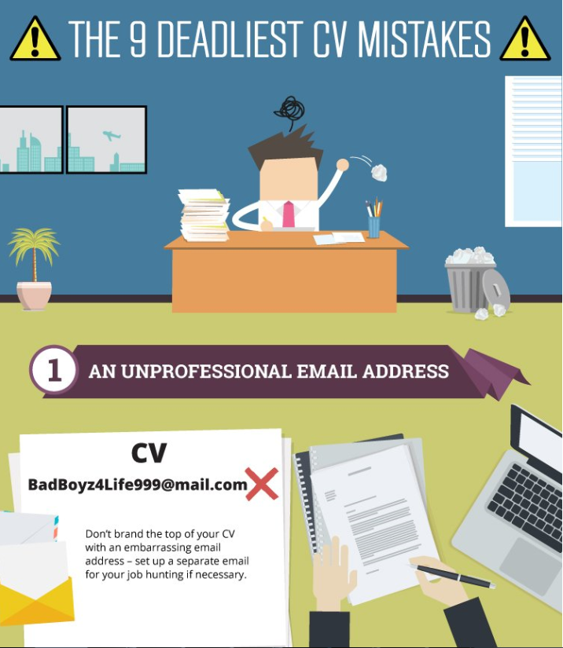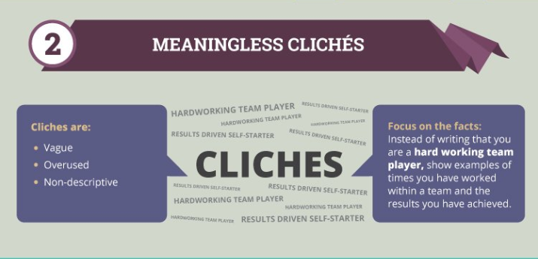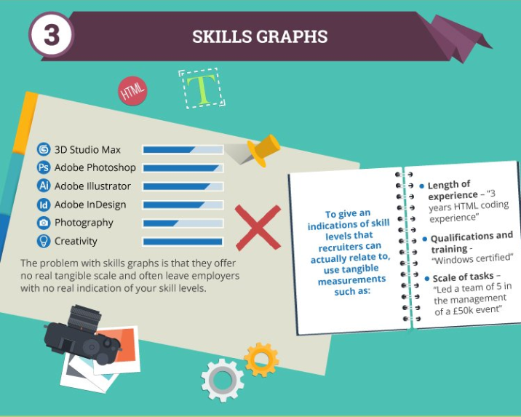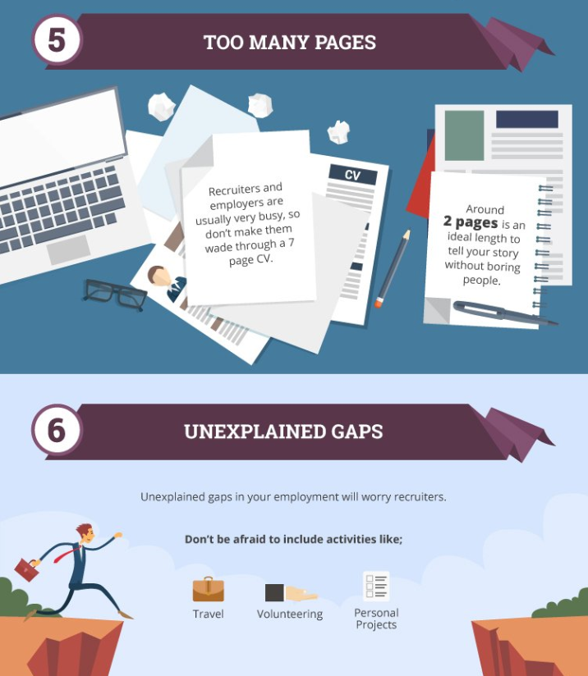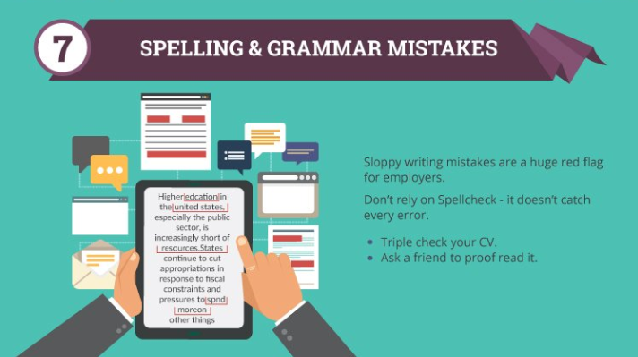

Good CV Example
Steven Jones
99 Long Road
Chesterfield
England
CH68 1PP

Tel: 0111 333 555
E: steven.jones@gaggle.co.uk

An excellent communicator with experience in a customer service role. Proven to work well as part of a team as well as on individual assignments. Looking to expand on these skills via a customer facing role in the retail sector

Work Experience

June 2011-Present
Paper delivery assistant: Smith Newsagents, Chesterfield.
- Bi-weekly newspaper delivery round
- Liaised with senior staff to ensure route efficiency for deliveries
- Regular face-to-face contact with customers
- Completed daily log of enquiries so that order information could be updated
- Updated customer details database to improve information quality

April 2012
Work Experience placement: Topman, Chesterfield.
- Two week work experience placement, involving customer contact and care of stock
- Greeted customers and assisted with face-to-face enquiries regarding sizing and availability of products
- Served customers, operated the till and handling money and card payments
- Worked with permanent members of staff on the monthly stock check, with sole responsibility for the accurate log of men’s footwear
- Assisted with the general upkeep and appearance of the store

Education

September 2008 – Present
Chesterfield Comprehensive Secondary School & Sixth Form

A-Levels: Grades Pending, August 2014
- Business Studies, English, Maths, General Studies
GCSE’s: August 2012
- English (B), English Language (C), Maths (C), Science – Double Aware (BB), Information Technology (A), Business Studies (A), History (C), French (B), Music (C), Graphic Design (C)

Key Skills and Achievements
- Microsoft Word, Powerpoint, Excel and Outlook
- Captain of Riverside Under 18’s five-a-side football team – including organising weekly team games and mentoring junior members of the team
- Achieved Grade 5 in electric guitar
- French – basic conversational

Interests

I enjoy my football and as well as captaining my local fice-a-side team I am a member of the School Sixth Form team and Sheffield United Supporters Club. I have a keen interest in music, and as well as playing guitar I regularly attend local concerts. I am also a member of the school music society and have participated in a number of school performances.

References

Available upon request


Apprenticeships

Apprenticeships

Apprenticeships are a mixture of work-based training and education for young people aged 16 and over. They include:
- a National Vocational Qualification (NVQ) in the appropriate occupational area
- key skills such as communication and application of number
- a technical certificate (which underpins your NVQ with the knowledge you will need to do the job)

Apprentices are paid the national minimum wage. However, as skills develop, many employers tend to increase wages. The national minimum wage applies to all 16 to 18-year-olds and to those aged 19 and over in the first year of their apprenticeship.

Council apprenticeships
There are two types of Council apprenticeship - intermediate and advanced. We mostly offer Business Administration apprenticeships but other apprenticeships are sometimes available.

Business Administration apprentices
We recruit Business Administration apprentices all year round, into opportunities in every area of the Council. A Business Administration apprenticeship could be for you if you believe you can demonstrate the following qualities:
- enthusiasm to learn
- willingness to help others and work as part of a team
- genuine interest in the activities of the Council
- reliable and able to work accurately with good attention to detail
- good response to management direction and ability to act on feedback
- flexible and adaptable
- good interpersonal skills to work as part of a team
As a Business Administration apprentice, you’ll not only be paid for your work but you’ll also complete a recognised qualification (Level 2 Diploma in Business Administration) and learn skills such as:
- handling mail
- minute taking
- organising and reporting data
- working effectively with others
- operating a computer
- dealing with visitors and customers
- using word processing/spreadsheet software
Normally we ask for five GCSEs at grade C or above, including Maths and English. However, enthusiasm for the role and commitment to learning are more important and for the right candidate, support will be provided with meeting the minimum standards of Maths and English if required.

Applying for a Business Administration apprenticeship
If shortlisted, you’ll be invited to interview. It’s therefore not possible to give any definite timescales as to when this might happen if you do decide to apply for an apprenticeship with us, please note the following.
- All correspondence with you will take place by email, so please check your emails regularly and if you change email address, let us know.
- Our apprentice opportunities may be based anywhere in the Borough. Most positions will be based at either HQ Building in Chester City Centre, or Civic Way in Ellesmere Port. A smaller number of positions may arise at Wyvern House, Winsford and at other locations across the borough. If invited to interview, you will be informed where the role will be based. We won’t 'deselect' you for a position based solely on where you live compared to where the role is based so if this location is not realistically practical for you in terms of travel to work, please do let us know.
- Similarly, our opportunities are in all areas of the organisation. For Business Administration apprenticeships your experience gained working with us in any department will help you with the qualification and in securing a future role, in or outside of the Council (and almost all of our Business Administration apprentices go on to secure a permanent role in the Council, often after they have progressed to the Advanced diploma qualification).
As well as Business Administration, we also offer apprenticeships in other areas from time to time, for instance:
- streetscene / land management
- communications and Marketing
- accountancy
- legal
- human resources

We plan to grow our range of apprenticeships in the future.

We advertise our Business Administration apprenticeships, along with all other Apprenticeship opportunities, on the Council Vacancies page.

If you are interested in applying for an apprenticeship with us, please check regularly as new vacancies are uploaded as soon as they become available. You can apply for as many vacancies as you like. And remember, from 1 May 2017 all age-related funding restrictions (and most qualification-related) are lifted. So, no matter your age or previous qualifications, you may be suitable for an apprenticeship and we would love to hear from you.

Apprenticeships
1. Overview
Apprenticeships combine practical training in a job with study.
As an apprentice you’ll:
- work alongside experienced staff
- gain job-specific skills
- earn a wage and get holiday pay
- get time for study related to your role (usually one day a week)
Apprenticeships take 1 to 5 years to complete depending on their level.

Levels of apprenticeship
Apprenticeships have equivalent educational levels.
Name | Level | Equivalent educational level
Intermediate | 2 | GCSE
Advanced | 3 | A level
Higher | 4,5,6 and 7 | Foundation degree and above
Degree | 6 and 7 | Bachelor’s or master’s degree
Some apprenticeships may also give you an additional qualification, such as a diploma.
Who can apply
You can apply for an apprenticeship while you’re still at school. To start one, you’ll need to be:
- 16 or over by the end of the summer holidays
- living in England
- not in full-time education

How to apply
There are 3 steps to applying for an apprenticeship.
- Search for an apprenticeship.
- Sign in or create an account.
- Complete and submit your application.
The National Careers Service has advice on writing applications and what to do at interviews.

If you’re unsuccessful
You can ask for feedback if you don’t get selected for an interview or for the apprenticeship.
You can complain if you think you weren’t successful because you were discriminated against, or your treatment in the interview or application process was unfair.

Apprenticeship helpline
nationalhelpdesk@apprenticeships.gov.uk
Telephone: 0800 015 0400
8am to 10pm, 7 days a week
If you need more experience
If you feel you’re not ready for an apprenticeship, a traineeship is a course designed to prepare you for one.

2. Pay and conditions
You’ll be paid during your apprenticeship.
You’re entitled to the National Minimum Wage.
The current minimum wage rate for an apprentice is £3.50 per hour.
This rate applies to apprentices under 19 and those aged 19 or over who are in their first year.
You must be paid at least the minimum wage rate for your age if you’re an apprentice aged 19 or over and have completed your first year.
Check you’re being paid the minimum wage with the national minimum wage calculator.

Hours apprentices are paid for
You must be paid for:
- your normal working hours
- training that’s part of your apprenticeship (usually one day per week)

Holidays
You’ll get at least 20 days paid holiday per year, plus bank holidays.

Help and advice
Contact the Acas helpline for free and confidential advice on your rights at work.


Interview
Techniques

Writing a Covering Letter

A covering letter is a brief letter to a potential employee outlining your interest in the job and why you feel you would be a good applicant. Please see below for more information and have a look at the suggested format.

To make this as easy as possible we suggest using a basic format that you can follow each time. Remember, every letter you write should be tailored to the specific job role or company you’re applying for.

Your cover letter should address the following:
- Which position interests you and why
- Your most relevant skills and experiences
- How your skills and experiences can benefit the employer
- Requesting an interview

Below is a basic break down of how you should structure your cover letter:

How to structure and write a cover letter

Even though most covering letters are sent online today, your covering letter should still be set out like a traditional letter, even if you’re emailing it.
Start with your address and contact details in the top right-hand corner. Make sure your contact details are sensible – email addresses likegreenwithenvy@hotmail.co.uk won’t make you look very professional! You should then follow this with the address of the company you’re applying for and the date further down and on the left-hand side.

How long should my cover letter be?

Your cover letter should be no longer than a single A4 page. This can be tricky, especially since you want to impress the employer with all your skills and experience. Keep it short, sweet, and simple.

Tailoring each cover letter

Each cover letter you write should be tailored specifically to the company and role you’re writing it for and should be detailed.
During the research stage, try to find the name of the hiring manager or whoever will be reading your letter. This way you can make the letter even more personal, and it will prove you’re a determined candidate who wants this job.
Read the job description so you can pick which of your skills or experiences to reference, and try to mirror some of the phrases they use in the job description. Illustrate your skills with examples to show why you’re the ideal candidate; as each company and role will be different, you’ll probably find that you’re using different examples on each letter.
Having done your research, you should also be able to talk specifically about the company in greater detail. Refer to their values or specific campaigns they have run that you enjoyed. This way they’ll know that you took the time to learn about their company and that you’re genuinely interested in them and the role.

When there’s no job advertised
If you haven’t seen an advertised position, but you’re contacting a company to find out if they currently have any vacancies, the format will be slightly different as you’ll be submitting a cold-contact cover letter.
You should address the letter formally as before.
As you aren’t responding to a job ad, you should use your opening paragraph to explain why you’re writing to them and what it was that drew you to their company. If the reason for your application is a recommendation from someone, you know that already works there include their name.
You should also refer to the area of the company that you’d like to go into, for example, marketing or sales.
The body of the letter should remain relatively the same, highlighting your skills and experiences and giving detailed examples. Reiterate why you’re interested in their company specifically, talk about the sector and show that you’ve done your research.
In this instance, you should close the letter by thanking them for their time and expressing your interest in hearing from them with any available job vacancies that they may have.
Remember, each cover letter should be unique (even if you follow the basic format), and the aim is to make yourself stand out to recruiters.

[Address Line 1]
[Address Line 2]
[Address Line 3]
[Phone Number]
[Company address line 1]
[Company address line 2]
[Date]

To [Name],

Paragraph 1:
Your opening paragraph should be short and sweet made up of three things: why you’re writing the letter, the position you’re applying for, how you found out about the position. For example: “I am writing to apply for the role of [job title], in response to an advert I saw on [name of job site]. Please find my CV attached.”

Paragraph 2:
The second paragraph should be about you, expanding on your CV and giving a brief summary of any relevant skills or education you have. Remember, your cover letter shouldn’t be a copy of your CV; it should take your most notable achievements, explain a bit more about them, and then show how these skills could benefit the employer. Mirror the skills mentioned and the phrasing that’s used in the job description.

Paragraph 3:
The third paragraph is your chance to show your knowledge of the company and the sector and go into detail about why you want to work for their company specifically. You should state how you can help the company and add to their success, as well as why you’ll fit in with the company culture and core values.

Paragraph 4:
End your letter with a call to action. As you’re hoping to secure an interview, let them know your availability for a call-back. If you plan to follow up with a phone call, say so! If you plan to wait for a response, close with “I look forward to hearing from you”. Thank them for taking the time to read your letter and sign off with:

Yours sincerely,
[Your Name]

Good Covering Letter Example
Sam Smith
34 Hammond Road
Manchester
M34 2AA
Tel: 0161 237 4568
E: sam.smith@talktalk.net

23rd October 2013

Mrs Lucy Watts
Personnel Office
The Grange Hotel
Manchester
M17 1BB

Dear Mrs Watts

Re: Hospitality Front of House Vacancy, Ref:243Hosp

Please find enclosed a copy of my CV in response to the advert for the vacancy advertised in the Manchester Evening News on 22nd October 2013.

As you will notice from my CV, I worked in a hotel during my work experience placement and this gave me an insight in to the hospitality industry which I thoroughly enjoyed and I am keen to take on a permanent role in this area.

I gained lots of skills during my placement, including working as part of a team, communicating with customers and working under pressure. I would very much like the opportunity to use and build upon these skills and feel that I would prove to be a valuable addition to your team.

Thank you for taking the time to consider my application and I look forward to hearing from you in the near future.

Yours sincerely
Sam Smith

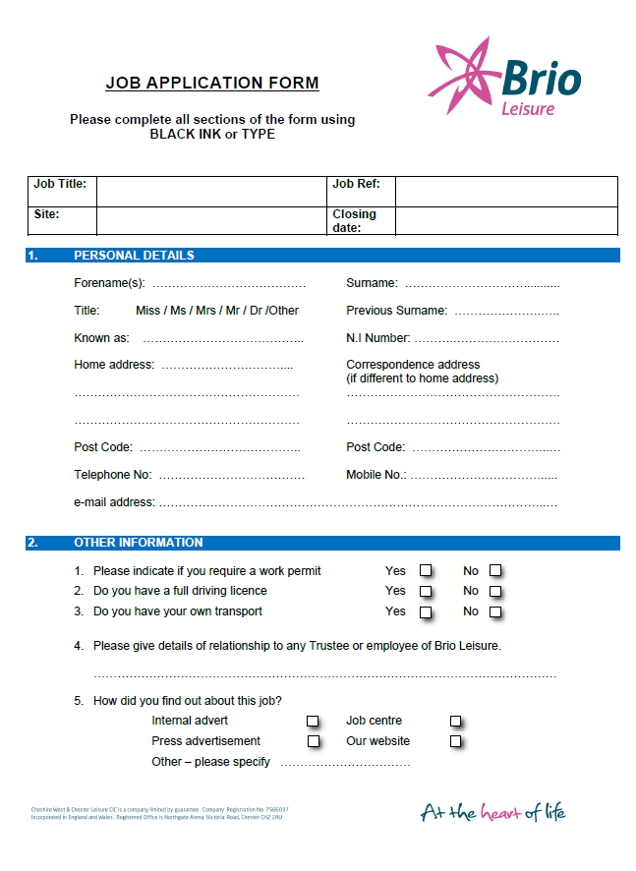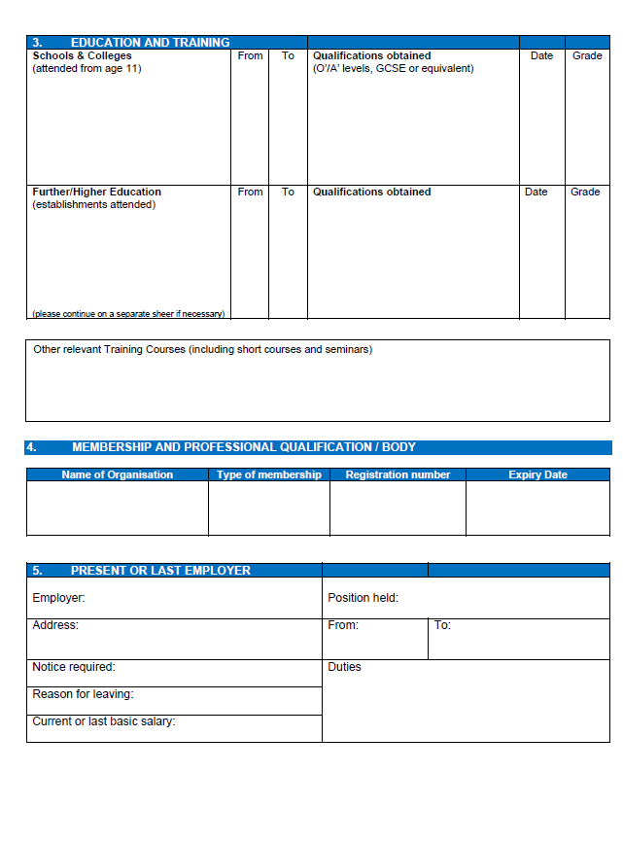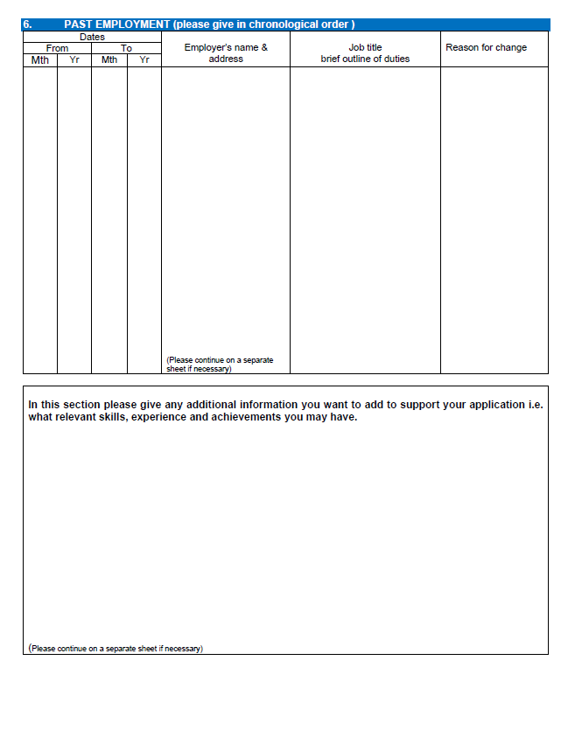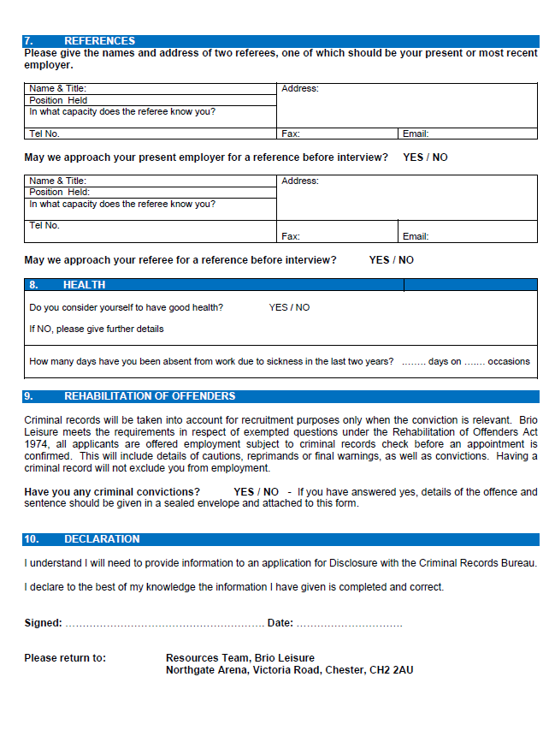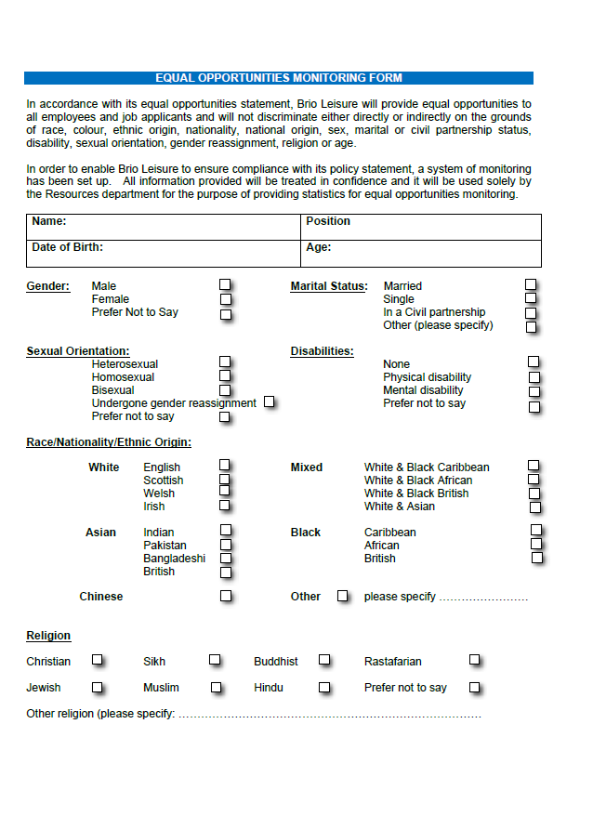

CONFIDENTIAL


Job Application Form

Please complete all sections of the form using black ink or type.
The outside pages of this application form (which contain all your personal details and the equal opportunities information) will be detached and retained in Human Resources. This ensures that your application is dealt with objectively. Please complete these pages even if you are submitting a CV.

Data Protection Act
Information from this form will be processed in accordance with the Data Protection Act 1998. In signing it you agree to this data being held and processed and if appointed to the job you also agree to further personal information, including sensitive data (e.g. bank details, medicals, etc) being held and processed by Cheshire West & Chester in accordance with the Act.

Cheshire West and Chester Council is under a duty to protect the public funds it administers. To this end we may use the information we hold for the prevention and detection of fraud, which also includes for the assessment and/or collection of any tax or duty. This will include sharing of information held internally and with external organisations where the law allows.

For internal candidates only
Are you on the Redeployment Recruitment List ? Yes No

Title of job applied for
 | Title of job applied for: | Ref:

Personal Details
Mr/Mrs/Miss/Ms/Dr | First Names: | Known as:
Surname: NI Number:
Previous Surname(s):
Address:
Post Code:

Telephone Numbers
Home: | Work:
Mobile: | E-mail address:
May we contact you at work? Yes No

How can we contact you? Telephone / E-mail / Mobile

Where did you first see the advertisement for this job? If a newspaper, please state which one.

References
Please provide two referees. One of these must be your present or most recent employer, or, for students, your personal tutor or head teacher. The second should, preferably, be a previous employer or someone who can comment on your suitability for this job. Note –Council Recruitment Policy requires references to be provided by current line managers for internal candidates. Please nominate who that is under present/most recent employer.
Please let your referees know that you have quoted them as a referee, to expect a request for a reference and clarify how best to contact them e.g. letter, e-mail, should you be shortlisted.
Present/most recent employer* |  | Previous employer/other
Organisation: |  | Organisation:
Name: |  | Name:
Role in Organisation: |  | Occupation:
Address: |  | Address:
Postcode: |  | Postcode:
Phone No: |  | Phone No:
E-mail: |  | E-mail:
Preferred method of communication:
Letter E-mail Letter E-mail

In what capacity does the referee know you? |  | In what capacity does the referee know you?
- Employer/former employer |  | - Employer/former employer
- Colleague/former colleague or manager but the reference is given on a personal basis |  | - Colleague/former colleague or manager but the reference is given on a personal basis
- Personal |  | - Personal
If the referee knows you by a different name please state:
* If you have not had previous employment, please provide details of another referee.
A reference will normally be taken up from your present/previous employer. Please tick the box if you do not want us to contact your referees without your prior agreement. However, if this job is working within Children's Social Care all references will be taken up prior to interview.

Please do not contact my present/most recent employer

CONFIDENTIAL

Job Application Form
CVs will only be accepted in place of pages 3, 4, 5 and 6 if the information requested in these sections is covered. Please write the reference number at the top of your CV. You should not include the equal opportunities information on your CV.

Title of job applied for: |  |  | Ref:
Name:

Current/Most Recent Appointment
Title of current Job: |  | Start Date:
Current Employer: |  | Salary Range:
Employer Address: |  | Current Salary: £
Permanent or temporary contract: |  | Notice Required:

Main Responsibilities

Job related training
Brief details and dates of any training courses attended, excluding further education.

Current memberships of institutions/professional bodies
Please state level of membership, i.e. Graduate, Fellow, and membership number.

Employment History
(Most recent first)  Name of Employer, type of Business and job title |  | Dates |  |  | Duties and reason for leaving

Relationship to Councillors or employees

If you have any personal relationship to any employee of Cheshire West & Chester, or to a Cheshire Councillor, please give their name and relationship. This does not stop a Councillor or employee giving a reference. (Any approach to Councillors or other employees to influence a selection decision will disqualify you).

If Councillor: Name Relationship
If Employee: Name Relationship
Work location Their present job

Education and training

Maths and English Qualifications
Do you have a qualification in English and/or maths*? Please list your highest full qualification attained:
Subject | Qualification |  |  | Grade attained | Date
English
Maths
Please give details of schools and colleges attended from age eleven, including part-time education and other courses.

Secondary education  (name and town of school) |  | Dates  from / to | Qualifications gained or for which you are studying |  |  | Grade attained
Education and training after school (name and town of college/university)

*CWaC is committed to supporting literacy and numeracy skills across all its employees.

Other Information
Additional skills e.g. languages sign language, keyboard skills.

Do you have a valid driving licence? Yes No

If yes, please state type of licence

Does your licence have any endorsements or penalty points? Yes No

If yes, please give details

Supporting Information
Please use this section to explain why you are applying for the job. Concentrate on how your experience, training and personal qualities match the requirements of the job description and person specification.

If you require more space please attach a separate sheet.

Activities and interests away from work which may be relevant to the job applied for.

Diversity
We are committed to equality of opportunity for everyone. To assess whether our Diversity policy is effective we need to monitor it and to do this we need the information requested below. We can then compare the success rates of different groups at both the shortlisting and appointment stages to ensure that unfair discrimination is not taking place This will also enable us to comply with our obligations under current legislation.
The information below will be used only for monitoring purposes and not in the selection process. Please tick correct boxes:
Do you describe yourself as? Male Female
Marital Status: Married Civil Partnership Single
Date of Birth: Age:
Please indicate your ethnic origin
White: Mixed: Asian
White British Mixed White/Black Caribbean Indian
White Irish Mixed White/Black African Pakistani
Any other White Mixed White/Asian Bangladeshi
Other Mixed Other Asian

Black or Black British: `Other:
Black Caribbean Chinese
Black African Gypsy/Traveller
Other Black Other

Nationality ( Please State)
How would you define your sexual orientation?
Bisexual Gay Heterosexual Lesbian Prefer not to say
What is your religious belief?
Buddhist Christian Hindu Jewish Muslim Sikh

No religion Other (please specify)__________________ Prefer not to say

Disability: The Disability Discrimination Act of 1995 made it unlawful for employers to discriminate against their employees who are disabled and places a duty on the employer to make reasonable adjustments to enable the employee to undertake the work. The definition in the Act is "People with disabilities are individuals who have, or have had, a physical or mental impairment which has a substantial and long term effect on his or her ability to carry out normal day to day activities". If you do consider yourself to be disabled under the definition in the Act, please indicate this, even if you do not currently need any adjustments to undertake your job.


Do you consider yourself to have a disability? Yes No

Have you any unspent convictions? If so please give details.
If between the completion of this application form and taking up a job with the Council you are convicted of a criminal offence you must inform the Council of this.

The Rehabilitation of Offenders Act (only complete this section if instructed to do so on the Job Description and Person Specification enclosed with this form)

The Rehabilitation of Offenders Act allows for a person who has been convicted of a criminal offence involving a sentence of not more than 2½ years imprisonment and who has since lived trouble free for a specified period of time (related to the severity of the offence) to be treated as if the offence, conviction or sentence had never occurred. This is known as a spent conviction.

The job for which you are applying is one of those to which the provisions of the above Act in relation to spent convictions, do not apply. You must, therefore, disclose whether you have any previous convictions, whether or not they are spent.

Should you identify that you have a criminal conviction, this will be discussed in confidence at interview. However you should note that only convictions that are relevant to the job in question will be taken into account.

Do you have any spent criminal convictions? Yes No

If yes please state:
If you do not disclose any conviction you have it could lead to your application being rejected, or, if you are appointed, may lead later to your dismissal.
People who have convictions will be treated fairly and given every opportunity to establish their suitability for the job.
Any information that you give will be kept in strict confidence and will be used only in respect of your application for this job.
As part of the recruitment process we will check our records for information we hold about you in relation to your suitability for the post for which you have applied.

Disclosure and Barring Check
Successful applicants will be asked to apply for a Criminal Record Check (Disclosure) from the Disclosure and Barring Service.
Please check the Job Description and Person Specification to identify the level of check required for the position for which you are applying.
A copy of the Disclosure and Barring Service Code of Practice is available on request.
Further information about the Disclosure process can be found at www.disclosure.gov.uk
I certify that the details on this application form and any supplementary information attached are true as far as I know. I understand that if I give false information or withhold relevant information, it could result in my dismissal.

Signed Date

Cheshire West & Chester has a duty to protect public funds and may use the information you have provided for the prevention and detection of fraud. It may also be shared with other public bodies solely for these purposes.

25 Great Questions To Ask At The Job Interview
1. What is the history of this role? Is it a new position, or was there someone in the job before?
2. What would you say is the overall purpose of the job?
3. How does this position help your department achieve its goals?
4. How does your department fit into the organization overall?
5. Who are the other members of the department (by position) and how would we all interact?
6. Who are the internal customers for this position (by job title) and how would I support them if I were in this role?
7. What are the major metrics or yardsticks for the person in this position?
8. What are you hoping for your new employee to accomplish in the first three months on the job?
9. How do you envision your new employee stepping into the role? Will they jump in and ask a lot of questions to learn the job, or do you expect them to follow a week-by-week or day-by-day training plan, or something else?
10. What do you see as the major goals for the person in this role over the next year?
11. How do you anticipate interacting with your new employee — do you have a weekly one-on-one meeting, or do you mostly rely on email, or something else?
12. How does your department communicate? Do you meet as a group, or communicate another way?
13. What are the working hours, and your expectations for overtime?
14. What sorts of technology will your new employee use in the job?
15. What kinds of writing will your new person do?
16. You are interviewing me, an external candidate. Often job openings are filled from within the company. What made you think about interviewing external candidates like me this time?
17. What are the items you'd most like to see your new employee take care of and check off your list right away?
18. How will the arrival of your new employee make your life easier?
19. How do people typically dress for work in your department? Does that vary depending on their level of customer contact, or other factors?
20. What are your thoughts on working from home — for example when there's bad weather, or in general?
21. What are your expectations around arrival and departure times, and taking work home?
22. What would you say is the most fun or creative part of the job?
23. How did you get to the company, and to your current position?
24. What are the company's senior leaders like? What do they care about and talk about most?
25. When are you hoping for your new employee to start?
Most likely you will not be able to ask all of these questions in one interview.

These are the ten most frequently-asked interview questions that you can expect to face:
- What can you tell me about yourself?
- Can you list your strengths?
- What weaknesses do you have?
- Why should I consider hiring you?
- Where do you see yourself five years from now?
- Why do you want to work here?
- What is your salary expectation?
- What motivates you?
- What makes a good team player?
- Is there anything that you would like to ask me?
It is fair to say that you might not be asked every one of these questions at an interview. You may even be asked other, more bizarre ones, like ‘if you were an animal, which would you be?’

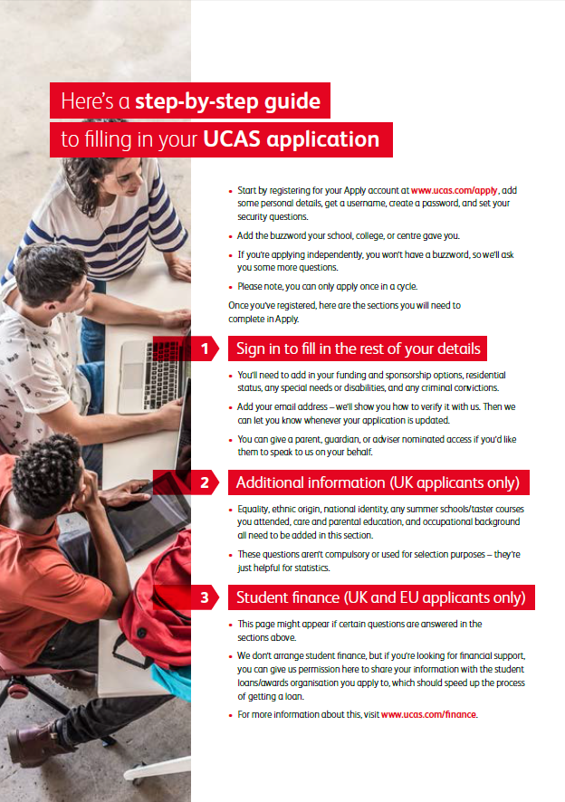
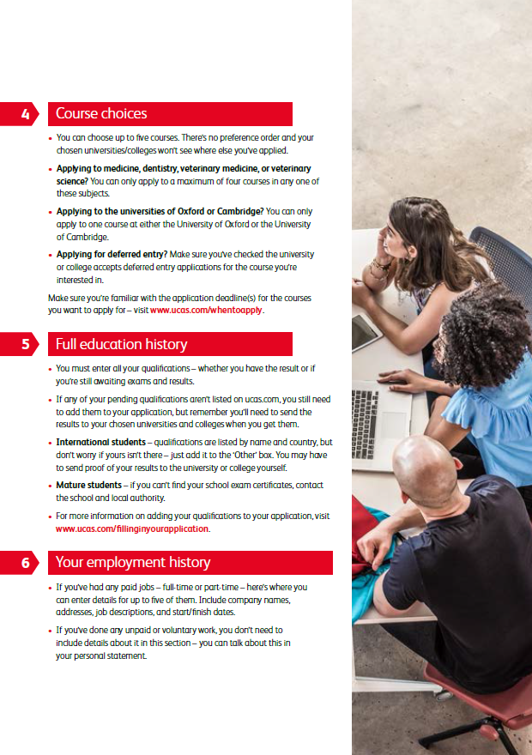

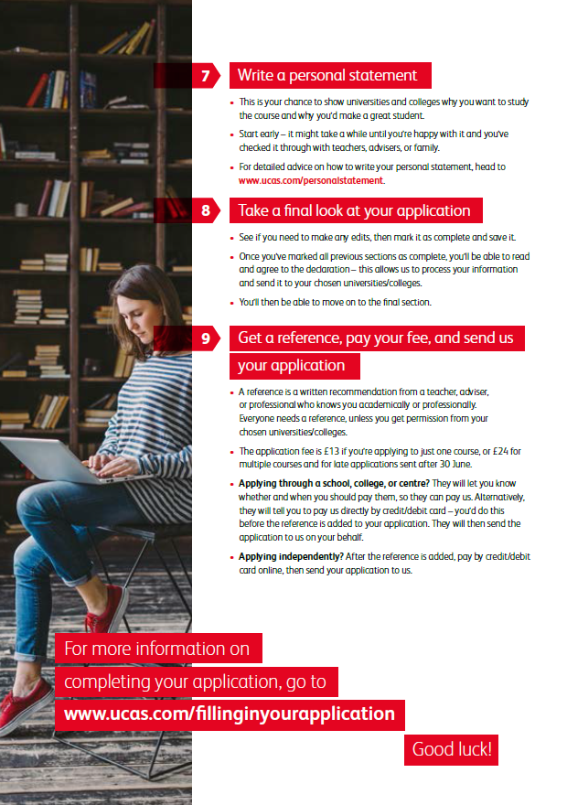

Useful contact details
Kelly Jackson – Education Engagement Mentor. The Virtual School for Children in Care. 01606 274 324 kelly.jackson@cheshirewestandchester.gov.uk
Or for more information visit www.cheshirewestvirtual.school/
Get in Go far – this is the government’s official website on apprenticeships and traineeships. It provides lots of information about these programmes and lets you search for vacancies. www.getingofar.gov.uk
GOV.UK – A government website that provides information on a range of public services, including education and employment. www.gov.uk
National Apprenticeship Service – Lots of information about Apprenticeships and Traineeships including frequently asked questions. www.Apprenticeships.org.uk
National Careers Service – Provides free information, advice and guidance to help in decision making regarding learning, training and work opportunities. www.nationalcareerservice.direct.gov.uk
National Network for the Education if Care Leavers (NNECL) – NNECL works with staff and professionals to support the progression of young people in or leaving care into and through further and higher education. www.nnecl.org
Skills Support for Care Leavers – A website with lots of information on learning and work options for care leavers and the support they should receive in education and employment. www.skillssupport.org.uk
Young People Service –support young people to help them plan for the future and make the most of their life and career opportunities - our aim is to support young people into making successful and sustained transitions into education, employment or training. www.cheshirewestandchester.gov.uk/residents/young-people/young-peoples-service/young-peoples-service.aspx
Local Offer - Information and Service for Adults and Children in West Cheshire www.westcheshirelocaloffer.co.uk

