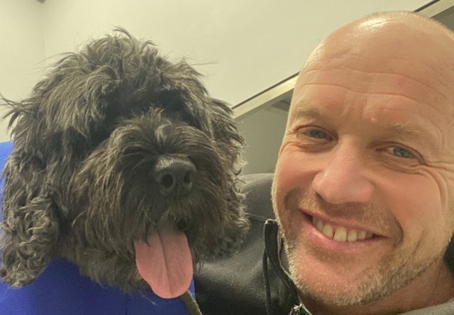 |  |  |  | Adam Croft  Virtual School Headteacher

What’s important to me?

I love being outside - walking my dog Dex, running or riding and often falling off my bike!

Spending time with people I like.

Visiting different places.

Eating lots - spicy food is my favourite.

My Job
I used to be a primary headteacher and although I don't have a school building anymore, I am still a Headteacher – of something called the Virtual School.
The Virtual School is a group of adults who, along with your social workers are called your Corporate Parents. This means we work with your designated teacher at school or designated person at college and your social worker to help put things in place so that you do as well as possible in school and college. Sometimes this means helping you get extra support or even attend the right school for you.
If you are of school age and attend a school you therefore really have two headteachers!

People describe me as…
Happy, friendly, helpful and caring.
They also say I’m always on the move and a bit loud!

What would I like to get better at?

Concentrating on things that don’t really interest me.

Being patient!

Cooking.

Although I meet some of you at Children In Care Council I haven’t really had much chance to meet with you directly.

If you do want to tell me something or ask me something you can get in touch by email (do this yourself or get your carer to help)

 |  | 
 | Adam.Croft@cheshirewestandchester.gov.uk

