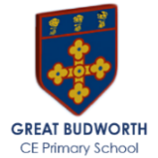

Otter Class Summer 1 Newsletter
Mrs Gould and Mrs Davis-Hilliard
Welcome back!
We hope you had a restful holiday

As we begin the Summer Term, Otter and Owl Class is buzzing with energy, curiosity, and a real love for learning. We’re incredibly fortunate to have such a dedicated team supporting your children each week, ensuring they feel safe, inspired, and ready to shine.
🌟 Our Classroom Team
• Mrs Gould teaches Reception and Pre-School every morning from Monday to Thursday, creating a nurturing and engaging start to the day where children’s ideas and creativity can flourish. She then teaches the year 1, year, 2 class every afternoon, providing consistency and a calm, purposeful learning environment.
• Mrs Davis-Hillard teaches Year 1, Year 2, and Year 3 each morning, bringing clear structure, high expectations, and a supportive approach that helps the children grow in confidence and independence.
• Mrs Hathaway supports learning on Monday, Tuesday, and Wednesday, helping to make each day purposeful, calm, and full of opportunities to succeed.
• Vicky brings her enthusiasm to the classroom on Thursdays and Fridays, working closely with the team to guide, encourage, and celebrate the children’s achievements.
• Mr Holland leads the class on Fridays, with Vicky supporting, ensuring continuity, consistency, and a positive end to the week.
As we move into the Summer Term, our goal remains the same: to ensure every child feels confident, supported, and inspired each day. We’re looking forward to a wonderful half‑term filled with learning, laughter, and plenty of opportunities for the children to shine.

🟢 Phonics and English- year 1 and year 2
We’re excited to share that the purple phonics group has now moved up to the pink group!
The children will continue developing their phonics skills through daily phonics lessons.
Mrs Davis-Hilliard’s reading groups will be exploring the text Keisha Jones is a Force of Nature by Natalie Denny.

In English this term, they will be exploring the story Toys in Space by Mini Grey.
By the end of this unit, the children will aim to write a fantasy story about some toys who are taken on a spaceship with a change in character.

🔴 Red Ditty Readers – Reception
Our reception children have made fantastic progress on their Read Write Inc. journey this term! They are becoming increasingly confident with their Set 1 Speed Sounds, blending skills, and early reading. Many children have now moved on to the Red Ditty storybooks, which will help build their fluency, accuracy, and enthusiasm for reading — a wonderful achievement and something we are very proud of.
🌼 EYFS class Update
Our EYFS children are growing in confidence, exploring new ideas, and becoming increasingly independent in their learning. From imaginative play to early maths and phonics, the children are curious, engaged, and proud of everything they are achieving each day.
📖 Reading at Home:
The children are continuing to strengthen their knowledge of Set 1 Speed Sounds and special friends, and they are practising blending these sounds to read simple words and sentences. Their hard work and determination are really shining through, and it’s a joy to see their confidence grow with each new sound they master.
We would like to gently remind families of the importance of recording home reading in the yellow reading record. When the record isn’t signed, it appears as though your child hasn’t read at home, even when they have — and we want to make sure we celebrate every bit of their effort. Working together makes a huge difference to your child’s reading journey.
Please continue to support your child by listening to them read regularly at home:
• Don’t forget to sign their yellow reading record each time they read.
• In school, children read daily with their RWI partner, take part in guided sessions, and are heard 1:1 by an adult in class.
🎥 Helpful Parent Resource
Don’t forget to use the QR codes in your child’s reading record. These short videos are a great way to support blending practice and help your child on their journey to becoming a confident, independent reader.
🏃‍♂️P.E. – Summer 1 all children
P.E. this half term takes place on Tuesday and Friday afternoons, and is led by, our specialist PE coach.
This term, children will be focusing on team games and athletics.
🌍 EYFS Science Focus: On the Move Through Nature🌿
This half term, our science learning is all about “On the Move Through Nature.” The children will be exploring how movement happens all around us — from the way our bodies jump and stretch, to how animals travel, how the wind blows objects, and how water helps things float and glide. We’ve also been watching plants grow and noticing how they slowly move and change over time. The children have loved investigating, predicting, and talking about what they notice, and it will be wonderful to see their curiosity and confidence grow as young scientists.

💛 PSHE – Think Positive (Year 1 & 2)

This unit is designed to help children recognise, talk about and accept their feelings, both positive and negative, as well as how to manage certain emotions. The lessons support themes of thinking positively and calmly, making good decisions and developing resilience. It also encourages the children to explore the positive feelings associated with being thankful, grateful and mindful.

RE – What do Christians believe happened at ascension and Pentecost?

Within RE this half term the children are going to understanding the significance of the ascension and Pentecost. We will explore the concept of God as three in one and emphasis the importance of these in the events in the life of Jesus and the church, then and now.

🌱 EYFS (Reception & Pre-School) Maths – Building 9 and 10
This term in Maths, we’re following the White Rose scheme as we explore the numbers 9 and 10. The children will be practising saying the number names, matching them to numerals, and counting out objects carefully by touching each one.
We will also be spotting groups of 9 and 10 in stories, pictures, and around the classroom. Seeing these numbers in lots of different ways helps the children build confidence before they begin creating their own representations
📚 Key books to share at home:
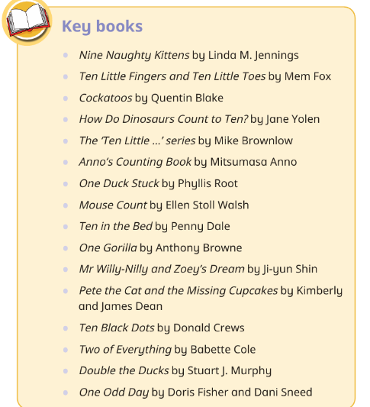
Reading these stories together at home is a great way to reinforce our learning — helping children to spot shapes, count objects, and talk about numbers in everyday life!

➕ Maths
Year 1 children
Measurement: Mass and Volume
Multiplication and Division
Fractions
Position and Direction
Place Value (within 100)
Money
Time
Year 2 children
Fractions
Time
Statistics
Position and Direction
Consolidation of KS1 Maths

🔔 Important Reminders
To help everything run smoothly this term, please take note of the following:
- P.E. Days: Children should come to school wearing their P.E. kit on Tuesdays.
- Forest School: WILL BE ON A TUESDAY this term!
- Water Bottles: Each child should bring a named water bottle to school every day to stay hydrated.
- Snacks: each child can bring a healthy snack pot we recommend cut up fruit for EYFS children, cheese or a small yogurt.
- Waterproof Coats: Please ensure your child has a suitable waterproof coat for unpredictable weather—don’t forget to label it with their name.
Thank you for your continued support and cooperation—it makes a real difference
✏️ Spelling & Homework – Year 1 and year 2
Spellings for Summer term can be found on the school website and have been sent out via school spider. Spelling tests will take place on a Friday or on a Thursday for flexi-school children.

White Rose Maths homework books will be collected in each Tuesday and marked with a new week’s worth of maths homework being set. The work the children will be completing will be linked to learning that has been taking place in class.
Thank you for your continued support — it really helps the children grow in confidence and independence! 🌟
🏠 Home Learning – Flexi School Children
Flexi School children will be receiving a pupil on a page document during the first week of the summer term. This will contain specific objectives for the children to work on over the following weeks and will ensure that the children are being given access to a full curriculum.
Work the children complete needs to be sent to school each Tuesday. This can either be brought into school and handed to the teacher, or it can be sent for the attention of the class teacher via the admin email in the school office. admin@antrobus.cheshire.sch.uk

🌼 Looking Ahead – Summer Two
As we move into the summer term, our days in Otter Class and Owl Class are filled with calm, cosy learning and plenty of seasonal discoveries. The children are continuing to grow in confidence, curiosity, and independence as we build on all the wonderful progress made so far.
We’re looking forward to a joyful half-term full of creativity, exploration, and shared learning as we head towards the sunshine of Summer Two.
Mrs Gould and Mrs Davis Hilliard

