Class 3
Summer Newsletter
Mrs Phoenix/ Miss King

Welcome to the Summer term – how quickly did that come around?!
We hope that you have all had a wonderful break during the Easter holidays and that you’ve all eaten lots of yummy chocolate eggs! We certainly did!
This is just a quick newsletter to provide you with some necessary information to help you get
organised for the busy term ahead.

Forest Schools:
Forest schools will take place again this half term every Tuesday morning. Please ensure that your child has waterproofs and wellies in school for any wet days.

End of Key Stage Two Assessments (SATs)

Year 6 children will be assessed in Maths and English: Writing, Reading, Spelling and Grammar. These will start on Monday 12th May and last for four days. All year six children will be expected to be in school this week.

Here is an overview of the assessment week for Year 6 children:

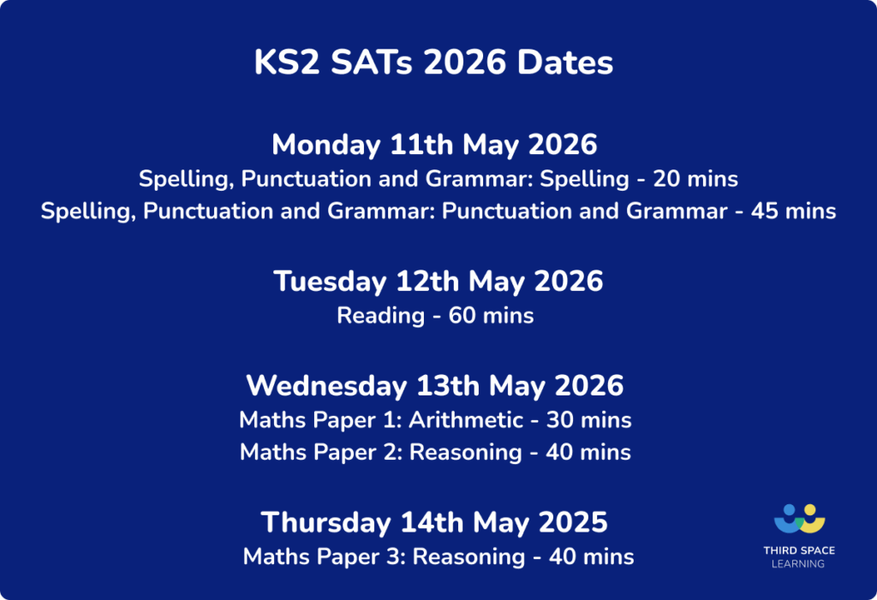

Romans Trip:
On Wednesday 29th April we shall be visiting the Grosvenor museum as part of our Romans topic. All details have been sent out already on School Spider.

Class residential:
The residential for Years 3, 4, 5 and 6 will take place from the 23rd – 25th June at Gulliver’s World in Warrington A kit list will be sent home and there will be an information evening for parents closer to the time.

PE:
PE days are Tuesday and Friday (with our PE coach).
Please make sure your child has appropriate clothing in school on these days.
Long hair must be tied up and earrings should be removed or otherwise, covered with plasters brought in from home.

A few reminders…
Expected attendance targets are set at 95% by the government. We would be grateful if you could please make every effort to send your children to school daily, if they are unwell we will always call you.
Obviously, if they have been sick or had diarrhoea, we ask that you keep your children at home for 48 hours following their last episode of illness.

Homework Timetable:

All children will receive weekly spellings.
The children will be given opportunity to practise these during the week but will also need to learn them at home. Children will be tested on their spelling list on the Friday.

Reading Homework
Strive for Five
All children are expected to read for 20 minutes every day as part of their homework.

Please ensure your child has a reading book in school each day.
Also, please encourage and support your child with filling in their reading records so we are able to
keep track of their reading and make recommendations where appropriate.

Maths homework will be set and go home on a Tuesday to be returned on the following
Tuesday. We use the White Rose Maths books and the work is directly linked to the learning that has taken place in class that week.

Flexi -School Children – Please use the class timetable and topic web/ newsletter to see which subjects we teach in school on a Monday and Friday. These are also available to view on the class webpages. As part of our flexi school agreement, a portfolio of work, completed outside of school, based on these subject areas is to be shared at our half termly review meetings. This can be in any format you choose. If you have any further questions about this, please do get in touch.

Once again, it is another busy but exciting term full of positive learning experiences. As always, should you have any queries about your child’s education, please do not hesitate to contact us.

Mrs Phoenix

