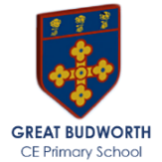
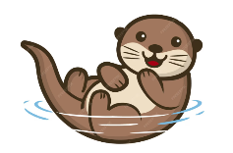
Otter Class Spring 2 Newsletter

Welcome Back to Spring 2!
I hope you all had a lovely half term break and managed to enjoy some rest and early spring sunshine 😊
🧑‍🏫 🦦 Otter Class has had a wonderful start to Spring, and the children have settled back into routines with enthusiasm and curiosity. This half term is full of exciting learning, growing independence, and plenty of opportunities to shine.
- Mrs Gould leads the class from Monday to Thursday, continuing to nurture curiosity, creativity, and confidence in every child.
- Mrs Hathaway supports the classroom on Monday, Tuesday, and Wednesday afternoon, helping each day run smoothly and joyfully.
- Vicky brings her energy and enthusiasm on Thursdays and Fridays, working closely with the teachers to support and encourage the children.
- Mr Holland teaches on Fridays, with Vicky providing support — ensuring a consistent and engaging end to our week.
- Our goal remains the same: to make every child feel confident, supported, and inspired each day. We’re looking forward to a busy and exciting half term filled with learning, laughter, and new adventures!

🟢 Class Update – Spring 2
We’re delighted to share how brilliantly the children are progressing this term. The Purple Group has now moved up to the Pink Group, and they continue to shine as they build on their phonics knowledge. The year one and two children will keep developing their reading and writing skills through Pathways to Write with Mrs Davis-Hilliard, exploring new texts and strengthening their confidence.
Our reception children are now deepening their understanding of Set 2 Speed Sounds. They are practising blending these sounds to read simple words and sentences, and it’s wonderful to see how their determination is helping them grow as early readers. Their enthusiasm and resilience are evident every day, and we’re incredibly proud of the progress they’re making.
📚 Home Support Matters
Your support at home makes a huge difference. Listening to your child read their Speed Sounds and Reading books regularly helps to build fluency and confidence. Just a few minutes each day can have a lasting impact — little and often is the key!
🎥 Helpful Parent Resource
Don’t forget to use the QR codes in your child’s reading record. These short videos are a great way to support blending practice and help your child on their journey to becoming a confident, independent reader.
📖 Reading at Home:
Please continue to support your child’s reading journey by listening to them read regularly at home.
- Don’t forget to sign their yellow reading record each time they read.
- In school, children read daily with their RWI partner, take part in guided sessions, and are heard 1:1 by an adult in class.
We have noticed that some reading records are still not being signed. This simple step really helps teaching staff understand how much reading practice children are doing at home and allows us to work together to support their progress. Your partnership makes a genuine difference to their confidence and fluency.

🏃‍♂️P.E. – Spring 2
P.E. this half term takes place on Tuesday and Friday afternoons and is led by our specialist PE coach Holly.
This term, Yr1/2 will be focusing on gymnastics and dance while EYFS will focus on fine and gross motor skills, using the balance bikes and apparatus.

🌍 Science EYFS: Looking after our Planet
This term, our reception children will be learning about how we can help to look after our planet. Through stories, discussions, and hands-on activities, the children will explore ideas such as recycling, reusing materials, reducing waste, and caring for the natural world. Our continuous provision will offer plenty of opportunities for sorting materials, creating with recycled resources, and thinking about small changes we can make to protect our environment. We’re excited to see the children develop their understanding of how everyone can play a part in keeping our planet clean and healthy.
🔬 Science Scientists and Inventors – Year 1 & 2
This half term, the children will be learning about a range of inspiring scientists and inventors linked to our science curriculum. They will explore how waterproof materials were developed, including the invention of the waterproof coat, and will carry out simple tests to investigate which materials keep things dry. The children will also learn about the important work of doctors and discover the achievements of Elizabeth Garrett Anderson, the first woman to qualify as a doctor in Britain. As part of the unit, they will have the chance to design and create their own mini greenhouse, applying their scientific knowledge in a practical, hands-on way.
💛 PSHE – Be yourself (Year 1 & 2)
This half term in PSHE, our focus is Be Yourself. This unit is inspired by the idea that it is important to have confidence to be yourself. It aims to enable children to identify their strengths and achievements as well as help them to recognise different emotions they experience. In this unit, children will also explore how to express their thoughts and feelings respectfully and how to be assertive when in uncomfortable situations. The children will also have an opportunity to explore the influence of the media in how we view ourselves and analyse the reality of these messages. The unit ends with the children exploring how to make things right when we make mistakes, both in person or online, and the importance of learning from these.

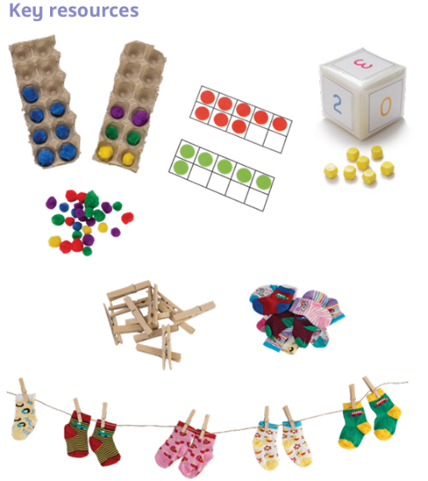
🌱 🔢 Maths EYFS (Reception & Pre School)
Spring Block 3: Growing 6, 7, 8
This half term, the children will be deepening their understanding of the numbers 6, 7 and 8 through lots of practical, hands-on activities. They will be learning to:
- Find and recognise the numbers 6, 7 and 8
- Represent these numbers in different ways
- Explore 1 more and 1 less
- Understand the composition of 6, 7 and 8
- Make pairs and begin noticing odd and even
- Explore doubling up to 8
- Combine two groups to find a total
- Develop their conceptual subitising skills (seeing small quantities without counting)
These small steps help build strong number sense and confidence, and the children will revisit these ideas through play, problem-solving and daily routines.
📚 Key Books to Share at Home
This half term, we’ll be enjoying a range of wonderful stories that link to our maths and topic learning. Sharing these books at home is a lovely way to build confidence, spark conversations, and help children spot numbers, patterns, and problem-solving in everyday life.
Some of our key texts include:
- Sidney the Silly Who Only Eats 6 – M.W. Penn
- Six Dinner Sid – Inga Moore
- 1, 2, 3 to the Zoo – Eric Carle
- Kipper’s Toybox – Mick Inkpen
- Quack and Count – Keith Baker
- Simon Sock – Sue Hendra & Paul Linnet
- Missing Mittens – Stuart J. Murphy
- Noah’s Ark
- Double Dave – Sue Hendra
- Minnie’s Diner – Dayle Ann Dodds
- Two of Everything – Lily Toy Hong
- Don’t Forget the Bacon! – Pat Hutchins
- The Snail and the Whale – Julia Donaldson
Reading these stories together at home is a great way to reinforce our learning — helping children to count objects, notice patterns, compare amounts, and talk about numbers in meaningful, everyday contexts.
🔔 Important Reminders
To help everything run smoothly this term, please take note of the following:
- P.E. Days: Children should come to school wearing their P.E. kit on Tuesdays and Friday.
- No Forest School this term.
- Water Bottles: Each child should bring a named water bottle to school every day to stay hydrated.
- Waterproof Coats: Please ensure your child has a suitable waterproof coat for unpredictable weather—don’t forget to label it with their name.
- 🍎 Snacks
Each child may bring a small, healthy snack pot to school. We recommend options such as cut-up fruit (required for all children under 5, in line with government safety guidance), breadsticks, cheese, or a small yoghurt. Please ensure that any fruit sent in for Pre-School and Reception children is already cut into smaller pieces, including items in packed lunches. This helps us keep everyone safe and supports healthy eating habits throughout the day.
➕ Maths – year 1 and 2 will be taught by Mrs Davis-Hilliard
✏️ Spelling & Homework – Year 1
Most children are now following Pathways to Spell and will receive weekly spellings to practise at home from Mrs Davis-Hilliard. Children in the pink phonics group will continue to receive spellings linked to their phonics and reading books, and their spelling checks will be completed with Mrs Gould.
Maths homework will continue in the children’s Maths Journals.
🏠 Home Learning – Flexi School Children
Flexi School children should send in the work they have completed at home every two weeks. If you would like a copy of this term’s Maths activities, please contact admin or see me at the end of the school day.
Thank you for your continued support — it really helps the children grow in confidence and independence. Here’s to a term of creativity and joyful learning as we head towards Spring! 🌟
Mrs Gould

