Uniform Policy
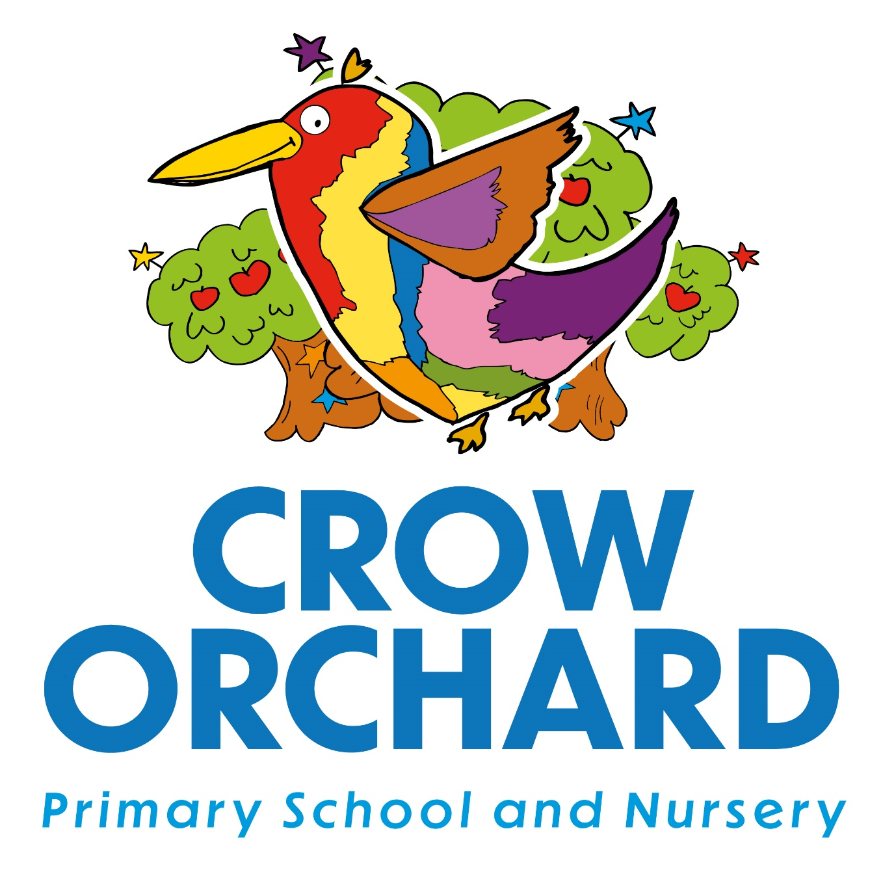

Written by: | J Hollings
Role: | Headteacher
Date: | September 2025
Review Date: | May 2026

School Uniform Policy
As a school, our core values are at the heart of all we do. With this in mind, we endeavour to ensure that they underpin our policies too.
LOVE – Be kind. Be honest. Be proud.
GROWTH – Be curious. Be creative. Dream big (aspire).
STRENGTH – Be brave. Keep going- be resilient!
We follow the Department for Education statutory guidance on school uniform (2022), ensuring our policy is affordable, inclusive, and considerate of families’ needs.
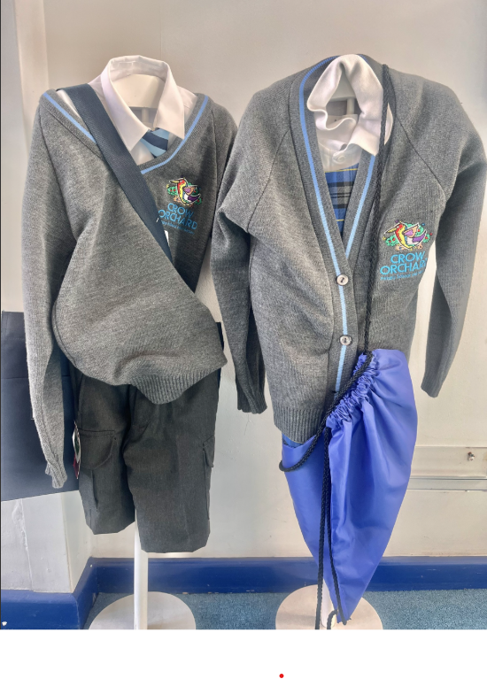

Daily Uniform
Boys
- Grey/blue edging logo school jumper
- Nursery- Year 2 White polo shirt (logo optional)
- Years 3-6 White collared shirt and blue striped tie (elasticated or tied)
- Grey trousers or shorts
- Grey, white or black socks
- Black plain school shoes
Girls
- Grey/blue edging logo school jumper
- Nursery- Year 2 White polo shirt (logo optional)
- Years 3-6 White collared shirt and blue striped tie (elasticated or tied)
- Blue tartan pleated skirt or pinafore
- Grey skirt or pinafore
- Grey trousers or shorts
- Grey, white or black socks/tights
- Black plain school shoes (no open-toe sandals)

PE Kit- Summer/warmer weather
- Plain white T-shirt or school logo t-shirt
- Navy shorts
- Plain black trainers suitable for outdoor sport
- Plimsolls for indoor (gymnastics/dance)
- Plain navy hoody for outdoor PE

PE Kit- Winter/colder weather
- Plain white T-shirt or school logo t-shirt
- Navy shorts, leggings, or plain navy jogging bottoms
- Plain black trainers suitable for outdoor sport
- Plimsolls for indoor (gymnastics/dance)
- Plain navy hoody for outdoor PE

Additional Guidance
- Jewellery: Only small stud earrings and watches are permitted. Earrings must be removed or covered during PE for safety. Please note that in the interests of your child’s safety, our recommendation is that no earrings are worn.
- Hair: Long hair should be tied back. Hair accessories should be plain and in school colours. Extreme hairstyles, ‘tram lines’ or dyed colours are not permitted.
- Make-up/Nail Polish: Not permitted.
- Coats & Outdoor Wear: A warm, weather-appropriate coat should be worn in colder months.

Affordability and Access
- Branded uniform with the school logo is optional. Affordable plain alternatives are widely available from supermarkets and high-street shops.
- Second-hand uniform is available through our half-termly pop up shop (in school) or via the school office if required urgently. Families are encouraged to reuse and recycle uniform where possible.
- The school will support families experiencing financial difficulty — please contact the office in confidence for assistance.

Equality and Inclusion
Our uniform policy is designed to be inclusive and not disadvantage any pupil. Pupils may wear the uniform in the way that best reflects their identity.
Religious and cultural dress will be respected and incorporated into the uniform in consultation with families.

Where to Buy
Uniform with the school logo is available from our official supplier NU Uniform in Chorley Crow Orchard Primary School
Plain items may be purchased from most supermarkets and clothing retailers.

