Physical Education Policy
Intent

At Havannah Primary School, we recognise that Physical Education and school sport play a vital role in the physical, social, emotional and intellectual development of all pupils. Our PE curriculum is designed in line with the National Curriculum to ensure all children develop competence in a broad range of physical activities, are physically active for sustained periods, engage in competitive sport, and understand how to lead healthy, active lives. We aim to ensure that all pupils are ready to learn and participate by developing fundamental movement skills, physical confidence and resilience. Through a carefully sequenced and progressive curriculum, pupils build knowledge, skills and understanding, enabling them to perform with increasing competence and apply these across a range of sports and activities. We foster a culture where pupils are respectful of themselves and others. Children learn the importance of teamwork, fairness and sportsmanship, celebrating effort, perseverance and success. Opportunities to work collaboratively and compete, both within school and through local partnerships, help to build character and a sense of belonging, with achievements recognised and celebrated. Safety is central to our approach. Pupils are taught to be safe by understanding how to use equipment appropriately, follow rules, and assess risk. They develop the knowledge and understanding needed to make informed choices about healthy living, positively impacting their physical and mental wellbeing.
Our inclusive PE curriculum provides a wide range of sporting and physical activity opportunities in a safe, supportive environment where all pupils can succeed and enjoy being active. We aim to inspire a lifelong love of physical activity and equip pupils with the skills, confidence and values they need to lead healthy, active lives beyond primary school.

Our PE aims are:
- To deliver a broad, balanced and progressive curriculum that meets the requirements of the National Curriculum and enables all pupils to develop competence across a range of physical activities.
- To ensure all pupils are ready to learn and participate through access to at least two hours of high-quality physical activity each week.
- To foster a positive environment where pupils enjoy PE and sport, are motivated to participate, and develop a lifelong engagement in physical activity.
- To develop pupils’ understanding of the importance of physical activity for a healthy lifestyle, including physical, social and emotional wellbeing, both now and in the future.
- To provide inclusive opportunities for all pupils, regardless of ability, to experience success in enjoyable, challenging and purposeful physical activity.
- To offer a wide range of opportunities for pupils to participate in competitive sport, both within school (intra-school) and beyond (inter-school), alongside creative and challenge-based activities, as individuals and as part of a team.
- To develop and apply fundamental movement skills, as well as control and coordination in both gross and fine motor skills.
- To build pupils’ physical capacity, including stamina, strength, agility and flexibility, alongside resilience and determination.
- To ensure high-quality teaching in PE, with clear learning objectives and success criteria, opportunities for pupils to demonstrate and apply their knowledge and skills, and appropriate challenge to support progression, decision-making and problem-solving.
- To promote pupils as respectful learners who demonstrate teamwork, fairness, leadership and effective communication.
- To make meaningful links with other areas of the curriculum and wider contexts, enhancing pupils’ overall learning and understanding.
- To provide a rich extra-curricular programme, including clubs, festivals and competitions, to extend and enrich pupils’ experiences and increase participation in physical activity.
- To develop pupils’ understanding of how to be safe, including the safe use of equipment, awareness of risk, and the importance of hygiene and responsibility within PE.

Implementation

At Havannah Primary School, our PE curriculum is implemented through a structured and progressive programme that ensures all pupils receive their National Curriculum entitlement, including a minimum of two hours of high-quality physical activity each week. Lessons are delivered by trained teaching assistants and specialist coaches from Bee Active, who work alongside class teachers to model high-quality practice and support ongoing professional development. This ensures consistency, progression and increasing staff confidence across the school. Pupils experience a broad range of activities that build skills over time, with opportunities to apply these in both competitive and cooperative contexts. Swimming is provided for pupils in Years 4 and 5, who attend weekly sessions for one term at Congleton Leisure Centre, ensuring they meet national expectations for water safety and swimming proficiency. Additional enrichment includes Bikeability sessions for Years 4 and 5, delivered by Everybody Leisure, supporting pupils to develop confidence and safety awareness when cycling. Our curriculum is further enhanced through access to facilities and specialist teaching at Eaton Bank Academy, as well as outdoor and adventurous activities during residential visits. A wide range of extra-curricular clubs, competitions and partnerships provide further opportunities for pupils to apply their skills, represent the school and develop the values of being ready, respectful and safe in a variety of contexts.

Safe Practice
- Pupils are expected to behave in a ready, respectful and safe manner at all times, showing consideration for others, following instructions promptly and using equipment appropriately.
- Pupils should come to school dressed in their PE kit on their allocated days. Parents/carers are informed of PE days in advance, including any requirements for additional kit such as suitable outdoor clothing.
- Pupils are expected to wear appropriate PE kit (e.g. T-shirt, shorts or suitable alternatives, and appropriate footwear). For indoor activities, pupils may work barefoot where it is safe and appropriate. For outdoor activities, suitable trainers must be worn.
- All staff wear appropriate clothing and footwear for safe participation and modelling of good practice.
- Jewellery should be removed for PE in line with health and safety guidance. If earrings cannot be removed, they must be made safe (e.g. covered) in accordance with school policy and risk assessment. Long hair must be tied back.
- Pupils are taught to recognise and manage risk, and are encouraged to discuss safety considerations for themselves and others as part of their learning.
- Staff carry out appropriate risk assessments of activities, equipment and environments, and ensure equipment is safe and suitable for use.
- In the event of an accident or injury, the activity will be stopped where necessary, and appropriate first aid procedures followed. A qualified first aider will be contacted for more serious injuries, in line with school policy.
- Pupils with medical needs (e.g. asthma) must have immediate access to their medication, such as inhalers, during PE lessons.
- When attending off-site events, competitions or visits, appropriate staffing ratios, risk assessments and first aid provision are in place, including access to a qualified first aider and first aid equipment.
- Swimming lessons for Years 4 and 5 are delivered by qualified instructors at Congleton Leisure Centre, where established health, safety and emergency procedures are followed.
- The use of swimming goggles is considered on an individual basis, with parental consent required, particularly where there is a medical need.
- Pupils must wear appropriate swimwear in line with school guidance (e.g. one-piece costumes or suitable alternatives for girls, and close-fitting trunks or appropriate swimwear for boys). Swimming hats are recommended for hygiene and safety.

Travel for sporting events
Havannah staff may drive children to and from sporting events with permission from parents or carers. Staff are required to provide photocopies of valid insurance and MOTs to the school office to be covered by the school insurance when transporting children. Children must never be alone with a member of staff in a vehicle. There should be another member of staff or another child present. Recently, we have been asking parents to transport their own children to and from events with only a small number of children requiring transport.

PE Curriculum
The national curriculum defines the content of the school curriculum for PE:
Key Stage 1
Pupils should develop fundamental movement skills, become increasingly competent and confident and access a broad range of opportunities to extend their agility, balance and coordination, individually and with others. They should be able to engage in competitive (both against self and against others) and co-operative physical activities, in a range of increasingly challenging situations.
Pupils should be taught to:
• master basic movements including running, jumping, throwing and catching, as well as developing balance, agility and co-ordination, and begin to apply these in a range of activities
• participate in team games, developing simple tactics for attacking and defending
• perform dances using simple movement patterns

Key Stage 2
Pupils should continue to apply and develop a broader range of skills, learning how to use them in different ways and to link them to make actions and sequences of movement. They should enjoy communicating, collaborating and competing with each other. They should develop an understanding of how to improve in different physical activities and sports and learn how to evaluate and recognise their own success.
Pupils should be taught to:
• use running, jumping, throwing and catching in isolation and in combination
• play competitive games, modified where appropriate [for example, badminton, basketball, cricket, football, hockey, netball, rounders and tennis], and apply basic principles suitable for attacking and defending
• develop flexibility, strength, technique, control and balance [for example, through athletics and gymnastics]
• perform dances using a range of movement patterns
• take part in outdoor and adventurous activity challenges both individually and within a team
• compare their performances with previous ones and demonstrate improvement to achieve their personal best

Swimming and water safety
All schools must provide swimming instruction either in key stage 1 or key stage 2.
In particular, pupils should be taught to:
• swim competently, confidently and proficiently over a distance of at least 25 metres
• use a range of strokes effectively [for example, front crawl, backstroke and breaststroke]
• perform safe self-rescue in different water-based situations

Early Years
Children should develop the fundamental skills of moving and handing involving agility, balance, coordination, throwing, catching, jumping and kicking. Children show good control and co-ordination in large and small movements. They move confidently in a range of ways, safely negotiating space. They handle equipment and tools effectively.

Teachers and specialist coaches work in collaboration to follow the long term PE plan below. This ensures coverage of the curriculum and that progress in skills and knowledge is made.
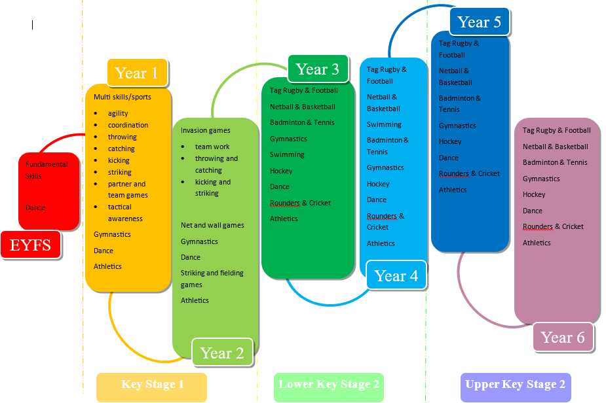

Equal Opportunities
At Havannah Primary School, we are committed to ensuring that all pupils, regardless of gender, ability, ethnicity, disability or socio-economic background, have equal access to a high-quality Physical Education curriculum and are supported to make the best possible progress. In PE, we actively promote an inclusive environment where all pupils feel ready to participate, respectful of others, and safe to take part, challenge themselves and succeed. Teaching and learning are adapted to meet the diverse needs of all pupils. Through differentiation, appropriate challenge and supportive strategies, all children are enabled to access the curriculum, develop confidence and achieve their potential. Pupils are encouraged to work collaboratively, valuing diversity and demonstrating fairness, respect and teamwork. Pupils with Special Educational Needs and/or Disabilities (SEND) are fully included in PE lessons. Activities are carefully adapted, and where appropriate, additional adult support, modified equipment or alternative approaches are used to ensure full participation and success. Our aim is that all pupils experience enjoyment, achievement and progression in physical activity. Further information can be found in the school’s SEND Policy.

Assessment, Record keeping and Reporting
Assessment in Physical Education is ongoing and supports both teaching and learning. Formative assessment takes place during and at the end of each lesson, enabling staff to adapt teaching, provide feedback and support pupils’ progress in developing skills and knowledge. Summative assessment is recorded at the end of each unit of work or sport. Pupils are assessed against age-related expectations, alongside an effort grade which reflects their engagement, attitude and application. This approach is consistent with assessment practices in other non-core subjects. Assessment information is used by teachers to monitor progress, identify strengths and areas for development, and inform planning. It also supports end-of-year reporting and discussions with parents, ensuring a clear understanding of each pupil’s attainment and participation in PE.
Impact

As a result of our PE curriculum, pupils develop the knowledge, skills and confidence to participate successfully in a wide range of physical activities and competitive sport. They demonstrate the school values of being ready, respectful and safe, showing teamwork, resilience and fairness. Pupils make clear progress in their physical competence and understanding of healthy, active lifestyles, and are well prepared to continue participation in sport and physical activity beyond primary school.

Monitoring and review
The role of the PE subject leader is to:
- To liaise with coaches regarding planning, assessment, recording and competitions.
- To keep up to date with local and national developments in PE and disseminate relevant information.
- To lead staff meetings/ CPD.
- To develop and review action plans and share with staff and link governors.
- To report PE and Sport Premium funding on school website and evaluate its impact.
- To organise teams and staff to attend competitions along with obtaining permission from parents.
- To monitor planning and teaching of PE.
- To ensure assessment system is up to date.
- To attend CECP sports cluster meetings

The subject leader monitors and collects planning from both teachers and specialist coaches to ensure coverage of the National Curriculum. Examples of lesson plans can be found in the PE folder and the full range is available for viewing electronically on Honeycomb. There are regular lesson observations of all staff involved in delivering Physical Education lessons and these are assessed against the teaching standards.

Staff training is led by specialist coaching staff alongside the physical education lead. These may be in areas such as progression of skills across the year groups or how to plan a successful PE lesson. This term we have focused on sport specific coaching as this is what staff felt they needed. Teaching members of staff also observe PE lessons taught by specialist coaches every week for a select half term, filling in lesson observations and monitoring the progress of select children.

It is also the role of the subject leader to audit and monitor use of equipment. All PE equipment is kept in a designated shed on the playground and is kept locked at all times. Staff are responsible for retrieving and returning equipment and children should not be allowed to do so without adult supervision. Playground equipment is kept in a smaller shed on the playground which children have free access to at break and lunch times. The school has a great range of sports kits that children wear when representing the school at sporting events and fixtures. These are safely kept by the subject lead and are handed back into the school office where a member of staff ticks them back in on a register. This method has really helped to keep track of sport kits and collect them all back in as there is sometimes a quick turn around needed.

