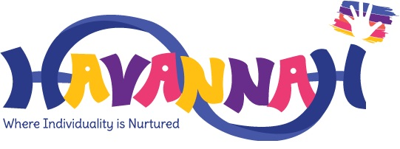

Positive Behaviour and Relationships Policy
Autumn 2024

Havannah Primary School
Positive Behaviour and Relationships Policy
Introduction
At Havannah Primary School we provide every child with a loving, caring environment, where pupils feel safe, respected and valued. Havannah pupils are determined, ambitious learners each feeling nurtured as they strive to fulfil their potential, emotionally, socially and intellectually.
Havannah Primary School is committed to creating an environment where exemplary behaviour is at the heart of productive learning. Everyone is expected to maintain the highest standards of personal conduct, to accept responsibility for their behaviour and encourage others to do the same.
The purpose of this policy is to guide teachers, pupils and parents on our restorative and relationship- focused approach to positive behaviour management. This will allow our pupils to enjoy a safe and caring environment and to become positive, confident and increasingly independent members of the school community and to prepare them for their next stage of schooling and eventually adult life. The policy reinforces our core values of nurturing respect and kindness; celebrating individuality and fostering resilience with a heavy emphasis on respectful behaviour, a partnership approach to managing poor conduct and interventions that support staff and pupils who attend. We encourage pupils to achieve in a learning environment where managing behaviour through self-regulation is promoted and pupils are taught and modelled the skills to achieve this.
We believe that most children behave well when they feel safe and happy; when teaching is good and when learning is presented in a relevant, interesting and engaging context. We also believe that children need to be taught and learn how to behave appropriately.
Our Aims:
- To provide a clear, fair and consistent approach to behaviour based on nurturing principles and restorative practices
- To promote high standards of behaviour and create an atmosphere where all members of the school community feel valued
- To foster, nurture and value strong and healthy relationships, recognising these as lifelong skills
- Ensure an environment in which the pupils feel safe, secure and respected and in which effective learning can take place
- To provide staff with tools to equip pupils with strategies to manage their behaviour and build positive relationships with others
- To create a culture of exceptionally good behaviour: for learning, for community, for life
- develop into happy and confident individuals with a secure foundation in learning that will last throughout their lives.
- To help learners take control over their behaviour and be responsible for the consequences of it
- To build a community which values kindness, good humour, care and empathy for others
- To ensure that excellent behaviour is a minimum expectation for all
- be valued and treated equally irrespective of gender, race, physical characteristics or any other factors
Havannah Primary School has 3 simple rules ‘Be Ready, Be Respectful and Be Safe’ which can be applied to a variety of situations and are taught and modelled throughout the school explicitly. Our whole school community are expected to follow our high expectations of behaviour that positively promote the school’s ethos and core values.
Be ready | Be Respectful | Be safe
We are ready to learn;  We arrive at school on time;  We wear the correct uniform and PE kit;  We have our equipment ready;  We are ready to listen;  We are ready to be curious and ask questions;  We are ready to try our best | We listen when others speak;  We look after property belonging to the school and other people;  We speak to people respectfully, using appropriate language;  We respect that other people have different ideas, beliefs and backgrounds to our own;  We respect that people may look different and have different needs to us;  We try our best to be kind | We travel to and from school safely;  We move around school safely;  We follow instructions to keep ourselves safe;  We keep equipment safe;  We stay safe online;  We are brave to speak out when someone may be in danger

This is recognised through weekly certificates, positive reinforcement strategies, house points (through Class dojo) and recognition boards in classrooms. We focus on the pupils who go above and beyond using this behaviour to model excellence throughout the school.

‘If you consistently reward minimum standards then children will strive for minimum standards. If you reward children for going over and above, then there is no limit to their excellent behaviour’
Paul Dix

Expectations and Conduct
At Havannah Primary School, staff, pupils and parents/ guardians are all expected to share a collective responsibility for the promotion of positive behaviour. Consistent adult behaviour will lead to pupils consistently conforming to our expectations. We expect every adult to:
- meet and greet every child every morning
- plan lessons that engage, challenge and meet the needs of all pupils
- refer to Ready, Respectful, Safe regularly
- Model positive behaviours and build relationships
- use a visible recognition mechanism throughout every lesson (recognition board and Dojo points)
- have high expectations of pupils’ achievements, attendance and behaviour and challenge when necessary
- follow up all behaviour and engage in reflective dialogue with pupils
- actively model the type of behaviour they want to see
- be alert to signs of bullying and racist attitudes and deal firmly with such issues
- deal sensitively with children in distress, by listening to them and dealing with any incidents appropriately
- ensure conversations are held privately with pupils and not in front of other peers
- actively establish positive relationships with pupils, parents and the wider community
- recognise the pupils’ achievements, academic or otherwise
- provide opportunities for the pupils to demonstrate responsibility
- actively use the restorative practice to support pupils

The role of the parent/carer
At Havannah, active parent involvement is welcomed, appreciated and deliberately encouraged in order to:
- Ensure that children attend school regularly, arriving on time alert and ready for the tasks ahead and are collected promptly at the end of the day
- Understand and reinforce the school values as much as possible
- Share in the concern about standards of behaviour generally
- Support the work of the school as staff seek to support the whole family
We will always aim to contact parents quickly when there are concerns about deteriorating levels of acceptable behaviour. However, staff will not routinely contact or inform parents of minor digressions.
Strategies
The following positive strategies will be used consistently by all adults in the school. They are designed to ensure ‘first attention goes to best conduct’ and to create clear, simple routines and expectations that make children feel valued members of our community and motivated to always try their best.
Teachers will create a welcoming environment by greeting every pupil every morning at the classroom door. If the class teacher is not available, the teaching assistant will be there. Each morning pupils will have an emotional check-in with their teacher. This can be done as a whole class or 1:1 where needed. This is a way of pupils and teachers building trusting relationships and for teachers to have a better oversight of the pupils emotional wellbeing.
All adults within Havannah Primary School are looking out for pupils who are displaying the school values and rules and going over and above. We have a range of ways that pupils will be recognised for doing so.
Weekly certificates – each class will allocate a minimum of 2 certificates per week. Pupils will receive these certificates as recognition of exceeding the school values and/or school rules, modelling this consistently through their school week. These can be awarded within assembly or in the classroom.
Recognition board - a Recognition Board will be used to encourage social or learning behaviours. For example, ‘kind words’ or ‘readiness for learning’ are written on the board. Adults and pupils in the class can nominate names for the board and there is emphasis on children working together as a team to ensure everyone’s name is on the board. There is an instant celebration when all the pupil’s names from the class are on the board, e.g. celebration song, whole class celebration dance, movement break etc.
House Dojo Points - pupils are awarded points to reflect their commitment to our school values. These are instant and can be given by any members of staff. These points are visible to parents/ carers through Class Dojo and they can see what they were awarded for. These contribute to the school house points and are shared and celebrated on the screens throughout school.
Phone call home/ card through the post - A member of staff will phone or email parent (s) to share their child’s success.

Restorative Approach – Process and Consequences
‘Punishment doesn’t better behaviour – restorative conversations do’
Paul Dix
As a restorative school, Havannah Primary School will take a restorative approach to solving conflict and preventing harm. We promote good behaviour and resolve unacceptable behaviour in a fair and consistent way. Restorative approaches enable those who have been harmed to convey the impact of harm to those responsible, and for those responsible to acknowledge this impact and take steps to put it right.
Restorative approaches refer to a range of methods and strategies which can be used both to prevent relationship-damaging incidents from happening and to resolve them if they do happen. It can also alleviate problems such as bullying, classroom disruption, poor attendance, and disputes between pupils.
Every adult in our school can deal with behaviour incidents. If an incident occurs outside of the classroom this will normally be dealt with by the member of staff who is there using the strategies outlined in the behaviour policy. This allows an intervention to take place immediately and may involve a restorative conversation. It will not usually be revisited by the class teacher or SLT unless further action is required.

Restorative Conversations
At Havannah Primary School, we believe that nurturing and restorative practice, combined with clear and high expectations and routines are key to building positive relationships. Restorative conversations aim to help the child to realise how their behaviour impacts others, teach what appropriate behaviour looks like and equip the child with tools they can use to avoid a similar incident occurring in the future. Restorative questions will be used to support restorative meetings and conversations (please see Appendix 1 for Restorative Questions).
Restorative Reflective Sheet
To support pupils in moving forward after a behaviour incident (where deemed appropriate) they will complete a Reflection Sheet (see Appendix 2 for each Key Stage Reflection sheets). The Reflection Sheets will be kept on file to support in building a bigger picture of the pupil’s behaviour and to find any common themes.
Consequences
At Havannah Primary School, we encourage positive behaviour which reflects our values. Our behaviour management approach is based upon building strong, trusting relationships between pupils and adults. The use of positive reinforcement strategies will always be our default approach. Consequences need to be as immediate as possible, short and appropriate for the behaviour and only aimed at the behaviour not the child. Staff should always use a measured, gentle approach referring to the child by name, lowering themselves to the child’s physical level, making eye contact delivering the required message and then leaving the conversation to allow the child to take up time.
Learners are held responsible for their behaviour. Staff will deal with behaviour without delegating. Staff will use the steps in behaviour for dealing with poor conduct (please see Appendix 3 for our school level system).

Persistent Poor Behaviour
This results in parents being notified through a phone call home or direct conversation. As a school, we recognise that behaviour is a way of communicating emotions. Where children persistently struggle to self-regulate their behaviour, class teachers will work in conjunction with parents/carers, SLT, SENDCo and the pastoral team to devise a support plan.

Serious incidents
Depending on the age of the children these incidents will be dealt with at the discretion of the school staff. All serious behaviour matters must be referred immediately to the Headteacher or SLT. Such incidents could include:
- Fighting
- All forms of bullying
- Racist, sexist or homophobic comments
- Inappropriate name calling
- Using abusive/ offensive language targeted at another person
- Physically striking other children/ adults with intent to harm

Any of these behaviours will result in an instant move to reflection time as well as an additional sanction specific to the child and behaviour which will be decided by the class teacher in conjunction with SLT. Serious incidents will also result in either a phone call home from the class teacher, or a face to face conversation between the parents/ carer and class teacher. Depending on the severity, this may be from the Head Teacher or a member of SLT. All serious incidents should be recorded on CPOMS.

Exclusions
Fixed Term Exclusions
Havannah Primary School believes that, in general, exclusions are not an effective means of moving behaviour forward. However, in order for children to achieve their maximum academic potential in the school they must feel safe from physical and verbal aggression and disruption. If a child seriously breaches the school’s behaviour policy and if the child remaining in school would seriously harm the education or welfare of the pupil or others in the school, the Head teacher may take the decision to exclude for a fixed period. If this decision is taken, work will be set for the pupil to complete at home. Following a fixed term exclusion, the pupil and parents meet the Head teacher to discuss the pupils’ reintegration to school and the best way forward to support the child. Each day is a new day and where a child has transgressed it is expected that they will be welcomed and treated without and resentment when they return.

Permanent Exclusions
The Secretary of State for Education feels that permanent exclusions should be seen as a last resort and that a school should be able to show that is has taken all reasonable steps to avoid exclusion (See Exclusion Regulations). The governors of Havannah Primary School agree with this stance and all policies and procedures are in place to support inclusion of all pupils.
Permanent exclusions should only occur when risk assessment indicates that to allow the child to remain in school would be seriously detrimental to the education or welfare of the pupil concerned or to other pupils at the school. All behaviour incidents are logged on CPOMS to help record behaviour patterns and incidents for all children.
SEND pupils
When a child is on the Special Educational Needs register for specific behavioural difficulties or has difficulties as a result of a disability, the procedure for dealing with that child may differ from our sanction system. The alternative adapted procedure will be formed in agreement with the child, their parents and the relevant school staff.
As in line with our ‘SEN’ policy, we treat all children as individuals and as such the ‘behaviour system’ may need to be tailored to provide a different approach for children with specific needs. Identified children will be given bespoke plans in which strategies are clearly identified and external advices sought, when necessary, from appropriate agencies.
Misbehaviour by pupils outside the school day
If a pupil misbehaves outside of the school day, when they are not on the school premises and are not under the lawful control or charge of a member of staff at the school. (Education and
Inspections Act 2006 s.89 (5)) the school will impose a sanction, where the school is satisfied it is reasonable to do so if the behaviour:
- has repercussions for the orderly running of the school
- poses a threat to another pupil, a member of staff or member of the public
- could adversely affect the reputation of the school.
Involving parents
We aim to encourage a positive relationship with parents/carers to develop a shared approach to involve them in the implementation of the school’s policy and practices.
Parents need to know what Havannah expects and what happens if behaviour is unacceptable. This is communicated using our school planners, telephone conversation, Class Dojo or in person. Communication is vital so that parents can offer support and be engaged in any behaviour issues.

Policy review
This policy is to be reviewed every year although any suggestions/ amendments will be considered on their merits.
Drafted and adopted: September 2024
To be reviewed: September 2025
Chair of governors: John Sherwood
Signed:

Appendix 1 – Restorative Questions
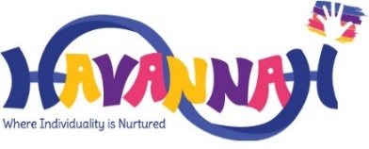
What happened?
How were you feeling?
Who has your behaviour impacted?
What would you do differently next time?
What needs to happen now?
It is okay to feel like that, but it is not okay to do that…

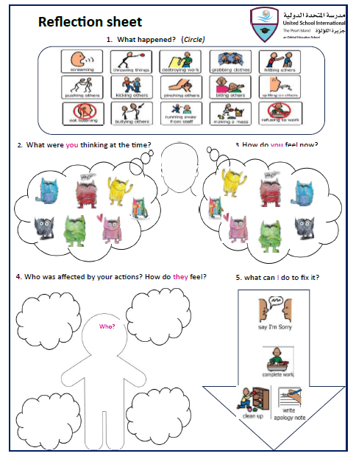
Appendix 2 – Key Stage 1 Reflection Sheet

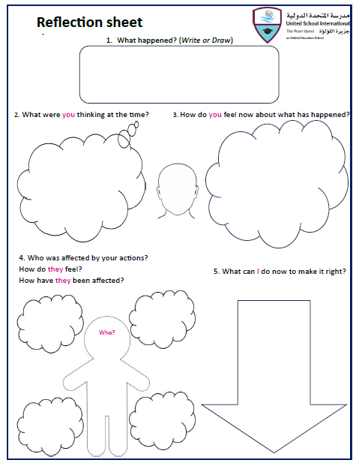
Key Stage 2 Reflection Sheet

Appendix 3 - Level Behaviour System
Behaviour Levels
1 | Follow Havannah’s Ready Respectful, Safe school rules  Use positive behaviour strategies - reminder of behaviour we want to see.
2 | After 1 verbal warning:  - Disrupting class  - Refusal to follow instructions  - Intentional physical harm to others  Miss 5 minutes of break/ lunch
3 | - Persistent Level 2 behaviour  - Repetition of or more serious Level 2 behaviours  Miss 15 minutes of break/ lunch in the reflection room  Reflection sheet to be completed
4 | - Persistent Level 3 behaviour  - Fighting  - Racism  - Persistent verbal/ physical abuse to any member of staff/ pupil  - Malicious physical assault on another pupil or staff member  Meeting with parents – SLT to attend  Reflection sheet with SLT  Fixed period of internal exclusion / external exclusion to be applied (at discretion of SLT depending on severity).
Pupils going above and beyond - Praise, Dojos, Havannah Heroes awards, Email/ phone call/ home, Recognition Board

