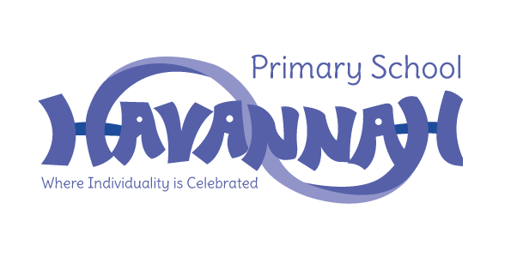
Havannah Primary School
Assessment Results 2024

EYFS – Good Level of Development (GLD)
School | National
71% | 68%

Year 1 – Phonics Screening Check
School | National
83% | 80%

End of Key Stage 1
Subject | School  Expected and above | Greater Depth
Reading | 72% | 24%
Writing | 55% | 0%
Maths | 72% | 52%

End of Key Stage 2
Subject | School | National
Reading | 87%  (37% Greater Depth) | 74%
Writing | 60%  (0% Greater Depth) | 72%
Maths | 70%  (20% Greater Depth) | 73%
GPS | 83% | 72%
Combined R, W and M | 55% | 61%

