Harvest!  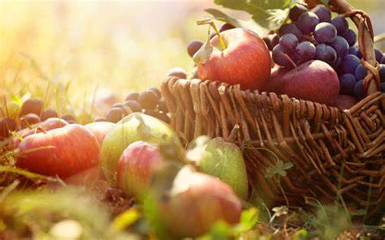  Autumn  Year 6 | Assessment  Write the initials of the child next to each objective to show the level that they are working at.
Can I… | Working  Towards | Expected | Exceeding
- Perform expressively and creatively in unison and canon to an audience
- Listen to 2 different composers from different time periods and discuss your thoughts on their pieces
- Understand and compare the musical styles between 2 composers from different time periods
- Understand and recap The 8 Elements of Music
- Develop and understanding of the history of music

End Points – Autumn | Assessment  Write the initials of each child to show the level that they are working at.
 | Working Towards | Expected | Exceeding
Can I perform creatively and expressively in unison to an audience?
Can I discuss composers based on their musical styles and time periods?
Can I understand the differences between the sound of different instruments?

The 4 Elements of Success:
- Performing and Playing
- Listening and Evaluating
- Understanding and Exploring
- Create and Compose

Please write the initials of each child next to each objective to show what level they are working at for each objective. This is the same for the end points.

