Music Policy
Intent

At Havannah Primary School, it is our intent to provide the best start in life for all pupils in our care by providing a broad, balanced and enriching curriculum.
Music is a universal language that encourages creativity and expression. At Havannah Primary School, it is our intent that we make music an enjoyable learning experience. To do so, we provide a high-quality music education which engages and inspires pupils to develop a love of music; additionally, we celebrate all talents and achievements of our young musicians. We encourage children to participate in a variety of musical experiences in order to increase their self-confidence, creativity and sense of achievement.
As pupils progress through our unique curriculum, they will begin to engage critically with music. They are provided with multiple opportunities to compose, to listen and to appreciate a wide range of music, from a range of different backgrounds and genres. In turn, this will develop their musical vocabulary in order to speak about the subject in the correct form.

The aims of the Music curriculum at Havannah Primary School are:
- To promote positive attitudes and enthusiasm for Music
- To inspire children to create, compose and listen to new music
- To ensure the progressive development of Music knowledge, skills and attitudes
- To know and understand how sounds are made and then organised into musical structures
- To Know how music is made through a variety of instruments
- To Know how music is composed and written down and be able to read simple notation
- To develop the interrelated skills of performing, composing and appreciating music
- To perform using a range of musical instruments and singing

Implementation

The curriculum for music has a particular focus each term, which is the same for all year groups. Each year group will have a different focus song for that term to perform in our ‘music recital’ at the end of term. Each year group will have a different range of objectives to achieve their end point.

All pupils have the opportunity to learn how to play a percussion instrument in KS2 and are encouraged to take it home weekly to practise.

In KS2, the music focus is based upon learning key language, developing critical listening skills and becoming a more competent performer.

There are opportunities to join a whole school choir, to perform in the wider community and to show case musical talents in a whole school talent show.

The ‘four elements of success’ are used throughout the school to underpin our objectives in order for children to reach their potential:
1. Performing and Playing
2. Listening and Evaluating
3. Understanding and Exploring
4. Create and Compose

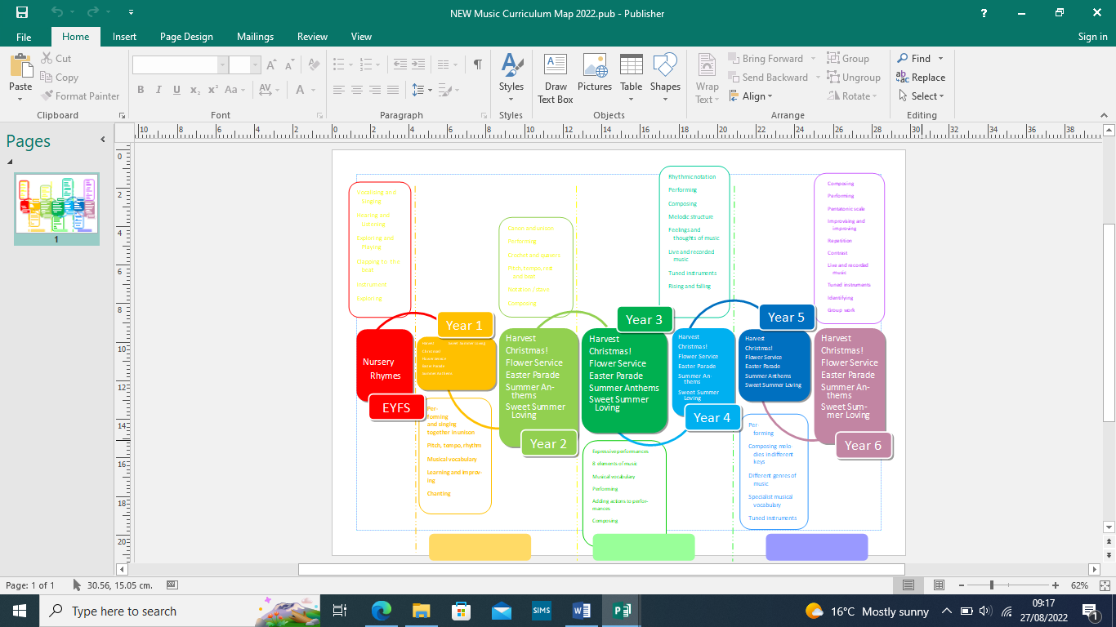

At Havannah Primary School, we ensure that Music is an enjoyable and accessible learning experience. Our teaching focuses on developing the pupil’s ability to sing in tune and with other people. Through singing songs, pupils learn about the structure and organisation of music. We teach them to listen and to appreciate different forms of music.
As pupils get older, we expect them to maintain their concentration for longer and to listen to more extended pieces of music. Pupils develop descriptive skills in music lessons when learning about how music can represent feelings and emotions. We teach them the disciplined skills of recognising pulse and pitch, musical notation and composition. Throughout all of our lessons, we either encourage individual working or promote positive teamwork. We recognise and appreciate that all musical abilities can differ and therefore make our lessons adaptable to suit a wide range of needs.
We achieve this in a variety of ways by:
• Setting open-ended tasks which could have a variety of responses
• Setting tasks of increasing difficulty
• Providing resources depending on the ability of the child
• Taking part in class and whole school performances to showcase achievements

Music Curriculum
The national curriculum defines the content of the school curriculum for Music:
Foundation Stage
We teach Music in the foundation stage as an integral part of the topic work covered during the year. We relate the Music element of the children’s work to the objectives set out in the Early Learning Goals (ELGs). These underpin the curriculum planning for children aged three to five. We focus on teaching simple rhymes and songs which are repeated to build up a store of known songs. We encourage pupils to make up simple songs and to experiment with ways of changing them. We teach the pupils to use their own ideas, thoughts and feelings represented through music and dance.
Key Stage 1
Pupils use their voices expressively and creatively by singing songs, speaking chants and reciting rhymes. They play un-tuned instruments musically. Pupils listen with concentration and understanding to a range of high-quality live and recorded music. They experiment with, create, select and combine sounds using the inter-related dimensions of music.
Key Stage 2
Pupils play and perform in solo and ensemble contexts, using their voices and playing musical instruments with increasing accuracy, fluency, control and expression. They improvise and compose music for a range of purposes using the inter-related dimensions of music. Pupils listen with attention to detail and recall sounds with increasing aural memory. They use and understand musical notations. Pupils develop an appreciation and understanding of a wide range of high-quality live and recorded music drawn from different traditions and from great composers and musicians. They develop an understanding of the history of music. Pupils have the opportunity to play tuned instruments in a ten-piece band.

Equal Opportunities
All teaching and non-teaching staff should ensure that all pupils, irrespective of gender, ability, ethnicity and social circumstances, have access to, and make the greatest progress possible, in all areas of the curriculum. History provides opportunities for teaching that reinforces this ideal. Special Educational Needs Children with special educational needs are taught the full music curriculum which is tailored by their teacher to meet their needs. Some children may receive additional support to help them take a full and active role in music lessons. Tasks will be adapted if necessary to help children to succeed and reach their potential. See Special Education Needs Policy for more details.

Assessment, Record keeping and Reporting
Children’s work in Music is assessed by making informal judgements as we observe them during each music lesson. On completion of a piece of work, the teacher marks the work and writes the initials of each child next to the objectives within the success criteria, depending on their level. Work is often photographed and recorded as evidence of different skills being taught.
The whole class music book will provide the basis for the summative assessment at the end of each term. The success criteria’s have end points at the bottom to assess the children against three levels:
- Working Towards
- Expected
- Exceeding
Teachers should judge which description best fits the pupil’s performance.

Impact

Our outcomes show a broad and balanced curriculum, which produces confident musicians. Pupils will be fully immersed into the whole world of music as well as allowing pupils to become enthusiastic and enjoy music.
They learn to listen with a critical ear and develop musical language that underpins their experience. Pupils develop into more confident performers who appreciate varied musical genres. Pupils will know more, remember more and understand more about music.

Monitoring and review
The Music subject leader is responsible for:
- Monitoring the standard of the children’s work and the quality of teaching and learning in Music
- Reviewing and contributing to teacher's planning to ensure full coverage of the National Curriculum through the topic units taught
- Supporting colleagues in the planning, teaching and assessment of Music
- Informing colleagues about current developments in the subject, providing advice and maintaining the availability of resources and the music curriculum budget
- Evaluating the strengths and weaknesses in the subject and highlighting areas for further improvement on the school action plan

Monitoring of the subject will take part termly and will involve:
- Planning and book scrutiny
- Interviews with pupils
- Conversations with staff
- Learning walks
- Checking assessments are up to date
- Answering and assisting staff when needed
- Success criteria’s
- Knowledge sheets

