Religious Education Policy
Intent

At Havannah Primary School our intention within Religious Education, is to develop within our pupils a deep sense of belief, practises and experiences of other’s religious and non-religious beliefs.
Our curriculum will nurture a deep sense of inquisitiveness and ingenuity within our pupils and enable children to make connections and transfer skills and knowledge to a variety of learning opportunities. Our uniquely creative curriculum will inspire our pupils, stimulate their curiosity of key religions by comparing and being inquisitive.
The aims of the RE curriculum at Havannah Primary School are for pupils to discover:

- What are the beliefs, practices and experiences at the heart of the religions and worldviews being studied? What are the key stories?
- Who are the crucial people whose lives and teaching exemplify those traditions?
- In what creative ways do adherents express and live out their most deeply held convictions?
- What about the nature of religion and belief itself? What are the big questions and how do different people set about answering them?

Implementation

The curriculum for Religious Education is divided into two ‘cycles’. Each cycle contains a discrete body of knowledge and, at the end of each cycle, knowledge is tested through informal creative assessments, which seek to demonstrate the knowledge gained through the unit of work. Cycles will build on each other across phases and develop a deeply embedded knowledge of beliefs, practises and experiences of key religions. Phases work together in the planning and implementation of the curriculum and ‘Curriculum Organisers’ are used to identify key focus’ and progression.

Religious Education is taught within topic blocks throughout the year, so that children achieve depth in their learning. Teachers have identified the key knowledge and skills of each religion and consideration has been given to ensure progression across topics throughout each year group across the school. By the end of year 6, the children should understand the beliefs, practises and experiences of 4 religions of Judaism, Islam and Hinduism with a more in depth exploration in Christianity. Each with knowing the crucial people and key stories in each of these religions, as well as their creative ways and any big questions that occur in each religion.

Cross curricular outcomes in Religious Education are specifically planned for with strong links between the non-core curriculum and writing cycles enabling further contextual learning. The local area is also fully utilised to achieve the desired outcomes, with extensive opportunities for learning outside the classroom embedded within practice. Planning is informed by and aligned with the SACRE for Cheshire East agreed syllabus with a particular emphasis on comparing and questioning about the 4 religions.
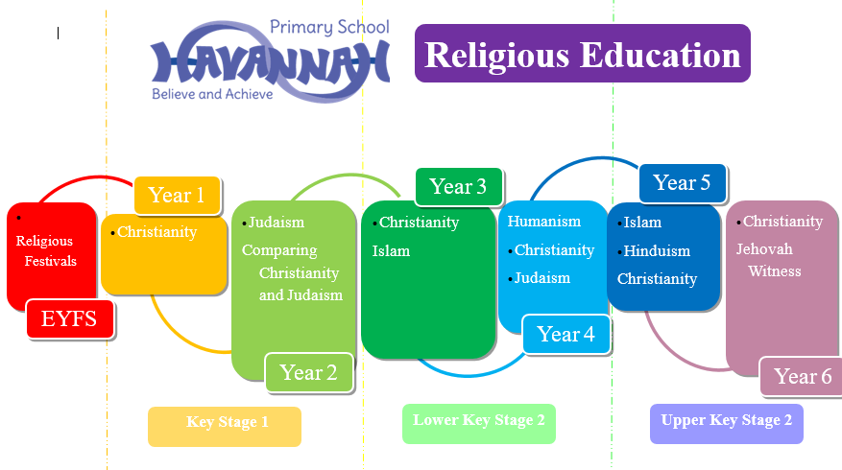

Outcomes in Religious Education books demonstrates a broad and balanced curriculum, which offers pupils a variety of creative opportunities. Pupils review their knowledge throughout the unit which develops throughout their primary career.
Our Religious Education curriculum also demonstrates progression across key skills of 4 major world religions: Christianity, Judaism, Hinduism and Islam
We achieve this by:
- Setting common tasks which are open-ended and can have a variety of responses
- Setting tasks of increasing difficulty
- Planning across year groups to ensure progression of skills
- Grouping children by ability in the room and setting different tasks for each ability group
- Providing resources of different complexity depending on the ability of the child
- Using classroom assistants to support children individually or in groups.

Religious Education Curriculum
The Curriculum for Religious Education is taken from the Cheshire East Standing Advisory Council on Religious Education (SACRE), which was updated in 2023.
Religious education contributes dynamically to children and young people’s education in schools by provoking challenging questions about meaning and purpose in life, beliefs about God, ultimate reality, issues of life and death and issues of right and wrong and what it means to be human. In RE they learn about and from religions and worldviews in local, national and global contexts, to discover, explore and consider different answers to these questions. They learn to weigh up the value of wisdom from different sources, to develop and express their insights in response, and to agree or disagree respectfully.
Every pupil has a statutory entitlement to Religious Education as it makes a distinctive contribution to a broad and balanced curriculum. Pupils should be given the opportunity to explore the role and significance of religion in society and the important beliefs and values that shape the world today. Religious Education helps pupils understand the religious experience of others and the ways in which it gives adherents a sense of purpose and meaning in their lives. The exploration:
- supports pupils in their own search for meaning and purpose in life
- helps pupils develop their own beliefs, values and ideals
- provides a safe and secure environment for pupils to challenge prejudices and misconceptions
- encourages tolerance and respect for themselves and for other people
- enables pupils to be discerning so that they can make informed choices about systems of belief whether faith based or secular
- encourages pupils to recognise and celebrate diversity in society
- enhances pupils’ understanding of history, art, music, literature and the media.

Equal Opportunities
All teaching and non-teaching staff should ensure that all pupils, irrespective of gender, ability, ethnicity and social circumstances, have access to, and make the greatest progress possible, in all areas of the curriculum. RE provides opportunities for teaching that reinforces this ideal. Special Educational Needs Children with special educational needs are taught the full RE curriculum which is tailored by their teacher to meet their needs. Some children may receive additional support to help them take a full and active role in RE lessons. Tasks will be adapted if necessary to help children to succeed and reach their potential. See Special Education Needs Policy for more details.

Assessment, Record keeping and Reporting
Children’s work in Religious Education is assessed by making informal judgements as we observe them during each lesson. On completion of a piece of work, the teacher marks the work and highlights the success criteria in accordance with the school’s marking policy and comments as necessary. This will provide the basis for the summative assessment at the end of each term. At the end of each topic, the children will be assessed against criteria: emerging, exceeding and expected expectations for the key Religious Education objectives. Teachers should judge which description best fits the pupil’s performance.
It is important in the assessment of RE, that the children can apply their knowledge, skills and understanding to identify key aspects of religions and compare. Pupils should also be able to record their knowledge in a variety of ways, using artefacts and photos.

Impact

Outcomes in Religious Education books demonstrates a broad and balanced curriculum, which offers pupils a variety of creative opportunities. Pupils review their knowledge throughout the unit s and produce work based on key ideas and beliefs of each religion studied.
Our Religious Education curriculum also demonstrates progression across key skills: beliefs, practises, experiences, comparing and questioning.
Monitoring and review
The Religious Education subject leader is responsible for:
- Monitoring the standard of the children’s work and the quality of teaching and learning in Religious
- Reviewing and contributing to teacher's planning to ensure full coverage of the SACRE curriculum through the topic units taught
- Supporting colleagues in the planning, teaching and assessment of Religious Education
- Informing colleagues about current developments in the subject, providing advice and maintaining the availability of resources and the RE curriculum budget.
- Evaluating the strengths and weaknesses in the subject and highlighting areas for further improvement on the school action plan.

Monitoring of the subject will take part termly and will involve:
- Book scrutiny
- Interviews with pupils
- Conversations with staff and peer coaching
- Learning walks
- Checking assessments are up to date

Updated August 2023

