
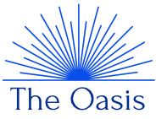
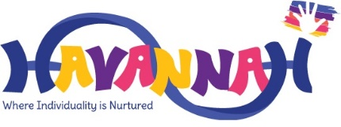
The Oasis
Autumn 2 – Celebration / Autumn
Maths

In The Oasis, we will be following the Power Maths curriculum in line with the rest of the school. We will use a range of manipulatives and physical objects to gain attention and focus as well as aid understanding of a concept. This half-term will focus on:
- Part-whole models
- Addition and Subtraction within 10
- 2D and 3D shape

Our books will be based on our topic ‘Celebration’ and ‘Autumn’. We will use Makaton as a way of learning the story and to create and structure our sentences. We will be focusing on the following:
- Speech marks
- Adjectives
- A range of punctuation
- Expanding sentence structure
Literacy

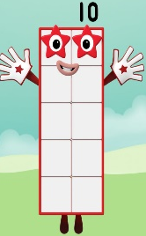


PSHE and RE

These sessions are aimed to aid children when communicating both outside and inside the classroom. These sessions will discuss the thoughts and feelings of the children about each topic area:
- Learning how to be a part of a team
- Bonfire night
- Remembrance Day
- Learning and discussing about a variety of celebrations from around the world, such as, Hanukah
- Learning about The Nativity and the history of Christmas
Art & Design + Technology

Our art and design sessions are aimed to teach children a new skill, whilst being creative and imaginative with what they are creating. We will follow the theme of ‘Celebrations and Autumn’ to create our art work. We will learn the following:
- Learning how to draw and use a range of tools / equipment
- Looking at the artist Andy Warhol and re-creating his pieces
- Using a wide range of materials to create imaginative pieces
- Learning Christmas Carols
- Playing instruments
- Drawing based on observations
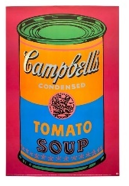

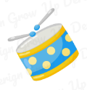


Science, History and Geography

Our life skills sessions are aimed to give children the skills they need to independently look after themselves in the classroom and beyond. Like much of our other sessions, these sessions are interactive and follow our overarching topic for this half-term. These sessions will cover:
- Fastening my shoes
- How to cross a road safely
- How to take care and be safe when walking within the community / shopping
- Looking and discussing different houses / buildings that we can see
- How to keep clean when cooking / baking
- Baking safely and using ingredients correctly

Life Skills

Our Science, History and Geography sessions also follow our overarching topic of ‘Celebration and Autumn’. These sessions will look at one subject area each week. They will be interactive and engaging as well as very hands on! The sessions will cover:
- Ice exploration
- A change in materials
- Exploring chemical reactions
- Parts of a tree
- Looking at structures
- Where animals live – hot and cold climates
- Where we live



The Oasis
Autumn 2 – Ourselves / Autumn

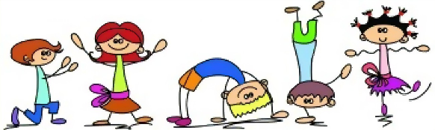
Information / Contact

You will be kept updated via our class dojo page, where you will see pictures of what we have gotten up to and any updates.
Should you have any questions about the overview for this half-term, or any other questions regarding The Oasis, please do not hesitate to get in touch.
You can send me a message via our class dojo page or send me an email on barry@havannah.cheshire.sch.uk

Physical development in early years is embedded throughout our day and our curriculum. Our tuff trays and activities provide children with the opportunity to develop their physical development skills. However, each Thursday we have a PE session whereby we focus on certain skills. This half-term we will be focusing on:
- Listening skills / listening to instructions and commands
- Ball control
- Balancing skills
- Short travel sequences using ball control

Physical Education

