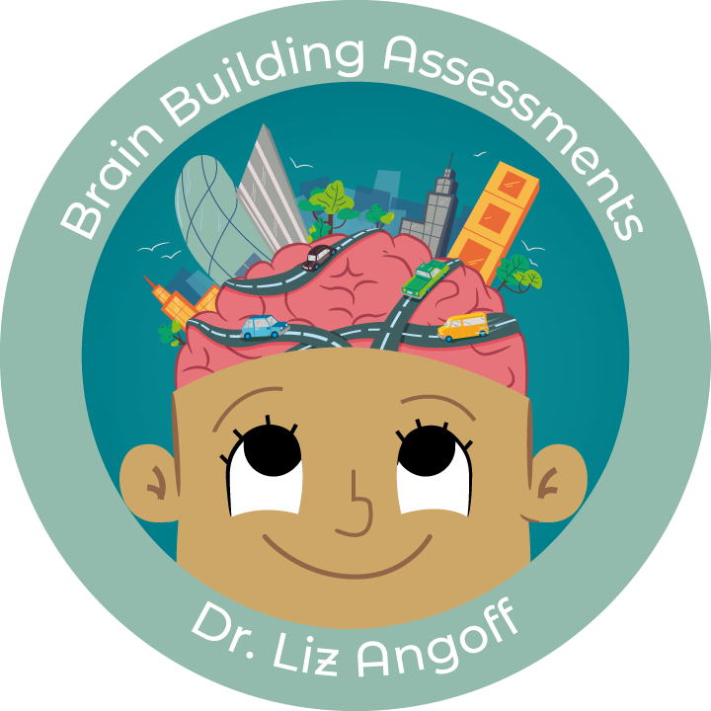
Recommendations for High-Masking Children

Supports to help reduce stress and anxiety during the school day

What Masking Means
“Masking” is when a child hides or changes parts of who they are to fit in or avoid negative attention. For neurodivergent kids, this can mean copying the way others talk, act, or express emotions, even if it feels unnatural or exhausting. While masking can sometimes help a child feel accepted in the moment, it often takes a lot of energy and can lead to stress, anxiety, or burnout over time.
The following supports can help reduce this stress and anxiety at school, preventing burnout and explosive patterns at home.
You can read the full article on supporting high-masking students here: www.ExplainingBrains.com/masking

Sensory Regulation Supports

Many neurodivergent students are highly sensitive to sights, sounds, smells, and textures. Their brains are working overtime to process this information, and it can be distracting and taxing. To help, consider:

- Noise-cancelling headphones during independent work time (and making them available to all students to reduce stigma)
- A separate space to go to when needed (not as a privilege or punishment)
- Fidgets to help with self-regulation
- A sensory “tool box” with items from home
- Encouraging stimming as needed
- Have a class-wide discussion about different sensory needs

Safe Spaces

Sometimes the overwhelm of the day can build up unexpectedly. Having a “safe space” or “safe adult” to go to when things feel “too much” can help reduce stress. This may be the library, a counselor’s office, or a private space in the classroom. An accommodation in this area may sound like:

- A “hall pass” in the child’s desk to go to the counselor’s office at any time
- Asking to do work in the library by giving the teacher a special nonverbal signal

Knowing What to Expect

Changes and transitions can be especially taxing and anxiety-provoking for neurodivergent minds. And yet, the school day is full of these moments. Here’s what it might look like to help:

- Review the schedule with the student in the morning
- Add a post-it to the student’s desk to remind them of any changes to the routine
- Give notice and pair the student with a safe adult during fire drills
- Let the student know what class discussion question they will be expected to answer ahead of time to encourage participation
- Give the student a meaningful job during transitions

Choice

Many neurodivergent students feel the weight of having to meet so many demands and expectations during the day, which are often very different from what they would prefer or need. Having choice and agency when possible can help kids feel empowered and energized. For example, this may sound like:

- When work is completed, choosing a preferred activity
- Working with a counselor to create a “choice list” for recess, including independent and social activities as desired
- Having a choice of “brain breaks” as needed, developed ahead of time with Josie’s input
- Having a choice of which assignment or task to do first
- Allow the student to choose their partner during paired activities

Proactive Problem-Solving

For chronic challenges, neurodivergent students (and all students) tend to do best when they are involved in creating solutions. Dr. Ross Greene’s Collaborative Proactive Solutions approach is well-researched and helpful for ongoing difficulties. As an accommodation, this may look like:

- Provide release time for the teacher to problem-solve with the student around ongoing challenges
- Involve the student in any changes or interventions to get her feedback
- In the event of a challenging moment, give the student tools to help with self-regulation before redirecting or working to solve the problem

Learn More Tools for Supporting Neurodivergent Students
Feel free to download and edit this for your own practice (File → Make a Copy)
Learn more strategies at:
ExplainingBrains.com/empowering-learners
