St Wilfrid’s Primary School Literature Spine
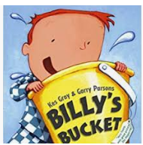
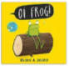
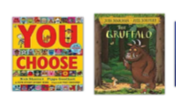
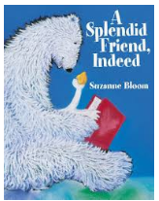
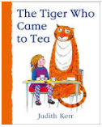
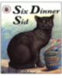
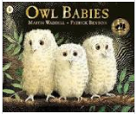
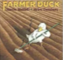
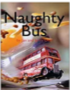
To ensure every child is exposed to good quality literature, we have developed our very own literature spine. These books have been chosen as recommended texts and we will try to introduce the children to as many of these books as possible throughout their time at St Wilfrid’s. The purpose of this literature spine is to ensure every child has the experience of storytelling and to help develop a love of reading in every child. This book list is also intended to help parents when choosing books for their children.
Reception: We read books everyday but here is a selection of our core reading spine.
The Gruffalo & The Guffalo’s Child – Julia Donaldson
Owl Babies – Martin Waddell
Mr Grumpy’s Outing – John Burningham
The Naughty Bus – Jan and Jerry Oke
Six Dinner Sid – Inga Moore
Mrs Armitage – Quentin Blake
Farmer Duck – Martin Waddell
Shhh! – Sally Grindley
Oi Dog – Kes Gray
The Pea and the Princess – Mini Grey
Owl Babies – Martin Waddell
Where the wild things are – Maurice Sendak
The Lion Inside – Rachel Bright
Knuffle Bunny, Knuffle Bunny 2 - Mo Williams
I want my Potty – Tony Ross
Handa’s Surprise – Eileen Brown
The Leopards Drum – Jessica Souhami
The Tiger who came to Tea – Judith Kerr
A Splendid Friend Indeed – Suzanne Bloom
The Lighthouse Keeper series –Ronda and David Armitage
Indian Tales – Barefoot Books
Chandra’s Magic Light – Barefoot Books
Billy’s Bucket – Kes Gary

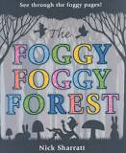
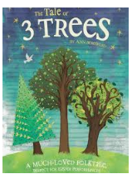
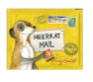
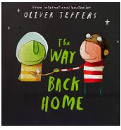
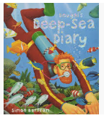
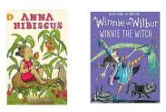
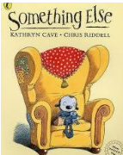
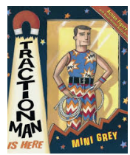
Year 1 : We read books everyday but here is a selection of our core reading spine.
Lila and the Secret of Rain – David Conway and Jude Daly
Dougal’s Deep Sea Diary – Simon Bartram
Not Now Bernard – David McKee
Meerkat Mail – Emily Gravett
Traction Man – Mini Grey
I Want My Hat Back – Jon Klassen
Click, Clack, Moo: Cows That Type – Doreen Cronin
The Way Back Home – Oliver Jeffers
Gorilla – Anthony Browne
Dear Greenpeace – Simon James
The tales of Three Trees – Angela Elwell
Foggy, Foggy Forest – Nick Sharratt
Something Else – Kathryn Cave
Marty Monster – Malorie Blackman
Starlight – Gillian Lobel
Stuck – Oliver Jeffers
Pumpkin Soup – Helen Cooper
Grandad’s Secret Giant – David Litchfield
Ruby’s worries – Tom Percival
The Pig and the Porker – Peter Bently & David Roberts
We read a range of traditional and twisted traditional tales.
We also share a variety of Bible Stories throughout the year e.g. Nick Butterworth – Stories Jesus Told
Poetry
Mustard, Custard, Grumble Belly and Gravy – Michael Rosen and Quentin Blake
The Puffin Book of Fantastic First Poems – edited by June Crebbin

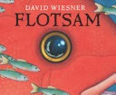
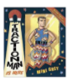
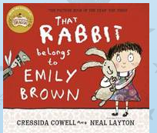
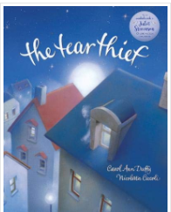
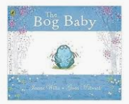
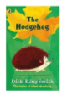
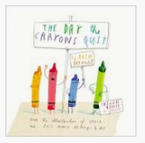
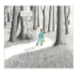
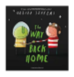
Year 2
The True Story of the Three Little Pigs – Jon Scieszka
Tadpole’s Promise – Jeanne Willis
Dr Xargle’s Book of Earthlets – Tony Ross
The Day the Crayons Quit – Drew Daywalt and Oliver Jeffers
Once Upon an Ordinary School Day – Colin McNaughton
The Incredible Book Eating Boy – Oliver Jeffers
The Mousehole Cat – Antonia Barber and Nicola Bayley
The Dark – Lemony Snicket and Jon Klassen
The Hodgeheg – Dick King Smith
Who’s afraid of the big bad book? – Lauren Child
Tuesday – David Weisner
Three by the Sea – Mini Grey
Emily Brown and the Thing – Cressida Cowell
Malala’s Magic Pencil – Malala Yousafzai
The Bog Baby – Jeanette Willis
Captain Flynn and the pirate dinosaurs – Giles Andreae
The Cat in the Hat – Dr Seuss
Clarice Bean That’s Me – Lauren Child
The Tear Thief – Carol Anne Duffy
That Rabbit belongs to Emily Brown – Cressida Cowell
Flotsam – David Weinser
Poetry
A Children’s Treasury of Milligan – Spike Milligan
Jim, A Cautionary Tale – Hillarie Bell & Mini Grey

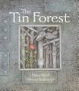
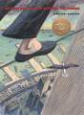
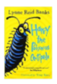
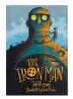
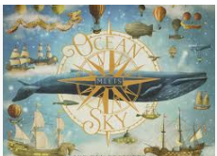
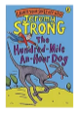
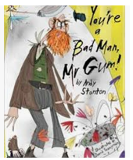
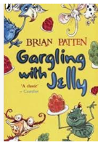
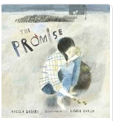
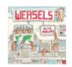
Year 3
Mirror – Jeannie Baker
The Tin Forest – Helen Ward
Ocean meets Sky – The Fan brothers
Stone Girl, Bone Girl – Laurence Anholt
Weasels – Elys Dolan
The Boy who grew Dragons – Andy Shepherd
The Promise – Nicola Davies
The Adventures of the Dish and the Spoon – Mini Grey
Into the Forest – Anthony Browne
Gregory Cool – Caroline Birch
One Dog and His Boy – Eva Ibbotson
Charlotte’s Web – E B White
Diary of a Killer Cat – Anne Fine
How to wash a woolly mammoth - Michelle Robinson
The Iron Man – Ted Hughes
The Abominables – Eva Ibbotson
The man who walked between the two towers – Mordicai Gerstein
Harry & the poisonous centipede – Lynne Reid Banks
The Nothing to see here Hotel – Steven Butler & Steven Lenton
Poetry
Gargling with Jelly – Brian Patten
Four O’clock Friday – John Foster
Pumpkin Grumpkin – John Agard and Grace Nichols

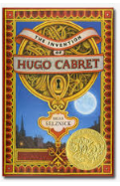
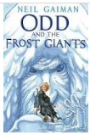
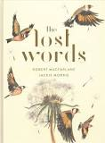
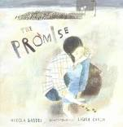
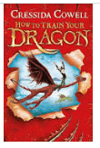
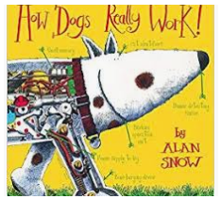
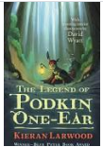
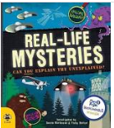
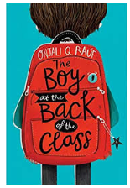
Year 4
The Boy in the back of the class – Onjali Q Rauf
The Lion, the Witch and the Wardrobe – C.S. Lewis
Marshall Armstrong New to our School – David Mackintosh
The White Fox – Jackie Morris
How Dogs Really Work – Alan Snow
Beowulf – Michael Morpurgo
How to Train a Dragon – Cressida Cowell
Invention of Hugo Cabret – Brian Selznick
The Wonder Garden – Jenny Broom
Rabbits – Emily Gravett
Wilfred Gordon McDonald Partridge – Mem Fox
The Lost Happy Endings – Carol Ann Duffy
The Legend of Podkin one Ear – Kieran Larwood
Odd and the Frost Giants – Neil Gaiman
Mysterious Traveller – Mal Peet
The Big Book of Blue – Yoval Zomar
Until I met Dudley – Roger McGough
The Promise – Nicola Davies
Poetry
Crazy Mayonnaisy Mum – Julia Donaldson
Where Zebras go – Sue Hardy Dawson
Be the Change – Poems that help save the World – Liz Brownlee
Roger Stevens, Matt Goodfellow
The Lost Words – Jackie Morris

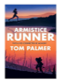
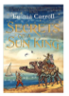
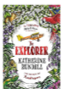
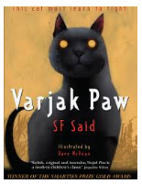
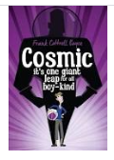
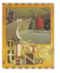
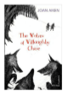
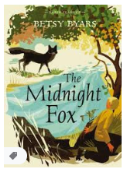
Year 5
The Red Tree – Shaun Tan
The Midnight Fox – Betsy Byars
Cold Tom – Sally Prue
The Conch Bearer – Chitra Banerjee Divakaruni
Cosmic – Frank Cottrell Boyce
The Lost Thing – Shaun Tan
Pig Heart Boy – Malorie Blackman
Varjak Paw – SF Said
Wonderstuck – Brian Selznick
The Turbulent Term of Tyke Tyler – Gene Kemp
Journey to the River Sea – Eva Ibbotson
Once – Morris Gleitzman
Journey to Jo’burg – Beverly Naidoo
The Secrets of the Sun King - Emma Carroll
The Wolves of Willoughby Chase – Joan Aitken
The Explorer – Katherine Rundell
The Armistice Runner – Tom Palmer
Charlie and the Chocolate Factory – Roald Dahl
Poetry
The Highwayman – Alfred Noyes
Talking Turkeys – Benjamin Zephaniah
New and Collected Poems for Children – edited by Carol Ann Duffy

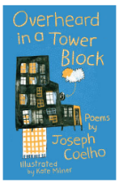
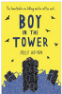
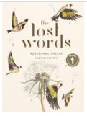
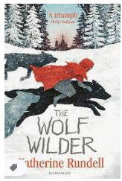
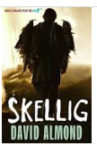
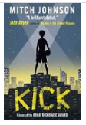
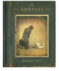
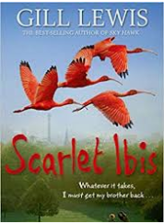
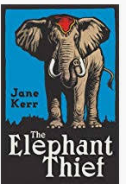
Year 6
The Arrival – Shaun Tan
Skellig – David Almond
The Windsinger – William Nicholson
Scarlett Ibis – Gill Lewis
Trash – Andy Mulligan
Wolf Brother – Michelle Paver
The Garbage King – Elizabeth Laird
Private Peaceful – Michael Morpurgo
The Giver – Lois Lowry
Goodnight Mr Tom – Michelle Magorian
The Elephant Thief – Jane Kerr
Kick – Mitch Johnson
The Boy in the Tower – Polly
The Wolf Wilder – Katherine Rundell
The Arrival - Shaun Tan
Poetry
The Lost Words – Robert MacFarlane
The Oldest Girl in the World – Carol Ann Duffy
Overheard in a Tower block – Joseph Coelho
If: A Treasury of Poems for Almost Every Possibility – edited by Allie Esiri and Rachel Kelly

