How to access eBooks
- Search - Oxford Owl Login
https://www.oxfordowl.co.uk/login?active-tab=students

- Click ‘Student’ and type in the log in details. These can be found in your child’s reading record.
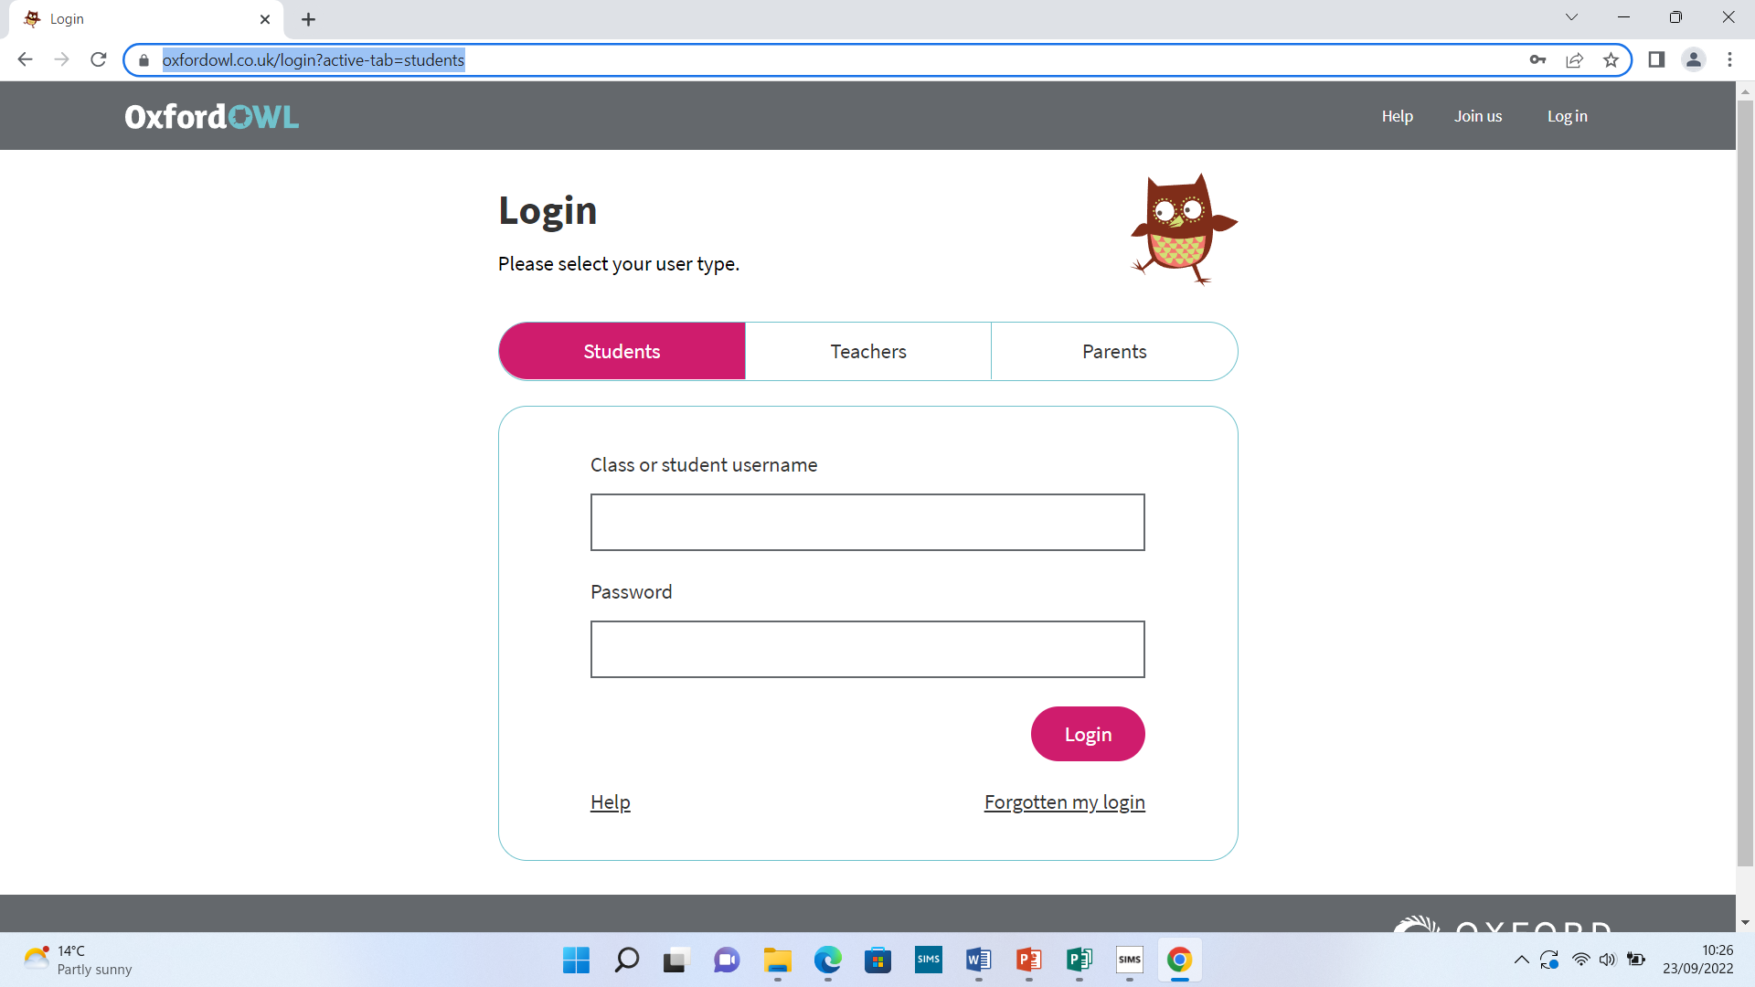

- Enter the school code ‘ygf7’
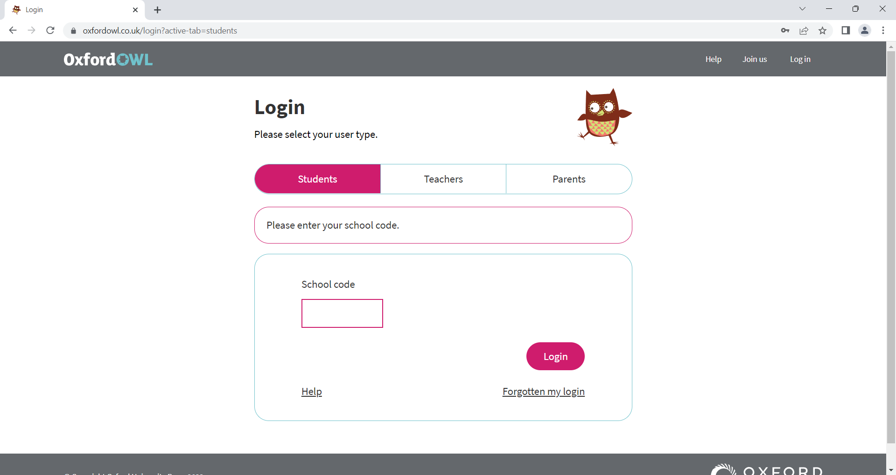
- Find your assigned book in the ‘Homework’ section of the page.
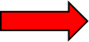
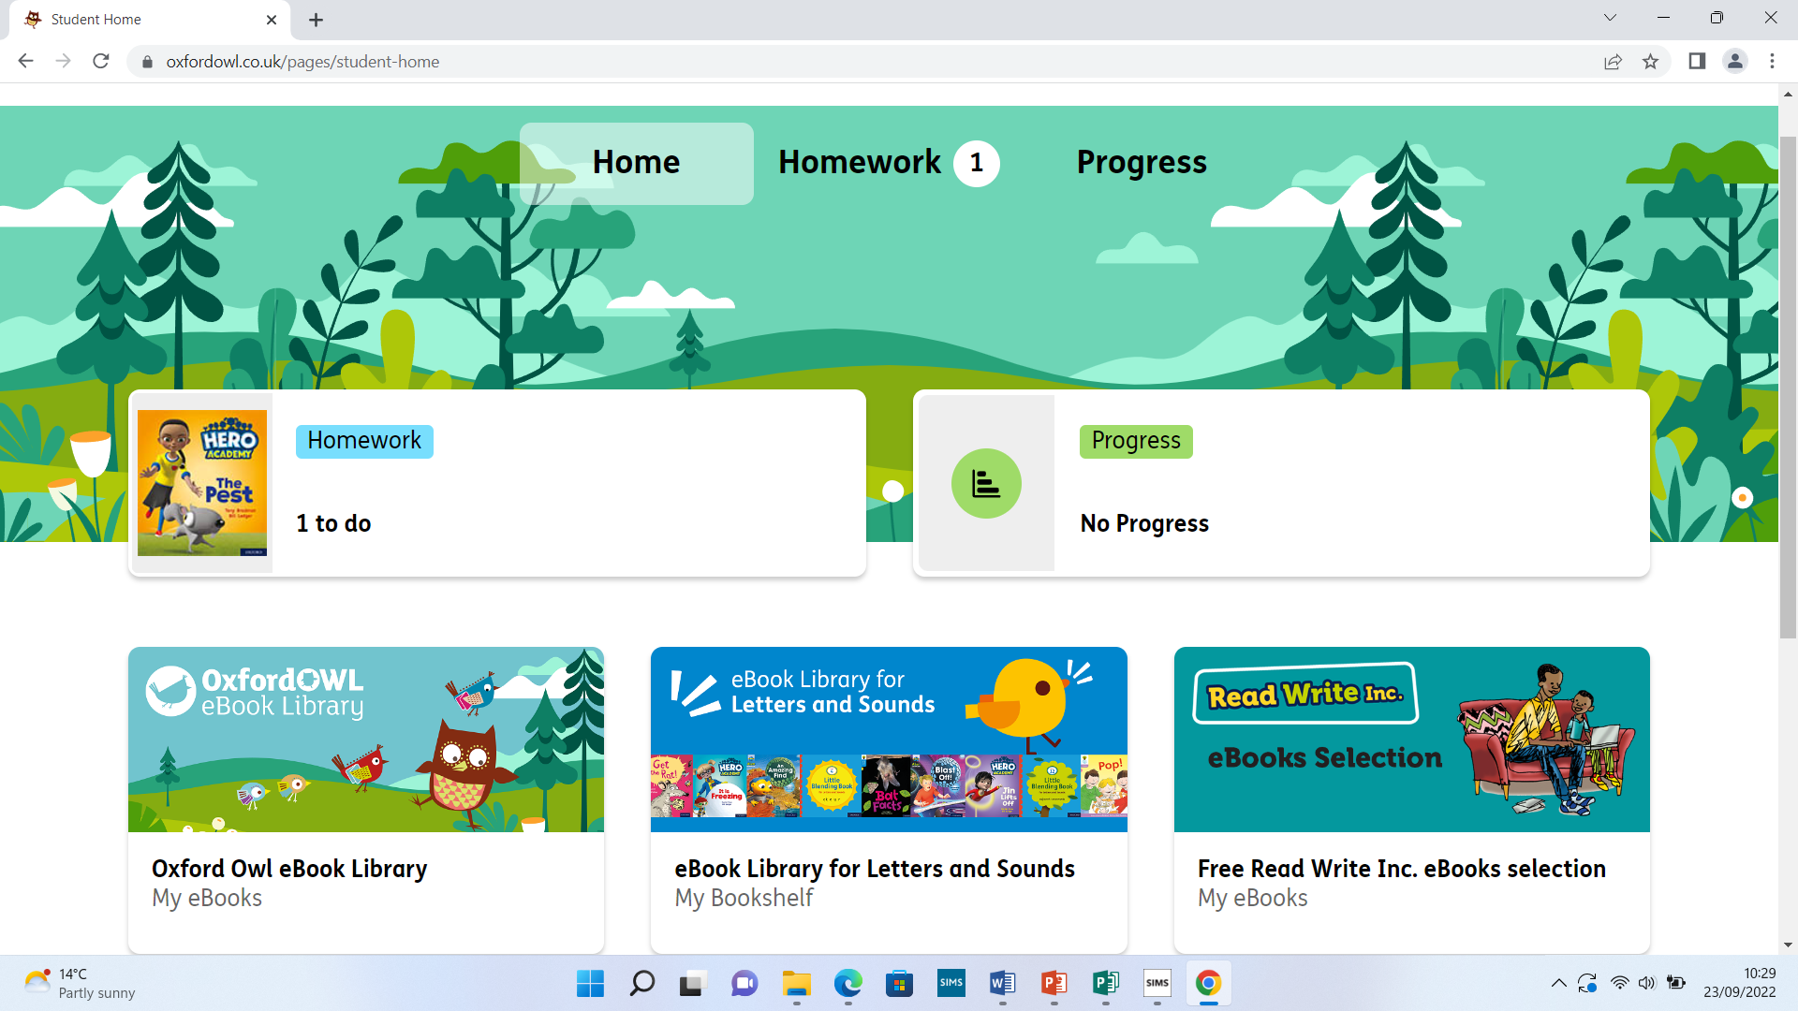

- Click on the book and then click on ‘Read the eBook’. This will open the book ready for you to read.
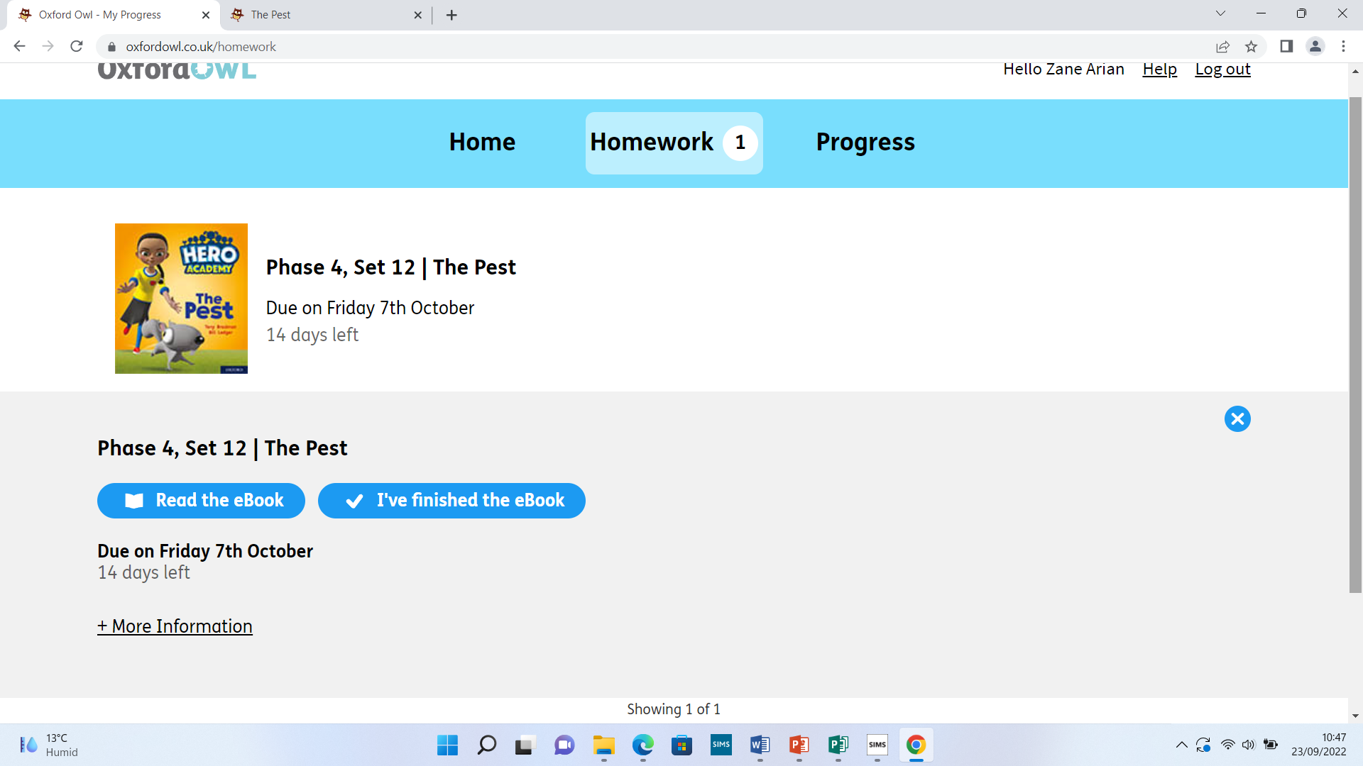

- Use the arrows in the bottom right corner to work through the book. Once finished click ‘Close book’.
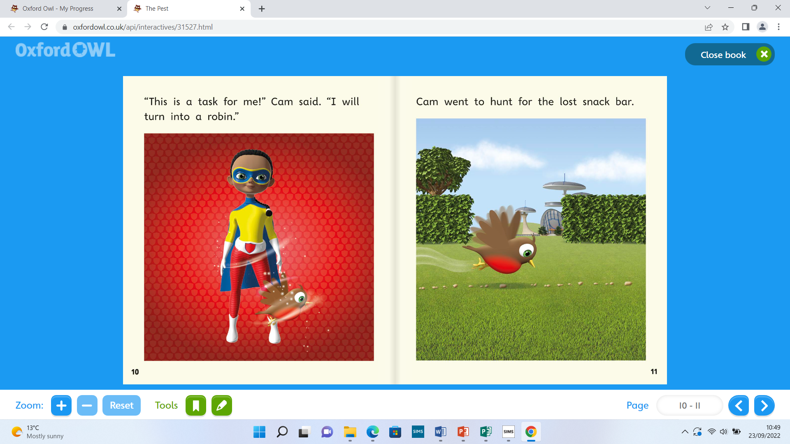

- Read the book 4 times over the week. Once the book has been read 4 times, click ‘I’ve finished the eBook’. The eBook will then be stored in the ‘eBook Library for Letters and Sounds’ and will remain there for the week.

- Tick and date that your child has read their eBook every time it has been read. This can be found in your child’s reading record.

