Aims
Woodfall Primary and Nursey School Calculation Policy

We aim to provide children with:
- a secure and appropriate knowledge of number facts
- a broad range of informal methods, which lead to reliable compact, efficient methods for all operations
- the confidence and ability to independently select an appropriate method for the numbers
- reliable strategies for checking the accuracy of their solutions
- an understanding of the relationships between the four operations. e.g.
  - inverses: addition/subtraction and multiplication/division
  - multiplication as repeated addition and division as repeated subtraction
  - commutative, associative and distributive laws (see appendix)

Why do we need this policy?
To ensure and provide:
- consistency in methods taught throughout the school.
- appropriate progression from informal / practical methods of recording to written methods for each of the four operations.
- an aid to parent’s understanding in their child’s stages of learning.

Things to remember
- Children should be introduced to a wide range of mental strategies for all four operations.
- Encourage children to record their mental calculations with informal jottings
- More formal written methods should follow only when the child is able to use a wide range of mental calculation strategies and informal jottings to support these. They should not replace mental calculation, which must continue to be taught alongside.
- Children should always try a mental method first – ask the question “Can I solve this in my head?” Look at the actual numbers and not assume a large number requires a written method.
- Ensure that mathematical inaccuracies are not introduced through recording multi-step calculations horizontally, with imbalance either side of the equals sign
e.g. 20 x 3 = 60 60 + 15 = 75
not 20 x 3 = 60 + 15 = 75
- Children should always estimate first
- Always check the answer, preferably using a different method e.g. the inverse operation
- Children who make persistent mistakes should return to the method that they can use accurately until ready to move on
- Children need to know number bonds and multiplication facts by heart for more formal methods to be efficient
- When revising or extending to harder numbers, refer back to expanded methods. This helps reinforce understanding and reminds children that they have an alternative to fall back on if they are having difficulties.
- Use appropriate models, images and practical equipment to introduce or review a concept
- A range of vocabulary should be used for each operation and attention paid to mathematical language modelled to children – be specific (e.g. quotient, product) and avoid misuse of vocabulary (e.g. sum)
- Children should be given the opportunity to experience calculation in context, through money and measure in real life contexts and problem solving situations
- Children should be given regular practise in selecting their method and justifying why this is the most appropriate method.
- If children are ready for an efficient method, there is no need to work through earlier progressions

PROGRESSION THROUGH CALCULATIONS FOR ADDITION

MENTAL CALCULATION FOR ADDITION

Mental recall of number bonds
- Addition pairs to 9+9 5 + 7 = 12
- Addition complements to 10 and then 100
6 + 4 = 10 □ + 3 = 10 25 + 75 = 100

Add a series of single digit numbers
4 + 8 + 5

Reorder sets of single digit numbers, looking for complements
3 + 6 + 7 + 4 = 3+7 + 6+4 = 10+10 = 20

Use near doubles
5 + 6 = double 5 + 1 = 11
Use related facts to add multiples of 10 and 100
6 + 7 = 13 so 60 + 70 = 130 and 600 + 700 = 1300

Addition using partitioning and recombining
e.g. 34 + 45 = (30 + 40) + (4 + 5) = 79

using place value
145 = 100 + 40 + 5

in different ways
145 = 120 + 25

Counting on or back in repeated steps of 1, 10, 100, 1000
86 + 57 = 143 (by counting on in tens and then in ones) 460 - 300 = 160 (by counting back in hundreds)

Add near multiples of 10 by adding the nearest multiple of 10, 100 and 1000 and adjusting
24 + 19 = 24 + 20 – 1 = 43
458 + 71 = 458 + 70 + 1 = 529

Use the relationship between addition and subtraction
36 + 19 = 55 19 + 36 = 55
55 – 19 = 36 55 – 36 = 19

MOVING TOWARDS EFFICIENT WRITTEN METHODS FOR ADDITION

- EARLY ADDITION: INFORMAL METHODS






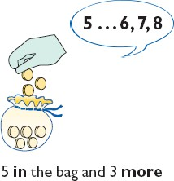
Counting songs/rhymes Pictorial and practical addition


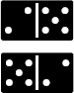
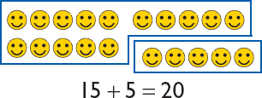

Dienes

Dienes to support calculations and teachers should demonstrate their use. Number sentences to be used alongside the use of Dienes. Dienes can then be used to support all other methods of addition
e.g. column method.

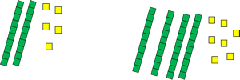
+

25 + 47 =

NUMBER LINES

Number lines and practical resources (e.g. bead strings) support calculation and teachers should
demonstrate their use.

Number lines should be annotated and may be accompanied by informal jottings Count on from the largest number irrespective of the order of the calculation.
3 + 2 = 5
+1
+1

0 1 2 3 4 5 6 7 8 9

Counting on first in ones

8 + 5 = 13

+1 +1 +1 +1 +1

0 1 2 3 4 5 6 7 8 9 10 11 12 13 14 15

Bridging through 10

8 + 5 = 13
+2 +3

0 1 2 3 4 5 6 7 8 9 10 11 12 13 14 15
The number line can be used for progressing to larger numbers, in preparation for partitioning.
3) THE “JUMP STRATEGY”

Counting on in tens and ones

34 + 23 = 57
+10
+10

+1 +1 +1
34 44 54 55 56 57

Counting on in multiples of tens and ones
Using fewer steps by adding the ones and eventually tens in one jump (by using the known facts 4 + 3 = 7 and 30 + 20 = 50).

34 + 23 = 57
+20

+3
34 54 57

Bridging through multiples of ten

37 + 15 = 52 +5
+10
+3
+2

37 47 50 52

COMPENSATION

Adding a near multiple of 10 or 100 and adjusting
49 + 73 = 122
+50
73
-1
122 123

EXPANDED METHODS: PARTITIONING

This should be encouraged alongside number lines as early as possible. Initially, record steps in the number line method using informal jottings 58 + 87
50 + 80 = 130
8 + 7 = 15
130 + 15 = 145

Leading to partitioned numbers being written under one another: -
50 8
80 7
130 15 = 145

Expanded Methods leading to “Column Addition”

Option 1 – Adding most significant digits first, then moving to adding least significant digits.

67 |  | 267
+ 24 |  | + 85
80 | (60 + 20) | 200
1 1 | ( 7 + 4) | 140 (60 + 80)
9 1 |  | 12 ( 7 + 5)
 |  | 352

Option 2 - Moving to adding the least significant digits first in preparation for ‘carrying’.

67 267
+ 24 + 85
1 1 ( 7 + 4) 12 ( 7 + 5)
8 0 (60 + 20) 140 (60 + 80)
9 1 200 (200 + 0)
352

EFFICIENT WRITTEN METHOD – “COLUMN ADDITION”
From this, children will begin to carry below the line.

625 | 783 | 367
+ 48 | + 42 | + 85
673 | 825 | 452
1 | 1 | 1 1

Using similar methods, children will:
  - add several numbers with different numbers of digits so that more than one ten or hundred is carried;
  - add decimal numbers, including amounts of money and measures, knowing that the decimal points should line up under each other, particularly when adding or subtracting mixed amounts,
e.g. £3.59 + 78p and where numbers have different numbers of decimal places

65.8 42
+ 58.48 6432
124.28 786
1 1 3
+ 4681
11944
1 2 1

PROGRESSION THROUGH CALCULATIONS FOR SUBTRACTION MENTAL CALCULATION FOR SUBTRACTION

Mental recall of addition and subtraction facts
  - Addition and subtraction complements to 10 and 20
  - Addition and subtraction facts to 20
  - Addition and subtraction complements of multiples of 10 to 100 10 – 6 = 4 17 - □ = 11 100 – 30 = 70
20 - 17 = 3 10 - □ = 2 100 - □ = 60

Use related facts
If 14 – 8 = 6 then 140 – 80 = 60 and 1400 – 800 = 600

Find a small difference by counting up
82 – 79 = 3

Counting on or back in repeated steps of 1, 10, 100, 1000
86 - 52 = 34 (by counting back in tens and then in ones) 460 - 300 = 160 (by counting back in hundreds)

Compensation - Subtract the nearest multiple of 10, 100 and 1000 and adjust
24 - 19 = 24 - 20 + 1 = 5
458 - 71 = 458 - 70 - 1 = 387

Use the relationship between addition and subtraction
36 + 19 = 55 19 + 36 = 55
55 – 19 = 36 55 – 36 = 19

Partition numbers:
- using place value
74 = 70 + 4

in different ways in preparation for decomposition
74 = 60 + 14

COUNTING ON OR COUNTING BACK?

When subtracting, whether mental or written, children will mainly choose between two main strategies:
-
- Taking away (Counting Back)
- Complementary Addition (Counting On)

The decision to count on or back will depend on the calculation but often the following rules apply:
- If the numbers are far apart, or there isn’t much to subtract (278 – 24) then count back.
- If the numbers are close together (206 – 188), then count up
- In many cases, either strategy would be suitable

MOVING TOWARDS EFFICIENT WRITTEN METHODS FOR SUBTRACTION

- EARLY ADDITION: INFORMAL METHODS

Counting songs/rhymes





Pictorial and practical Subtraction 9 – 5 = 4








Dienes

Dienes to support calculations and teachers should demonstrate their use. Number sentences to be used alongside the use of Dienes. Dienes can then be used to support all other methods of subtraction e.g. column method.
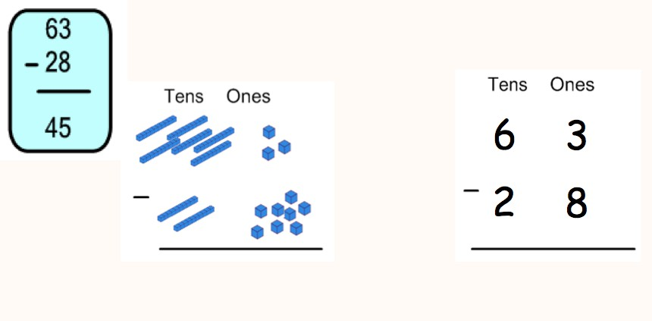

NUMBER LINES

Children use number lines and practical resources (e.g. bead strings) to support calculation. Teachers demonstrate the use of the numberline.

COUNTING BACK
6 – 3 = 3 -3

-1 -1 -1
-3

3 4 5 6 7 8

Children then begin to use numbered lines to support their own calculations - using a numbered line to count back in ones, leading to bridging through a multiple of 10.

13 – 5 = 8
-2 -3

-1 -1 -1 -1 -1
0 1 2 3 4 5 6 7 8 9 10 11 12 13 14 15
Larger numbers will be introduced with children counting back in tens and ones, leading to fewer steps 47 – 23 = 24
-1 -1
-1
- 10
- 10
47 – 23 = 24 25 26 27 37 47

Subtracting the tens in one jump and the ones in one jump.
24

47 – 23 = 24
-3
24 27
-20
47

Children begin to record informal jottings:
This should be encouraged alongside number lines.
47 – 20 = 27
27 – 3 = 24
Or 47 – 20 – 3 = 24

COUNTING ON

If the numbers involved in the calculation are close together or near to multiples of 10, 100 etc, it can be more efficient to count on. Children need experience of making this decision.

82 - 47
+1 +1 +1
+10
+10
+10
+1 +1
47 48 49 50 60 70 80 81 82

PARTITIONING (LEADING TO DECOMPOSITION)

This process should be demonstrated using arrow cards to show the partitioning and base 10 materials or straw bundles to show the decomposition of the number.
NOTE When solving the calculation 89 – 57, children should know that 57 does NOT EXIST AS AN AMOUNT it is what you are subtracting from the other number. Therefore, when using base 10 materials, children would need to count out only the 89.
89 = 80 9
- 57 50 7
30 2 = 32

From this the children will begin to EXCHANGE, NOT BORROW.

71
- 46
Step 1 70 1
- 40 6
Step 2 60 11
- 40 6
20 5 = 25

This would be recorded by the children as
60
70 ¹1
- 40 6
20 5 = 25

PROGRESSING TO 3 DIGIT NUMBERS
754
- 86

Step 1 700 50 4
- 80 6

Step 2 700 40 14 (adjust from T to O)
- 80 6

Step 3 600 140 14 (adjust from H to T)
- 80 6
600 60 8 = 668

This would be recorded by the children as
600 140
700 50 ¹4
- 80 6
600 60 8 = 668

AND DECIMALS

£8.95 = 8 0.9 0.05 leading to
-£4.38 - 4 0.3 0.08
8 1
= 8 0.8 0.15 (adjust from T to 0) 8.9 5
- 4 0.3 0.08 - 4.3 8

4 0.5 0.07 = £4.57 4. 5 7

Alternatively, children can set the amounts to whole numbers, i.e. 895 – 438 and convert to pounds after the calculation.

DECOMPOSITION – COLUMN SUBTRACTION

Numbers should continue to be referred to by their values and not their digits.
e.g. 140 – 80 | or | 14 tens – 8 ones | as opposed to | 14 - 8
7 14 1 |  | 1 13 16 11 1
8 5 4 |  | 3 4 7 . 2 6
- 2 8 6 - 1 8 9 . 5 8

5 6 8 1 5 7 . 6 8

This should be extended to exchange across two places due to the presence of a zero.
9
5 1 1
6 0 5
- 3 2 8
2 7 7

PROGRESSION THROUGH CALCULATIONS FOR MULTIPLICATION MENTAL CALCULATION FOR MULTIPLICATION

Counting in equal steps

Doubling and halving
Applying the knowledge of doubles and halves to known facts.
e.g. 8 x 4 is double 4 x 4

Using multiplication facts
Know multiplication facts to 12x12
Recognise relationships between multiples e.g. 5/10, 3/6/9, 2/4/8, etc

Using and applying multiplication facts
Children should be able to utilise their tables knowledge to derive other facts.
e.g. If I know 3 x 7 = 21, what else do I know?
30 x 7 = 210, 300 x 7 = 2100, 3000 x 7 = 21 000, 0.3 x 7 = 2.1 etc

Use closely related facts already known
13 x 11 = (13 x 10) + (13 x 1)
= 130 + 13
= 143

Multiplying by 10 or 100
Knowing that the effect of multiplying by 10 is a shift in the digits one place to the left. Knowing that the effect of multiplying by 100 is a shift in the digits two places to the left.

Partitioning
Using place value e.g. 23 x 4 = (20 x 4) + (3 x 4)
= 80 + 12 = 102

In different ways e.g. 145 = 120 + 25
So 145 x 6 = (120 x 6) + (25 x 6)
= 720 + 150 = 870

Inverses
3 x 7 = 21 and 21 ÷ 7 = 3
leading to use of symbols to stand for unknown numbers to complete equations
□ x 5 = 20 3 x △ = 18 □ x 🞅 = 32 This leads into algebraic notation e.g. 5n = 15

Factorising - Use of factors
8 x 12 = 8 x (4 x 3)
18 x 4 = 18 x (2 x 2)

NOTE:
Children must be taught to recognise when there is a quicker mental method, even for larger numbers.
e.g. For a calculation such as 25 x 24, a quicker method would be ‘there are four 25s in 100 so 25 x 24 = 100 x 6 = 600

TERMINOLOGY
Short multiplication – multiplication by a single digit, using any method Long multiplication – multiplication by two or more digits, using any method

MOVING TOWARDS EFFICIENT WRITTEN METHODS FOR MULTIPLICATION

- MODELS AND IMAGES

Children will experience equal groups of objects and will count in 2s and 10s and begin to count in 5s. They will work on practical problem solving activities involving equal sets or groups.



They will visualise sets of objects in arrays.

5 x3
2 x3 = 6 3 x2 = 6

5 5 5

SCALING

e.g. Find a ribbon that is 4 times as long as the blue ribbon

5cm 20 cm

NUMBER LINES: REPEATED ADDITION

3 times 5 is 5 + 5 + 5 = 15
or 3 lots of 5
or 5 x3 (record as 5 x3 so the association is “3 lots of 5”)
5 x 3 = 5 + 5 + 5
5 5 5

0 1 2 3 4 5 6 7 8 9 10 11 12 13 14 15
and on a bead bar:

COMMUTATIVITY

Children should know that 3 x 5 has the same answer as 5 x 3. This can also be shown on the number line.
5
5
0 1 2 3 4 5 6 7 8 9
5
10 11 12 13 14 15
3 3 3 3 3

ARRAYS
Children should be able to model a multiplication calculation using an array. This knowledge will support with the development of the grid method.



5 x 3 = 15
3 x 5 = 15

GRID METHOD
Children will continue to use arrays where appropriate leading into the grid method of multiplication.

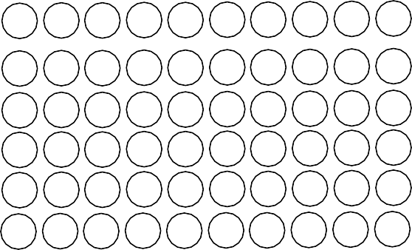

(6 x 10) + (6 x 4)
x
10
4
6
60
24
60 + 24
84

TO x O
x | 30 | 8
7 | 210 | 56 | 266

38 x 7

TO x TO
x | 20 | 7
50 | 1000 | 350 | 1120
6 | 120 | 42 | 392
 |  |  | 1512

27 x 56

Decimals
x | 4 | 0.9 | 0.02
3 | 12 | 2.7 | 0.06 | 14.76

e.g. 4.92 x 3

PARTITIONING

38 x 5 = (30 x 5) + (8 x 5)
= 150 + 40
= 190

OR 30 x 5 = 150 8 x 5 = 40 150 + 40 = 190 recorded horizontally or vertically

VERTICAL FORMAT: EXPANDED WORKING, LEADING TO EFFICIENT COMPACT METHOD
SHORT MULTIPLICATION
38
x 7
56 | ( 8 x 7)
210 | (30 x 7)
266
3 7 8 | 3 7 8
x 4 | x 4
3 2 | 1 5 1 2
2 8 0 | 3 3
1 2 0 0
1 5 1 2

LONG MULTIPLICATION

3 8 4 2 3
x 5 7 x 6 8
22 65 6 3 3 18 24
11 9₄0 0 2 5₁3₁ ₁8 0
2 1 6 6 2 8 7 6 4

NOTE:
The position of carried digits is up t the child and teacher as long as the intention is clear. Children should be encouraged to cross off carried digits after they have been added to avoid confusion.

FACTORISING FOR LONG MULTIPLICATION

Non-prime numbers can be factorised in order to carry out two short multiplication calculations instead of one long multiplication:

For 26 x 24 24 = 6 x 4 so 26 and 104
x 4 x 6
104 624

PROGRESSION THROUGH CALCULATIONS FOR DIVISION MENTAL CALCULATION FOR DIVISION

Doubling and halving
Knowing that halving is dividing by 2

Deriving and recalling division facts
Know multiplication and corresponding division facts to 12 x 12
e.g. 24 ÷ 4 = 6 because 6 x4 = 24

Using and applying division facts
Children should be able to utilise their tables knowledge to derive other facts.
e.g. If I know 3 x 7 = 21, then I know 21 ÷ 7 = 3 210 ÷ 7 = 30 etc

Dividing by 10 or 100
Knowing that the effect of dividing by 10 is a shift in the digits one place to the right. Knowing that the effect of dividing by 100 is a shift in the digits two places to the right.

Partition in different ways
Using place value | e.g. 63 ÷ 3 | = (60 ÷ 3) + (3 ÷ 3) = 20 + 1 | = 21
In different ways | e.g. 81 ÷ 3 | = (60 ÷ 3) + (21 ÷ 3) = 20 + 7 | = 27
Factorising: Use of factors
378 ÷ 21 378 ÷ 3 = 126 378 ÷ 21 = 18
126 ÷ 7 = 18

Using symbols
Symbols represent unknown numbers to complete equations using inverse operations, leading to algebraic notation
□ ÷ 2 = 4 20 ÷ △ = 4 □ ÷ △ = 4
KEY VOCABULARY: 18 ÷ 3 = 6
- Dividend – the number to be divided (18)
- Divisor – the number being used to divide (3)
- Quotient – the answer after division (6)

REMAINDERS
Any remainders should be shown:
- first as integers, i.e. 14 remainder 2 or 14 r 2.
- as fractions, i.e. if the children were dividing 32 by 10, the answer should be shown as 3 ²/10
which could then be written as 3 ¹/5 in it’s lowest terms.
- as decimals, by extending the dividend with a decimal point and several decimal place holders

ROUNDING UP OR DOWN AFTER DIVISION
Children need to be able to decide what to do after division and round up or down accordingly.
e.g. 62 ÷ 8 is 7 remainder 6, but whether the answer should be rounded up to 8 or rounded down to 7 depends on the context.
- I have 62p. Sweets are 8p each. How many can I buy?
Answer: 7 (the remaining 6p is not enough to buy another sweet)
- Apples are packed into boxes of 8. There are 62 apples. How many boxes are needed? Answer: 8 (the remaining 6 apples still need to be placed into a box)

MOVING TOWARDS EFFICIENT WRITTEN METHODS FOR DIVISION

- INFORMAL METHODS – PICTORIAL REPRESENTATIONS

Children will understand equal groups and share items out in play and problem solving. They will count in 2s and 10s and later in 5s.
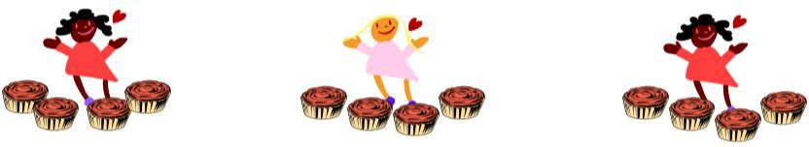
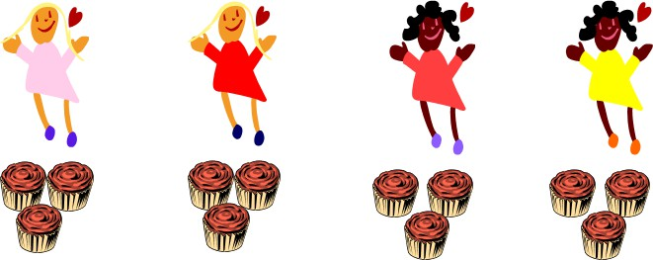

Children will develop their understanding of division and use jottings to support calculation

NUMBER LINES - REPEATED SUBTRACTION

12 ÷ 3 = 4
-3 -3 -3 -3

0 1 2 3 4 5 6 7 8 9 10 11 12

REMAINDERS
Children should also move onto calculations involving remainders, recording as whole numbers 13 ÷ 4 = 3 r 1
4
4
4
0 1 5 9 13

LARGER NUMBERS, USING MULTIPLES OF THE DIVISOR

72 ÷ 5

-2 -5 -5 -5 -5 -5 -5 -5 -5 -5 -5 -5 -5 -5 -5

0 2 7 12 17 22 27 32 37 42 47 52 57 62 67 72

Moving onto:
r2
-20
-50

0 2 22 72

PARTITIONING NUMBERS IN DIFFERENT WAYS

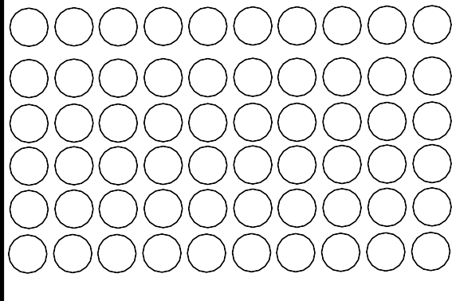
USING ARRAYS TO VISUALISE
10
4
60
24

6
Informal recordings for partitioning and recombining: 84 ÷ 6
84 = 60 + 24
60 ÷ 6 = 10
24 ÷ 6 = 4
10 + 4 = 14

Or using brackets:
84 ÷ 6 = (60 ÷ 6) + (24 ÷ 6)
= 10 + 4
= 14

This leads into the more compact method and demonstrates the exchange process visually.

COMPACT WRITTEN METHOD: BUS SHELTER

Short Division

468 ÷ 3= 156
1 5 6

3 ) 41 61 8

222 ÷ 6 = 37
0 3 7

6 ) 2 2 2 4 2

With remainders:

743 ÷ 4 = 185 remainder 3

1 8 5 r 3 | or 1 8 5 ¾ | or | 1 8 5 . 7 5
4 ) 73 42 3 | 4 ) 73 423 |  | 4 ) 73 423 .3 02 0

Long division uses the same method.
Due to the size of the divisor, children should be encouraged to make a list of multiples before beginning. They may carry 2 digits in some cases.

3992 ÷ 16 = 249 remainder 8

16
32 0 2 4 9 r 8 or 0 2 4 9 8/16 = 249 ½ or 0 2 4 9 . 5
48

64
80
96
112
128
144
160
16 ) 3 97 915 2 16 ) 3 97 915 2 16 ) 3 9 7 9152 8. 0

To avoid carrying 2 digits in the limited working space alongside difficult mental subtractions to find the remainder, this part could be shown below the dividend, with the next placed number being brought down to join the remainder after the subtraction.
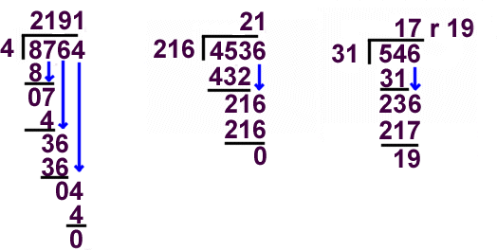
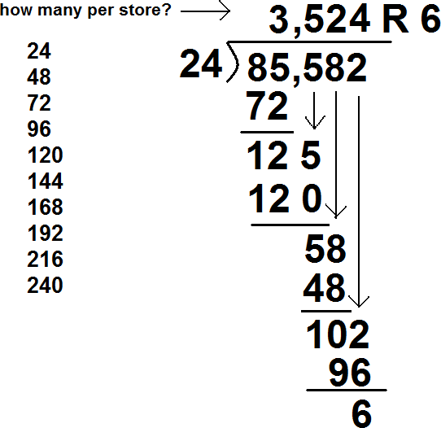

FACTORISING FOR LONG DIVISON

For long division where the divisor can be factorised into two single digit numbers, carry out two short division calculations to avoid long division:
864 ÷ 24
24 = 6 x 4 so instead 864 ÷ 6 ÷ 4

864 ÷ 24 = 36
1 4 4 | then | 0 3 6
6 ) 8 2 6 2 4 |  | 4 ) 11 42 4

THE SIMPLIFYING FRACTION METHOD

Division calculations can be written as fractions and cancelled down to their lowest terms. 864 ÷ 24
864 | = | 432 | = | 216 | = | 108 | = | 36 | = | 36
24 | ÷ 2 | 12 | ÷ 2 | 6 | ÷ 2 | 3 | ÷ 3 | 1

APPENDIX: COMMUTATIVE, ASSOCIATIVE AND DISTRIBUTIVE LAWS

COMMUTATIVE LAWS

The "Commutative Laws" say you can swap numbers over and still get the same answer ...

... when you add: a + b = b + a

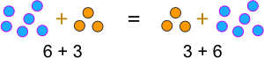
Example:

... or when you multiply: a × b = b × a

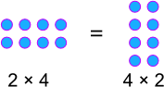
Example:

NOTE: The Commutative Law does not work for division or subtraction:

Example:
- 12 / 3 = 4 | but | 3 / 12 = ¼
- 15 – 4 = 11 | but | 4 – 15 = -11
ASSOCIATIVE LAWS

The "Associative Laws" say that it doesn't matter which numbers you calculate first...
... when you add: (a + b) + c = a + (b + c)
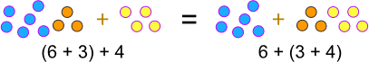

... or when you multiply: (a × b) × c = a × (b × c)
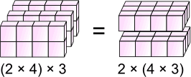

Examples:
This: | (2 + 4) + 5 = 6 + 5 = 11
has the same answer as this: | 2 + (4 + 5) = 2 + 9 = 11

This: | (3 × 4) × 5 = 12 × 5 = 60
has the same answer as this: | 3 × (4 × 5) = 3 × 20 = 60

USES:

Sometimes it is easier to add or multiply in a different order:

Example:
19 + 36 + 4 = 19 + (36 + 4) = 19 + 40 = 59

Or to rearrange a little:

Example:
2 × 16 × 5 = (2 × 5) × 16 = 10 × 16 = 160
NOTE: The Associative Law does not work for subtraction:

Example:
- (9 – 4) – 3 = 5 – 3 = 2, but
- 9 – (4 – 3) = 9 – 1 = 8

DISTRIBUTIVE LAW

The “distributive laws” say that you get the same answer when you:
  - multiply a number by a group of numbers added together, or
  - do each multiply separately then add them
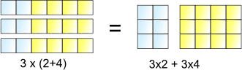

3 lots of (2+4) is the same as 3 lots of 2 plus 3 lots of 4

So, the 3× can be "distributed" across the 2+4, into 3×2 and 3×4

and we write it like this:
a × (b + c) = a × b + a × c

USES:

Sometimes it is easier to break up a difficult multiplication:

Example:
6 × 204 = 6×200 + 6×4 = 1,200 + 24 = 1,224

Or to combine:

What is 16 × 6 + 16 × 4?
16 × 6 + 16 × 4 = 16 × (6+4) = 16 × 10 = 160

You can use it in subtraction too:

26×3 - 24×3
26×3 - 24×3 = (26 - 24) × 3 = 2 × 3 = 6

You could use it for a long list of additions, too:
6×7 + 2×7 + 3×7 + 5×7 + 4×7 = (6+2+3+5+4) × 7 = 20 × 7 = 140
NOTE: The Distributive Law does not work for division:

Example:
    - 24 / (4 + 8) = 24 / 12 = 2, but
    - 24 / 4 + 24 / 8 = 6 + 3 = 9

SUMMARY

COMMUTATIVE LAWS: | a + b = b + a a × b = b × a
ASSOCIATIVE LAWS: | (a + b) + c = a + (b + c) (a × b) × c = a × (b × c)
DISTRIBUTIVE LAW: | a × (b + c) = a × b + a × c

