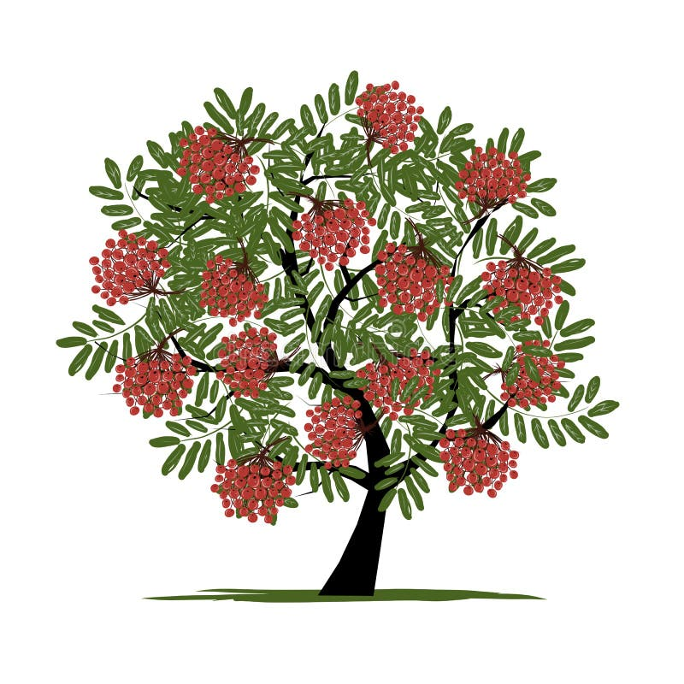

**Rowan Class**

All about Reception

**Our PE day** is a Thursday

For PE lessons, you will need:

* White P.E T-shirt (or plain white)
* Plain maroon/black shorts, joggers or leggings.
* Black Trainers
* Little Leigh P.E hoodie

**Home learning**

In Reception, our home learning focus is on Reading and Phonics. Every Friday, we will send home a new reading book linked to our Phonics lessons that week. We also share e-books via Oxford Reading Tree (login details for this will be found in your child’s reading records).

As we start or come to the end of a phase in Phonics, we will send home any sounds or Harder to Read and Spell Words (HRSWs), that we will be learning or any that may need consolidation.

*Please ensure children have their reading books and reading records in school with them each day, especially on a Friday so we can change their book.

The Reception Team

Miss Lloyd – Class Teacher (Monday – Wednesday)

Miss Hackney – Class Teacher (Thursday & Friday)

Miss Williams– Teaching Assistant

Things to look forward to this term

* Tuesday 9th September - Meet the teacher session
* Tuesday 14th and Thursday 16th October – Parents Evenings
* Harvest
* A visit to Barnton Library
* DEAR time
* Monday 3rd November - INSET

This term we will be learning:

|  |  |
| --- | --- |
| **Autumn 1 Term Key Learning** | |
| **Communication & Language** | What does good listening look like? |
| **Personal, Social & Emotional Development** | Settling in to school life.  Building relationships with new friends.  Our My Happy Mind module is: Meet Your Brain. |
| **Physical Development** | Body Management  We will explore balance and managing our own bodies. We will focus on stretches, reaching and extending our bodies in a variety of ways and positions.  We will begin to develop our fine motor skills with dough disco and lots of finger gym activities to get our hands ready for writing. |
| **Literacy** | Recognise and use phase 2 graphemes when reading and writing VC words e.g. in, on it, as, up.  Orally compose captions/simple sentences.  Begin to form some letters correctly.  Begin to read and write simple CVC words.  Begin to write a simple caption / sentence. |
| **Mathematics** | Numbers to 5.  Subitising to 5.  Match, Sort & Compare.  Begin to talk about Position, measure & patterns. |
| **Understanding the World** | Where Do We live?  How Have I Changed Since I was a Baby?  Special People & Christmas |
| **Expressive Arts and Design** | Practise and perform rhymes and simple poems.  Cooking – pumpkin soup & gingerbread people.  Self-portraits. |