Year 2 Retrieval Challenges
We have given you 10 activities to choose from and would like you to complete any 7 of these over the Autumn 2. All the activities are designed to help children recap on their learning from Autumn 1 This will help children to retain the knowledge in long-term memory. We are sure that you will put in a lot of effort for each piece and you will enjoy presenting your homework to the rest of the class, sharing all your hard work. Each activity is worth a different amount of dojo points. As you complete the activities please bring your homework into school – one per week (Please bring your homework in on a Thursday) Our new topic this half term is: The Great Fire of London!
Compulsory tasks:
Reading 15-20 minutes everyday
Spellings based on the test which will take place every FRIDAY
Please practise on TTRS Times table Rock Stars) using your login- some of the children will now start to a weekly test in class.

English    Imagine you are in a boat, just like in the story ‘ A river’  You are going on your own adventure. What do you see? What do you hear? Where does the river take you?  Write a short story describing your river journey.  You could use this as your starter: I looked out of my window and saw a river. I stepped into a boat and began to float away…..  Try to include:  4 to 6 sentences  Adjectives to describe what you see (e.g. green, winding, noisy)  Places the river passes (e.g. forests, mountains, animals, cities)  15 dojos | Maths (Place value)  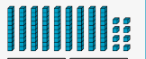  Make up your own place value riddle for someone at home.  Make up a tens and ones riddle for someone at home to solve. Example I have 6 tens and 3 ones what number am I? Can you include hundreds too to make your riddle trickier? E.g. I have 1 hundred, 3 tens and 2 ones what number am I ?  Can you challenge yourself and do a hundreds number?  I have also included some place value maths sheets if you want to do those?  (5 dojos) | Geography  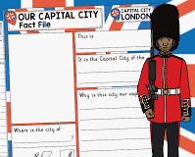  Make a fact file about London, include things like the flag, landmarks, famous people or events.  You can do your own template or I have included a template for you to use if you want to use that you are welcome to.  15 dojos | RE (Sacred Texts)  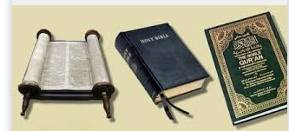  Choose a sacred text (Bible, Qur’an, (Torah). Draw it and write 2 things that people learn from it.  10 dojos. | Science (materials)    You are a materials properties’ detective. Your job is to find objects at home and describe their properties.  Properties to look for:  - Hard/ Soft  - Shiny/ Dull  - Rough/ smooth  - Waterproof/ Absorbent  - Flexible/ Stiff  - transparent/ opaque  Draw pictures and label them with what you find or take photographs.  Extra challenge: Why do you think the object’s properties make it good for its job?  10 dojos
Art/DT(Moving toy)  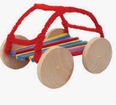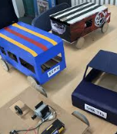  Create your own moving toy that includes wheels and axels to make it move.  You can use boxes and other junk modelling or use construction kits like KNEX  15 dojos  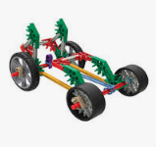 | PSHE(Me and my relationships )  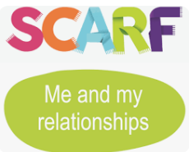  Draw a picture of someone who is kind and helpful. Write about what makes them a good friend.  5 dojos | Music(rhythm)    Ask a grownup to clap a rhythm for you e.g. clap, clap, pause, clap)  Try 3 different rhythms. Can you clap it back?  Then use your hands and feet and other instruments you have at home to make your own rhythm.  -You can clap it  -Stamp it  -Tap it on a pan or a table.  Get your grown up to video your rhythm and send it on dojo – we can’t wait to try and copy it in class.  5 dojos | PE (Gymnastics)  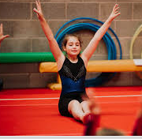  Design a gymnastics routine using balances, rolls and jumps. Show it to someone at home!  Can you video your routine for us to see at school?  10 dojos | Computing (online safety)  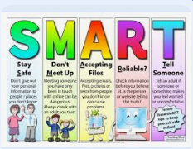  Make an online safety poster to remind others how to stay safe online.  5 dojos

