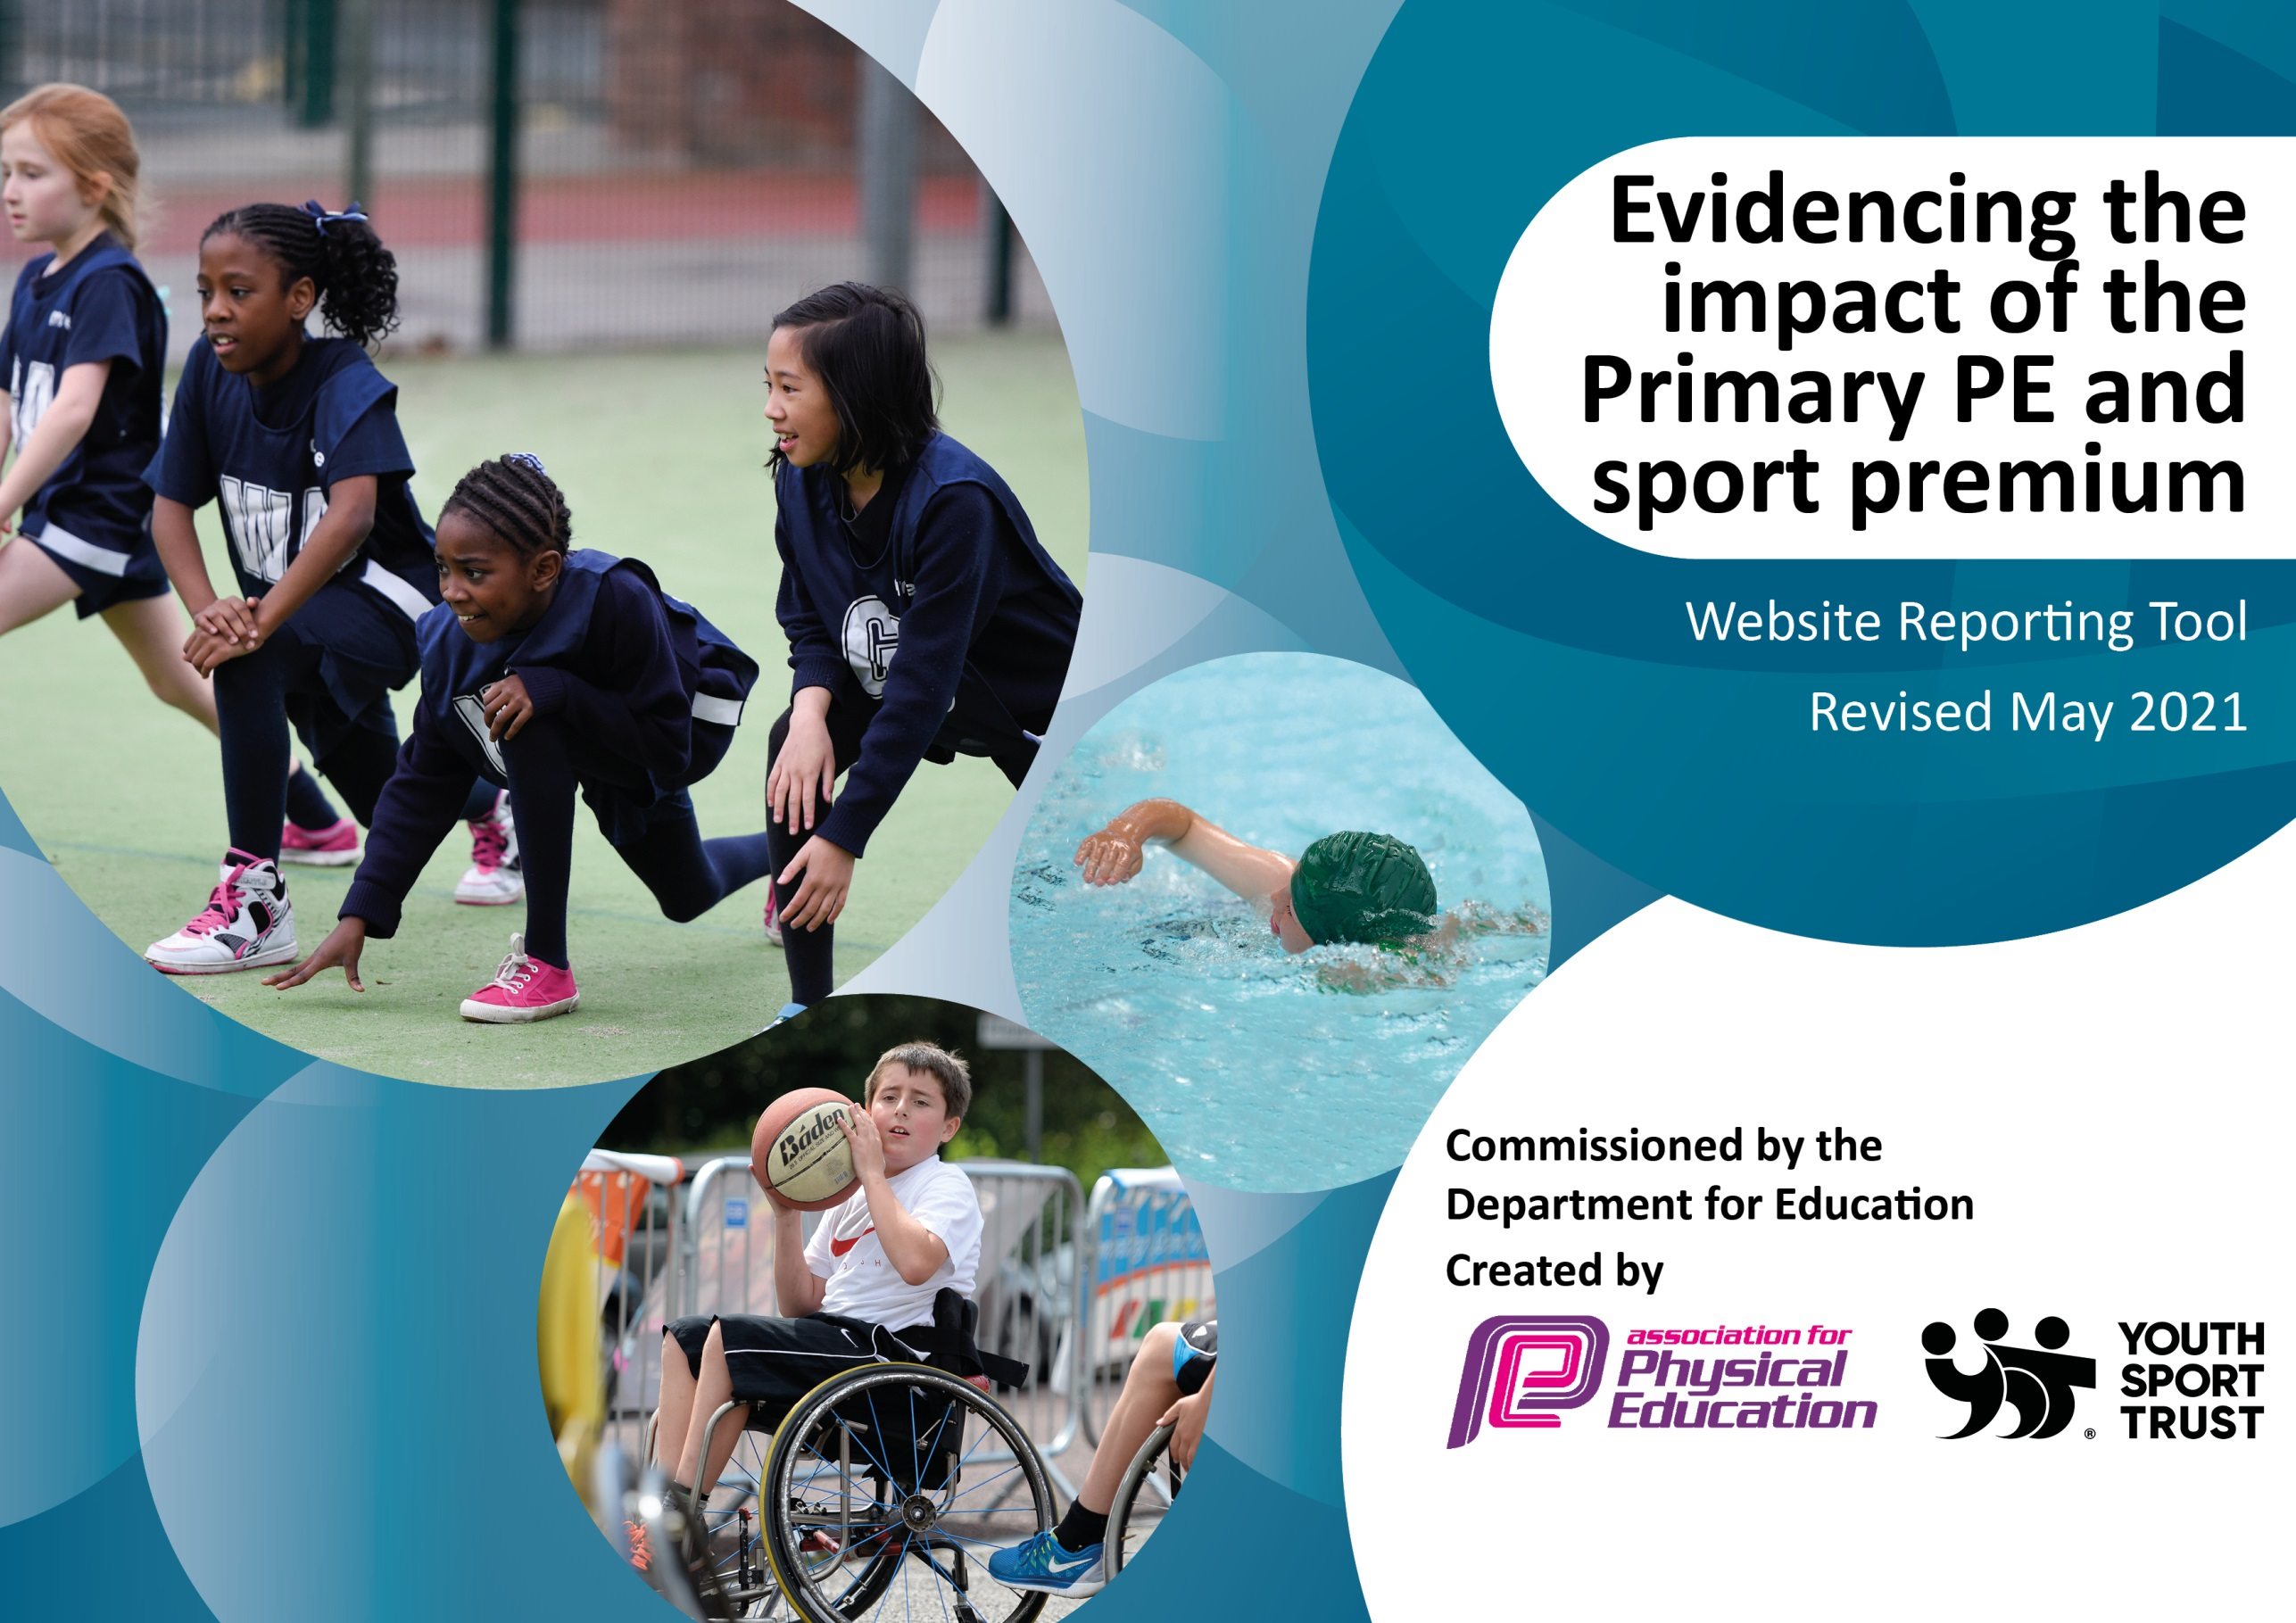

It is important that your grant is used effectively and based on school need. The Education Inspection Framework (Ofsted 2019 p64) makes clear there will be a focus on ‘whether leaders and those responsible for governors all understand their respective roles and perform these in a way that enhances the effectiveness of the school’.

Under the Quality of Education criteria (p41) inspectors consider the extent to which schools can articulate their curriculum (INTENT), construct their curriculum (IMPLEMENTATION) and demonstrate the outcomes which result (IMPACT).

To assist schools with common transferable language this template has been developed to utilise the same three headings which should make your plans easily transferable between working documents.

Schools must use the funding to make additional and sustainable improvements to the quality of Physical Education, School Sport and Physical Activity (PESSPA) they offer. This means that you should use the Primary PE and sport premium to:

- Develop or add to the PESSPA activities that your school already offer
- Build capacity and capability within the school to ensure that improvements made now will benefit pupils joining the school in future years
- The Primary PE and sport premium should not be used to fund capital spend projects; the school’s budget should fund these.
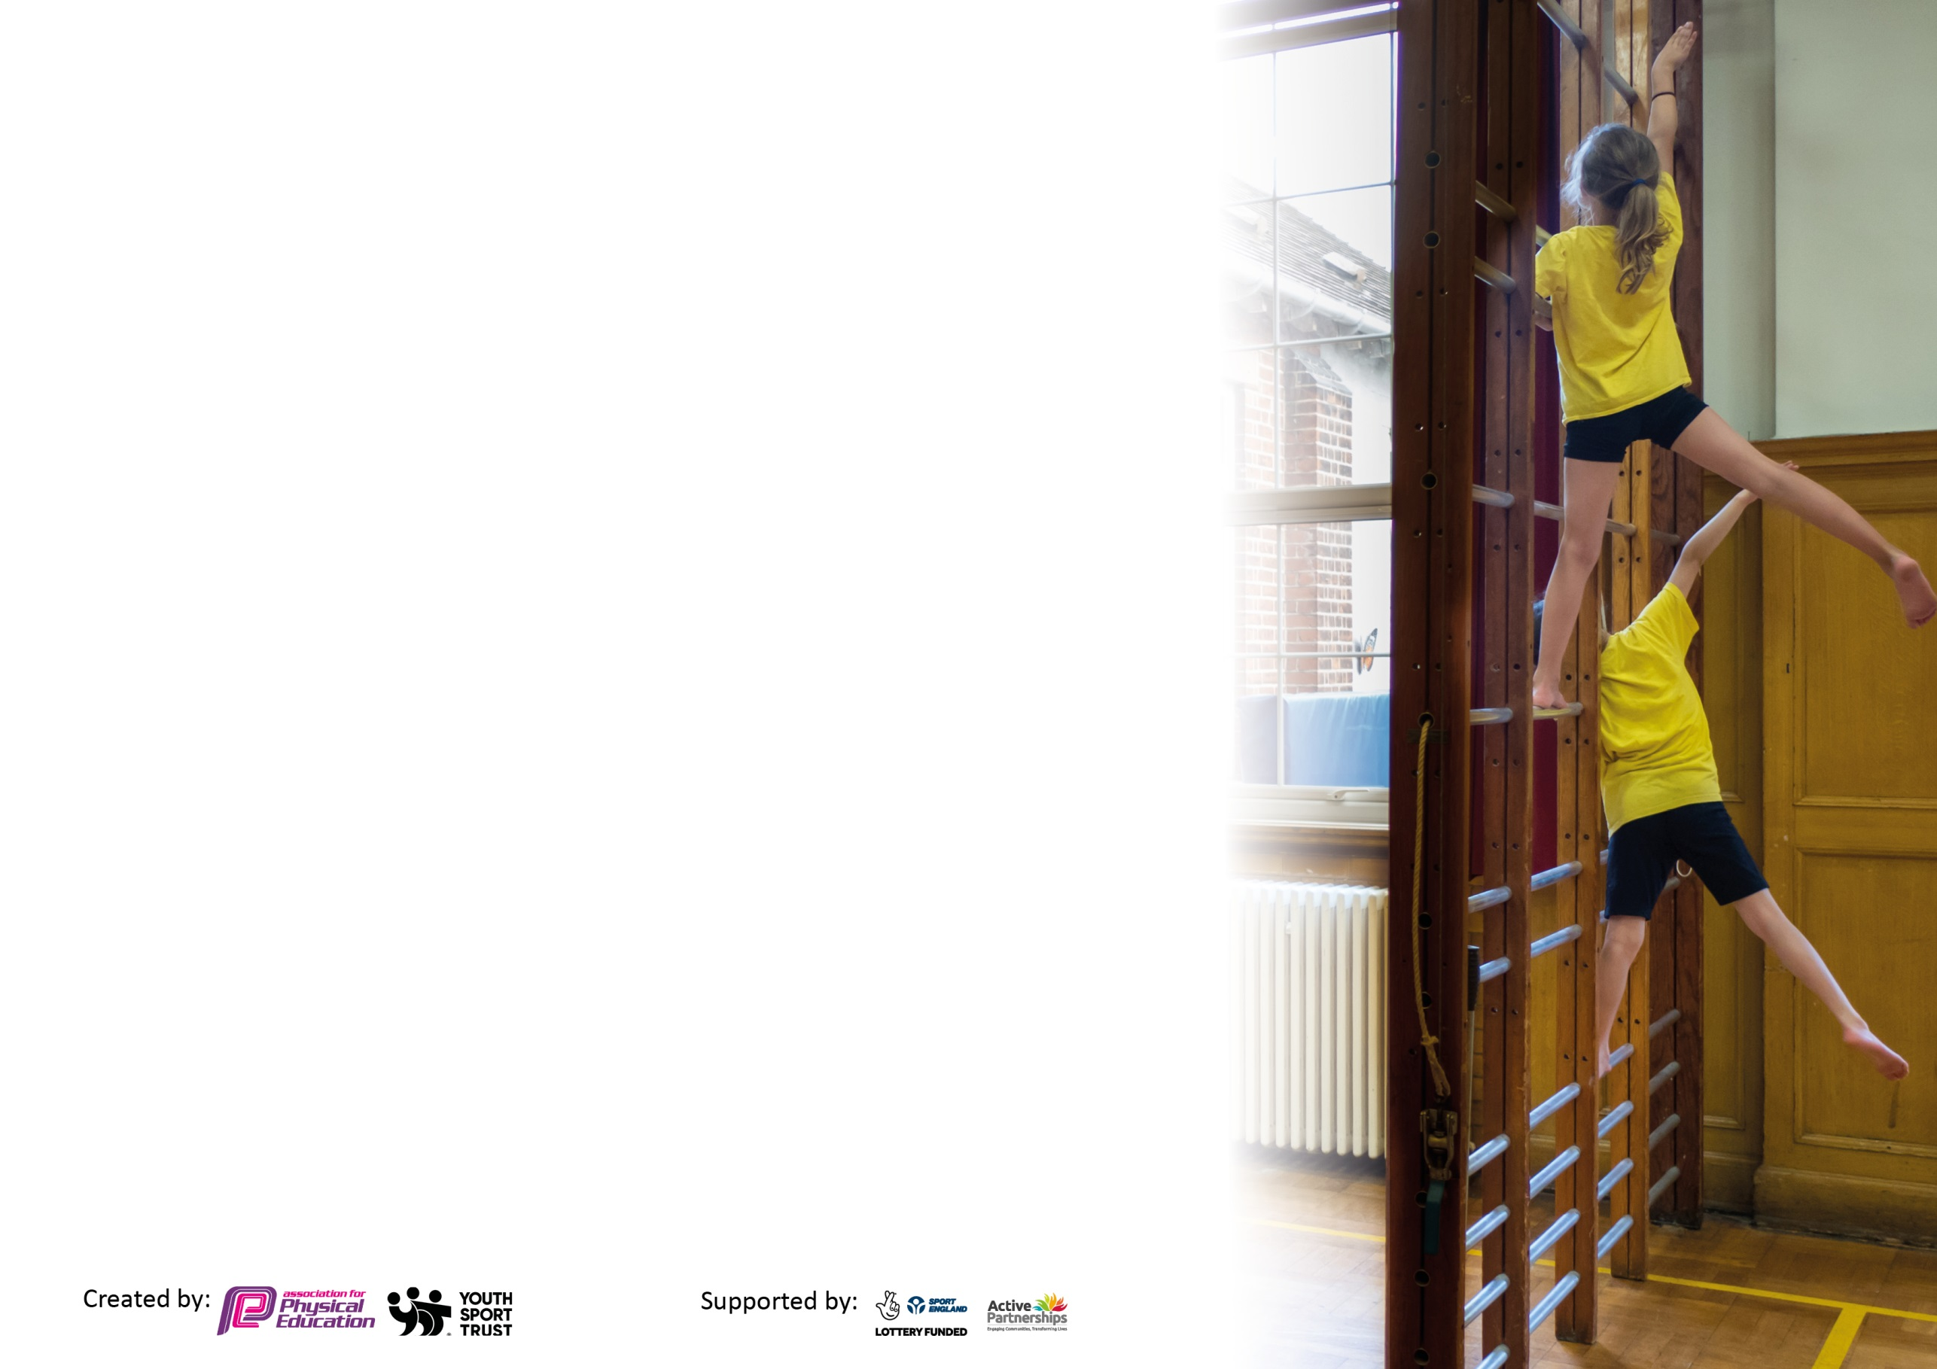
Please visit gov.uk for the revised DfE guidance including the 5 key indicators across which schools should demonstrate an improvement. This document will help you to review your provision and to report your spend. DfE encourages schools to use this template as an effective way of meeting the reporting requirements of the Primary PE and sport premium.

We recommend you start by reflecting on the impact of current provision and reviewing the previous spend.

Schools are required to publish details of how they spend this funding, including any under-spend from 2019/2020, as well as on the impact it has on pupils’ PE and sport participation and attainment by the end of the summer term or by 31st July 2021 at the latest.

We recommend regularly updating the table and publishing it on your website throughout the year. This evidences your ongoing self-evaluation of how you are using the funding to secure maximum, sustainable impact. Final copy must be posted on your website by the end of the academic year and no later than the 31st July 2021. To see an example of how to complete the table please click HERE.



Please note: Although there has been considerable disruption in 2020 it is important that you publish details on your website of how you spend the funding - this is a legal requirement.
Support for review and reflection - considering the 5 key indicators from DfE, what development needs are a priority for your setting and your pupils now and why? Use the space below to reflect on previous spend and key achievements and areas for development.

N.B. In this section you should refer to any adjustments you might have made due to Covid-19 and how these will influence further improvement.
Key achievements to date until July 2020: | Areas for further improvement and baseline evidence of need:
- Children have continued to be active during playtimes and lunchtimes, despite covid restrictions.
- Active learning encouraged through the daily mile and the Outdoor Orienteering course.

Did you carry forward an underspend from 2019-20 academic year into the current academic year? /NO * Delete as applicable
Total amount carried forward from 2019/2020 £.0
+ Total amount for this academic year 2020/2021 £10,691
= Total to be spent by 31st July 2021 £10,691

Meeting national curriculum requirements for swimming and water safety.

N.B Complete this section to your best ability. For example you might have practised safe self-rescue techniques on dry land which you can transfer to the pool when school swimming restarts.
Due to exceptional circumstances priority should be given to ensuring that pupils can perform safe self rescue even
if they do not fully meet the first two requirements of the NC programme of study.
What percentage of your current Year 6 cohort swim competently, confidently and proficiently over a distance of at least 25 metres?  N.B. Even though your pupils may swim in another year please report on their attainment on leaving primary school at the end of the summer term 2021.  Please see note above. | 93%
What percentage of your current Year 6 cohort use a range of strokes effectively [for example, front crawl, backstroke and breaststroke]?  Please see note above. | 61%
What percentage of your current Year 6 cohort perform safe self-rescue in different water-based situations? | 86%
Schools can choose to use the Primary PE and sport premium to provide additional provision for swimming but this must be for activity over and above the national curriculum requirements. Have you used it in this way? | No

Action Plan and Budget Tracking
Capture your intended annual spend against the 5 key indicators. Clarify the success criteria and evidence of impact that you intend to measure to evaluate for pupils today and for the future.

Academic Year: 2020/21 | Total fund allocated: £10,691 | Date Updated:30/6/21
Key indicator 1: The engagement of all pupils in regular physical activity – Chief Medical Officers guidelines recommend that primary school pupils undertake at least 30 minutes of physical activity a day in school |  |  |  | Percentage of total allocation:
 |  |  |  | %
Intent | Implementation |  | Impact
Your school focus should be clear what you want the pupils to know and be able to do and about  what they need to learn and to  consolidate through practice: | Make sure your actions to achieve are linked to your intentions: | Funding allocated: | Evidence of impact: what do pupils now know and what can they now do? What has changed?: | Sustainability and suggested next steps:
Continuation / extension of established successful programme of change for life, breakfast, lunchtime and after school activities. With the addition of more physical activity within lessons and during school in the form of the Daily Mile. | Sports Coaches to provide Breakfast club/Lunchtime Activities | (£1100) | Children fully engaged at lunchtimes in a range of activities.  Numbers from ASC registers.  Feedback from Children and Adults. | Continue to use Daily Mile to increase PA levels.  Continue to promote PA and benefits of an active school population.
Key indicator 2: The profile of PESSPA being raised across the school as a tool for whole school improvement |  |  |  | Percentage of total allocation:
 |  |  |  | %
Intent | Implementation |  | Impact
Your school focus should be clear what you want the pupils to know and be able to do and about  what they need to learn and to  consolidate through practice: | Make sure your actions to achieve are linked to your intentions: | Funding allocated: | Evidence of impact: what do pupils now know and what can they now do? What has changed?: | Sustainability and suggested next steps:
Using PE as a vehicle to be at the heart of British Values, supporting the whole school ethos. Whole school approach to PE & Swimming, and engagement in Physical Activity. | Sports Leaders (Crew) new leaders to be trained to support intra school sports comps / lunchtimes/Before School. Sports leaders to develop in school competitions and assist with the delivery of sports day and fitness club. | £160 | Year 5 children really enjoyed taking part in the training. | 20 year 5 Children fully trained as sports leaders. To be used next year as playground leaders. (Covid permitting)

Key indicator 3: Increased confidence, knowledge and skills of all staff in teaching PE and sport |  |  |  | Percentage of total allocation:
 |  |  |  | %
Intent | Implementation |  | Impact
Your school focus should be clear | Make sure your actions to | Funding | Evidence of impact: what do | Sustainability and suggested
what you want the pupils to know | achieve are linked to your | allocated: | pupils now know and what | next steps:
and be able to do and about | intentions: |  | can they now do? What has
what they need to learn and to |  |  | changed?:
consolidate through practice:
Continue to support staff confidence, competence and subject knowledge through CPD and improved access to resources. | Re-new license for PE Passport planning and assessment tool  Continue to audit and replenish PE equipment, using the sports leaders and staff to identify need for new equipment.  Manchester City to deliver curriculum sessions 1 day per week in EYFS/Y1-Y6 to increase staff Knowledge & Confidence within PE. | £300 (PE Passport)  (£800)  (£5745) | License for PE Passport has been renewed. This allows teachers in all years to have access to a range of planning that link directly from the curriculum and aims to improve children's physical literacy from EYFS to Year 6.  Teachers were asking prior to renewal if they felt the sessions benefitted their own knowledge and confidence. All teachers said it did. | Extend knowledge and understanding by continuing to train staff using the App.  Subject leader to have time to team teach and observe. Teachers will also benefit from observing in MCFC sessions.
Key indicator 4: Broader experience of a range of sports and activities offered to all pupils |  |  |  | Percentage of total allocation:
 |  |  |  | %
Intent | Implementation |  | Impact
Your school focus should be clear | Make sure your actions to | Funding | Evidence of impact: what do | Sustainability and suggested
what you want the pupils to know | achieve are linked to your | allocated: | pupils now know and what | next steps:
and be able to do and about | intentions: |  | can they now do? What has
what they need to learn and to |  |  | changed?:
consolidate through practice:
Additional achievements:

Key indicator 5: Increased participation in competitive sport |  |  |  | Percentage of total allocation:
 |  |  |  | %
Intent | Implementation |  | Impact
Your school focus should be clear | Make sure your actions to | Funding | Evidence of impact: what do | Sustainability and suggested
what you want the pupils to know | achieve are linked to your | allocated: | pupils now know and what | next steps:
and be able to do and about | intentions: |  | can they now do? What has
what they need to learn and to |  |  | changed?:
consolidate through practice:

Signed off by
Head Teacher: | Steve Wheeldon
Date: | 30.6.21
Subject Leader: | Pat Eccles
Date: | 30.6.21
Governor:
Date:

