We will continue to work on managing our emotions, using the Zones of Regulation strategies.
Sunshine Class
Autumn 2 overview

Reading, writing and communication
We will each continue to work on our targets for reading, writing and communication. We will be supported by our adults to make progress, through 1:1 and small group sessions, tailored to our own ability and potential. Adults will use visuals alongside verbal communication, to help our understanding. Early reading and writing skills will include mark making, sensory writing, pre-writing, Read Write Inc strategies (phonics and writing), where appropriate.

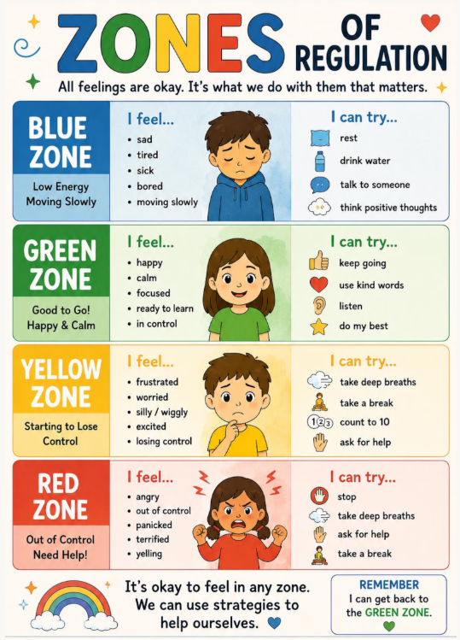
In music and movement, we will follow a series of lessons called, “Our land” and learn action songs related to our topic.

For our topic we will -
continue to base our learning on the book, “Here we are.” By Oliver Jeffers. As we read the book, we will continue to learn about the aspects of living on planet Earth that it addresses. We will look at the creatures that can be found under the sea, we will learn about towns/cities and the countryside and we will learn about ways to care for our planet.
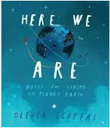
These aspects will link to our learning in Science and PSHE.
In Personal, Social, Health and Economic Education (PSHE) – We will continue our friendship topic, through stories and rhymes and be supported by our adults to form positive friendships with our peers.
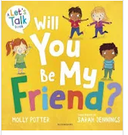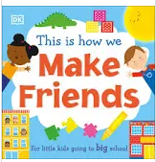
Dates: Term ends: Friday 18th December 2025 at 1:15
For our Maths development we will be-
working on our individual targets with an adult. We will continue to enjoy number songs and rhymes.
As a class, we will continue to work on our knowledge of number and work on ordering and sorting.
In the provision throughout the day, we will continue to practise our knowledge, ordering numbers and playing number games and completing number puzzles.
We will practise our sorting skills by sorting objects according to colour, shape and size.

