Reception Autumn 1 - Our theme this half term is Friendship
Other
Please remember to label all your child’s clothes.
Book bags need to be in every Monday for book change. These will given to the children on Monday 7th September
Please bring in a bottle of water each day.
Term ends on Thursday 22nd October
Maths
The children will be further developing subitising and counting skills. They will explore the composition of numbers within 5. 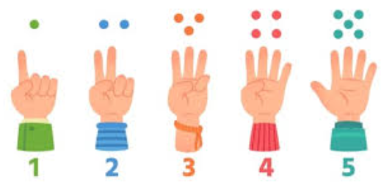
We will also be exploring patterns and what patterns the children can notice asking them to explain this.
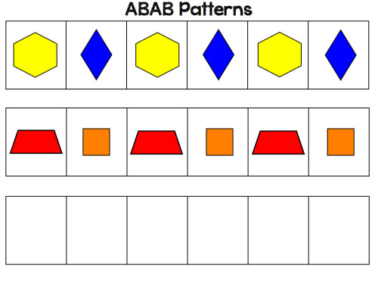
Literacy
We will starting our new RWInc phonics this half term. Where we will begin to learn the sounds, the letters make. There will be weekly videos for your child to watch to help support this.
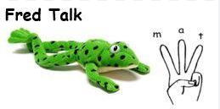
We will be reading Friendship bench and Amazing as our focus texts this half term.
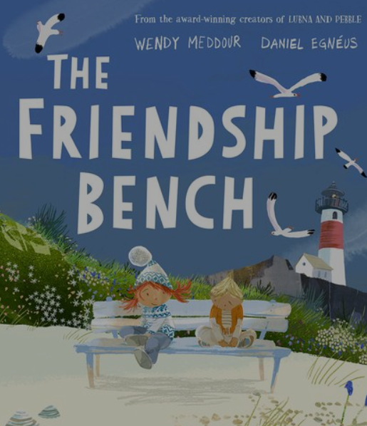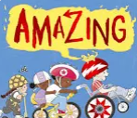

Physical development
Our PE sessions will be on a Monday.
Please ensure your child is wearing suitable clothing for that day. It does not need to be school uniform.
Joggers, leggings, shorts
Trainers
T-shirt, jumper or zip up
We will be outside for some of these sessions.
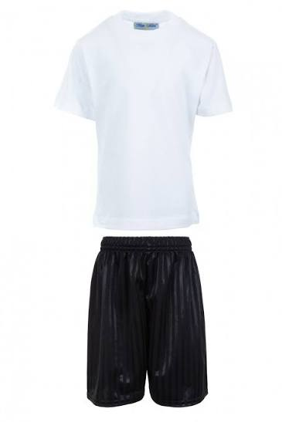
Expressive Arts and design
We will be exploring ways of drawing ourselves this half term using a range of resources.
