,
EYFS: Reception Sequenced Curriculum - 2025 to 2026
New EYFS Framework
Area of Learning | Autumn 1  Friendship | Autumn 2  Celebrations |  | Spring 1  Animals Living in Cold Places | Spring 2  Animals Living in Hot Places | Summer 1  Growing |  | Summer 2  Journeys
Other Possible Themes | Settling In Family  Our Community | Fire/Firefighters Bonfire Night  Celebrations |  | Arctic Animals  Transport | Jungle | Planting/Gardening Spring |  | Transport  Vehicles
Planning around a quality text: | 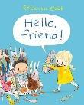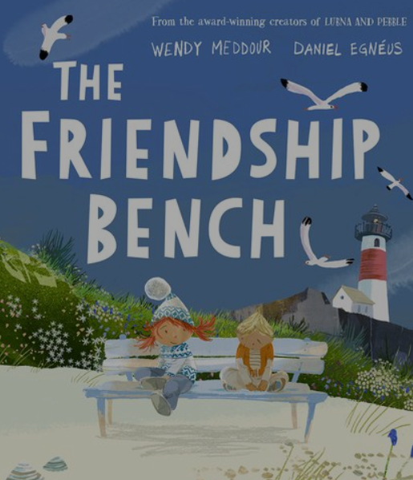 | 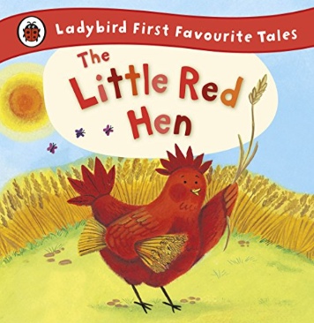  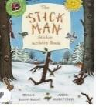 |  | 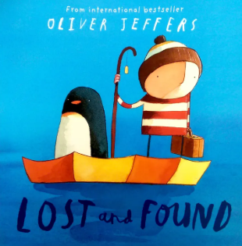 | 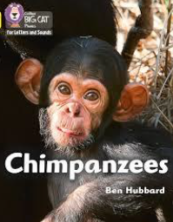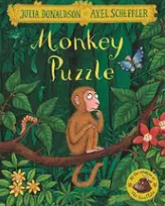 | 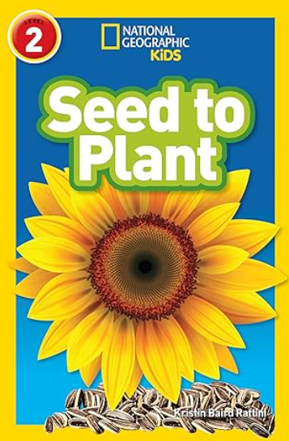  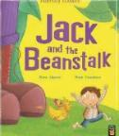 |  | 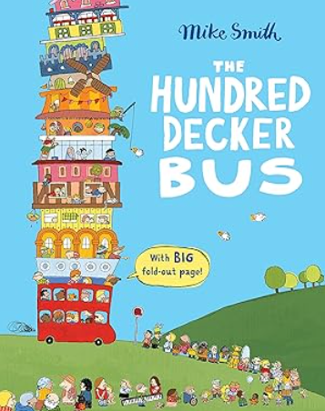
Linked texts | - We all have Different Families- Melissa Higgins  - All are Welcome- Alexandra Penfold  - Mixed- Arree Chung  - The Colour Monster-Anna Llenas | - Leaf Man- Lois Elhert  - Diwali–  Nancy Dickmann  - Bonfire Night- Nancy Dickmann  - The Nativity Story |  | - We Love Chinese New Year-  Saviour Pirotta and Camilla Lloyd | - Jazzy in the Jungle – Lucy Cousins  - Leap Frog – Jane Clarke- Alexandra Penfold  - Chimp and Zee – Laurence Anholt  - ▪ Rumble in the Jungle – Giles Andreae | - The Tiny Seed- Eric Carle  - The Extraordinary Gardener- Sam Boughton  - What can you see in Spring? Sian Smith |  | - The Hundred Decker Rocket – Mike Smith  - Naughty Bus – Jan and Jerry Oke  - You Can’t Take an Elephant on a Bus – Patricia Cleveland-Peck  - Martha Maps It Out – Leigh Hodgkinson
Trips/Visitors  Enrichments | - Local Area- Walk around the block | - Wythenshawe Park- Farm Visit |  | - Trip to China Town |  | - Park Trip |  | - Forest School Trip
Stay and Play | Stay and Meet the Staff | Stay and Sing Carols |  | Stay and Forest School  Bedtime Story | Stay and Present | Stay and Plant |  | Stay and Celebrate
Celebrations / Festivals / Special Events | - Black History Month  - Harvest Festival (5th October)  - Diwali (20th October)  - Halloween (31s October- during half term) | - Bonfire Night (5th Novemver)  - Remembrance Day (11th November)  - Christmas |  | - Big Garden Bird Watch (January)  - Penguin Awareness Day (20th January)  - Safer Internet Day (10th February)  - Valentines Day (14th February)  - Pancake Day (17th February)  - Lunar New Year (17th February)  - Ramadan (17th Feb-21st March) | - Ramadan (17th Feb-21st March)  - World Book Day (5th March)  - Mothers Day (15th March)  - Eid al-Fitr- TBC  - Easter (3rd-5th April) | - Mental Health Awareness Week (11-17th May)  - Eid-al-Adha-TBC |  | - Father Day  - Sports Day  - Reception celebration with parents
Art Focus/Artist | Drawing- Self-portraits |  |  | DT-Food | Colour, Pattern and Printing- Paul Klee | DT- Food |  | Form- Clay Models
Forest School | All about Me | 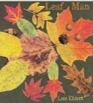  Exploring Autumn |  | 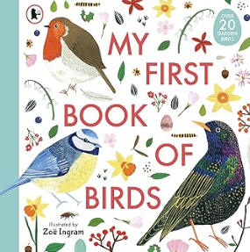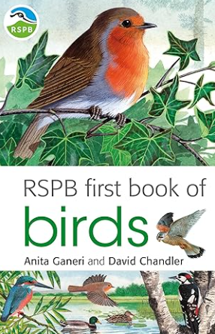  Birds | 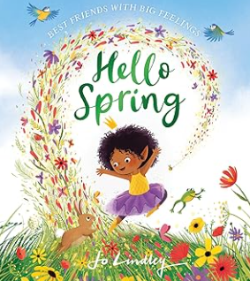Exploring Spring | 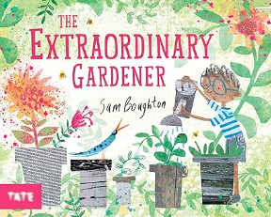  Planting/Growing |  | Moving On
COMMUNICATION & LANGUAGE: □ Listening, Attention & Understanding □ Speaking
Educational Programme: The development of children’s spoken language underpins all seven areas of learning and development. Children’s back-and-forth interactions from an early age form the foundations for language and cognitive development. The number and quality of the conversations they have with adults and peers throughout the day in a language-rich environment is crucial. By commenting on what children are interested in or doing, and echoing back what they say with new vocabulary added, practitioners will build children's language effectively. Reading frequently to children, and engaging them actively in stories, non-fiction, rhymes and poems, and then providing them with extensive opportunities to use and embed new words in a range of contexts, will give children the opportunity to thrive. Through conversation, story-telling and role play, where children share their ideas with support and modelling from their teacher, and sensitive questioning that invites them to elaborate, children become comfortable using a rich range of vocabulary and language structures.

Autumn |  |  | Spring |  |  |  | Summer
Learning Priorities: Linked to Development Matters 2021
Listening, Attention and Understanding  - Understand a question or instruction that has two parts  - Daily routines e.g. tidy up time, challenges… instruction  - Understand ‘why’ questions  - Why do you think he/she feels…?  - Understand how to listen carefully and why listening is important  - Learn new vocabulary linked to daily routine / theme  - See UW: □ Me and My Family □ Autumn □ Celebrations  - Begin to engage in story time  - Join in with repeated refrains / fill in rhyming words  - Listen to and begin to talk about stories to build familiarity and understanding  - Discuss characters, events, setting … character, happened  - Listen carefully to rhymes and songs and begin to pay attention to how they sound  - Learn rhymes, songs & poems  - Anticipate words, begin to adapt phrases (with support)  Speaking  - Use new vocabulary throughout the day  - Begin to ask questions to find out more and to check they understand what has been said to them  - Model & encourage questions after instructions  - Begin to articulate their ideas and thoughts in well-formed sentence  - Express □ Ideas to friends □ Book talk  - Begin to connect one idea or action to another using a range of connectives… because, although, but..  - Begin to describe events in some detail  - Develop social phrases  - Routines of the day … greetings, How are you?  - Friendship … Would you like to…?  - Begin to retell a simple story, once they have developed a deep familiarity with the text; some as exact repetition and some in their own words  - Focused & linked texts – within small world / role play |  |  | Listening, Attention and Understanding  - Hold conversation when engaged in back-and-forth exchanges with their teacher and peers.  - Listen carefully to and learn rhymes, poems and songs  - Listen to and talk about stories to build familiarity and understanding  - Begin to listen to and talk about non-fiction books, developing a familiarity with new knowledge and vocabulary  - Begin to understand humour e.g. nonsense rhymes / jokes  Speaking  - Use new vocabulary in different contexts  - Ask questions to find out more and to check they understand what has been said to them  - Articulate their ideas & thoughts in well-formed sentence  - Connect one idea or action to another using a range of connectives  - Describe events in some detail  - Use talk to help work out problems, organise thinking & activities explain how things work/why things happen  - Develop and use social phrases with confidence  - Retell a simple story, once they have developed a deep familiarity with the text; some as exact repetition and some in their own words |  |  |  | Listening, Attention and Understanding  - Listen attentively and respond to what they hear with relevant questions, comments and actions when being read to and during whole class discussions and small group interactions  - Make comments about what they have heard and ask questions to clarify their understanding  - Hold conversation when engaged in back-and-forth exchanges with their teacher and peers.  - Understand humour more readily e.g. nonsense rhymes/jokes  Speaking  - Participate in small group, class and one-to-one discussions, offering their own ideas, using recently introduced vocabulary;  - Offer explanations for why things might happen, making use of recently introduced vocabulary from stories, non-fiction, rhymes and poems when appropriate;  - Express their ideas and feelings about their experiences using full sentences, including use of past, present and future tenses and making use of conjunctions, with modelling and support from their teacher.
PERSONAL, SOCIAL & EMOTIONAL DEVELOPMENT: □ Self-Regulation □ Managing Self □ Building Relationships
Educational Programme: Children’s personal, social and emotional development (PSED) is crucial for children to lead healthy and happy lives, and is fundamental to their cognitive development. Underpinning their personal development are the important attachments that shape their social world. Strong, warm and supportive relationships with adults enable children to learn how to understand their own feelings and those of others. Children should be supported to manage emotions, develop a positive sense of self, set themselves simple goals, have confidence in their own abilities, to persist and wait for what they want and direct attention as necessary. Through adult modelling and guidance, they will learn how to look after their bodies, including healthy eating, and manage personal needs independently. Through supported interaction with other children, they learn how to make good friendships, co-operate and resolve conflicts peaceably. These attributes will provide a secure platform from which children can achieve at school and in later life.

Autumn |  |  | Spring |  |  |  | Summer
Learning Priorities: Linked to Development Matters 2021
Self-Regulation  - Talk with others to solve conflicts. Help to find solutions to conflicts and rivalries … fair, agree, turns, together, share  - How to compromise and negotiate to solve problems  - Use □ book talk □ puppets □ real life experiences  - Begin to express feelings and consider the feelings of others  - Identify and name emotions … emotion, lonely, sad/happy, confident, pleased, frightened, angry, confused, disappointed, nervous/worried, excited  - Link book character’s emotion to own experiences … expression, mood, feeling/emotion  - Begin to set own goals and show resilience and perseverance in the face of challenge  - Set a shared goal with a friend  - Begin to identify and moderate own feelings socially and emotionally  - Focus on □ keeping calm □ being patient □ waiting for a turn □ sharing □ tidying up after themselves  Managing Self  - Manage own self-care needs … fasten  - Independent use of □ zips □ buttons □ coats □ shoes  - Develop confidence to try new activities and show independence  - Access all types of enhancements (indoors & outdoors)  - Know and begin to talk about the different factors that support their overall health and wellbeing:  - Toothbrushing – importance and how … clean, decay  - Talk about importance of daily exercise and healthy eating … exercise, healthy / unhealthy, heartbeat, fit  Building Relationships  - Begin to see self as a valuable individual  - Describe self, positively … proud, special, love (use books: ‘Happy in Our Skin’ & ‘My Hair’)  - Begin to build constructive and respectful relationships  - Use social language to develop friendships see CL |  |  | Self-Regulation  - Express feelings and consider the feelings of others  - Set own goals and show resilience and perseverance in the face of challenge  - Identify and moderate own feelings socially and emotionally  - Think about the perspectives of others  Managing Self  - Manage own self-care needs  - Know and talk about the different factors that support their overall health and wellbeing: □ sensible amounts of ‘screen time’ □ having a good sleep routine □ being a safe pedestrian  Building Relationships  - See self as a valuable individual  - Build constructive and respectful relationships |  |  |  | Self-Regulation  - Show an understanding of their own feelings and those of others, and begin to regulate their behaviour accordingly  - Set and work towards simple goals, being able to wait for what they want and control their immediate impulses when appropriate  - Give focused attention to what the teacher says, responding appropriately even when engaged in activity, and show an ability to follow instructions involving several ideas or actions.  Managing Self  - Be confident to try new activities and show independence, resilience and perseverance in the face of challenge  - Explain the reasons for rules, know right from wrong and try to behave accordingly  - Manage their own basic hygiene and personal needs, including dressing, going to the toilet and understanding the importance of healthy food choices.  Building Relationships  - Work and play cooperatively and take turns with others  - Form positive attachments to adults and friendships with peers  - Show sensitivity to their own and to others’ needs.  - Continue to see self as a valuable individual
PHYSICAL DEVELOPMENT: □ Gross Motor Skills □ Fine Motor Skills
Educational Programme: Physical activity is vital in children’s all-round development, enabling them to pursue happy, healthy and active lives. Gross and fine motor experiences develop incrementally throughout early childhood, starting with sensory explorations and the development of a child’s strength, co-ordination and positional awareness through tummy time, crawling and play movement with both objects and adults. By creating games and providing opportunities for play both indoors and outdoors, adults can support children to develop their core strength, stability, balance, spatial awareness, co-ordination and agility. Gross motor skills provide the foundation for developing healthy bodies and social and emotional well-being. Fine motor control and precision helps with hand-eye co-ordination which is later linked to early literacy. Repeated and varied opportunities to explore and play with small world activities, puzzles, arts and crafts and the practise of using small tools, with feedback and support from adults, allow children to develop proficiency, control and confidence.

Autumn |  |  | Spring |  |  |  | Summer
Learning Priorities: Linked to Development Matters 2021
Gross Motor Skills  - Revise and refine the fundamental movement skills they have already acquired: - rolling - crawling - walking - jumping - running - hopping - skipping – climbing  - Engage in and develop confidence in actions  - Begin to develop overall body-strength, balance, co-ordination and agility.  - Use above actions, within obstacle courses … balance, obstacle, spatial, prepositions  - Set own physical challenge … challenge, goal  - Begin to use their core muscle strength to achieve a good posture when sitting at a table or sitting on the floor … straight, upright, flat  - Begin to combine different movements with ease and fluency  - See above obstacle course  - Change movements / directions quickly  - Begin to confidently and safely use a range of large and small apparatus indoors and outside, alone and in a group  - Understand rules and reasons  - Further develop and refine a range of ball skills including: throwing, catching, kicking  - Use different sizes / types of balls – in pairs  - Further develop the skills they need to manage the school day successfully: □ lining up and queuing □ mealtimes □ personal hygiene  Fine Motor Skills  - Use a comfortable grip with good control when holding pens and pencils  - Consolidate tripod grip  - Continue to develop small motor skills so that they can use a range of tools competently, safely and confidently. Suggested tools: pencils for drawing and writing, paintbrushes, scissors, knives, forks and spoons  - Ensure regular engagement and develop confidence in use of tools… grip, steady, snip, twist, curve, straight |  |  | Gross Motor Skills  - Continue to refine the fundamental movement skills they have already acquired: - rolling - crawling - walking - jumping - running - hopping - skipping – climbing  - Begin to progress towards a more fluent style of moving, with developing control and grace  - Develop overall body-strength, balance, co-ordination and agility.  - Use their core muscle strength to achieve a good posture when sitting at a table or sitting on the floor  - Combine different movements with ease and fluency  - Confidently and safely use a range of large and small apparatus indoors and outside, alone and in a group  - Further develop and refine a range of ball skills including: passing, batting and aiming  Fine Motor Skills  - Develop small motor skills so that they can use a range of tools competently, safely and confidently. Suggested tools: pencils for drawing and writing, paintbrushes, scissors, knives, forks and spoons  - Begin to develop the foundations of handwriting style which is fast, accurate and efficient, consolidating:  - Effective pencil grip  - Correct letter formation (see Writing) |  |  |  | Gross Motor Skills  - Negotiate space and obstacles safely, with consideration for themselves and others  - Demonstrate strength, balance and coordination when playing  - Move energetically, such as running, jumping, dancing, hopping, skipping and climbing.  Fine Motor Skills  - Hold a pencil effectively in preparation for fluent writing – using the tripod grip in almost all cases  - Use a range of small tools, including scissors, paint brushes and cutlery  - Begin to show accuracy and care when drawing.
LITERACY: □ Reading - Comprehension □ Reading - Word Reading □ Writing
Educational Programme: It is crucial for children to develop a life-long love of reading. Reading consists of two dimensions: language comprehension and word reading. Language comprehension (necessary for both reading and writing) starts from birth. It only develops when adults talk with children about the world around them and the books (stories and non-fiction) they read with them, and enjoy rhymes, poems and songs together. Skilled word reading, taught later, involves both the speedy working out of the pronunciation of unfamiliar printed words (decoding) and the speedy recognition of familiar printed words. Writing involves transcription (spelling and handwriting) and composition (articulating ideas and structuring them in speech, before writing).

Autumn |  |  | Spring |  |  |  | Summer
Learning Priorities: Linked to Development Matters 2021
Reading: Comprehension / Word Reading  - Begin to retell simple stories and narratives using their own words and some recently introduced vocabulary.  - Recall key events … event  - Talk about main characters… character, beginning, middle, end  - Begin to re-read books to build up their confidence in word reading, their fluency and their understanding and enjoyment  - Understand the five key concepts about print, with a focus on  - Left to right  - 1-1 correspondence … word, letter, first / last  - Continue to develop P1 phonological awareness, focusing on  - Rhythm & rhyme; alliteration (initial sounds); oral blending and segmenting … blending, segmenting  Writing:  - Write name correctly  - Use correct letter formation  - Use some of their print and letter knowledge in their early writing  - Begin to form lower-case letters correctly  - Begin to spell words by identifying the sounds and then writing the sound with letter/s, using known GPCs … spell  - Use □ initial sounds □ VC □ CVC words  - Write labels  - Begin to write lists & captions, focusing on …label, caption, space  - Oral rehearsal / vocabulary  - Begin to reread what they have written |  |  | Reading: Comprehension / Word Reading  - Begin to use and understand some recently introduced vocabulary during discussions about stories, non-fiction, rhymes and poems and during role play…fiction, non-fiction, set  - Retell story in small world / role play (in correct sequence) …beginning, middle, end, set  - Take on role of character using some story language  - Talk about likes and dislikes of texts, rhymes and poems  - Choose a book and begin to explain why …because  - Begin to anticipate - where appropriate - some key events in stories …predict / prediction  - Re-read books to build up their confidence in word reading, their fluency and their understanding and enjoyment  - Continue to develop P1 phonological awareness, focusing on  - Oral blending and segmenting  Writing:  - Form most lower-case and capital letter correctly  - Spell words by identifying the sounds and then writing the sound with letter/s, using taught GPCs - CVC words  - Write captions/phrases and begin to write simple sentences using known GPCs …sentence, full stop, capital letter  - Include word spacing  - Orally rehearse caption of sentence before writing  - Re-read what they have written to make sure it makes sense  - Begin to write a variety of □ fiction and non-fiction sentences / captions |  |  |  | Reading: Comprehension / Word Reading  - Continue to develop P1 phonological awareness  - Oral blending and segmenting  - Demonstrate an understanding of what has been read to them by retelling stories and narratives using their own words and recently introduced vocabulary …sequence  - Anticipate-where appropriate-key events in stories.  - Use and understand recently introduced vocabulary during discussions about stories, non-fiction, rhymes and poems and during role play.  - Begin to notice some relationships between one text and another  - Begin to comment on perceived links with own life experience or other experiences, e.g. films, books  - Say the sound for each letter of the alphabet and for at least 10 digraphs  Writing:  - Write recognisable letters (lower case and capital) most of which are formed correctly  - Spell words by identifying the sounds and then writing the sound with letter/s, using taught GPCs  - CVC words  - Write simple phrases and sentences that can be read by others  - Including: □ oral rehearsal of sentence before writing □ word spacing □ full stop □ capital letter  - Begin to sequence 2-3 sentences within purposeful fiction/ non-fiction writing, such as:  - 2-3 part story (e.g. using story map/planner)  - Instructions  - Fact cards (e.g. using a ‘spidergram’ to collate information)
Phonics: Children will be assessed at the end of September and placed in a phonics group to match their ability. They then follow RWI at their own pace throughout the year. Children are assessed frequently and regrouped if necessary.

MATHEMATICS: □ Numerical Pattern □ Number
Educational Programme: Developing a strong grounding in number is essential so that all children develop the necessary building blocks to excel mathematically. Children should be able to count confidently, develop a deep understanding of the numbers to 10, the relationships between them and the patterns within those numbers. By providing frequent and varied opportunities to build and apply this understanding - such as using manipulatives, including small pebbles and tens frames for organising counting - children will develop a secure base of knowledge and vocabulary from which mastery of mathematics is built. In addition, it is important that the curriculum includes rich opportunities for children to develop their spatial reasoning skills across all areas of mathematics including shape, space and measures. It is important that children develop positive attitudes and interests in mathematics, look for patterns and relationships, spot connections, ‘have a go’, talk to adults and peers about what they notice and not be afraid to make mistakes.

Autumn |  |  | Spring |  |  |  | Summer
Following NCETM Mastering Number as well as Learning Trajectories and Development Matters
Numerical Pattern / Number  - Subitising  - Subitise within 5, perceptually and conceptually, depending on the arrangements  - create their own patterns for numbers within 4  - practise using their fingers to represent quantities which they can subitise  - experience subitising in a range of contexts, including temporal patterns made by sounds.  - Cardinality, ordinality and counting  - relate the counting sequence to cardinality, seeing that the last number spoken gives the number in the entire set  - have opportunities to develop an understanding that anything can be counted, including actions and sounds  - explore a range of strategies which support accurate counting.  - explore the cardinality of 5, linking this to dice patterns and 5 fingers on 1 hand  - begin to count beyond 5  - begin to recognise numerals, relating these to quantities they can subitise and count.  - Composition  - see that all numbers can be made of 1s  - explore the concept of ‘wholes’ and ‘parts’ by looking at a range of objects that are composed of parts, some of which can be taken apart and some of which cannot  - explore the composition of numbers within 5  - Comparison  - understand that sets can be compared according to a range of attributes, including by their numerosity  - use the language of comparison, including ‘more than’ and ‘fewer than’  - compare sets using a variety of strategies, including ‘just by looking’, by subitising and by matching  - compare sets by matching, seeing that when every object in a set can be matched to one in the other set, they contain the same number and are equal amounts.  Shape, Space & Measure  - Pattern ABAB, ABC- copy, continue, fix  - 2D shapes – triangles, quadrilaterals, composing and decomposing shapes- |  |  | Numerical Pattern / Number  - Subitising  - increase confidence in subitising by continuing to explore patterns within 5, including structured and random arrangements  - explore a range of patterns made by some numbers greater than 5, including structured patterns in which 5 is a clear part  - experience patterns which show a small group and ‘1 more’  - continue to match arrangements to finger patterns.  - explore symmetrical patterns, in which each side is a familiar pattern, linking this to ‘doubles’.  - Cardinality, ordinality and counting  - continue to develop verbal counting to 20 and beyond  - continue to develop object counting skills, using a range of strategies to develop accuracy  - continue to link counting to cardinality, including using their fingers to represent quantities between 5 and 10  - order numbers, linking cardinal and ordinal representations of number  - continue to consolidate their understanding of cardinality, working with larger numbers within 10  - become more familiar with the counting pattern beyond 20.  - Composition  - continue to explore the composition of 5 and practise recalling ‘missing’ or ‘hidden’ parts for 5  - explore the composition of 6, linking this to familiar patterns, including symmetrical patterns  - begin to see that numbers within 10 can be composed of ‘5 and a bit’.  - explore the composition of odd and even numbers, looking at the ‘shape’ of these numbers  - begin to link even numbers to doubles  - begin to explore the composition of numbers within 10.  - Comparison  - continue to compare sets using the language of comparison, and play games which involve comparing sets  - continue to compare sets by matching, identifying when sets are equal  - explore ways of making unequal sets equal.  - compare numbers, reasoning about which is more, using both an understanding of the ‘howmanyness’ of a number, and its position in the number system.  Shape, Space & Measure  - 3D Shapes  - Position |  |  |  | Numerical Pattern / Number  - Subitising  - continue to practise increasingly familiar subitising arrangements, including those which expose ‘1 more’ or ‘doubles’ patterns  - use subitising skills to enable them to identify when patterns show the same number but in a different arrangement, or when patterns are similar but have a different number  - subitise structured and unstructured patterns, including those which show numbers within 10, in relation to 5 and 10  - be encouraged to identify when it is appropriate to count and when groups can be subitised.  - Cardinality, ordinality and counting  - continue to develop verbal counting to 20 and beyond, including counting from different starting numbers  - continue to develop confidence and accuracy in both verbal and object counting.  - Composition  - explore the composition of 10.  - Comparison  - order sets of objects, linking this to their understanding of the ordinal number system.  Shape, Space & Measure  - Comparing length  - Comparing weight/capacity

UNDERSTANDING THE WORLD □ Past and Present (KS1: History) □ People, Culture & Communities (KS1: R.E / Geography) □ Natural World (KS1: Geography / Science)

EYFS Educational Programme: Understanding the world involves guiding children to make sense of their physical world and their community. The frequency and range of children’s personal experiences increases their knowledge and sense of the world around them – from visiting parks, libraries and museums to meeting important members of society such as police officers, nurses and firefighters. In addition, listening to a broad selection of stories, non-fiction, rhymes and poems will foster their understanding of our culturally, socially, technologically and ecologically diverse world. As well as building important knowledge, this extends their familiarity with words that support understanding across domains. Enriching and widening children’s vocabulary will support later reading comprehension.

Autumn | Spring | Summer
Learning Priorities: Linked to Development Matters 2021
Past and Present  - Begin to make sense of their own life-story and family’s history  - Begin to comment on images of familiar situations in the past  - When Mum and Dad were little … past, history, long ago  People, Culture & Communities  - Talk about members of their immediate family and community  - Describe family members … grandparent, older, younger  - Understand that there are many different types of families …parent, step-sister / brother / mum / dad, similar, different  - Name and describe people who are familiar to them  - People in their local / school community… site manager, office manager, lolly pop person, shop keeper  - Begin to understand that some places are special to members of their community  - Talk about special places they go with their family… places of worship visited by children  - Begin to recognise that people have different beliefs and celebrate special times in different ways  - Understand how different people celebrate birthdays  - Develop a knowledge and awareness of other festivals … Harvest, Diwali, Christmas  Natural World  - Explore the natural world around them  - Leaves □ sort by shape/size □ begin to identify some local tree species … nature, natural  - Describe what they see, hear and feel whilst outside  - Leaf shape, size & colour… shape and colours words e.g. long, spiky, gold, rust, orange  - Understand the effect of changing seasons on the natural world around them – Autumn into Winter  - Observe / talk about changing □ seasons … season, summer, autumn, winter □ changes in autumn … temperature, change, hibernation, darker, weather, wind  * Develop interest in linked: □ texts across themes, fiction and non-fiction □ sources of technological information | Past and Present  - Comment on images of familiar situations in the past  People, Culture & Communities  - Talk about members of their immediate family and community  - Name and describe people who are familiar to them  - Understand that some places are special to members of their community  - Recognise that people have different beliefs and celebrate special times in different ways  - Recognise some similarities and differences between life in this country and other countries  Natural World  - Explore the natural world around them  - Describe what they see, hear and feel whilst outside  - Understand the effect of changing seasons on the natural world around them  * Continue to develop interest in linked: □ texts across themes, fiction and non-fiction □ sources of technological information | Past and Present  - Talk about the lives of the people around them and their roles in society  - Know some similarities and differences between things in the past and now, drawing on their experiences and what has been read in class  - Understand the past through settings, characters and events encountered in books read in class and storytelling.  People, Culture & Communities  - Describe their immediate environment using knowledge from observation, discussion, stories, non-fiction texts and maps  - Know some similarities and differences between different religious and cultural communities in this country, drawing on their experiences and what has been read in class  - Explain some similarities and differences between life in this country and life in other countries, drawing on knowledge from stories, non-fiction texts and – when appropriate – maps.  Natural World  - Explore the natural world around them, making observations and drawing pictures of animals and plants  - Know some similarities and differences between the natural world around them and contrasting environments, drawing on their experiences and what has been read in class  - Understand some important processes and changes in the natural world around them, including the seasons and changing states of matter.  * Continue to develop interest in linked: □ texts across themes, fiction and non-fiction □ sources of technological information

