Dates –
Term ends - Friday 17th July 1.15pm
To help us communicate and manage our feelings, we will continue to use the Zones of Regulation framework.
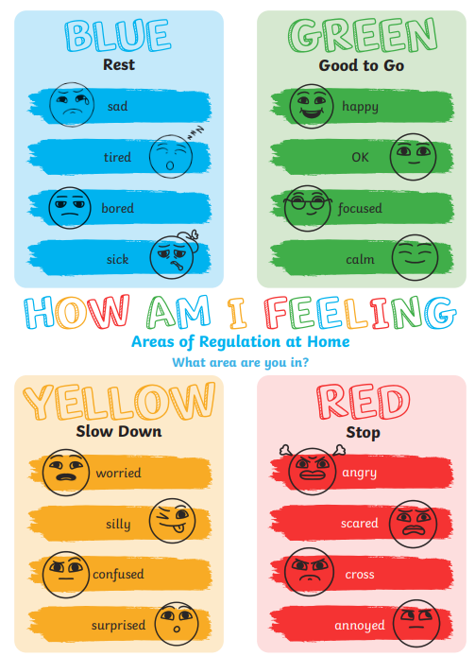
Our science topic this term is “Hot and Cold”. We will be learning what hot and cold mean and relating the meaning of the words to the weather, hot and cold places, animals that live in hot and cold places and the things we eat and the clothes we wear when it’s hot or cold.
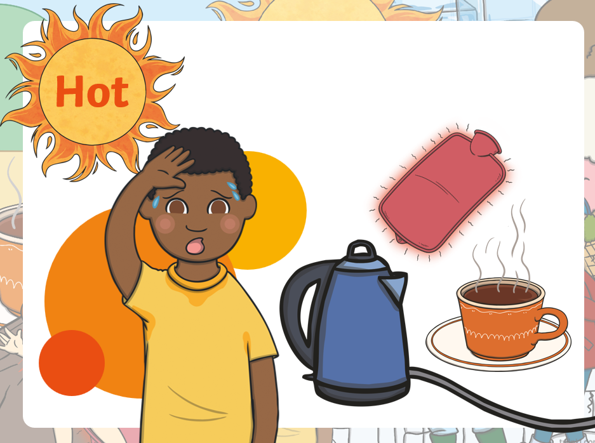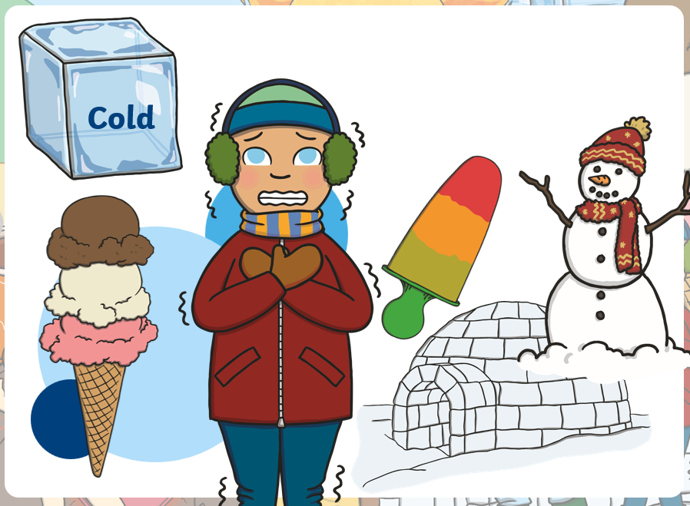

Literacy
This term we continue our Seasons topic and will enjoy songs, rhymes stories and activities about summer. We will link this to our learning about healthy eating and base our learning on two stories:
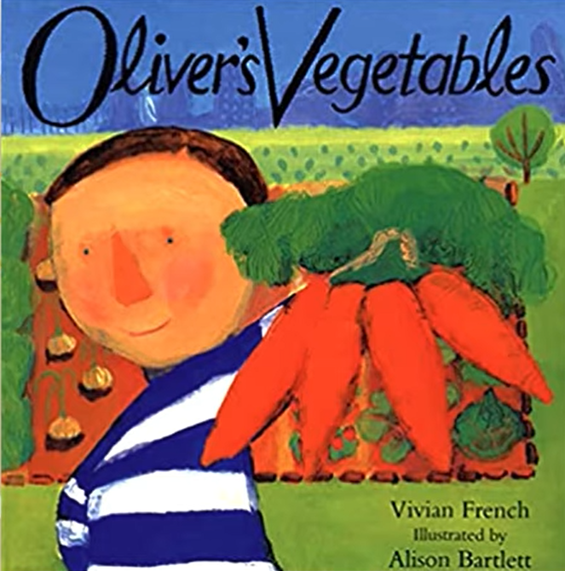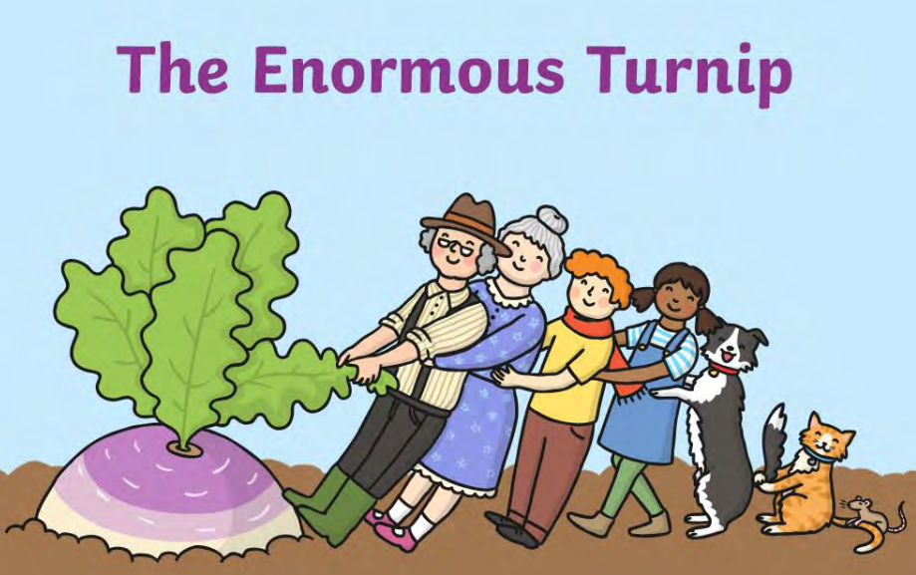
We will develop our communication skills by learning and using new vocabulary and learning to use visuals to support us.

Sunshine Room
Summer 2 overview

We will continue to develop our phonics knowledge and use it to progress along our reading journeys.
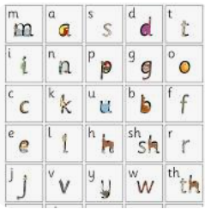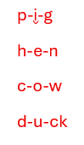

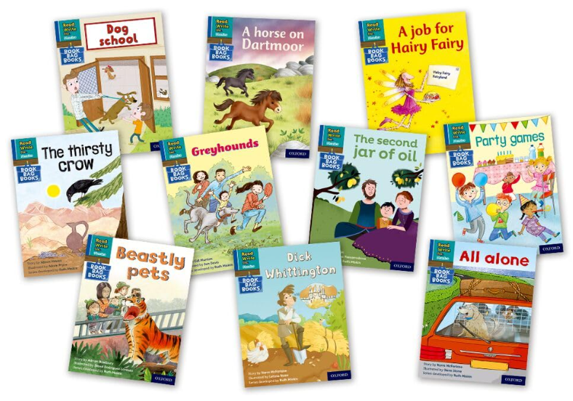

For our Maths development we will be- 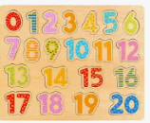
Practising counting to 20 and learning to count backwards from 20.
Through tasks and puzzles we will improve our fine motor skills, problem solving abilities, spatial awareness. We will practise stacking, sorting, one-to-one correspondence and patterns.
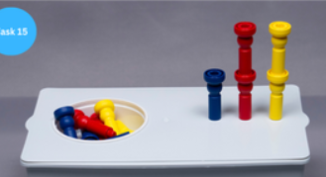
We will practise our subitising using our fingers, dots, pictures and the rekenrek.
We will also be working on our individual maths targets.


