
Mathematics vocabulary list Year 1

Maths is its own language. Sometimes that language looks like written word and sometimes it looks like symbols, but it is a language and it must be learned for math fluency and competency. If your child does not have a good understanding of key mathematical vocabulary, it can hinder them in making good progress in maths and in other areas of the curriculum.
At Kingsley, we explicitly teach maths vocabulary, giving it a context and allowing children to apply it in a variety of problems.
Listed below are the key mathematical terms your child will learn this year. This is the minimum we expect children to learn; however, we know children are curious and will undoubtedly want to learn more and we encourage this.

Vocabulary | Definition | Example
Number and Place Value
Above | Something that is over another  number. | ‘5 is above 3 when we count’.
Backwards | Back towards the starting point. | ‘7, 6, 5, 4, 3… this is counting  backwards’.
Below | Something that is lower than  something else. | ‘3 is below 5 when we are counting’.
Equal to | Being the same in quantity | ‘2 + 1 is equal to 3  6 is equal to 6’
Equivalent to | Equal in value, amount | ‘6 + 6 is equivalent to 2 x 6’
Forwards | To advance something | ‘2, 4, 6, 8, 10… We are counting  forwards in jumps of 2’.
Half-way between | 1 at or to half the distance; at or to the middle. | ‘Half-way between 1 and 3 is 2’.  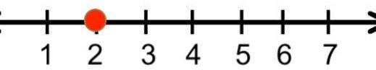
Known fact | A number fact which has been committed to memory (or very fast recall) and can be applied fluently to various calculation  strategies. | ‘When I use the ‘Make ten’ strategy to add, I use known facts to partition the number I’m adding.’
Least | Smallest in amount | ‘C has the least amount of stars in’.  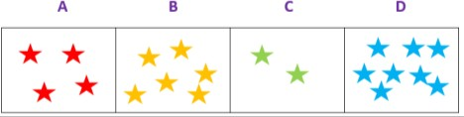
Many | A number representing some quantity. | ‘How many have you got in total?

Most | Largest in amount. | ‘D has the most amount of stars in’.
Multiple of | A number that may be divided by another a certain number of times without a remainder. | ‘10 is a multiple of 2.  2, 4, 6, 8, 10’
Numeral | A symbol or name that stands for a number. | 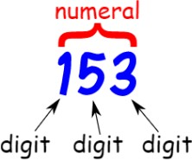
Numbers 20-100 | ‘Twenty-one, twenty-two … one hundred’
Rule | A consistent pattern which allows generalisation. Awareness of a rule allows a pupil to continue a sequence or generate a related  sequence. | ‘3, 5, 7, 9, 11…  The rule is that each number is two greater than the previous number. Therefore, the next number in this  sequence will be 13.‘
Addition and subtraction
Addend | The numbers or terms added together to form the sum. | 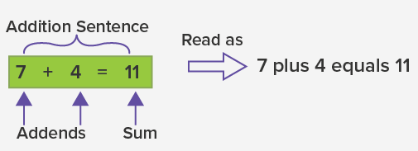
Difference | The numerical difference between two numbers or sets of objects. It is found by comparing the quantity of one set of objects with another. | 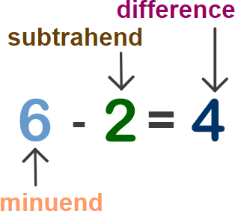
Equals | Be the same as in number or amount. | ‘5 + 5 = 10’  ’10 = 5 + 5’
Half | Either of two equal or corresponding parts into which something is or can be divided. | ‘4 + 4 = 8. So half of 8 is 4 because 8 –  4 = 4’.

Minuend | A quantity or number from which another is to be subtracted.
Missing number | A part of an equation that is missing. | ‘Find the missing number below:’  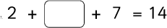
Near | Close to | ‘9 is close to 10’.
Number bonds/pairs | A pair of numbers with a given total. | ‘Number bonds to 10’.  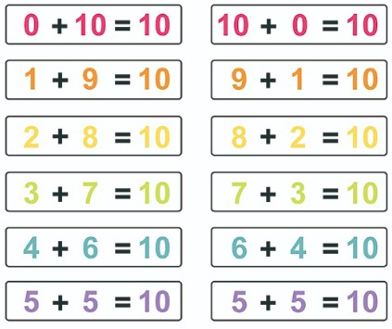
Repeated addition | A structure of multiplication where equal parts are added to make a whole. | ‘I can show 4 × 5 as repeated addition: 4 + 4 + 4 + 4 + 4.’
Repeated subtraction | A structure of division, where equal parts are subtracted and the number of equal parts summed to calculate a quotient. | ‘I can use repeated subtraction to calculate 20 divided by four: 20 – 4 –  4 – 4– 4 – 4.’
Subtract | Carry out the process of subtraction. | ‘Nine subtract three is equal to six.’
Subtraction | The inverse operation to addition. | ‘We are taking some away so it is a  subtraction question.’
Subtrahend | A quantity or number to be subtracted from another. | 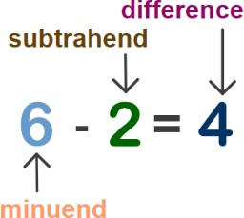

Multiplication and division
Array | An arrangement of counters or numbers, in columns and rows, used to represent multiplication and division. | ‘This array shows 3 × 4, 4 × 3, 12 ÷ 4  and 12 ÷ 3’.  
Divide | To share or group into equal parts. | ‘I can divide 12 by three using grouping or sharing’.
Dividend | A number to be divided by another number. | 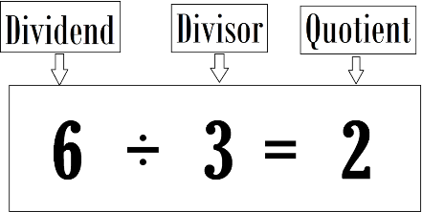
Division | Distributing a group of things into equal parts. | ‘Answer the division questions below:  There are 12 chocolates, and 3 friends want to share them, how do they divide the chocolates?’  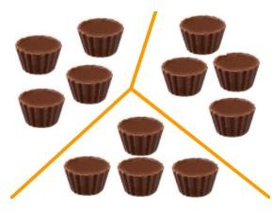
Divisor | A divisor is a number that divides another number either completely or with a remainder. | 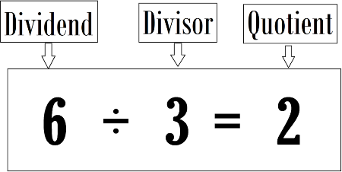
Grouping | Dividing things into equal groups or sets. This is one model for division. | 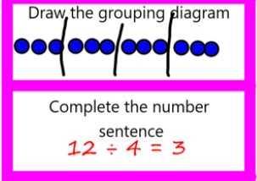

Multiplication | Gives the result of combining groups of equal sizes. | 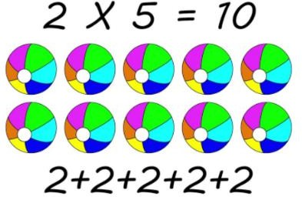
Multiple | The product result of one number multiplied by another number. | ’20 is a multiple of 10 and 2. 2 x 10 =  20’.
Multiplicand | A quantity which is to be multiplied by another (the multiplier). | 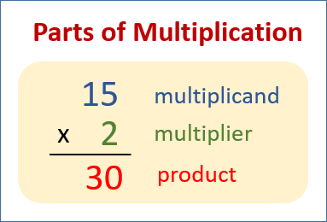
Multiplier | A quantity that multiplies the multiplicand.
Multiply | Add equal groups. | ‘Multiply 5 by 2’.
Product | The result of one or more multiplications
Quotient | A result obtained by dividing one quantity by another.
Sharing | To distribute fairly between a given number of recipients. This is one model for division. | 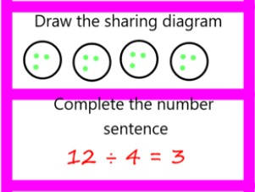

Fractions
Equal grouping | Groups that have the same number of equivalent items. | ‘Each bucket has the same number of  equal groups’
Equal part | Having the same portion, division, piece, or segment of a whole. | 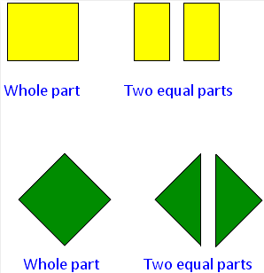
Equal sharing | Dividing the whole or a group of objects is into equal parts. | ‘The pizzas below have been shared  equally’.  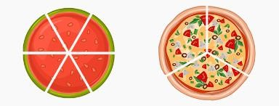
Fraction | How many parts of a whole:  - the top number (the numerator) says how many parts we have.  - the bottom number (the denominator) says how many equal parts the whole is divided into. | ‘I have shared my sweets into two equal parts. Everyone will get a fraction of the whole quantity of sweets. One group is a half of the whole.’  
One of two equal parts | When something is divided into two equal sections, half is one of the two parts. | 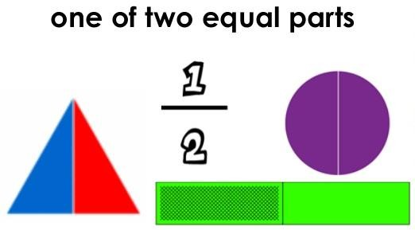
Quarter | One of four equal parts of a whole, quantity or object. | ‘I have shared the eight conkers into four equal groups – I have two conkers, which is one quarter of the whole.’

Length
Metre | A standard unit of measure, equal to 100 centimetres. | ‘I estimate that the table is about a  metre tall.’
Metre stick | A measuring stick one meter long that is marked off in centimeters and usually millimeters. | ‘About how many metres is the table in length? I am going to use my metre stick to measure it’
Ruler | A tool or device used to measure length and draw straight lines. | ‘The length of this line is 10cm. I  measured with a ruler’.
Weight
Kilogram | A standard unit of mass, equal to 1000 grams. | ‘The book has a mass of two  kilograms’.
Capacity and volume
Capacity | The maximum amount that something can contain. | ‘The capacity of the jug is 1 litre’.  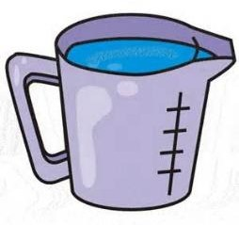
Less than | One value or amount is lesser than the other. | ‘The amount of water in this container is less than the amount of water in this container.’
Litre | A standard unit of volume, equal to 1000 millilitres. | ‘The capacity of the jug is about half a  litre.’
More than | One value or amount is greater than the other. | ‘The amount of water in this container is more than the amount of water in this container.’
Volume | A quantity or amount of any substance and the 3-D space it fills. | ‘The bottle contains a volume of one litre but its capacity is two litres. The bottle is half full.’  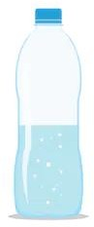

Time
Always | At all times. | ‘Christmas is always on December 25th’.
Analogue clock | A clock with a face and hands. | 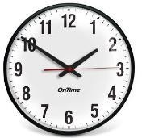
Date | The day of the month or year as specified by a number. | ‘Monday 1st September 2021 01.09.21’
Earlier | Before the usual or expected time. | ‘We have finished our lesson a bit  earlier today’.
Half past | 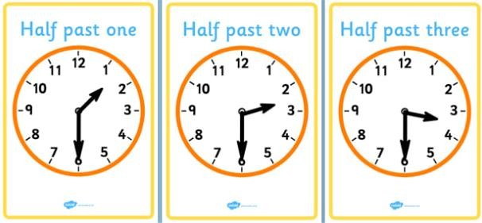
Hour hand | 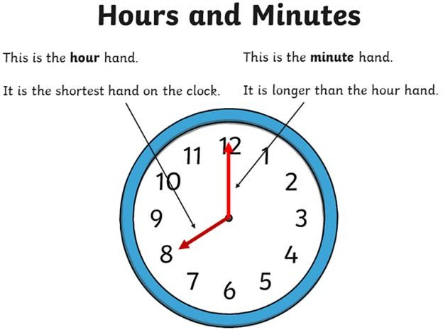
Later | A time or situation that is after the one that you have been talking about or after the present one. | ‘It is not lunchtime yet. It is later’.

Midnight | 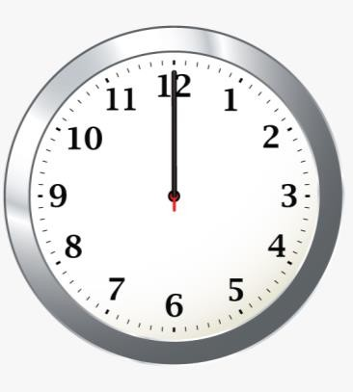
Minute hand
Minute | A unit of time. | ‘We will have lunch in five minutes.’
Months of the year | ‘January, February, March, April, May, June, July, August, September, October, November, December’.
Never | ‘I wish it was Christmas in the summer in this country. That will never  happen’.
Often | ‘In Britain, it often rains in the winter’.
Once | On one occasion or for one time only. | ‘I completed that challenge once. I  need to complete it twice’.
Quarter past | 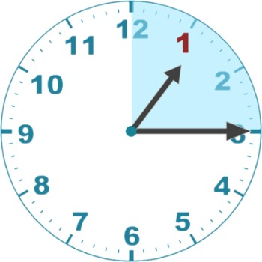

Quarter to | 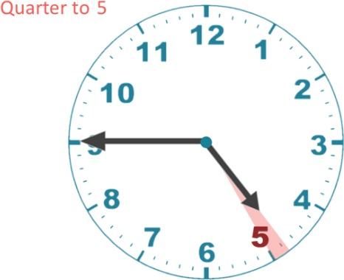
Seasons | ‘Spring, summer, autumn, winter’.
Sometimes | ‘Sometimes, it might snow in the winter’.
Twice | Two times; on two occasions | ‘I completed that challenge once. I  need to complete it twice’.
Usually | ‘Usually we have our lunch at 12pm’.
Weekend | ‘Saturday and Sunday is the weekend’.
Year | The period of 365 days (or 366 days in leap years) starting from  the first of January, | ‘Next year, you will be moving into  year 2.’
Money
Change | Receiving money back after purchasing. | ‘If I buy this teddy, how much change  would I get?’  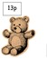
Cheap | Low in price, especially in relation to similar items or services. | ‘These sweets are very cheap in the shop. In the other shop, they cost  more’.
Costs less | Cheaper in one place than in another. | ‘The doll costs less than the teddy bear’.  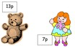
Costs more | More expensive in one place than in another. | ‘The teddy bear costs more than the doll’.

Costs the same as | Equal in price. | ‘The plant is shop A costs the same as  the same plant in shop B.’
Dear | Very expensive. | ‘It would cost a lot of money to go on  holiday abroad. It would be very  dear’.
Total | Comprising the whole number or amount. | ‘The total cost is £5.’
2d shape
Oblong | A quadrilateral with two pairs of parallel sides of equal length. | 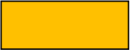
Point | A sharp point of a shape. | 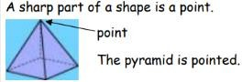
3d shape
Volume | A quantity or amount of any substance and the 3-D space it fills. | ‘The bottle contains a volume of one litre but its capacity is two litres. The bottle is half full.’
Position and direction
Anti-clockwise | Movement in the opposite direction to the motion of the hands of a clock. | 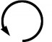
Center | A center is a point that is the same distance from all the extremities of a figure. | 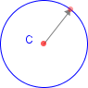
Clockwise | Movement in the direction of the hands of a clock. | 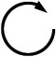

Quarter turn | A 90-degree rotation, i.e. ¼ of  a 360 degree ‘full’ turn. | 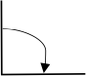
Three-quarter turn | A 270-degree rotation i.e. ¾ of a  360 degree ‘full’ turn. | 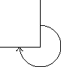
Statistics
Block graph | The pre-cursor to the bar graph, this representation of data has an x- and y-axis and one block represents one item. Each block is adjoined to the adjacent block. | 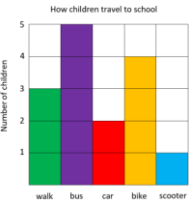
Chart | A table or a graph. | ‘I will mark one day for the sun  on our weather chart.’
Data | Quantitative information which has been counted or  measured. | ‘This block graph shows us data for the colour of the cars in the car park.‘
Table | A structure organised into columns and rows, in which data can be recorded. | ‘The information for Thursday is not yet complete on the table because it is only Wednesday.’
Table |  |  | Mon | Tues | Weds | Thurs
Table |  |  | 5 | 7 | 4

