
Mathematics vocabulary list Year 4

Maths is its own language. Sometimes that language looks like written word and sometimes it looks like symbols, but it is a language and it must be learned for math fluency and competency. If your child does not have a good understanding of key mathematical vocabulary, it can hinder them in making good progress in maths and in other areas of the curriculum.
At Kingsley, we explicitly teach maths vocabulary, giving it a context and allowing children to apply it in a variety of problems.
Listed below are the key mathematical terms your child will learn this year. This is the minimum we expect children to learn; however, we know children are curious and will undoubtedly want to learn more and we encourage this.

Vocabulary | Definition | Example
Number and Place Value
Consecutive | Following each other continuously | ‘1, 2, 3, 4, 5…’  ‘789, 790, 791, 792’  These are example of consecutive  numbers’.
Expression | One or a group of numbers, symbols or operators. An expression does not use equality or inequality signs. Using an equality or inequality sign will give an equation. | ‘2 × 3  4²’
Integer | A whole number that can be positive or negative. | ‘6 is an integer, 0.6 is not.’
Negative numbers | A number that is less than zero. | ‘-1, -24, -0.5’.
Positive number | A number that is greater than zero. Zero is neither positive or negative. | ‘3, 32, 0.5.’
Thousand, ten thousand, hundred thousand, million | ‘10,000- ten thousand.  100,000- one hundred thousand. 1,000,000- one million’.
Addition and subtraction
Associative law | No matter how the parts in an addition or multiplication equation are grouped, the answer will be the same. | ‘(6 + 3) + 2 = 11  6 + (3 + 2) = 11  Addition and multiplication are associative. Subtraction and division are not.‘

Multiplication and division
Distributive law | The process whereby adding some numbers and then multiplying the sum gives the same answer as multiplying the numbers separately and then  adding the products. | ‘39 × 7 = 30 × 7 + 9 × 7.  This is an example of the distributive law’.
Short division | A formal written layout where the quotient is calculated showing only one written step. | 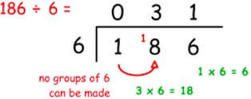
Short multiplication | A formal written layout where the multiplier is usually 9 or less. | 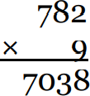
Fractions
Decimal equivalent | Two decimal numbers that are equivalent, that is, they represent the same value or amount. | 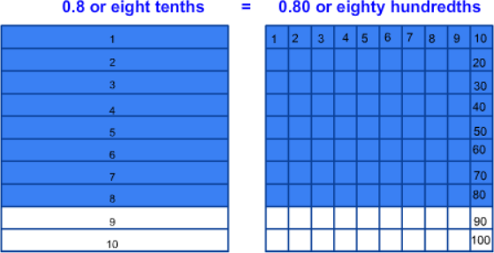
Decimal fraction | A fraction expressed in its  decimal form. | ‘Half written as a decimal fraction  is 0.5.’
Decimal place | The position of a digit to the right of a decimal point. | 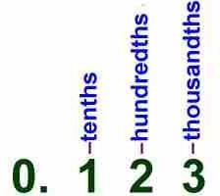
Decimal point | A full point or dot placed after the figure representing units in a  decimal fraction. | ‘7.89 is an example of a number with a decimal point’.
Hundredths | Each of one hundred equal parts into which something is or may be divided. | 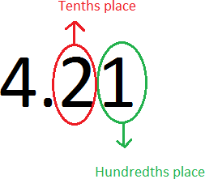
Mixed number | Numbers consisting of an integer  and fractional part. | ‘1 ½ is a mixed number’.
Proper fraction | A fraction with a value less  than one. | ‘½ and ¾ are proper fractions’.

Proportion | Harmonious relation of parts to each other or to the whole. | 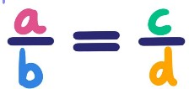
Simplify | To write a number or equation in its simplest form. | ‘I can simplify 8/10 to 4/5’
Length
Area | The space a surface takes up inside its perimeter. Area is always measured in square units. | 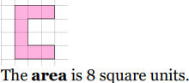
Breadth | The distance or measurement from side to side of something | 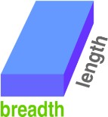
Convert | To change from one unit of measurement to another. | ‘2 km can be converted to metres  – it is equal to 2000 m.’
Square centimetre | A unit of measure for area equal to a square with the dimensions 1 cm by 1cm. | ‘Sometimes referred to as centimetre squared, abbreviated to cm².‘
Weight
Mass | Mass is commonly measured by how much something weighs. | ‘How much do those apples weigh?  What is their mass?’
Weight | Weight is the measure of how heavy an object is. | ‘The weight of those rocks is 750g’.
Capacity and volume
Measuring cylinder | Measuring cylinders are for holding and measuring varying amounts of liquids. | 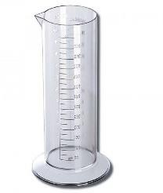
Temperature

Time
Arrive | Reach a place at the end of a journey or a stage in a journey. | ‘The bus arrives at 10am. It left the depot at 9.15am. How long was its  journey?’
Depart | Leave, especially in order to start a journey. | ‘The bus departs at 10.15am. It takes 1 hour and 20 minutes to get to its next destination. What time will it  arrive?’
Leap year | A year, occurring once every four years, which has 366 days including 29 February as an extra  day. | ‘How many days are there in a leap year?’
Millennium | A period of 1,000 years. | ‘How many years in a millennium?’
Noon | Twelve O’clock in the day.  Midday. | 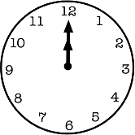
Timetable | A chart showing the departure and arrival times of trains, buses, or aircraft. | 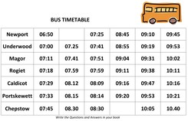
2d shape
Construct | Build or make. | ‘Can you use these art straws to  construct an irregular pentagon?’
Equilateral | Having all sides the same length. | ‘An equilateral triangle has three  equal sides’.
Heptagon | A plane figure with seven straight sides and angles. | 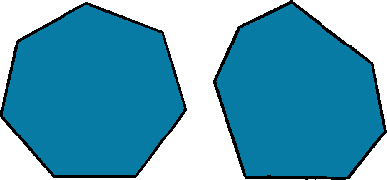
Isosceles | Having two sides of equal length. Isosceles triangles have two equal sides; isosceles trapezia have two equal, non-parallel sides. | 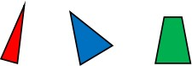

Kite | A flat shape with 4 straight sides that:  - has two pairs of equal length  sides.  - each pair is made of two adjacent sides (they meet) that are equal in length.  The angles are equal where the pairs meet. | 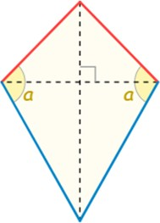
Oblong | A rectangle that is not a square. | 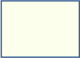
Parallelogram | A 2-D shape that has two pairs of parallel sides and equal opposite angles. | 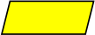
Polygon | A plane shape (two-dimensional) with straight sides. | 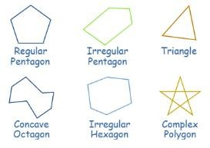
Rectilinear | A rectilinear shape has straight line edges which are perpendicular (all meet at right angles). | ‘A rectangle- a straight-sided shape that can be divided up into other rectangles.’  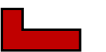
Rhombus | An equilateral parallelogram with four equal length sides. | 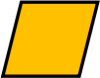
Scalene | A scalene triangle has three unequal sides and three unequal angles. | 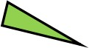
Trapezium | A quadrilateral with exactly one pair of parallel sides. | 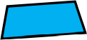

3d shape
Cylindrical | Like a cylinder. | 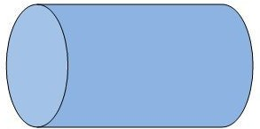
Polyhedron | A solid with flat faces. Each flat face is a polygon. | 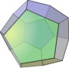
Spherical | Shaped like a sphere. | 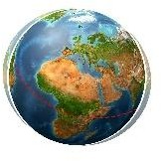
Tetrahedron | A polyhedron (a flat-sided solid object) with 4 faces. | 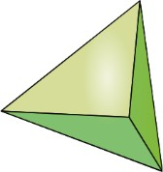
Position and direction
Coordinate | The position of a point, usually described using pairs of numbers. | ‘The coordinate (1,3) describes a point that is 1 on the x axis and 3 on the y axis.’  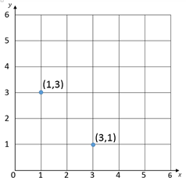
Degree | A measure for angles. There are 360 degrees in a full rotation. | ‘There are 180 degrees in a triangle’.

Grid | A series of evenly divided and equally spaced shapes, usually squares. | 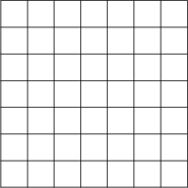
Plot | To mark out a point on a graph or grid. | ‘Plot the point (3,6) means to draw the precise location of that point, usually shown as a dot or a small cross’.
Point | The precise location of a position on a 2-D plane. | ‘An exact place on a graph or on squared paper. A point can be represented by a capital letter.’
Protractor/angle measurer | A measuring device for measuring the size of an angle. Angles are measured in degrees (°). | 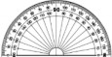
North-east, north- west, south-east, south-west, NE, NW, SE, SW | Compass directions | 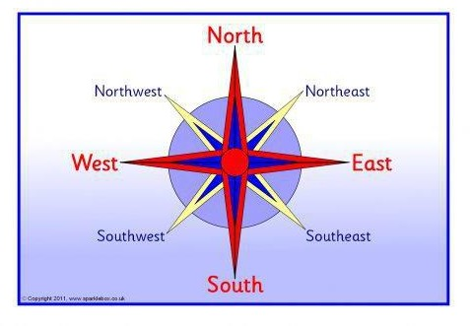
Reflection | An image or shape as it would be seen in a mirror. | 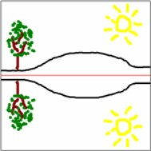
Rotation | The action of rotating about an axis or centre. | 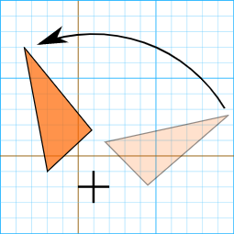

Set square | A right-angled triangular plate for drawing lines, especially at 90°, 45°, 60°, or 30°. | 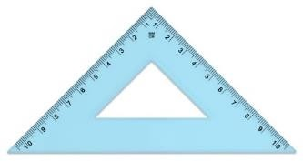
Translation | "Sliding": moving a shape without rotating or flipping it.  The shape still looks exactly the same, just in a different place. | 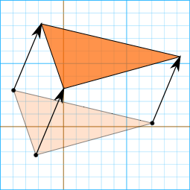
Statistics
Data | A collection of facts, such as numbers, words, measurements, observations or even just descriptions of things. | 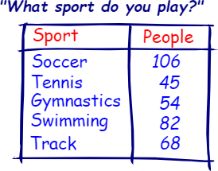
Interval | An interval on a graph’s axis lies  between two values. | ‘The graph below is going up in  intervals of 1.’  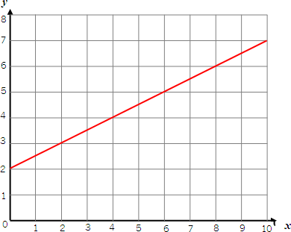
Survey | To gather information by  individual samples so we can learn about the whole thing. | ‘We are going to complete a survey of  children’s favourite ice cream flavour’.
Time graph | A graph that uses lines to connect the points on a data chart. Used to present continuous data, such as change over time. | 