
Mathematics vocabulary list Year 3

Maths is its own language. Sometimes that language looks like written word and sometimes it looks like symbols, but it is a language and it must be learned for math fluency and competency. If your child does not have a good understanding of key mathematical vocabulary, it can hinder them in making good progress in maths and in other areas of the curriculum.
At Kingsley, we explicitly teach maths vocabulary, giving it a context and allowing children to apply it in a variety of problems.
Listed below are the key mathematical terms your child will learn this year. This is the minimum we expect children to learn; however, we know children are curious and will undoubtedly want to learn more and we encourage this.

Vocabulary | Definition | Example
Number and Place Value
Approximate | Anything that is similar, but not exactly equal, to something else. | ‘The approximate answer to 199 + 100 is 300 because 199 is very close to  200.’
Formal written method | A way of carrying out a calculation which is done on paper rather than entirely mentally. | 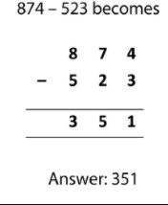
Numbers 101- 1,000 | ‘One hundred and one, one hundred and two… nine hundred and ninety- nine, one thousand.’
Place holder | A place holder is a zero used in any place value column (that contains a value of zero) to clarify the relative positions of the digits in other places. | ‘I need to use a place holder in the ones column to make it clear that my number is 320 and not 32.‘
Relationship | A mathematical relation is, a relationship between sets of numbers or sets of element. | ‘What is the relationship between  multiplication and division?’
Round | Approximate a number, normally to the nearest multiple of ten, to make it easier with which to calculate. | ‘I would round the number 17 to 20 because it is three away from 20 but seven away from 10.‘

Addition and subtraction
Columnar addition/subtraction | The formal written algorithms for addition and subtraction that are exemplified in Mathematics Appendix 1 of the 2014 national curriculum. | 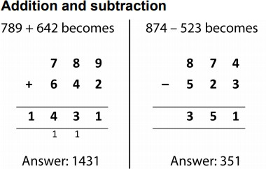
Multiplication and division
Factor | A number, that when multiplied with one or more other factors, makes a given number. | ‘The number six has four factors: 1, 2, 3 and 6.‘
Product | The result you get when you multiply two numbers. | ‘24 is the product of 3 and 8.’
Fractions
Sixths, sevenths, eighths, tenths | The fraction equal to one divided by six.  The fraction equal to one divided by seven etc. | ‘One sixth plus four sixths is equal to five sixths’.
Length
Distance from/to | How far away something is. | ‘What is the distance from house A to  house B on the map?’
Kilometre | A metric unit measure of length that is equal to one thousand metres. | ‘The distance from the school to Arun’s house was exactly one kilometre.’
Millimetre | A metric unit measure of length that is equal to one thousandth of one metre. | ‘The length of Philippa’s ruler is 300  millimetres.‘
Perimeter | The perimeter of a 2-D shape is the total distance around its exterior. | 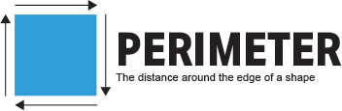

Temperature
Centigrade | The Celsius scale of temperature. | ‘The temperature outside is 22  degrees centigrade’
Time
12-hour clock time | The 12-hour clock notation uses am and pm to indicate morning and afternoon. | ‘The time is 12.45pm on a 12-hour  clock’.  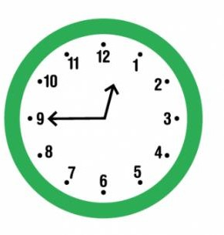
24-hour clock time | A way of telling the time in which the day runs from midnight to midnight and is divided into 24  hours, numbered from 0 to 24. | ‘The time is 1245 on a 24-hour clock’.  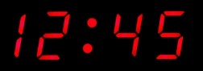
AM | The abbreviation a.m. stands for the Latin ante meridiem, meaning  before. | ‘The time is 9.00am’.
Calendar | A chart or series of pages showing the days, weeks, and months of a particular year, or giving particular seasonal information. | 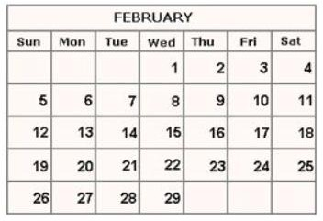
Century | A period of 100 years. | ‘WW1 ended just over a century ago’.
Earliest | Happening or done before the usual or expected time. | ‘What is the earliest that you can  arrive at school?’
Latest | Of most recent date. | ‘The latest you can finish your lunch is  12.30pm’

PM | The abbreviation p.m. stand for the Latin post meridiem, meaning after midday. | ‘The time is 9.00pm’.
Roman numerals | Roman numerals are a system of symbols used to represent numbers that were developed and used by the Romans. They do not use a place value system. | ‘The number twelve on this clock is represented by the Roman numerals XII, which is 10 + 1 + 1.’  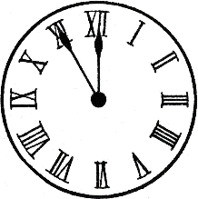
2d shape
Irregular | In geometry, irregular is a term used to describe shapes that are not regular (see below). | 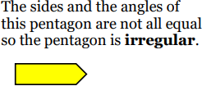
Parallel | Line segments that can be described as parallel must be on the same plane and will never meet, regardless of how far either or both line segments are extended. | 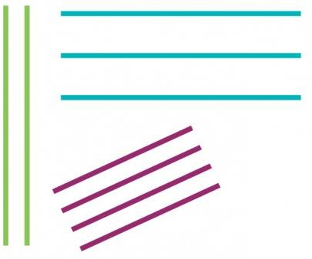
Perpendicular | A pair of line segments (or surfaces) can be described as perpendicular if they intersect at (or form) a right angle. | 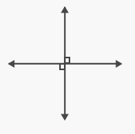
Regular | Regular 2-D shapes (regular polygons) have angles that are all equal and side lengths that are all equal. Regular 3-D shapes (the Platonic Solids) are those that have congruent (exactly the same) faces of a single regular polygon. | ‘A square is a regular 2-D shape because all four angles are right angles and all four sides are the same length. A cube is a regular 3-D shape with six identical square faces.’  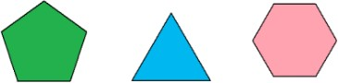

3d shape
Hemisphere | A hemisphere is a 3D geometric figure that is half of a sphere. | 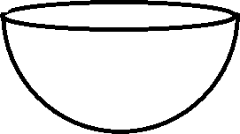
Prism | A prism is a 3-D solid with two identical, parallel bases and otherwise rectangular faces. | 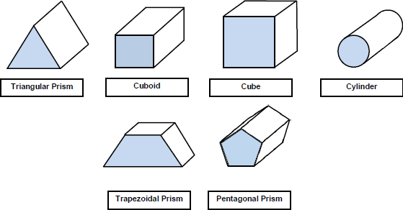
Square- based/triangular based pyramid | A pyramid is a 3-D shape with a 2- D shape (which gives the pyramid its name) as a base and triangular faces that taper to a point called a vertex or apex. | 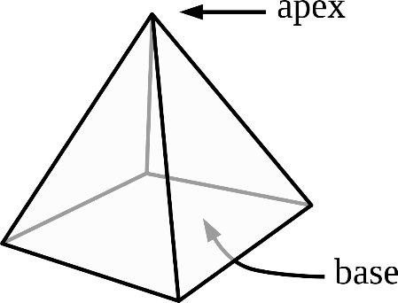
Position and direction
Acute angle | An angle that is smaller than a right angle. | 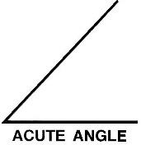
Compass point | The directions on the magnetic compass. The 4 main points are North, South, East and West. | 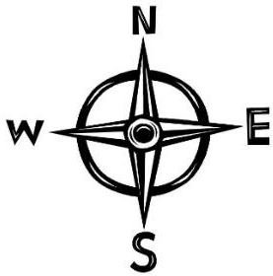

Diagonal | A diagonal is a straight line joining two nonadjacent vertices of a shape, that is, two corners of a shape that are not next to each other. | 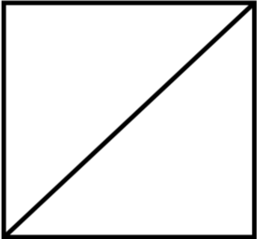
Horizontal | A line that runs right and left across the page.
North, south, east, west | Cardinal directions. | ‘The boy moves four squares north  and three squares west.’
Obtuse angle | An angle that is greater than a right angle but less than 180 degrees. | 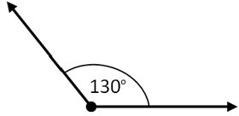
Vertical | A line that runs top to bottom down the page. | 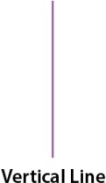
Statistics
Axis (plural axes) | A real or imaginary reference line. The y-axis (vertical) and x-axis (horizontal) on charts and graphs are used to show the measuring  scale or labels for the variables. | ‘The y-axis on this bar graph shows you how many pupils preferred each colour.’
Bar graph | A representation of data in which the frequencies are represented by the height or length of the  bars. | ‘This bar graph shows us the preferred colours of the pupils in our Year 3 class.‘
Carroll diagram | A way of sorting objects, numbers and shapes by their traits. | 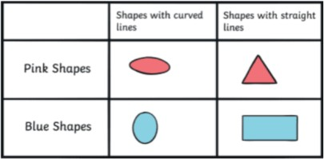

Frequency | The number of times an event or a value occurs | ‘Football was chosen by most of the children in the class- it was the most frequent sport played at lunchtime’.
Horizontal | Horizontal refers to planes and line segments that are parallel to  the horizon. | ‘The x-axis on a graph should be  horizontal.’
Venn diagram | An illustration that uses circles to show the relationships among things or finite groups of things. | 