
Mathematics vocabulary list Year 5

Maths is its own language. Sometimes that language looks like written word and sometimes it looks like symbols, but it is a language and it must be learned for math fluency and competency. If your child does not have a good understanding of key mathematical vocabulary, it can hinder them in making good progress in maths and in other areas of the curriculum.
At Kingsley, we explicitly teach maths vocabulary, giving it a context and allowing children to apply it in a variety of problems.
Listed below are the key mathematical terms your child will learn this year. This is the minimum we expect children to learn; however, we know children are curious and will undoubtedly want to learn more and we encourage this.

Vocabulary | Definition | Example
Number and Place Value
Ascending order | Arranged from smallest to  largest. Increasing. | ‘3, 9, 12, 55 are in ascending order.’
Descending order | Arranged from largest to  smallest. Decreasing. | ‘100, 45, 22, 18, 2 are in descending  order.’
≥ Greater than or  equal to | Something is either greater than  or equal to another thing. | ‘Marbles ≥ 1’
≤ Less than or equal  to | Something is either less than or  equal to another thing. | ‘Dogs ≤ 3’
Addition and subtraction
Multiplication and division
Common factor | A factor of two (or more) given numbers. | ‘A common factor of 12 and 9 is 3  because 3 × 4 = 12 and 3 × 3 = 12.’
Common multiple | A multiple of two (or more) given numbers. | ‘A common multiple of 3 and 6 is 12  because 3 × 4 = 12 and 6 × 2 = 12.’
Cube number | The result of multiplying a whole number by itself twice. | ‘3 × 3 × 3 = 27, so 27 is a cube number.’
Divisible | A number is said to be divisible by another if it can be divided by  that number without a remainder. | ‘24 is divisible by 8. When divided by 8 it gives a quotient of 3, with no remainder.‘
Factor pair | A factor pair is a pair of numbers that, when multiplied will result in a given product. | ‘The factor pairs of 10 are shown below:  - and 10  - and 5’

Long division | The formal written algorithm that can be used to divide by a number with two or more digits. | 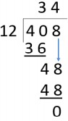
Long multiplication | The formal written algorithm that can be used to multiply a number by a number with two or more digits. | 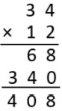
Prime factor | A factor that is a prime number. | ‘3 and 2 are prime factors of 6.‘
Prime number | A whole number with only two factors, one and the number itself. | ‘2, 3, 5, 7, 11, 13, 17 and 19 are the  prime numbers less than 20.’
Square number | The product of two equal factors. | ‘9 is a square number because 9 = 3 × 3.‘
Fractions
Percentage | The number of parts per hundred which is written using the % symbol. | ‘30% means for every 100 there are 30.‘
Thousandths | The third decimal digit from the decimal point is the thousandths digit. | ‘The thousandths digit below is 6.  4.426’
Length
Imperial unit | A system of measurement in use in the United Kingdom now mostly superseded by the metric system. | ‘The metric length of the line is 3cm. The imperial length of the line is 1.18 inches’.
Inches | A measure of length. | ‘One inch is exactly 2.54 centimetres.’

Scale | The ratio of lengths, in a drawing, are in proportion to the measurements of the real object. The lengths are not in proportion when not to scale. | ‘The diagram was not drawn to scale. That means I can’t use a ruler to measure the sides, because they are not in proportion to the real object.’  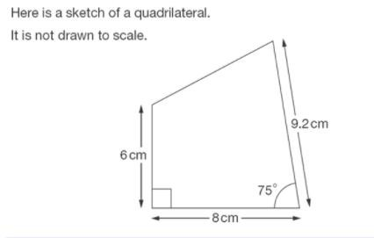
Square millimetre (mm²) | The area equal to a square that is 1mm on each side’ | ‘The area of that square is 1mm²’.
Square metre (m²) | The area equal to a square that is 1m on each side. | ‘The area of that square is 1km²’.  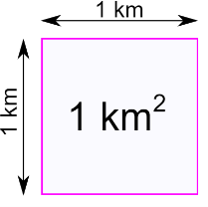
Weight
Pounds | A measure of mass in the  Imperial measurement systems. | ‘An average adult male weighs 180  lb’
Capacity and volume
Cubic centimetre | A unit used to measure volume. The space taken up by a cube with edges of length 1 cm or which measures 1 cm × 1 cm × 1 cm. | ‘The volume of this multilink cube model is eight cubic centimetres.’  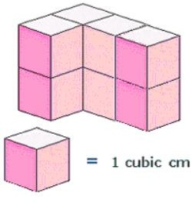
Cubic metre | A unit used to measure volume. The space taken up by a cube  with edges of length 1 metre. | ‘The volume of this fridge is two cubic metres.‘
Pint | A measure of volume in the Imperial systems of measurement. | ‘A pint is equal to about half a litre.’  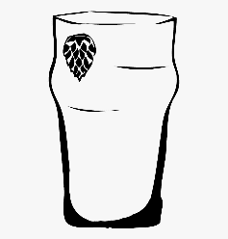

Money
Currency | A system of money in general  use in a particular country. | ‘The currency in England is Pound  Sterling.’
Discount | A reduction in price. | ‘The item below has been discounted  from $10 to $8.’  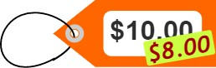
2d shape
Congruent | Used to describe two shapes or figures which are exactly the same size. | ‘The two triangles are congruent. If I place one on top of the other, there is no overlap.’  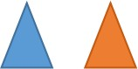
Decagon | A polygon with ten sides and ten angles. | 
Diagonal | A line segment that goes from one corner to another, but is not an edge. | 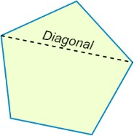
Dodecagon | A polygon with twelve sides and twelve angles. | 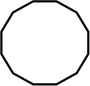
Nonagon | A polygon with nine sides and nine angles. | 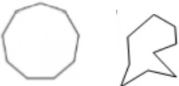

Quadrant | Any of the 4 areas made when we divide up a plane by an x and y axis. | 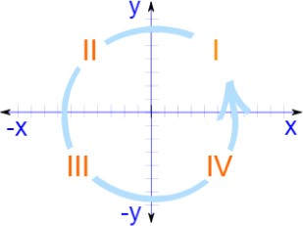
X-axis | The line on a graph that runs horizontally (left-right) through zero.  It is used as a reference line so you can measure from it. | 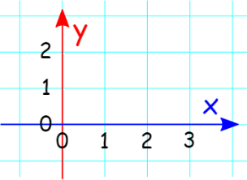
Y-axis | The line on a graph that runs vertically (up-down) through zero.  It is used as a reference line so you can measure from it.
3d shape
Octahedron | A polyhedron (a flat-sided solid object) with 8 Faces. | 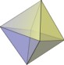
Position and direction
Angle at a point | Angles that meet at a point that sum to 360°. | 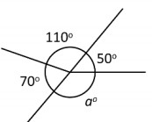
Angle on a line | Angles formed on a straight line that sum to 180°. | ‘Angle b below is equal to 55 degrees because angles on a line add to 180 degrees.’  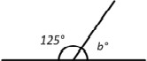

Coordinate | A set of values that show an exact position.  On graphs it is usually a pair of numbers: the first number shows the distance along, and the second number shows the distance up or down. | 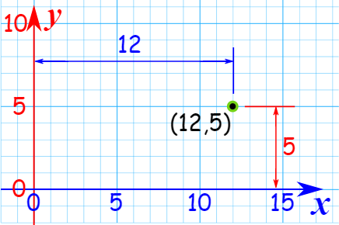
Reflex angle | An angle that is greater than 180°. | 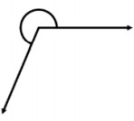
Transformation | A collective term for the ways that shapes can be changed, resulting in congruent or similar shapes, i.e. translation, reflection, rotation or  enlargement. | ‘Translations and reflections are types of transformations.‘
Statistics
Line graph | A graph with points connected by lines to show how something changes in value:  - as time goes by,  - or as something else changes. | 