Subject | Autumn 1 | Autumn 2 |  | Spring 1 |  | Spring 2 | Summer 1 | Summer 2
English | The Man Who Walked Between the Towers by Mordicai Gerstein  Information writing, letters of advice, persuasive speeches, first person recounts, interviews.  Biography / autobiography  Hidden Figures: The True Story of Four Black Women and the Space Race by Margot Lee Shetterly and Laura Freeman  Non-chronological reports, formal persuasive letter, informal letter, diary entry, character descriptions, opinion piece  Memoir of Dorothy Vaughan |  |  | The Lost Thing by Shaun Tan  Diary entries, formal letters, adverts, character and setting descriptions, non- chronological reports  Own version fantasy narrative in the style of The Lost Thing  Anne Frank by Josephine Poole  Letters, short descriptions, extended diary entries, obituary, optional opinion piece  Newspaper article |  |  | Firebird by Saviour Pirotta and Catherine Hyde  Retellings, character descriptions, fairytale narrative  The Lost Happy Endings by Carol Ann Duffy and Jane Ray  Newspaper report, an extended response to a text Prequel- alternative perspective
Maths   | Block 1- Place Value  Block 2- Number: Addition and Subtraction  Block 3- Number: Multiplication and Division  Block 4- Number: Fractions |  |  | Block 1- Number: Multiplication and Division  Block 2- Number: Fractions  Block 3- Number: Decimals and Percentages  Block 4- Perimeter and Area  Block 5- Statistics |  |  | Block 1- Geometry: Properties of Shape  Block 2- Geometry: Position and Direction  Block 3- Number: Decimals  Block 4- Number: Negative Numbers  Block 5- Measurement: Converting Units  Block 6- Measurement: Volume
R.E  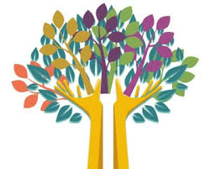 | Branch 1  Creation and covenant  Branch 2  Prophecy and promise |  |  | Branch 3  Galilee to Jerusalem  Branch 4  Desert to garden |  |  | Branch 5  To the ends of the earth  Branch 6  Dialogue and encounter
Science   | Earth and Space  How does the Earth fit into our solar system?  Living things and their habitats  How do living things reproduce, and why is this important in a life cycle? |  |  | Forces  Are there different types of forces? |  |  | Properties and changes of materials –  How do materials change?  Animals including humans –  How do we change as we grow old?
His/Geo | Geography fieldwork –  Rivers - What are the features of my local river? |  |  | Geography fieldwork –  Biomes and ecosystems - What trees, plants and animals are in our local ecosystems?  History –  How did England change during the settlement of the Anglo-Saxons? |  |  | Geography –  The United States - What are the similarities and differences between my region and the Western United States?  History –  What differences were there between the Maya Civilisation and England during the 10th and 11th Centuries?
Art & Design/DT | Art  Chromatic - How realistic do portraits need to be?  DT  Textiles - Moonlit Magic - How can fabric and stitching create atmosphere?  Art –  Monochromatic - How can we find our own style of drawing? |  |  | DT  Construction - Fairytale Engineering - How can we use pulleys and levers to solve a problem?  Art  Sculpture - How can flowers inspire artists |  |  | DT  Food & Nutrition - Central America on a Plate - How can we cook a dish that celebrates its cultural flavours?
P.E.   | Netball  Swimming | Gymnastics -  Key Steps 3  Swimming |  | Gymnastics -  Counter Balance and Counter Tension  Dance – Space |  | Football  Dance - The Greeks/ The Circus | Athletics  Badminton | Rounders  OAA  Communication and Tactics
Spanish  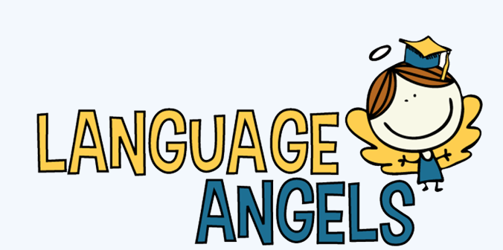 | Phonetics 3  Do You Have a Pet?  Christmas |  |  | In the Classroom  At the Cafe |  |  | Clothes  Traditions and Celebrations
Music   | Musical Minds Ukulele | Charanga  Livin’ on a Prayer  (Rock anthems) |  | Musical Minds  Singing |  | Charanga  Dancing in the Street  (Motown) | Musial Minds  Glocks 2 | Charanga  Reflect,Rewind, Replay (Listen and appraise classical music)
Computing | Digital Literacy:  Online Safety |  | Digital Literacy:  Computing Systems and Network; Search Engines | Computer Science  Programming: Music | Digital Literacy:  Data Handling: Mars Rover 1 |  | Computer Science  Programming: Micro:bit | Digital Literacy  Skills showcase: Mars Rover 2
PSHE   | - Keeping/ Staying Safe-  Peer Pressure Adults’ Views Children’s View  Keeping/ Staying Healthy  Smoking Adults’ Views Children’s Views | Growing and Changing-  (to be taught in line with our RSHE policy and resources)  Puberty Adults’ Views Children’s Views |  | Being Responsible-  Looking Out for Others Adults’ Views Children’s Views |  | Feelings and Emotions-  Anger Adults’ Views Children’s Views  Computer Safety-  Image Sharing Adults’ Views Children’s Views | The Working World-  Enterprise Adults’ Views Children’s Views | A World without Judgement-  Inclusion and Acceptance  Adults’ Views Children’s Views
Educational Visits and Experiences |  |  |  | Crosby Hall Educational Trust Residential |  |  | Aintree Racecourse
Significant Days | Bonfire Night 5th November  Remembrance Day 11th November  Advent begins 30th November |  |  |  |  |  | St George’s Day 23rd April  SATs week 11th – 14th May

