
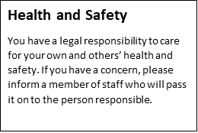
Safeguarding is EVERYONE’S RESPONSIBILITY
Any adult working (paid or voluntary) in our school must ensure that they have read and understood the Child Protection and Safeguarding Policy and at least Part 1 of the Keeping Children Safe in Education 2023. They must ensure they understand the signs and categories of abuse and know how to report any concerns. As a visitor, if you encounter any situation that gives rise to concerns about the conduct of a member of staff or the safety of a pupil, please speak to the Designated Safeguarding Lead for the Centre in the first instance.
Who to contact in school
If you have any concerns, please contact the Designated Safeguarding Lead: Kath Barratt 0161 696 7957/ 07736896117 or Deputy DSL Jennie Lea 0161 674 9673/ 07940720526
Welcome to Our School
Our priority is to ensure that our school is a safe place for children, staff and visitors. All staff and visitors have a duty of care towards the welfare and safety of the children and adults in this school, this is called Safeguarding. Safeguarding means:
- Children are protected from harm
- Children are quickly identified if they are at risk of harm
- Action is taken to ensure the best outcomes for all children
Visitors MUST sign in and wear the visitor’s lanyard so it is clearly seen at all times when on site. When leaving, ensure you sign out and return the lanyard. We ensure that all adults who work or volunteer in our school are subject to the appropriate security and employment checks including Enhanced Disclosure and Barring System (DBS) checks.

A Guide to Child Protection and Safeguarding at Manchester Secondary PRU for Visitors or Cover Staff
