


Manchester Secondary PRU
Curriculum Booklet
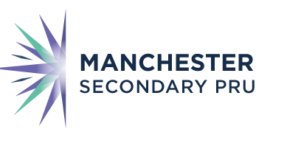

New Beginnings, Positive Futures
Curriculum Aims
Our curriculum aims to provide our learners with educational success and to prepare them for the next stage in their lives. We know our pupils well and have designed a curriculum which promotes their personal growth and academic achievement.
Curriculum Overview
Manchester Secondary PRU provides education and emotional support to children from Year 7 to Year 11, We offer a broad and ambitious curriculum which supports to identify and overcome their barriers to learning and build confidence and self-esteem.
Our curriculum is based on our shared values:
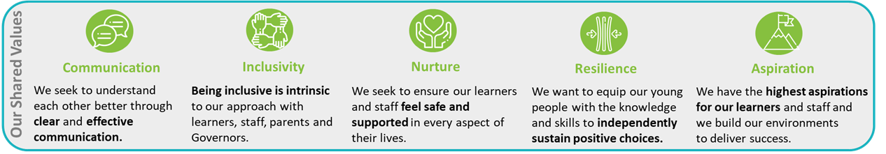
and is guided by the 6 Principles of Nurture
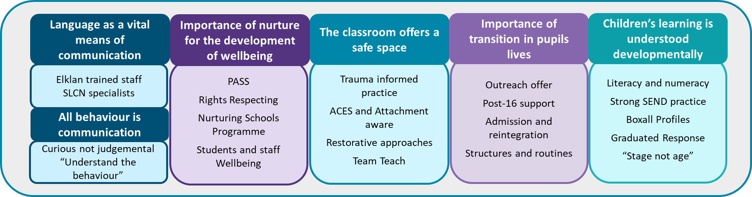

Curriculum Intent

Our curriculum aims to provide our learners with educational success and to prepare them for the next stage in their lives. It has been designed with the following:

Curriculum Principles - We will provide a curriculum which:
- Is high quality and ambitious for all, giving students access to a broad range of academic and vocational subjects as well as fostering creativity
- Is based on the National Curriculum but is adapted at a whole-school and subject level to ensure we can meet the needs of our learners
- Has a strong focus on personal and social development
- Is inclusive, setting high expectations of all learners
- Provides all students with the opportunity to develop the essential skills for life
- Ensures progression is an integral part of the curriculum design

Definition of Learning - Learning is a persistent change in knowledge. At MSPRU we understand learning as both a process and a product:
We refer to learning as something we do, as well as something we end up with. We define the process of learning as thinking and the product of learning as knowledge.

Intent - The curriculum we provide will allow our students to know more, remember more and do more. They will learn:
- a broad range of powerful knowledge in key national curriculum subjects
- how to read, write and communicate confidently
- about the principles of fluency in mathematics
- how to be critical thinkers
- to respect and celebrate individuality and diversity
- how to be resilient in the face of adversity and challenge
- how to understand and manage their emotions
- how to recognise risks and identify benefit and harm
- about different career pathways and the skills and knowledge required to be successful
- about the culturally rich communities in which they live

Curriculum Rationale



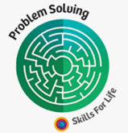

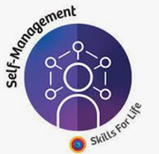
At Manchester Secondary PRU we place the curriculum at the heart of our school. Growing out from our shared vision and values, under-pinned by the 6 Principles of Nurture and with the Manchester Skills for Life framework running through all aspects, our curriculum forms a cohesive whole. It has been constructed with a strong focus on a core set of National Curriculum subjects alongside structured support for our students’ Personal Development.

We aim to develop a clear understanding of our learners’ needs at the point of referral and throughout their time with us. Many are referred to us with undiagnosed SEND, some have had their education disrupted due to adverse childhood experiences and others may be referred for a serious one-off incident. As a result, our curriculum needs to be:
- Highly ambitious for all learners
- Delivered through high quality teaching
- Adapted to meet the needs of our learners
Our curriculum has been designed to give all students access to the same, high quality curriculum content. For learners who have difficulty, our approach is not to alter the curriculum content but, rather, adapt our approach to teaching and pupil-support to ensure the learners can access the curriculum at an appropriate level. To achieve this our curriculum is structured into specific targeted pathways which allow us to provide a highly personalised programme for our students.

Key Stage 3 – Curriculum Pathways
Curriculum Structure
Our Key Stage 3 curriculum is divided into 3 discrete pathways. Initial allocation to a particular pathway will be determined using information provided at referral and information gathered through assessments undertaken as part of a planned induction process. Over the course of a placement, pupils may move between pathways.
Induction
SEND – Undertake a priority needs assessment

All students will study a core curriculum which consists of English, Maths and Personal and Social Development
Pathway 1 and 2: Engage & Achieve and Support & Build Confidence pathways
- delivered via a thematic based approach which supports students’ making connections between subjects and improves knowledge acquisition and retention
- one teacher and one learning mentor teaching a range of skills and knowledge from across the curriculum
- short, 10 minute bursts
- strong focus on experiential learning; all students will have regular access to Outdoor Ed
- staff trained to provided targeted interventions depending on the pathway – ELSA, ELKLAN, precision teaching, literacy interventions
- students will be assessed for SEND – Cognition and Learning or SEMH
Pathway 3: Return to mainstream
- delivered via discrete lessons by specialist teachers
- aim to cover a broad range of academic, National Curriculum subjects to maintain parity with mainstream peers
- students likely to have been excluded for significant, one-off reason
- interventions to specifically target the reason for exclusion
Pathway 4: Commissioned AP - Intensive Support
- delivered via discrete, subject-based lessons
- a range of academic subjects delivered by subject specialists
- smaller settings, each commissioned provider has experience in providing intensive emotional support
- broad range of academic and behavioural interventions

Key Stage 4 – Curriculum Pathways
Curriculum Structure
Our Key Stage 4 curriculum is divided into 4 pathways. Our Core pathway is delivered in MSPRU Centres and commissioned AP Centres. Initial allocation to a particular pathway will be determined using information provided at referral and information gathered through assessments undertaken as part of a planned induction process. Over the course of a placement, pupils may move between pathways.
Induction
SEND – Undertake a priority needs assessment

- All students study a core curriculum: GCSE English, Maths and Science and a high quality Personal Development programme
- Range of other accreditations - Functional Skills and Entry Level available
- Offer of a full GCSE (or equivalent) programme for all KS4 students to allow them to access the Level 2 threshold
- Additional GCSE (or equivalent) qualifications available dependent on the Centre or provider:
  - GCSE English Literature,
  - GCSE Art,
  - BTEC Sport and Fitness,
  - BTEC Creative Media Production,
  - GCSE Citizenship,
  - GCSE RE,
  - GCSE Drama,
  - BTEC L1/2 Home Cooking Skills,
  - BTEC L1/2 Money and Finance Skills,
  - BTEC L1 Workskills,
  - OCR National L1/2 Child Development
  - BTEC First L1/2 Award in Health and Social Care
- Students will have the opportunity to engage in a number of additional activities matched to their interests (not all activities available at all Centres):
  - Bike maintenance
  - Gardening
  - Music
- Vocational learning available from the Manchester AP Framework for targeted students
- Students supported to return to mainstream if appropriate – significant one-off incidents; school ready
- Students will have a formal assessment of their SEND and either transition to named setting or supported into post-16 provision
- Pathway 3 developed in conjunction with the Manchester College, students supported to progress to FE college or other EET provider
- All students supported to make an effective transition to post-16 Education, Employment or Training

