Pupil premium strategy statement Academic year 21/22
Manchester Secondary PRU

This statement details our school’s use of pupil premium (and recovery premium for the 2021 to 2022 academic year) funding to help improve the attainment of our disadvantaged pupils.

It outlines our pupil premium strategy, how we intend to spend the funding in this academic year and the effect that last year’s spending of pupil premium had within our school.

School overview
Detail | Data
School name | Manchester Secondary PRU
Number of pupils in school | 418
Proportion (%) of pupil premium eligible pupils | Typically 75% See further information
Academic year/years that our current pupil premium strategy plan covers (3 year plans are recommended) | 20/21
Date this statement was published | 21/9/21
Date on which it will be reviewed | 21/7/22
Statement authorised by | Andrew Burton
Pupil premium lead | Colin Rigby
Governor / Trustee lead | Chair of Governors
Funding overview
Detail | Amount
Pupil premium funding allocation this academic year | £149425
Recovery premium funding allocation this academic year | £
Pupil premium funding carried forward from previous years (enter £0 if not applicable) | £0
Total budget for this academic year  year | £

Part A: Pupil premium strategy plan

Statement of intent
Six Principles of Nurture
- Children's learning is understood developmentally
- The classroom offers a safe base
- The importance of nurture for the development of wellbeing
- Language is a vital means of communication
- All behaviour is communication
- The importance of transition in children's lives
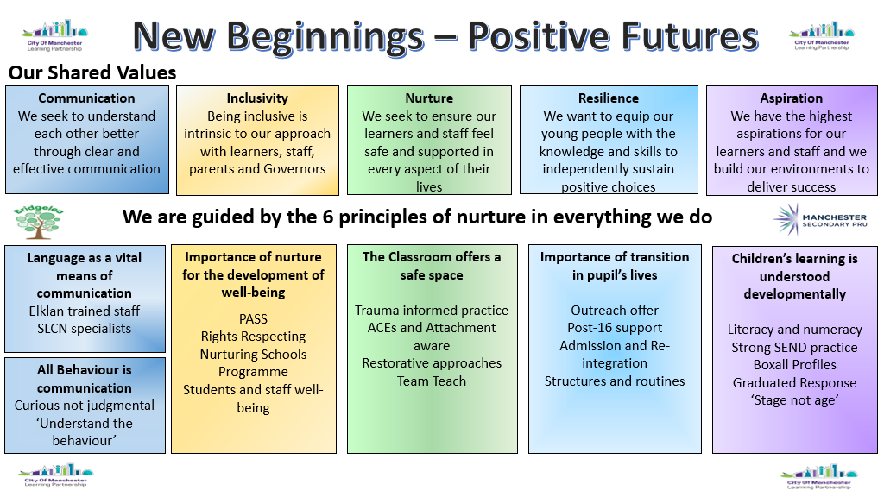

The pupils at MSPRU have either been permanently excluded from main stream schools or are at risk of being so. Many have complex additional needs, many have gaps in learning due to frequent or extended time out of education. Many arrive at MSPRU highly anxious due to the stress of being excluded. Pupils arrive with us throughout the academic year.
Our objective for pupil premium funding is to address these issues (academic and personal/social) and develop the pupil to the best possible position when they move to the next phase of their life / education. This requires a holistic approach and may integrate other agencies.
Interventions may be whole school, whole class or individual. It may include pupils who are not entitled to PPG.
Funding will be used to remove any barriers to learning/development.
We will continue using this funding in the next year for the same purposes, integrating it with other school developments.

Challenges

This details the key challenges to achievement that we have identified among our disadvantaged pupils.
Challenge number | Detail of challenge
1 | Our population changes over the year
2 | Repeated transitions for pupil
3 | Lower than expected attendance
4 | Increased numbers of pupils with complex needs, including speech and language, social communication, poor working memory, attention difficulties, motor skills, social emotional and mental health. Children Social Emotional Mental Health is a barrier as children struggle to engage regulate and have the resilience to tolerate challenge in their academic work.  Children have often had very negative experiences of education and come to MPSRU with incredibly low self-esteem and a spiky profile of missed learning. Children with diagnosis of ADHD have low levels of concentration and have poor listening and attention skills.  Children at MSPRU often have undiagnosed Speech, Language and Communication Needs. Communication is a barrier to learning for our pupils and we recognize that all behaviour is communication. Trying to understand this behaviour and support our children to communicate and develop their underlying communication needs supports pupils to make progress. Often this has been the driver of their SEMH behaviours in mainstream. Once settled at MPSRU, their SLCN needs are apparent and are assessed by a Speech and Language Therapists. Staff are trained to support children to develop SLCN so that they can make progress both socially and academically
5 | Narrowness of curriculum and is it the most appropriate curriculum
6 | High number of LAC pupils
7 | High number of EHCP and individual needs
8 | Post covid concerns regarding mental health of many students and staff
9 | Gaps in learning and learning deficit due to absences from education e.g. exclusions

Intended outcomes
This explains the outcomes we are aiming for by the end of our current strategy plan, and how we will measure whether they have been achieved.
Intended outcome | Success criteria
Improved exam results | Higher average point score
Reduced or improved transitions for pupils | Fewer transitions taking place.
 | Improved parental and pupil feedback regarding transitions
Improved attendance | Attendance of identified PP pupils increases and the gap between PP and non PP narrows. (Attendance Tracker)  Increased present marks,  Identification of factors effecting attendance and action plan to address  Reduced % exclusions,  reduced % C code
Pupils access a wide range of enrichment experiences both in and out of school. | Improved curriculum offer  Increased pupil engagement  Appropriate curriculum offer for all students
Review of support to pupils and staff | Action plan developed and implementation started to identify and resolve mental health and wellbeing issues in students and staff
“Narrowing the gap” | Evidence of progress above forecast / expected level

Activity in this academic year
This details how we intend to spend our pupil premium (and recovery premium funding) this academic year to address the challenges listed above.

Teaching (for example, CPD, recruitment and retention)
Budgeted cost: £ 20,000
Activity | Evidence that supports this approach | Challenge number(s) addressed
CPD on pupil wellbeing | Various EEF research work | 6,7,8
EKLAN training | EEF Effective Professional Development | 4,5,6,7
Additional Specialist SEN Staff to support teachers. Identifying individualised learning programmes and integrating into classrooms  CPD on specific phonics strategies for SEN support | EEF SEN in mainstream schools (aimed at mainstream but nevertheless has useful guidance)  - Metacognition EEF  - EEF Literacy KS1 & KS2  - EEF Assessment & Feedback  - Thinking Matters  - EEF Toolkit  - 81% of children with SEMH have significant unidentified communication needs.  - 2/3 of pupils at risk of exclusion were found to have SLCN.  - “Barriers to communication which spark inappropriate behaviours should be removed.” RCSLT January 2019.  - Melanie Cross Feb 2019 paper consolidates this further and discusses that SEMH and SLCN are often co-current and the impact of training and interventions for staff by SLT.  - Both these studies show that having SLCN interventions positively impacts on the SEMH needs for children. Developing staff to communicate with this in mind to SEMH children, supports their development both academically and socially.  - Oral language interventions consistently show positive impact on learning. | 4,5,6,7
Federation wide role introduced focusing on partnership development across the City of Manchester Partnership (COMLP) with one key role being the development of CPD. | - EEF guide to pupil premium – tiered approach – teaching is the top priority, including CPD.  - Sutton Trust – quality first teaching has direct impact on student outcomes.  - Training and supporting highly qualified teachers deliver targeted support.

Targeted academic support (for example, tutoring, one-to-one support structured interventions)
Budgeted cost: £ 80,000
Activity | Evidence that supports this approach | Challenge number(s) addressed
One to one interventions | EEF Making Best Use of Teaching Assistants | 4, 7, 9
Increase attendance support | In house exam evidence strongly supports “if they are not in, they can’t learn”  - Attendance of identified PP pupils increases and the gap between PP and non PP narrows.  - Dedicated person in the role, who builds a relationship where the parents trust them and feels they will listen to them and provides them with the support they require, leads to improved relationships with school and home lives for the whole family.  - EEF toolkit – parental engagement | 3, 9
School nurse support | Many pupils have unmet medical needs due to chaotic households and family poor mental health/ poor engagement with agencies | 8
Practical sessions e.g. Horticulture and Bike maintenance | EEF Improving Behaviour in Schools | 4,5,8,9
Self Esteem building to avoid transitions and increase success of those needed | Various EEF research work  EEF Improving Behaviour in Schools | 2,9
Extra IT etc. resources | Providing individualised laptops to pupils to enable elements such as speech recognition to be developed. | 4,5,6,7,9
Use of third party support  Unity Youth Arts and Sounds  Sporting Pathways for additional sports provision | Arts Council  TES  https://www.sec-ed.co.uk/best-practice/pupil-wellbeing-the-healing-power-of-art  - Learning is contextualised in concrete experiences and language rich environments.  - Oftsed research (2019) places emphasis on improving cultural capital, particularly for disadvantaged pupils.  - Pupil surveys reflect greater enjoyment and engagement in school.  - Enrichment activities offer children a context for leaning and a stimulus to trigger their interest which can be evidenced in pupil books and data.  - SHUE data  - EEF – sports participation increases educational engagement and attainment.  - EEF – outdoor adventure learning shows positive benefits on academic learning and self -confidence | 3,4,6,7,

Wider strategies (for example, related to attendance, behaviour, wellbeing)
Budgeted cost: £ 49,000
Activity | Evidence that supports this approach | Challenge number(s) addressed
Review of Curriculum  Contribution to Outdoor Education; resources, training, transport | Duke of Edinburgh info  https://www.englishoutdoorcouncil.org | 3, 4, 5, 6, 7
Work on transition management |  | 2,9
Continued contribution to LAC Support staff | DfE Guidance 2018-‘ Looked after and Previously Looked After children start with the disadvantage of their- pre-care experiences and, often have special educational needs…’ we need to promote their educational attainment’. | 2, 6

Total budgeted cost: £ 149k

Part B: Review of outcomes in the previous academic year

Pupil premium strategy outcomes
This details the impact that our pupil premium activity had on pupils in the 2020 to 2021 academic year.
Last year many of the planned actions were disrupted by Covid and funds had to be redirected. Very difficult to measure against proposed targets.
Transitions - The restructuring of the school has led to a reduced number of transitions. Work staff undertook with pupils, improved the quality of transitions (Staff and pupil feedback). The three main areas of transition (see table and graph below) were to more appropriate pre-16 provision (specialist school or a return to mainstream) or to an appropriate post-16 provision for our Year 11 leavers.
Destination | Frequency
Specialist School | 15
CME | 0
EHE | 4
Hospital School | 0
Mainstream | 10
Out of area | 8
LA | 0
Y11 leaver | 124
TOTAL | 161

Staff from the SEND team and the Pastoral Support team undertook supported, phased, pre-16 transitions which significantly reduced the number of failed transitions. The impact of the work to support the post-16 transitions (improved communication, additional staffing deployed to support enrolment) is still being monitored but currently this is very positive (see charts below).
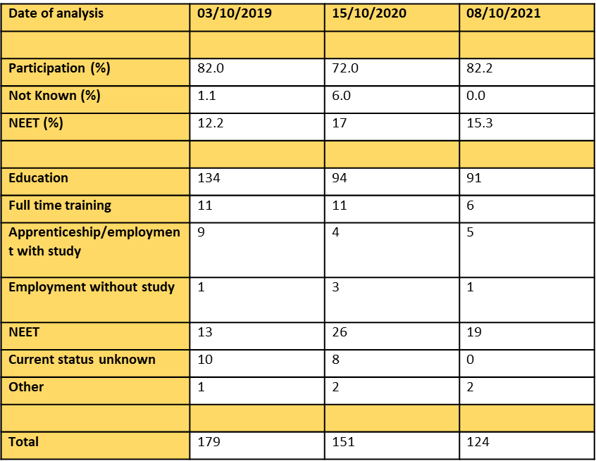
Attendance – A large number of home visits were undertaken due to Covid restrictions, Money used to support high level of home school contacts. (Pupil and staff feedback). In the academic year 2020,-21, 264 home visits for students across 19 of our Centres were undertaken by the Pastoral Support team with a specific focus on improving attendance. In our three ‘intensive support’ centres, where the proportion of PP students is very high, 70 home visits were undertaken. The overall impact of this strategy can not be determined due to Covid but in the autumn term, the direct focus on attendance resulted in a X.X% increase in attendance on the same time in the previous year.
Physical and Mental Health. - The school nurse service was not available. High number of home school contacts, Student wellbeing packs and visits. Support for Home FSM where necessary (Positive feedback from Staff, pupils and parents). Positive feedback from parents was gathered via Microsoft Office – Forms:-
https://forms.office.com/r/RP3Dnk0cHc

Inability to concentrate in classroom setting – Redirected resource to support for on line learning. Project to re-establish pupils in classroom on their return (Positive feedback from Staff, pupils and parents, improved exam results). Positive feedback from parents was gathered via Microsoft Office – Forms:-
https://forms.office.com/r/vH7td39yX3
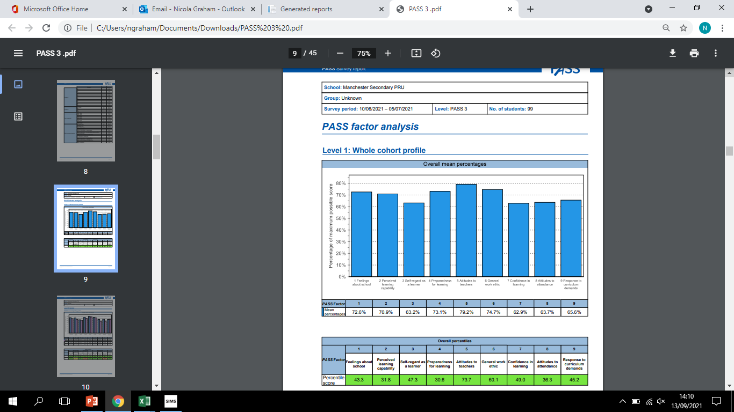
The data above shows the PASS results from around 100 students taken in summer last year. The strongest outcome was ‘Attitudes to Teachers’ and the lowest was ‘Preparedness for learning’. We will be tracking this cohort as closely as possible so that we can re-issue the PASS at a later date to compare results
Improved exam results were seen in the school’s analysis of the KS4 results:
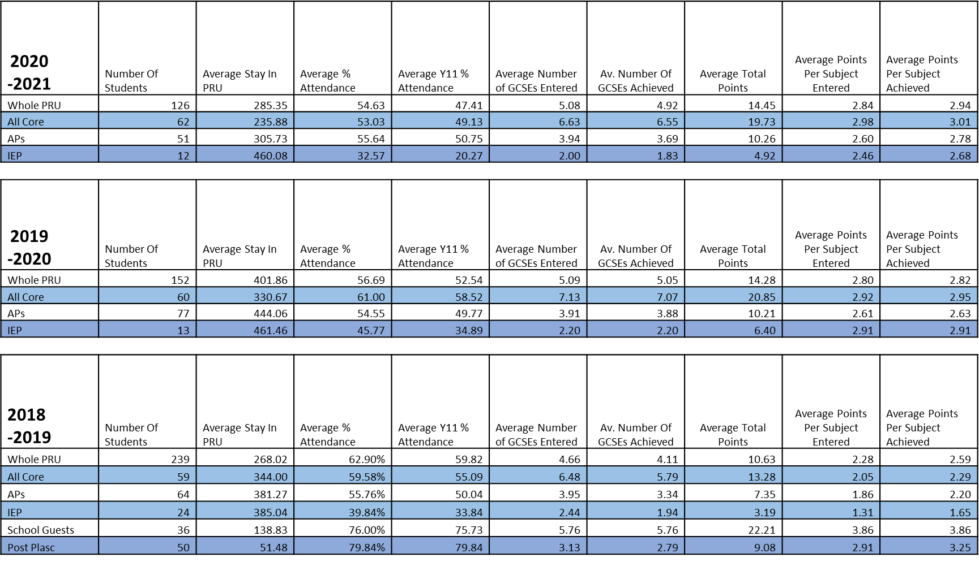
Narrowness of Curriculum – Ensured full width of curriculum to all pupils during lockdown. Enrichment activities on their return to class. (Positive feedback from Staff, pupils and parents, improved exam results)
LAC Pupils High level of support through lockdown and on return. LAC pupils supported with Post-16 transitions throughout the summer and in the autumn term. The improved outcomes for LAC pupils in 2019-20 were sustained in 2020-21 and the improvement for this group of pupils outstripped the overall improvement in outcomes (average points score). All students gained qualifications which allowed them to move on to suitable destinations (see table below).
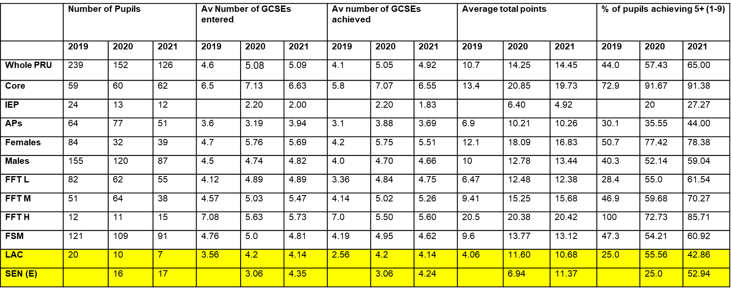
Additional individualised support of pupils during lockdown. Extra support on return. Additional CPD for all staff.

Externally provided programmes
Please include the names of any non-DfE programmes that you purchased in the previous academic year. This will help the Department for Education identify which ones are popular in England
Programme | Provider
None

Service pupil premium funding (optional)
For schools that receive this funding, you may wish to provide the following information:
Measure | Details
How did you spend your service pupil premium allocation last academic year? | n/a
What was the impact of that spending on service pupil premium eligible pupils? | n/a

Further information (optional)
There are a large number of Subsidiary Dual registered pupils who are entitled to PPG. However the money goes to their home schools. Many of these school use this money as part of the funding to place the pupils with us. As such these pupils are entitled to extra support but we receive no money to provide it.
The money we do receive is therefore used to provide support to all pupils irrespective of registration status but this is less than there should be.
Our pupils grow over the year from around 250 in September to 420 in July. The PPG being based on the October census means we do not receive funding for all our pupils. The money for those who arrive later the money will go to the school they were at in October.

