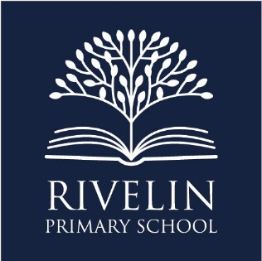
‘Excellence for every child, every day’

Wednesday 3rd September 2026
Dear Parents and Carers,
We are delighted to let you know that on Tuesday 22nd September, award-winning author and illustrator Bethan Woollvin will be visiting our Year 2 children for a special morning of art, illustration and storytelling.
As part of our Art curriculum, Year 2 will explore the question, “How do illustrators communicate ideas?” Bethan’s visit has been carefully planned to support this learning, giving the children the opportunity to learn directly from a professional illustrator about how pictures can communicate characters, emotions and stories.
During the morning, Bethan will share her journey to becoming an author and illustrator and give the children an insight into her creative process. She will show examples of her original artwork and explore the journey from an initial idea and early sketches through to a finished illustration. The children will discover how illustrators make purposeful choices, including the use of facial expressions and visual clues, to communicate meaning to their readers.
The children will then take part in Bethan’s storyboarding workshop, using Hansel and Gretel as their starting point. They will become illustrators themselves and create their own fairy tale storyboards, thinking carefully about how their pictures can communicate what happens next. Bethan will also encourage the children to experiment, refine their ideas and embrace imperfections as a natural part of the creative process.
The visit will also support our wider careers education by allowing the children to meet a practising professional and learn about what it is really like to work as an author and illustrator. We want our children to understand that the skills and creativity they develop in school can connect to exciting careers beyond the classroom.
To help cover the cost of Bethan’s visit, we kindly ask for a voluntary contribution of £7 per child. Without sufficient contributions, we may unfortunately be unable to offer this experience. Voluntary contributions can be made via School Gateway.
We are really excited to welcome Bethan back to Rivelin and know this will be a memorable experience for our Year 2 children.
Thank you, as always, for your continued support.
Kind regards,
The Year 2 Team

