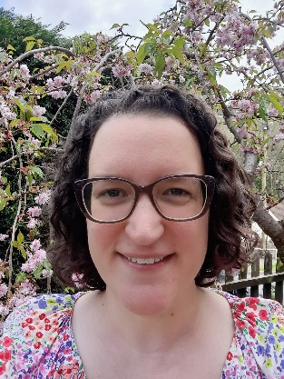
Dear Parents/Carers,
My name is Miss Gooch and I am the class teacher in nursery (FS1).
A little about me:
I have been working in schools since 2010 and I have been teaching since 2013.
I started working at Rivelin Primary School in 2014 and moved to nursery in 2018.
I love teaching in nursery – I enjoy supporting the children’s learning through play. I love sharing stories with the children and I love singing with them. I often hear from parents that the children have gone home and taught them some of the songs we sing in nursery, so you have that to look forward to!
I have recently finished an MA on autism and I am very passionate about supporting children with additional needs in early years.
I am originally from Suffolk, but I also lived in Scotland for a while, before moving to Sheffield in 2009.
I have an eight-year-old daughter and a cat called Melody. In the school holidays and on the weekends, I enjoy taking my daughter out for day trips around Sheffield or going camping. In my free time, I like to read – I read a mixture of fiction and non-fiction books. I also like going for walks when I can.
I am very much looking forward to meeting, and getting to know, your child. I am sure they will have a fantastic time in nursery and make lots of new friends.
I look forward to seeing you soon.
Miss Gooch

