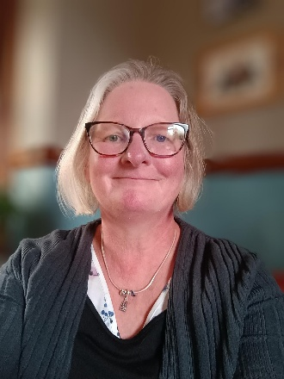Dear Parents/Carers,

My name is Miss Gartside I am a teaching assistant in the nursery at Rivelin Primary School.

I have worked in education for over 30 years and feel very fortunate to be a part of such a caring vibrant school community.

In nursery, children enjoy a free flow environment where they can choose to play and learn both inside and outside.

As a qualified Forest School leader, I am especially passionate about supporting outdoor learning. It helps children to develop confidence, resilience independence and teamwork. We are very lucky to have a wonderful outdoor area at Rivelin, and it’s a joy to see how much curiosity and creativity it inspires in the children each day. I am looking forward to continuing to support them as they grow and thrive through play exploration and discovery,

Warm regards,

Miss Gartside.