The Brow Community Primary School
Coverage of Relationship and Health Education in PSHE 2020/2021

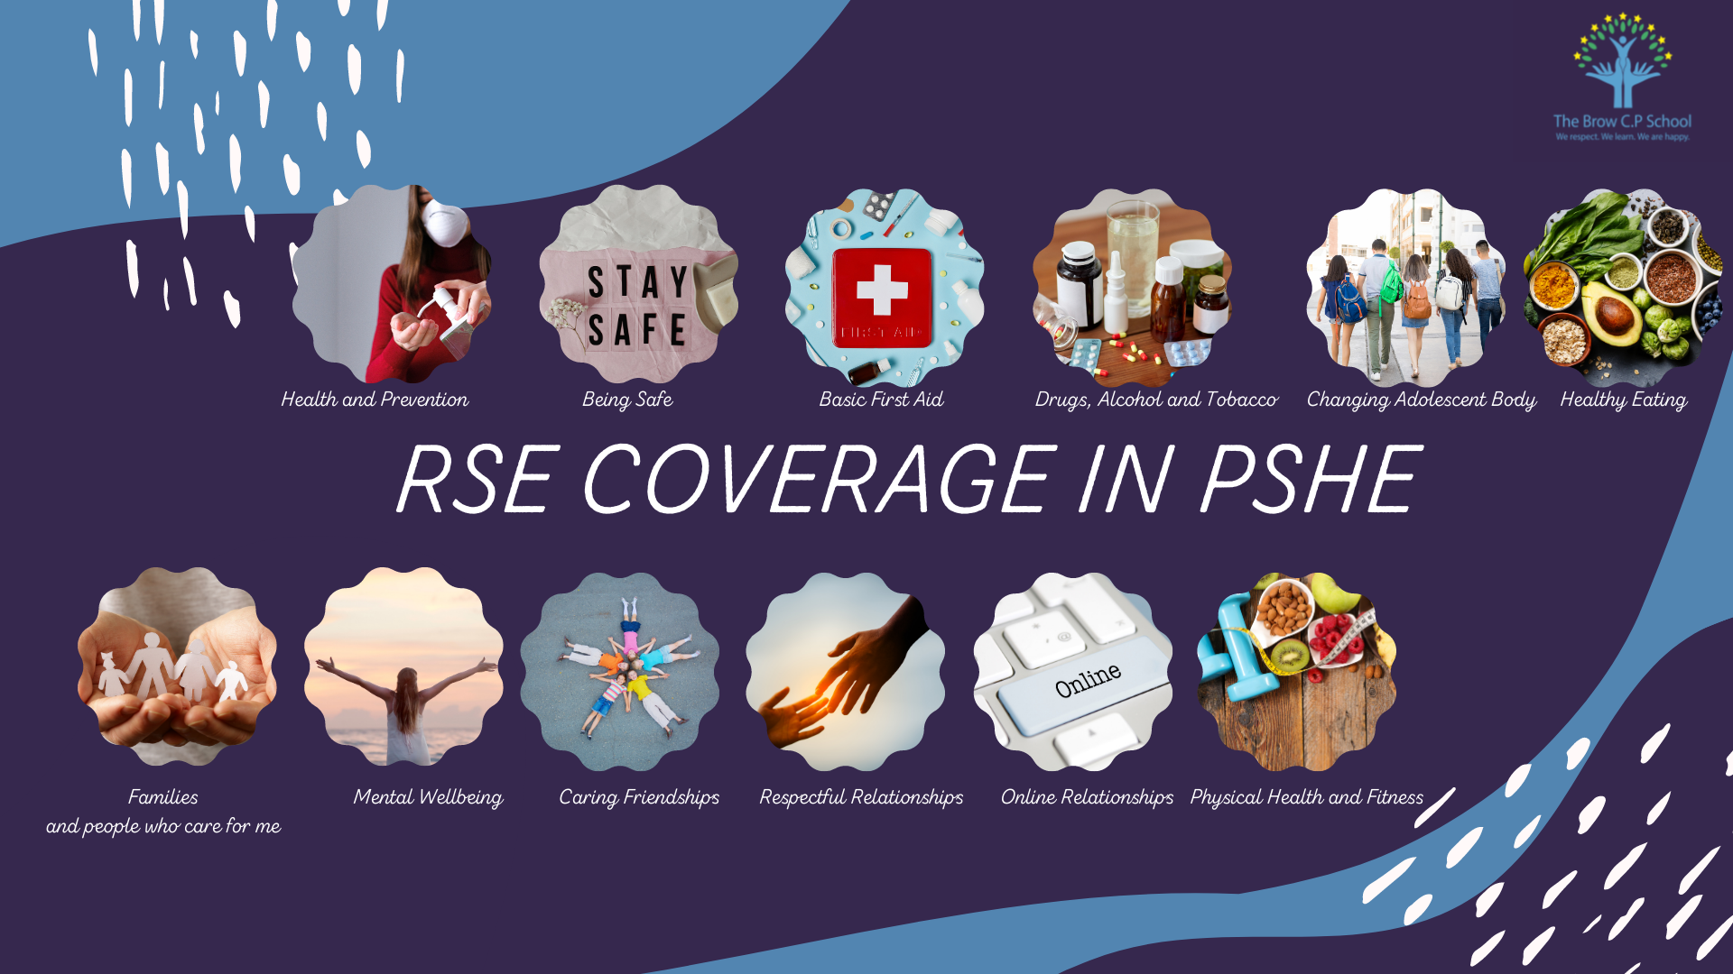
Families and people who care for me | Y1 | Y2 | Y3 | Y4 | Y5 | Y6
That families are important for children growing up because they give love, security, and stability. | Aut 2 |  | Spr1
The characteristics of healthy family life, commitment to each other, including in times of difficulty, protection and care for children and other family members, the importance of spending time together and sharing each other's lives. |  |  | Spr1 |  | Spr2
That others' families, either in school or in the wider world, sometimes look different from their family, but that they should respect those differences and know that other children's families are also characterised by love and care. |  |  | Spr1 |  | Aut 1
That stable, caring relationships, which may be of different types, are at the heart of happy families, and are important for children's security as they grow up. |  |  |  |  | Spr2
That marriage represents a formal and legally recognised commitment of two people to each other which is intended to be lifelong. |  |  |  |  |  | Sum 1&2
How to recognise if family relationships are making them feel unhappy or unsafe, and how to seek help or advice from others if needed. |  |  | Spr 1

Caring Friendships | Y1 | Y2 | Y3 | Y4 | Y5 | Y6
How important friendships are in making us feel happy and secure, and how people choose and make friends. |  | Aut 1 | Aut 1
The characteristics of friendships, including mutual respect, truthfulness, trustworthiness, loyalty, kindness, generosity, trust, sharing interests and experiences and support with problems and difficulties. | Aut 2 | Aut 2 | Spr 2 | Aut 2 | Aut 1
That healthy friendships are positive and welcoming towards others, and do not make others feel lonely or excluded. |  | Aut 1 | Aut 1
That most friendships have ups and downs, and that these can often be worked through so that the friendship is repaired or even strengthened, and that resorting to violence is never right. |  | Aut 1 | Aut 1 |  | Spr 2 | Sum 1 &2
How to recognise who to trust and who not to trust, how to judge when a friendship is making them feel unhappy or uncomfortable, managing conflict, how to manage these situations and how to seek help or advice from others, if needed. |  |  |  |  | Spr 2
Respectful Relationships | Y1 | Y2 | Y3 | Y4 | Y5 | Y6
The importance of respecting others, even when they are very different from them (for example, physically, in character, personality or backgrounds), or make different choices or have different preferences or beliefs | Aut 1&2 |  |  | Aut 2
Practical steps they can take in a range of different contexts to improve or support respectful relationships. | Aut 1&2
The conventions of courtesy and manners. |  |  |  | Aut 2
The importance of self-respect and how this links to their own happiness. |  |  |  | Aut 1
That in school and in wider society they can expect to be treated with respect by others, and that in turn they should show due respect to others, including those in positions of authority. |  |  |  | Sum 2
About different types of bullying (including cyberbullying), the impact of bullying, responsibilities of bystanders (primarily reporting bullying to an adult) and how to get help. |  | Aut 2 | Spr 2 | Aut 2
What a stereotype is, and how stereotypes can be unfair, negative or destructive. |  |  |  |  | Autumn 1
The importance of permission-seeking and giving in relationships with friends, peers and adults. |  | Aut 2 | Aut 2

Online Relationships | Y1 | Y2 | Y3 | Y4 | Y5 | Y6
That people sometimes behave differently online, including by pretending to be someone they are not. |  |  |  | Aut 2
That the same principles apply to online relationships as to face-to-face relationships, including the importance of respect for others online including when we are anonymous. |  |  |  |  | Spr 2
The rules and principles for keeping safe online, how to recognise risks, harmful content and contact, and how to report them. |  |  |  | Sum 2
How to critically consider their online friendships and sources of information including awareness of the risks associated with people they have never met. |  |  |  |  | Spr 2
How information and data is shared and used online. |  |  |  |  | Spr 2 | Spr 1&2

Being Safe | Y1 | Y2 | Y3 | Y4 | Y5 | Y6
What sorts of boundaries are appropriate in friendships with peers and others (including in a digital context). |  |  |  |  | Spr 2
About the concept of privacy and the implications of it for both children and adults; including that it is not always right to keep secrets if they relate to being safe. | Aut 1 |  | Aut 2 | Aut 2 |  | Sum 1&2
That each person's body belongs to them, and the differences between appropriate and inappropriate or unsafe physical, and other, contact. | Aut 1 |  | Aut 2 | Aut 2 |  | Sum 1&2
 | Y1 | Y2 | Y3 | Y4 | Y5 | Y6
How to respond safely and appropriately to adults they may encounter (in all contexts, including online) whom they do not know. | Sum 1
How to recognise and report feelings of being unsafe or feeling bad about any adult. | Sum 1 | Aut & Spr 2 | Aut 2  Spr 1& 2
How to ask for advice or help for themselves or others, and to keep trying until they are heard.
How to report concerns or abuse, and the vocabulary and confidence needed to do so. |  | Aut 22 |  | Aut 2  Sum 2 |  | Spr 1 & 2
Where to get advice e.g. family, school and/or other sources. |  | Aut 2 Spr 2  Sum 2 |  |  | Sum 1 | Aut 1 & 2

Physical Health and Mental Wellbeing (Health Education)
Mental wellbeing | Y1 | Y2 | Y3 | Y4 | Y5 | Y6
That mental wellbeing is a normal part of daily life, in the same way as physical health. |  |  |  |  |  | Aut 1 & 2
That there is a normal range of emotions (e.g. happiness, sadness, anger, fear, surprise, nervousness) and scale of emotions that all humans experience in relation to different experiences and situations. |  | Sum 2 |  | Spr 1 & 2 | Autumn 2 | Spring 1 & 2
How to recognise and talk about their emotions, including having a varied vocabulary of words to use when talking about their own and others' feelings. |  |  |  | Spr 1
How to judge whether what they are feeling and how they are behaving is appropriate and proportionate. |  |  |  | Spr 1
The benefits of physical exercise, time outdoors, community participation, voluntary and service-based activity on mental wellbeing and happiness. |  | Sum 1 | Sum 2 |  |  | Aut 1 & 2
Simple self-care techniques, including the importance of rest, time spent with friends and family and the benefits of hobbies and interests. |  |  |  |  |  | Aut 1&2
Isolation and loneliness can affect children and that it is very important for children to discuss their feelings with an adult and seek support. |  | Aut 1 | Aut 1
That bullying (including cyberbullying) has a negative and often lasting impact on mental wellbeing. |  | Aut 2 Sum 2 |  | Sum 2 | Spr 2
Where and how to seek support (including recognising the triggers for seeking support), including whom in school they should speak to if they are worried about their own or someone else's mental wellbeing or ability to control their emotions (including issues arising online). | Summer 1 |  | Aut 1 | Spr 1&2 | Sum 1 | Aut 1&2

Internet safety and harms | Y1 | Y2 | Y3 | Y4 | Y5 | Y6
That for most people the internet is an integral part of life and has many benefits. |  | Spr 1 |  | Sum 2 | Spr 2
About the benefits of rationing time spent online, the risks of excessive time spent on electronic devices and the impact of positive and negative content online on their own and others' mental and physical wellbeing. |  |  | Sum 2 |  |  | Aut 1 & 2
How to consider the effect of their online actions on others and know how to recognise and display respectful behaviour online and the importance of keeping personal information private. |  |  |  | Sum 2 | Spr 2
Why social media, some computer games and online gaming, for example, are age restricted. |  |  |  |  |  | Spr 1&2
That the internet can also be a negative place where online abuse, trolling, bullying and harassment can take place, which can have a negative impact on mental health. |  |  |  | Sum 2 | Spr 2
How to be a discerning consumer of information online including understanding that information, including that from search engines, is ranked, selected and targeted. |  |  |  |  |  | Spr 1& 2
Where and how to report concerns and get support with issues online. |  | Aut 2 |  | Aut 2

Physical Health and Fitness | Y1 | Y2 | Y3 | Y4 | Y5 | Y6
The characteristics and mental and physical benefits of an active lifestyle. |  |  |  |  |  | Aut 1& 2
The importance of building regular exercise into daily and weekly routines and how to achieve this; for example walking or cycling to school, a daily active mile or other forms of regular, vigorous exercise. |  |  |  |  |  | Aut 1& 2
The risks associated with an inactive lifestyle (including obesity). |  |  |  |  |  | Aut 1& 2
How and when to seek support including which adults to speak to in school if they are worried about their health. | Sum 1 | Spr 2 | Spr 1

Healthy Eating | Y1 | Y2 | Y3 | Y4 | Y5 | Y6
What constitutes a healthy diet (including understanding calories and other nutritional content). |  | Sum 1 | Sum 1 |  |  | Aut 1&2
The principles of planning and preparing a range of healthy meals. |  | Sum 1 | Sum 1 |  |  | Aut 1&2
The characteristics of a poor diet and risks associated with unhealthy eating (including, for example, obesity and tooth decay) and other behaviours (e.g. the impact of alcohol on diet or health). |  | Sum 1 | Sum 1 |  |  | Aut 1&2

Drugs, Alcohol and Tobacco | Y1 | Y2 | Y3 | Y4 | Y5 | Y6
The facts about legal and illegal harmful substances and associated risks, including smoking, alcohol use and drug-taking. | SPR 1 | Spr 2 | Aut 2 | Sum 2 | Sum 1 | Aut 1 and 2

Health and Prevention | Y1 | Y2 | Y3 | Y4 | Y5 | Y6
The importance of sufficient good quality sleep for good health and that a lack of sleep can affect weight, mood and ability to learn. |  | Sum 1 | Sum 2 | Sum 2 | Sum 1 | Aut 1& 2
About dental health and the benefits of good oral hygiene and dental flossing, including regular check-ups at the dentist. |  | Sum 1 | Sum 1 |  |  | Aut 1 & 2
About personal hygiene and germs including bacteria, viruses, how they are spread and treated, and the importance of handwashing. | Spr 1 |  | Aut 2 | Spr 2
The facts and science relating to allergies, immunisation, and vaccination. | Spr 1 |  | Aut 2

Basic First-Aid | Y1 | Y2 | Y3 | Y4 | Y5 | Y6
How to make a clear and efficient call to emergency services if necessary. |  |  |  |  | Spr 1
Concepts of basic first-aid, for example dealing with common injuries, including head injuries. |  |  |  |  | Spr 1

Changing adolescent body | Y1 | Y2 | Y3 | Y4 | Y5 | Y6
Key facts about puberty and the changing adolescent body, particularly from age 9 through to age 11, including physical and emotional changes. |  |  |  |  |  | Sum 1
About menstrual wellbeing including the key facts about the menstrual cycle. |  |  |  |  |  | Sum 2

