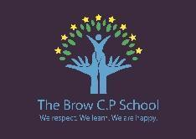
Long Term Planning 2025-2026

 |  | Autumn 1 | Autumn 2 | Spring 1 | Spring 2 | Summer 1 | Summer 2
Y1 |   P2W | Misha Makes Friends  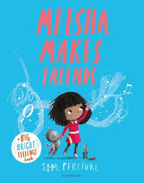 | Katie in London  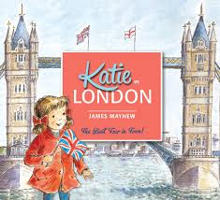 | Grandpa’s Gift  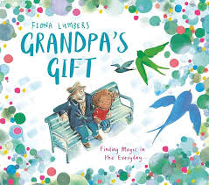 | Beegu  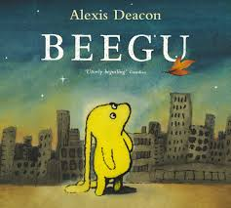 | Somebody Swallowed Stanley  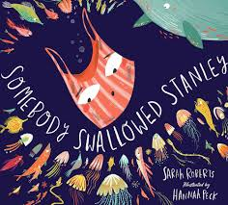 | A Midsummer Night’s Dream  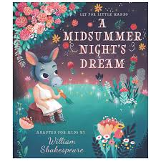
Y1 | 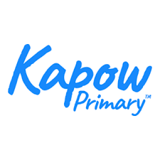  History  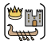 | How am I making history? |  | How have toys changed? |  | How have explorers changed the world? *
 | Geography   |  | What is it like here? |  | What is the weather like in the UK? * |  | What is it like to live in Shanghai? *
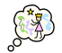
Let’s say

Science
 |   Lyfta | Keep London smiling
Y2 | P2W | Look Up!  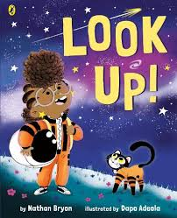 | Great Fire of London  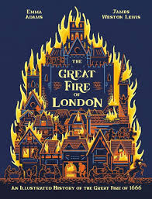 | Grandad’s Camper  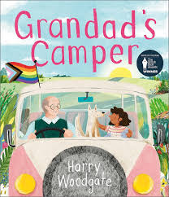 | My Name is not Refugee  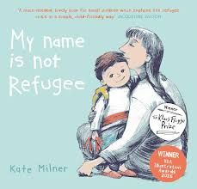 | Tidy  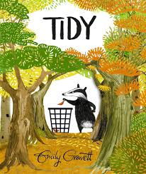 | The Tempest  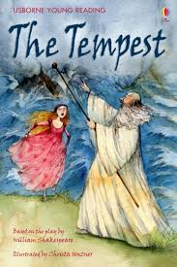
Y2 |   P2R
Y2 | History |  | How was school different in the past? |  | How did we learn to fly?* |  | What is a monarch?*
Y2 | Geography | Would you prefer to live in a hot or cold place?* |  | Why is our world wonderful? |  | What is it like to live by the coast?
 | Let’s say
 | Science
 | Lyfta | Space mission Lucy
Y3 | P2W | Seal Surfers  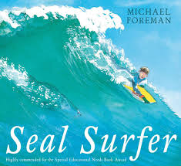 | Winter’s Child  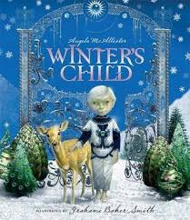 | Stoned Age Boy  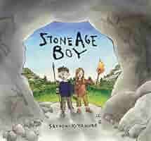 | Big Blue Whale  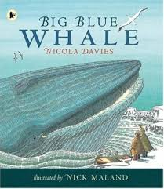 | Journey  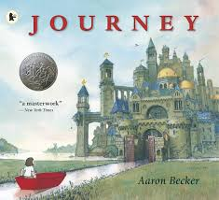 | A Stage Full of Shakespeare Stories  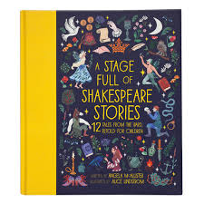
Y3 | P2R
Y3 | History |  | BH1: Would you prefer to have lived in the Stone Age, Iron Age or Bronze Age? > |  | BH2: Why did the Romans invade and settle in Britain?* |  | What was important to ancient Egyptians? *
Y3 | Geography | Why do people live near volcanoes?* |  | Who lives in Antarctica?* |  | Are all settlements the same? (New Delhi) *
 | Let’s say
 | Science
 | Lyfta | We live among volcanoes
Y4 | P2W | Counting on Katherine  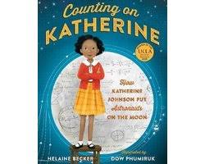 | Greek Myths  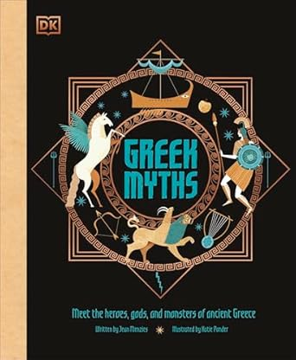 | Our Tower  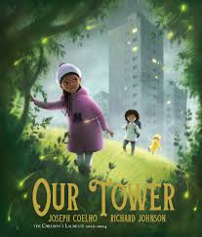 | Wisp: a Story of Hope  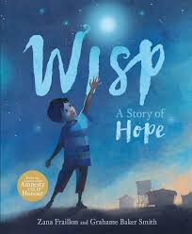 | Alba The Hundred Year Old Fish  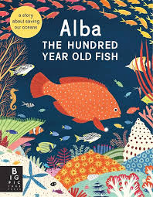 | Stage Full of Shakespeare Stories
Y4 | P2R
Y4 | History | How have children’s lives changed? (Victorians)* |  | BH3: How hard was it to invade and settle in Britain?  (Anglo Saxons) * |  |  | How did the achievements of the Maya civilisation influence their society and beyond? *
Y4 | Geography |  | Why are rainforests important to us?* |  | Where does our food come from?* | What are rivers and how are they used?
 | Let’s say
 | Science
 | Lyfta | Ethiopian treasures
Y5 | P2W | Young, Gifted and Black  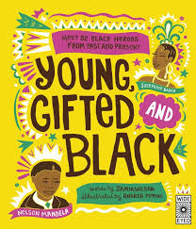 | Beowulf  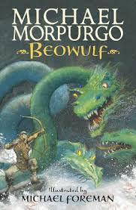 | Kai and the Monkey King  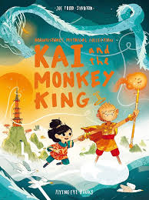 | Malala’s Magic Pencil  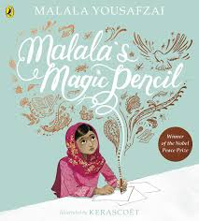 | The Brilliant Deep  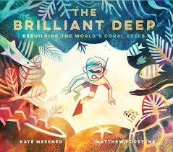 | Bold and Brave Women from Shakespeare  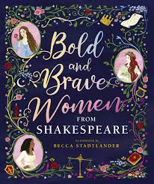
Y5 | P2R
Y5 | History | BH4: Were the Vikings raiders, traders or something else?* | BH5: What was life like in Tudor England?* |  | What is the legacy of the ancient Greek civilization?*
Y5 | Geography |  |  | What is life like in the Alps?* |  | Why do oceans matter? | Would you like to live in the desert?*
 | Let’s say
 | Science
 | Lyfta | Music is my social tool
Y6 | P2W | King Kong  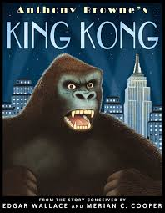 | The Place for me Windrush  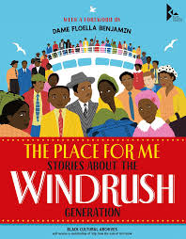 | Shackleton’s Journey  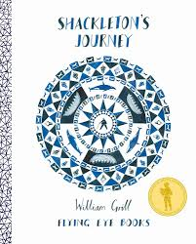 | 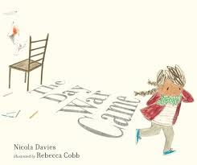 | Plastic Planet  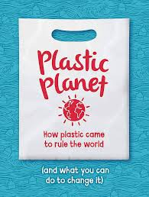 | Poetry for Kids William Shakespeare  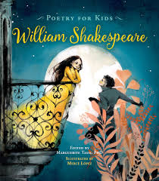
Y6 | P2R
Y6 | History | What can the census tell us about local areas? * |  |  | BH6: What was the impact of World War 2 on the people of Britain? * |  | Who should go on the banknote?
Y6 | Geography |  | Why does population change? * | Where does our energy come from? * |  | Can I carry out an independent fieldwork enquiry? *
 | Let’s say
 | Science
 | Lyfta | Guardians of the canopy

