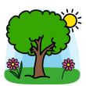
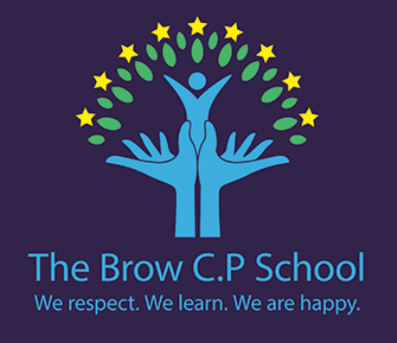

Year 2
Autumn 1
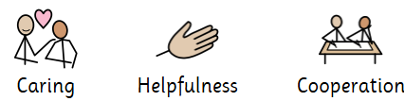
PE days:
Wednesday & Thursday

Dates to note:

8th Sep – International Literacy Day
15th Sep – International Day of Democracy
25th Sep – International Day of Languages
1st Oct – Black History Month begins
5th Oct – World Space week/Cycle to school week begins
9th Oct – World Mental Health Day
13th & 14th Oct – Parents evening

We are reading…

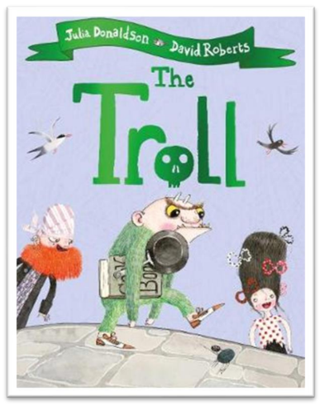
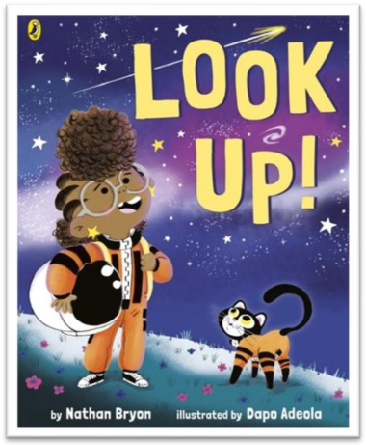

• Where are the continents and major geographical features of our world?
• What is the Equator and where is it found?
• What are the North and South Poles like?
• How are Kenya and the UK similar and different?
• What is the weather like, and how does it affect where we live?

We are asking…

In History we are asking…

Why do you think people live in very different places?
How might living near the Equator or the Poles affect people's lives?
Why might Kenya and the UK have different human and physical features?
Would you rather live in a hot or cold place?
What can we learn about a place by studying its weather and physical features?
we are Geography Explorers on a worldwide adventure with Captain Atlas! Together, we will complete exciting missions to explore, investigate and compare different places around our world.
Let’s say… Critical thinking
I can…

- I can research and select key information about a life process and present my findings clearly.
- I can classify objects into groups, giving reasons for my choices.
- I can communicate information about a habitat clearly to others.
- I can carry out research to find answers to questions.
- I can give examples of how animals and plants depend on each other.
- I can use arrows to show the order of a food chain.
I know…

- I know some of the life processes, including
movement, reproduction, sensitivity, growth.
- I know the difference between things that are living, dead, and things that have never been alive.
- I know a variety of habitats and the plants and animals that live there.
- I know how a habitat provides animals and plants with what they need to survive.
- I know how animals and plants rely on each other.
- I know how animals get their food from plants and other animals.

Writing

- Use punctuation correctly – full stops, capital letters
- Use expanded noun phrases to describe and specify
- Use subordination (because) and coordination (and)

Reading

- Make inferences on the basis of what is being said and done
- Discuss the sequence of events in books and how items of information are related

Mastery keys

Number and place value to 100
Addition and Subtraction
Maths

Science:

Geography:
I know…

- I know the names of the seven continents.
- I know the Equator is an imaginary line around the middle of the Earth.
- I know the North and South Poles are the coldest places on Earth.
- I know human features are made by people and physical features are natural.
- I know weather can be observed, measured and recorded.
- I know the climate of a place can affect what it is like to live there.

I can…

- I can locate the seven continents on a world map.
- I can locate the Equator on a map and identify two countries on it.
- I can locate the North and South Poles and identify their physical features.
- I can identify and compare human and physical features of Kenya and the UK.
- I can measure and record local weather conditions.
- I can explain why I would rather live in a hot or cold place, using features of the environment to support my choice.

Paint and mixed media: Colour mixing
My healthy self: How can we look after our bodies?

Animals: Call and response

Dance and Fundamental movement skills
Christianity: Does how we treat the world matter?

IT around us

Mechanisms: Levers
Music Computing

PSHE

RE PE

Art DT

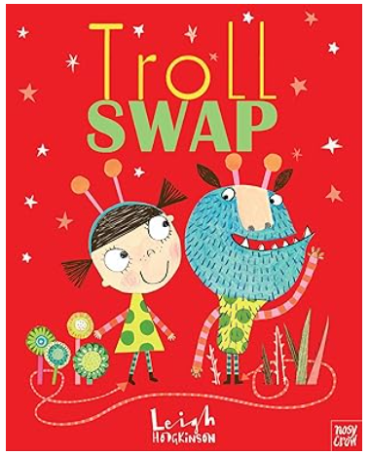
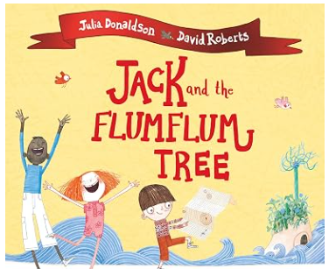
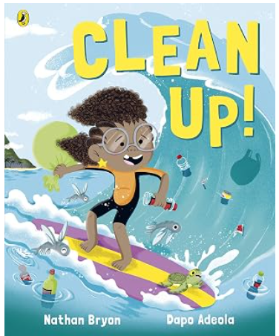
Timothy Limpet feels out of place in the troll family - he likes things to be just so, and most trolls, frankly, don't. Tabitha Lumpit likes things to be loud, loopy and messy and she feels like a fish out of water in her very neat family.
Sometimes they wonder if their families really see them for who they are, so when Timothy and Tabitha meet on the bridge they each decide the other's family is a better fit and swap places . . . with hilarious and touching results.

Jack's Granny is sick with a bad case of the moozles! And the only cure is the fruit of the flumflum tree which grows on the faraway Isle of Blowyernose. It's a perilous journey, but Jack bravely sets sail with a motley crew of three and a large patchwork sack that Granny has filled with an odd assortment of items from chewing gum to tent pegs. But what use will they be against hungry sharks, a leaky boat and a thieving monkey?
Join Rocket as she sets sail on a brand new mission - to save a Caribbean island from plastic pollution!
When Rocket goes on holiday to visit her grandparents, she's shocked by the pollution that's spoiling their island home and putting the local sea life at risk.
Can she think of a way to save the day?
If you enjoy reading Look Up and The Troll, you may also enjoy…

