
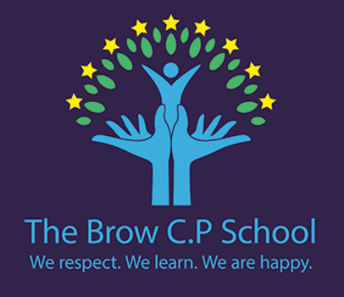

Year 3
Summer 2
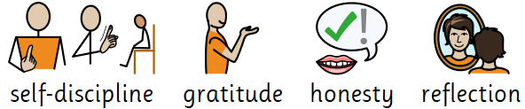
PE days:
Wednesday & Thursday

Dates to note:

29th June - INSET day
3rd July - Sports Day
10th July - Nursery Graduation
16th July - Leavers assembly/Prom
17th July - 1:30pm finish

5th June - World Environment Day
6th June - D-Day Anniversary
12th June - Coffee Morning
21st June - Fathers Day
22nd June - Make Music Day

We are reading…
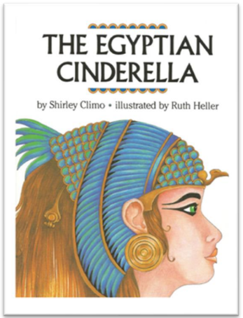
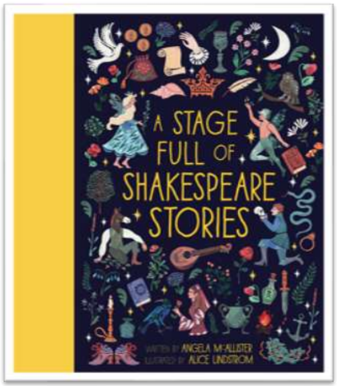

In History we are asking…

Where and when did the first civilisation appear?
Why was the River Nile so important to Ancient Egyptians?
How do we know so much about Ancient Egyptians?
What were the religious beliefs in Ancient Egypt?
What did Ancient Egyptians believe about death?

We need to work as archaeologists to unlock a mysterious Ancient Egyptian tomb.

What can artefacts and tombs tell us about what Ancient Egyptians believed?
Why did Ancient Egyptians spend so much time and effort preparing tombs for the afterlife?
What do the pyramids, mummies, and hieroglyphs tell us about everyday life in Ancient Egypt?
Why do you think Ancient Egyptian civilisation became so successful and powerful?

Let’s say… Critical thinking
Mastery keys

Maths block
Maths

Science: Rocks
Science: Making connections

Writing

Build an increasing range of sentence structures.
Use simple organisational devices including headings and subheadings to aid presentation.
Use present and past tenses correctly and consistently.
Reading

Use dictionaries to check the meaning of words that they have read
Retrieve and record information from non-fiction.
Identify main ideas drawn from more than one paragraph and summarise.
Fractions, money and time.
I can…
Plan a simple scientific investigation.
Measure, gather and record data to answer questions.
Use data to answer questions.
Make predictions and compare results.
Teach others about what I have learnt.

I know…
How muscles move the skeleton.
Rock purposes based on their properties.
The role of fruits in plant reproduction.
Some of the nutrients in fruit.
How friction helps with grip.
The best material for specific uses.
How shadows are formed.
The role of joints in the skeleton.
I know…
How archaeologists and historians use evidence.
How trade and discoveries changed civilisations.
How to make inferences from archaeological evidence.
The limitations of historical evidence.
The structure of Ancient Egyptian society.
Ancient Egyptian beliefs and how they compare to other cultures.

I can…
Use archaeological sources to ask simple questions.
Explain the significance of the River Nile.
Create a timeline.
Identify what sources suggest about Ancient Egypt.
Explore continuity and change.

Art DT
Art Computing

Music Computing
Music DT

RE PE
RE PE

Spanish PSHE
PSHE Spanish

Consolidation

Events and Actions

Traditional instruments and improvisation

Cross stitch and applique
Sikhism: Why are the Gurus important to Sikhs?

Athletics and OAA

Economic wellbeing

Journey to Latin America
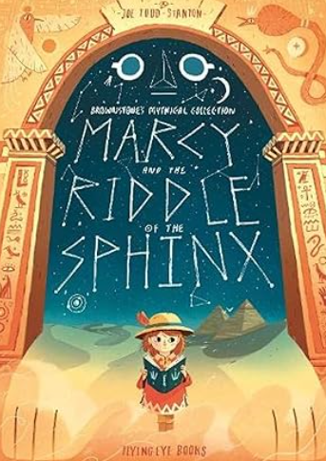
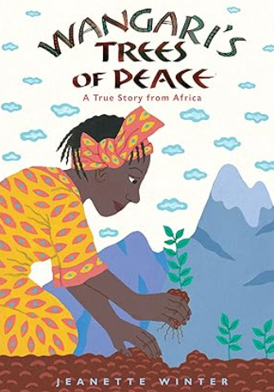
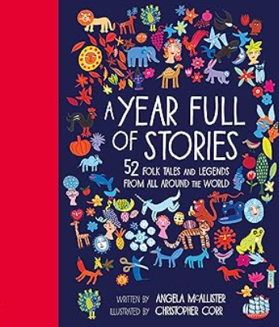
If you enjoy reading A Stage Full of Shakespeare Stories or The Egyptian Cinderella you may also enjoy…
Turn the pages and get lost in a year full of stories as you journey around the world reading tale after tale to keep storytime alive from one end of the year to the other. This rich resource collects together folk tales from home and legends and myths from distant lands to commemorate the changing seasons, cultural events and international festivals throughout the year.

As a young girl growing up in Kenya, Wangari was surrounded by trees. But years later when she returns home, she is shocked to see whole forests being cut down, and she knows that soon all the trees will be destroyed. So Wangari decides to do something—and starts by planting nine seedlings in her own backyard. And as they grow, so do her plans . . .
Many years have passed since the tale of Arthur and the Golden Rope and Arthur is now a world-famous adventurer. If only his daughter Marcy shared his enthusiasm for exploration... Determined to bring out Marcy’s adventurous side, Arthur sets off to Egypt to bring back the legendary Book of Thoth. When Arthur doesn’t return, Marcy must follow in his footsteps. Can she overcome her fears and rescue her father from the clutches of the Great Sphinx?

