WC | Reading   | Writing   | Maths  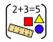 | Science   | 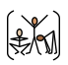  PE | Let’s Say  (subject driver: Writing ) | Geography or History   | Art or DT   | Music  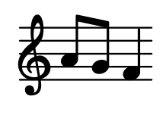 | MFL  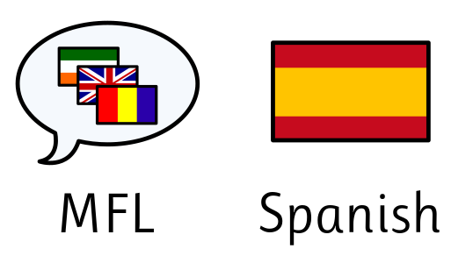 | Computing  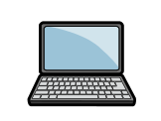 | RE   | PSHE   | Virtues
01.06.26 | Draw inferences (inferring characters’ feelings, thoughts and motives from their actions); justify with evidence    Evaluate authors’ language choice, including figurative language | Identify and Discuss Themes and Conventions  Use Relative Clauses | Finding the Whole  Using Fractions as Operators  Write decimals up to 2 Decimal Places | 1: How Do Humans Change as They Grow? | Tennis 1 – Ready Position and Racket Control  Athletics 1 – Middle Distance Running | You are part of a planning team for a new desert town. The government has asked us to design a settlement where people can survive in extreme heat. But there are problems: water is limited, food is scarce, and transport is difficult. We need your ideas.  How will you get water? Where will people live? How can we adapt to the desert environment? | What is a Hot Desert Biome? | Whole School Art Exhibition Unit | To understand that musical  theatre includes both character  and action songs, which explain  what is going on and how  characters feel. | Read and interpret locational language in a description of South America’s geography. | L4 (Carried from Summer 1) | RE 1 – Shared Human Experience: Rules and Guidance  • Why do we have rules? | L6: What Makes a Suitable Career? | Self - discipline
08.06.26 | Draw inferences (inferring characters’ feelings, thoughts and motives from their actions); justify with evidence    Evaluate authors’ language choice, including figurative language | Participate in a Performance; Speak Audibly and Fluently  Use a Wider Range of Devices to Build Cohesion | • Thousandths as Fractions  • Thousandths as Decimals  • Thousandths on a Place Value Grid | 2: What Happens During Puberty? | Tennis 2 – Forehand Shots  Athletics 2 – Throwing for Accuracy and Distance |  | Where Are Deserts Located? | Whole School Art Exhibition Unit | To know that choreography means  the organisation of steps or moves  in a dance. | Write sentences about animal habitats in South America, comparing them now and in the past. | L5 Drawing Designs  L6 (in PSHE slot) Writing and Testing Algorithms | RE 2 – Beliefs and Values: Moses and the Torah  • How did the Torah come to Jewish people? |  | Self - discipline
15.06.26 | Draw inferences (inferring characters’ feelings, thoughts and motives from their actions); justify with evidence    Evaluate authors’ language choice, including figurative language | Use Relative Clauses  Use Adverbs to Indicate Degrees of Possibility  Link Ideas Using Tense Choices | • Compare and Order Decimals (Same Number of Decimal Places)  • Compare and Order Decimals (Up to 3 Decimal Places)  • Round to the Nearest Whole Number | 3: How Long Do Babies Grow Before Birth? | Tennis 3 – Backhand Shots  Athletics 3 – Shot Put Technique |  | What Physical Features Are Found in a Desert? | Whole School Art Exhibition Unit | To know that musical theatre uses  transitions, which are short  passages of music used to move  between sections of the musical  action. | Identify causes of environmental problems in South America and possible solutions. | L1 Exploring Conditions  L2 Selecting Outcomes | RE 3 – Beliefs and Values: The Torah as a Guide to Life  • How does the Torah guide Jewish life? |  | Gratitude
22.06.26 |   Evaluate authors’ language choice, including figurative language    Identify and discuss themes and conventions    Draw inferences (inferring characters’ feelings, thoughts and motives from their actions); justify with evidence | Use Relative Clauses  Use Adverbs to Indicate Degrees of Possibility  Identify and Discuss Themes and Conventions | • Round to One Decimal Place  • Understand Percentages  • Percentages as Fractions and Decimals  Equivalent Fractions, Decimals and Percentages | 4: How Can We Investigate Asteroid Craters? | Tennis 4 – Volleying  Athletics 4 – Jumping Techniques |  | How Can People Use Deserts? | Whole School Art Exhibition Unit |  | Give instructions using imperative verbs on how to protect South America’s environment. | L3 Asking Questions  L4 Planning a Quiz | RE 4 – Living Religious Traditions: The Synagogue and Jewish Worship  • Why is the synagogue important? |  | Gratitude
29.06.26 |   Evaluate authors’ language choice, including figurative language    Identify and discuss themes and conventions    Draw inferences (inferring characters’ feelings, thoughts and motives from their actions); justify with evidence | Writeaway: Planning and Drafting  Writeaway: Writing and Editing  Writeaway: Publishing Final Piece | Perimeter of Rectangles•  Perimeter of Rectilinear Shapes (Lessons 2 & 3 combined) | 5: What Affects the Size of a Crater? | Tennis 5 – Serving and Advanced Shots  Athletics 5 – Hurdling |  | What Are the Threats to Deserts? | Whole School Art Exhibition Unit |  | Script and present an advert campaigning for action to address South America’s environmental problems. | L5 Testing a Quiz | RE 5 – Living Religious Traditions: Respecting the Torah  • How do Jewish people show respect for the Torah? |  | Honesty
06.07.26 |   Evaluate authors’ language choice, including figurative language    Identify and discuss themes and conventions    Draw inferences (inferring characters’ feelings, thoughts and motives from their actions); justify with evidence | Check and Review Learning  Performance and Presentation | • Perimeter of Polygons  • Area of Rectangles (Lessons 5 & 6 combined)  • Area of Compound Shapes  • | 6: What Can Our Investigation Tell Us? | Tennis 6 – Tennis Tactics and Competitive Play  Athletics 6 – Relay Baton Exchanges |  | Would You Like to Live in the Desert? | Whole School Art Exhibition Unit |  |  | L6 Evaluating a Quiz | RE 6 – Search for Personal Meaning: Where Do I Find Guidance?  •Where do I find guidance in my own life? | Transition Lesson | Honesty
13.07.26 |  |  | Estimate Area  Line Graphs  Tables and Two-Way Tables  Timetables |  |  |  | Mojave Desert Presentation |  |  |  |  |  |  | Reflection
 | Assessment Retrieval Review

