Getting ready for Pre School
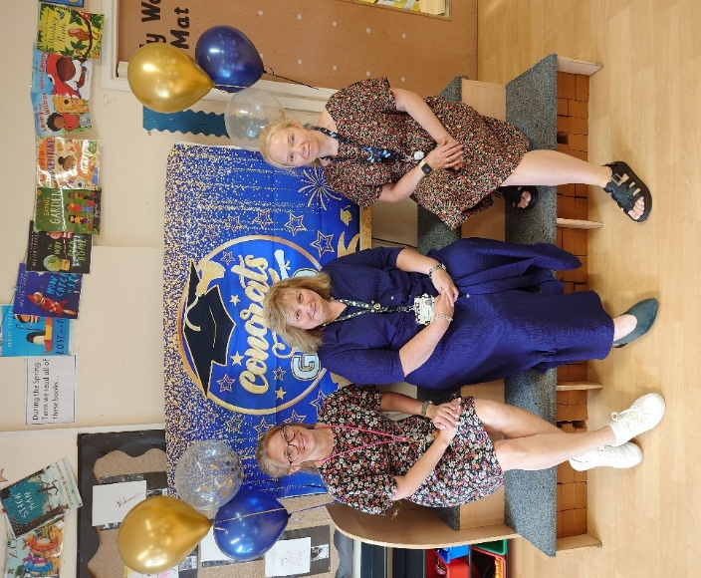
Nursery Staff - Mrs Holding, Mrs Pendlebury and Mrs Arikboga
About the team -
Mrs Pendlebury – Nursery Lead, Early Years SENCO, Thrive Licenced Practitioner.
Mrs Arikboga – Deputy Nursery Lead, WELLCOMM Lead, Paediatric First Aider
Mrs Holding – Nursery Assistant , First Aider.

Here are some helpful hints ahead of the new term.

Is your child happy to be left with a friend or relative?
Pre School can be the first time that your child stays somewhere without you. Some children are happy to do this whereas others can become upset and need support. We are an experienced team and over the years we have settled every child who has attended our pre-school.
There are some things that you can do to help your child between now and September.
1 Play hide and seek with your child – this is a fun way to show your child that they are safe even though they can’t see you – begin in the family home, extend to the garden and then visit a park or relative’s house. Let the child set the pace and only play it for as long as they feel comfortable.
2. Ask a relative or close friend/neighbour to look after your child. Start off with only 5 minutes and build it up to longer periods – this will show your child that you will always come back.
3. Prepare your child before they start – use puppets, stories , toys to act out what will happen on the first day.
4. Put a small comfort object in their bag – spray it with your perfume or aftershave so that the smell reminds them of you.
Is your child toilet trained or able to let you know that their nappy needs changing?
Every child reaches developmental milestones at different times.
Some children are fully toilet trained, independent in self-care and happy to use the toilets at Nursery. Whereas others may only just be toilet aware or not even ready to begin the process. We can support your child at whatever stage that they are at.
To help us help your child here are some things to support us.
- To enable your child to be as independent as they can please dress them in clothing that they find easy to manage – leggings/joggers, etc that aren’t too restrictive.
- Let us know how your child indicates that they need to use the toilet/need their nappy changed – words, gestures, hiding in a corner to do a poo in their nappy, a set time that they need a poo, etc.
- If your child wears nappies/pull ups, do they let you know when they need changing. Do they use gesture or words?
- If you are toilet training your child, please let a member of staff know your routine we will try where possible to do the same at Nursery.
- No matter how independent your child is there can still be toilet accidents – they become distracted, not get to the toilet in time or even be unsure of using a different toilet. Every child needs spare clothes, wipes (pull ups/nappies were appropriate) with them every day. These can be left in a bag on their peg so that we can change them into familiar clothing that smells like home.
- Toileting/Toilet training can become a battleground – if your child has a toilet accident at Nursery or is reluctant to become toilet trained, please do not be embarrassed or become anxious, they will get there.
Is your child happy to try different foods and able to feed themselves?
At Nursery we have snack each morning. We sit as a family in key person groups and children are offered a piece of fruit, a healthy carbohydrate – bagel/toast and milk or water. They are encouraged to pour water into a cup or put a straw in their milk carton.
If your child attends for 30 hours then they will eat lunch in Nursery – either a hot meal purchased from the school kitchen or a packed lunch from home.
Children are supervised by one member of staff during lunchtime and are assisted in eating. However, there are some things you can do to support their independence.
- We have 20-30 minutes to eat lunch – try not to over face your child by putting too much in their lunch box. Two small sandwiches/ or other savoury item, a piece of fruit, one treat and a drink are more than enough.
- Try to put items in packaging that your child finds easy to open.
- Practice eating from the packed lunch box so that your child is familiar with what to do.
- If your child will be eating a hot meal practice using cutlery – fork and spoon, or knife and fork.
- Remember that some foods can be a choking hazard, for example grapes need to be cut in half length ways, please check guidelines on healthy eating sites.

Is your child used to being around other children?
Attending Pre School is the perfect opportunity for your child to socialise with their peers. Some children are more than ready to play with other children, whereas others are happier to play on their own. This is a developmental process and every child is unique. We are here to support your child in their play.
During their time with us children learn ‘how to get along, how to resolve differences, share equipment and take turns’. This can sometimes lead to conflict, and it can be upsetting for you to see that your child is sad. If you are worried at any point please speak to a member of staff who will be able to reassure you and offer ways in which we can work together to support your child.

Getting messy!!
At this age children use their senses to learn through play and attending Pre School involves lots of mess – sand, water, mud, gloop, paint, play dough, shaving foam, the list is endless. Even washing their hands is messy! For this reason, we ask that children wear their Nursery uniform every day – it stops their special weekend clothes from becoming ruined. We know that it is sometimes difficult to wash paint/mud out of a white polo shirt which is why we have added a navy polo shirt to our uniform list. But if your child’s polo shirt is clean, we don’t mind if it is slightly stained from a previous painting activity that just won’t wash out.

Comfort objects
To help settle your child into Pre School you may wish to leave a favourite comfort object in their bag – cuddly toy, snuggle blanket/cloth, etc. We can then give it to them if needed. Please make sure that this object has their name on – just in case it is like another child’s comfort object.

Toys and precious objects from home
We will plan a show and tell sessions on Stay and Play days – this will give your child the opportunity to show a new toy, etc to their friends. Apart from these occasions we ask that children leave toys at home. This is for various reasons –
- A new toy/object may get lost and cause upset.
- Another child may want to play with it and not understand why they can’t which will cause upset.
- Some toys may have small parts which become choking hazards – some of our children mouth objects in play. We are aware of this, and plan activities based on which children are in session on a given day, so can minimise the risk of choking.

Labelling belongings
We try our best to keep track of every child’s belongings but it helps us enormously if your child has their name written on their bag, uniform, coat, shoes, wellies, etc. It only needs to be written in pen on the label – just remember to re write it when it starts to wash off.

Stay and Play sessions
On the last Friday of each month during term time Pre School and Reception Class hold Stay and Play sessions. This is an opportunity for you to join your child at Pre School from 9:00-10;30am. The dates for the next academic year are –
- Friday 26th September
- Friday 24th October
- Friday 28th November
- Friday 30th January
- Friday 27th February
- Friday 27th March
- Friday 24th April
- Friday 22nd May
- Friday 26th June
In addition, we plan to hold special activity mornings – one or two per term where Pre School parents can join their child for the morning. These dates will be available at the beginning of the new term.

We hope that these suggestions have been helpful. If you need to chat to us at any time throughout the year please approach any member of the team, we will be only too happy to help you. We are looking forward to the next year but for now enjoy the Summer.

Kind regards
The Nursery Team.

