
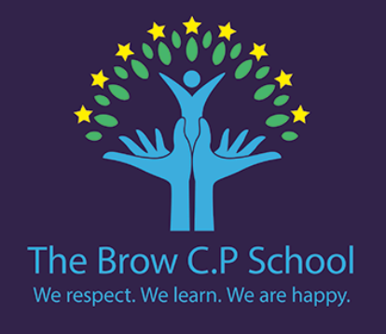

Year 3
Summer 1
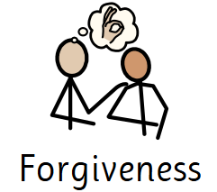
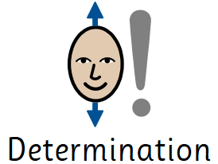
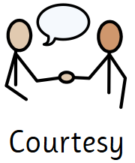
PE days:
Wednesday & Thursday

Dates to note:

23rd April - St George’s Day
28th/29th April - Parent’s evening
4th May - Bank Holiday
8th May - VE Day
11th May - KS2 SATs week begins

We are reading…

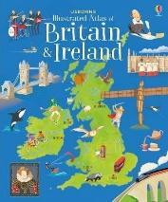
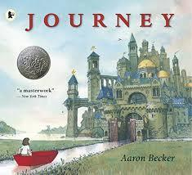

In History we are asking…

What is a settlement and why do people live in them?
How is land used in our local area?
How can we describe where things are in our settlement?
How and why do settlements change over time?
How is land use in New Delhi similar to and different from our local area?

What might happen if land in a settlement was not organised properly?
Are changes in settlements always a good thing? Why or why not?
Is it better to live in a busy city or a quieter area? Why?
If you were the aliens, where and how would you build your settlement on Earth?

Let’s say… Critical thinking

Aliens need our help to build a settlement on Earth.

Mastery keys

Maths block
Maths

Science: Rocks
Science: Plant reproduction

Writing

Use adverbs and conjunctions to express time, place and cause.
Group related ideas into paragraphs.
Use accurate tense.
Use a or an correctly.

Reading

Retrieve and record information.
Identify how language, structure and presentation contribute to meaning.
Use dictionaries to check the meaning of words.

Fractions, length and perimeter and mass and capacity.
I can…
Ask testable questions and plan how to answer them.
Design a simple table and gather results.
Plan a simple enquiry and evaluate it.
Complete, read and interpret data from a bar chart.
Use results to draw conclusions.

I know…
Plants need air, water, light, nutrients and space to grow
Different parts of flowering plants and their functions.
Parts of the plant involved in water transport and how water travels through a plant.
The role of flowers in pollination and fertilisation.
Effects of different variables on plant growth.
different ways that seeds are dispersed
I know…
What a settlement is and can name different types of settlements. Land is used in different ways in a settlements. How to describe where places are in my local area using maps and simple directions. Settlements change over time and can give examples of how and why. What land use is like in New Delhi. How New Delhi is similar to and different from my local area.

I can…
Identify settlements on aerial photographs and OS maps.
Identify the human and physical features in the local area.
Suggest reasons for the location of the features.
Identify how land use in my local area has changed and begin to discuss why. Locate features on a map. Compare land use in two different locations.

Art DT
Art Computing

Music Computing
Music DT

RE PE
RE PE

Spanish PSHE
PSHE Spanish

Egyptian Artwork

Sequence in music

Jazz

Wearable technology
Christianity: What do Christians mean by the ‘holy spirit’?

Football and rounders

Citizenship

Where do I live?
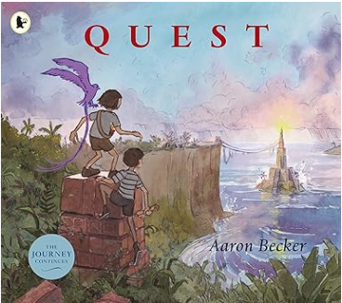
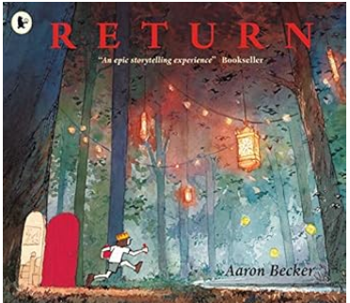
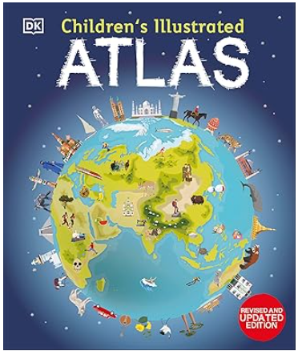
If you enjoy reading Journey or the illustrated atlas of Britain and Ireland you may also enjoy…
In the city park, two friends are startled by the sudden appearance of a king, who thrusts into their hands a map and some strange objects. But before he can explain, the king is captured by enemy forces and whisked back into his enchanted world. Just like that, the girl and boy are caught up in a wild dash to rescue the mysterious monarch.

Failing to get the attention of her busy father, a lonely girl turns back to a fantastic world for friendship and adventure. It’s her third journey into the enticing realm of kings and emperors, castles and canals, exotic creatures and enchanting landscapes. But this time, it will take something truly powerful to persuade her to return home.
Discover the world map-by-map with this exciting world atlas book for children, featuring more than 50 maps! Each page is filled with fascinating information, facts and colourful illustrations of our world.

