Spr 2
W/ | Theme days/  Whole school events | Reading   | Writing   | Maths  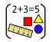 | Science   |   PE | Let’s Say  (subject driver: ) | History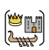 | Art or DT     | Music  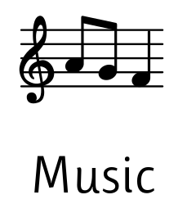 | MFL  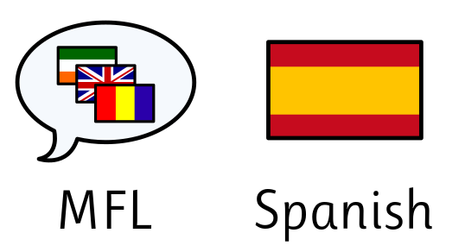 | Computing     | RE | PSHE   | Virtues
23.02 |  | Session 1  Identify how language, structure and presentation contribute to meaning Distinguish between fact and opinion | Session 1 Organise Paragraphs Around a Theme (Make predictions and ask questions about a text.)  Session 2 Use Relative Clauses (Gateway Letter)  Session 3 - Use Commas to Clarify Meaning and Avoid Ambiguity | Fractions Lesson 10  Fractions Lesson 11  Unit 7 Multiplication and Division L1  Geometry - Starter Lesson 1 and 2 | Missed due to Art Lesson | To learn and perform the Haka  (Missed due to Crucial Crew) | Let’s say the head gardener at Chester Zoo, is panicking because none of the rare flowers in the tropical greenhouse are producing seeds’ | Lesson 1 - Who were the Ancient Greek’s | Drawing - Lesson 1: Expressing movement  DT - Lesson 1 - gears | Composition to represent the festival of colour  Lesson 1 +2 | Food - likes and dislikes | Missed Due to Crucial Crew | What is a Miracle? | Lesson 1 Breaking the Law | Self-discipline
2.03 | World Book Day 05.03.26  Int Women’s Day | Session 2  Identify how language, structure and presentation contribute to meaning Distinguish between fact and opinion  World Book Day activities | S4 Extend Sentences Using a Wider Range of Conjunctions  S5 Use Brackets to Indicate Parenthesis.  S6  Use a Variety of Verb Forms Correctly and Consistently. | Geometry - Lesson 3+4 | L1 Life Cycles and Reproduction in Plants | develop an individual section to add to last lesson’s Haka  Skittle ball- signal with my hands to receive a pass | “Let’s say a gardener at Chester Zoo can’t work out why her flowers aren’t making seeds.” | Lesson 2-  Who lived on Mount Olympus? | Drawing - Session 2: Showing emotion  DT lesson 2 - improving gears | lesson 3 + 4 | Lesson 2 - preferences | 1. Creating a paper-based database | Miracles Performed by Jesus | Lesson 2 Rights and Responsibilities
09.03 | British Science Week Mother’s Day | Session 3  Identify how language, structure and presentation contribute to meaning Summarise the main ideas from more than one paragraph, identifying key details Distinguish between fact and opinion | S7 link ideas across paragraphs using adverbials of time, place and number. (Letter in Role)  S8 use brackets and commas accurately to indicate parenthesis.  (Diary refinement.)  S9 To Extend Sentences Using a Wider Range of Conjunctions for Cohesion | Geometry - Lesson 5+ 6 | Life Cycle of a Mammal | To develop a 22 second pairs section using a picture as a stimulus | “Let’s say a vet in the Lake District finds a baby mammal and doesn’t know its life stage.” | Lesson 3 - How was Ancient Greece governed? | Session 3 - Showing depth  Lesson 3 - Pulleys | Session 5 | Lesson 3 Cafe conversation | 2. Computer databases | Important Journeys and Places for Christians | Lesson 3 Protecting the Planet | Gratitude
16.3 | Neurodiversity Celebration  St Patrick’s Day  Eid  World Poetry Day | Session 4  Identify how language, structure and presentation contribute to meaning Summarise the main ideas from more than one paragraph, identifying key details Distinguish between fact and opinion | S10 To Organise Paragraphs Around a Theme  S11To Identify and Apply the Key Features of an Autobiography  S12 Link Ideas Across Paragraphs Using Adverbials of Time, Place and Number | Geometry - end of unit/journal | Life Cycle of a Bird | To work in small groups and start to develop a 20 second small group section using chance choreography | “Let’s say a ranger in Delamere Forest finds eggs and doesn’t know what happens next.” | Lesson 4 - Did the Ancient Greeks give us democracy? | Lesson 4 - Composition for printing  DT Lesson 4+5 - Market research and design |  | Lesson 4 +5 - personalised pizza | Using a Database | My Views on Miracles | Lesson 4: Contributing to the Community | Honesty
23.03 | Assessment Week | NFER | S13 Apply a Variety of Verb Forms Consistently in Extended Writing  S14 Use Relative Clauses and Parenthesis Accurately Within Extended Writing  S15 Edit Writing by Checking All Mastery Keys for Accuracy and Cohesion | NFERs | Life Cycle of an Amphibian and Insect  Asexual Reproduction in Plants | To finalise and perform our small group section | Let’s say a scientist at a pond in Runcorn can’t explain why the frogs are disappearing.” | Lesson 6 and retrieval | Lesson 5 - Printing |  |  | Using Search Tools  Comparing Data (Visually/In Real Life) | Class Debate | Lesson 5: Pressure Groups  Lesson 6: Parliament

Lesson 5: Multiply a 4-digit number by a 2-digit number
(Pages 24–27)

Lesson 6: Divide a number up to 4 digits by a 1-digit number (1)
(Pages 28–31)

Lesson 7: Divide a number up to 4 digits by a 1-digit number (2)
(Pages 32–35)
Lesson 8: Divide with remainders
(Pages 36–39)

Lesson 9: Efficient division
(Pages 40–43)

Lesson 10: Solve problems with multiplication and division)
Fractions unit introduction & fluency
(Pages 50–51)

Lesson 1: Multiply unit fractions by an integer

Lesson 2: Multiply non-unit fractions by an integer
Multiply mixed numbers by integers (1)

Lesson 4: Multiply mixed numbers by integers

Lesson 5: Fraction of an amount

