Spring 2
Week  Beginning | Theme days/  Whole school events | Reading   | Writing    Planning in route map created with JC | Maths  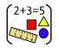 | Science   | 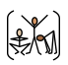  PE | Let’s Say  (subject driver: ) | Geography or History   | Art or DT     | Music  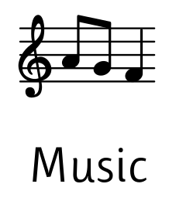 | MFL  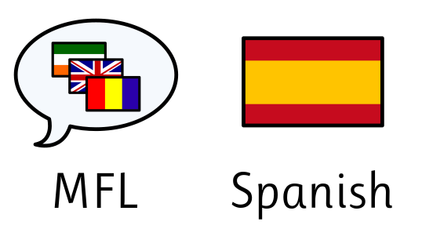 | Computing   | RE   | PSHE   | Virtues
23.02.26 |  | Mastery Keys:  Draw inferences (inferring characters’ feelings,  thoughts and motives from their actions); justify  with evidence | 1. Gateway write  Assess application  of previously  taught skills  2.  Expanding noun phrases | Division of 2 and 3 digit numbers  Length and Perimeter Lessons 1-3 | How are sounds made? | Gymnastics and Health Related Fitness |  | How can our food choices impact the environment? | Painting techniques | What is Samba music? | How can I read a Spanish menu? | How can I answer questions using data? | Jesus in the wilderness | What are Human Rights? | Patience
02.03.26 |  | Mastery Keys: Draw inferences (inferring characters’ feelings,  thoughts and motives from their actions); justify  with evidence | 1.  Choosing pronouns to avoid repetition  2.  Expanding noun phrases | Length and perimeter Lessons 4-6  Fractions lessons 1 -2 | How are sounds heard? | Gymnastics and Health Related Fitness |  | What does it mean to trade responsibly? | Still life composition | How can I play a syncopated rhythm? | How can I order Spanish food and drink? | How can I collect data? | Am I willing to make sacrifices? | How can I care for the environment? | Patience
09.03.26 |  | Mastery Keys: Discuss words and phrases that capture the  reader’s interest and imagination | 1.  Using inverted commas to punctuate speech  2.  Using commas after fronted adverbials | Fractions Lessons 3 -7 | What is the relationship between vibration strength and volume? | Gymnastics and Health Related Fitness |  | How do we get our chocolate? | Mindful moments - market research | How can I play a syncopated rhythm as part of a group? | Can I have a casual conversation? | How can I log data? | How do we express commitment? | What is my role in the community? | Respect
16.03.26 |  | Mastery Keys: Discuss words and phrases that capture the  reader’s interest and imagination | Planning writeaway.  1.Paragraphing  2.Rich vocabulary  3.Expanded noun phrases | Fractions 8-9  Fractions 2  Lessons 1 -3 | What is the relationship between volume and distance? | Gymnastics and Health Related Fitness |  | Where does our food come from? | Mindful moments - Design stage | How can I compose a basic rhythm? | Ordering the menu of the day | How can I analyse data? | What are the five pillars of Islam? | How can I contribute? | Respect
23.03.26 |  | Mastery Keys: Discuss words and phrases that capture the  reader’s interest and imagination | Writeaway to assess skills taught. | Fractions 2 Lessons 4 - 8 | What is pitch?  How can sounds be muffled? | Gymnastics and Health Related Fitness |  | Is it better to buy local or import food? | Mindful Moments - Creating | Performing | Performing | How can I use data to answer a question? | Why do Muslims fast during Ramadan? | What is a diverse community? | Reflection
23.03.26 | Assessment Week

