


Year 2
Autumn 2
W
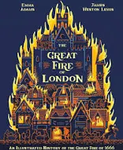
We are reading…
In History, we are asking…

Dates to note:

•How have schools changed over time?
What are the similarities and differences between schools in the 1900s and schools now?
Would you prefer to go to schools in the 1900s or schools today?

Wednesday 5th November - Safety Central Trip
Monday 10th November – Anti-bullying week
Friday 14th November- Children in Need
Monday 17th November- Maths Week
Friday 21st November – Rockstars Day

Our virtues this half term are…

History- How was school different in the past?
I can…  - Sequence photographs, focusing on the intervals between events.  - Recognise things that have changed/ stayed the same as the past.  - Use a source to answer questions about the past.  - Make comparisons with my own life. | I know…  - A decade is 10 years.  - Beyond living memory is over 100 years ago.  - That there are explanations for similarities and differences between children’s lives in the past and today.  - Historians use evidence from sources to find out more about the past.
Art | DT
Sculpture and 3D: Clay houses | Food and Nutrition: A balanced diet.
Music | Computing
Orchestral instruments (traditional stories) | Digital Photography
RE | Spanish
Christianity: Why do Christians say Jesus is the light of the world? | Let’s sing!
PSHE |  | PE
Families and relationships  Health and Wellbeing |  | Yoga  Gymnastics

Let’s Say… | Critical Thinking
Grandma Dorris hasn’t been to school in over 50 years. She wants to find out what schools are like today. | How might school have been different 50 years ago?  What is the same and what is different?
Writing Mastery Keys | Maths Blocks
- Adverbs  - Using and, but, or to join sentences  - Using commas | - Addition  - Subtraction  - Geometry- properties of shapes
Science- Living Things: Microhabitats
I can…  - Raise simple questions about the world around me.  - Recognise the different enquiry types.  - Predict what might happen during an experiment.  - Observe and record my results from an experiment. | I know…  - A microhabitat is a very small habitat.  - That living things depend on each other.  - A variety of plants and animals and describe some differences.

If you enjoy reading The Great Fire of London, you may also enjoy…

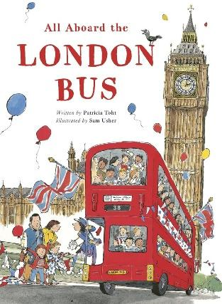
Come! Board the London Bus
and see the London sights with us.
At any time, hop off, explore!
Then climb back on, and ride some more…
As a family of four spend a day exploring London, fun, child-friendly poems introduce readers to our wonderful capital city, and all its secrets. Well-known landmarks like Buckingham Palace, Big Ben and the London Eye, plus inescapable features like rain and taking tea, all get Patty Toht’s witty treatment.

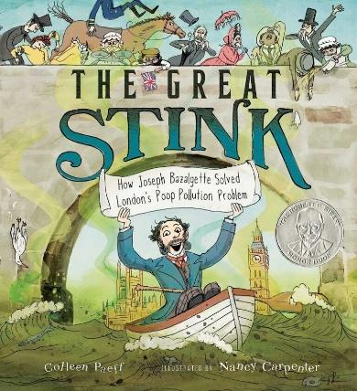
Discover the true story about the determined engineer who fixed London’s pollution problem in this funny, accessible nonfiction picture book.
It’s the summer of 1858, and London’s River Thames STINKS. What is creating this revolting smell? The answer is gross: the river is full of poop.
But the smell isn’t the worst problem. Every few years, cholera breaks out, and thousands of people die.
One engineer dreams of making London a cleaner, healthier place. His name is Joseph Bazalgette. His grand plan to create a new sewer system to clean the river is an engineering marvel.

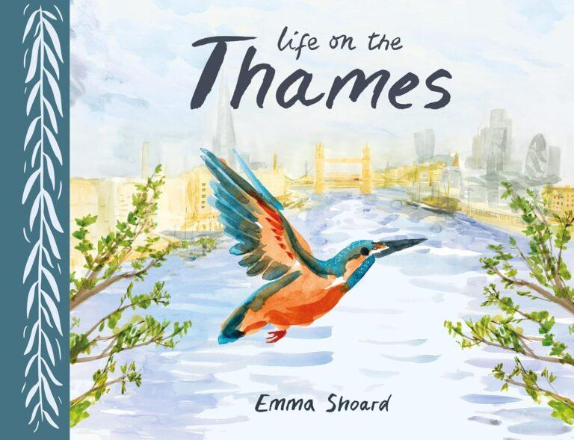
A gorgeously illustrated journey along one of Britain’s most well-known rivers. The Thames sustains a staggering number of birds, mammals and other creatures. Learn about them in-depth as you progress from the source of the river to its estuary.

