SPECIAL EDUCATIONAL NEEDS

AND DISABILITIES (SEND) AND

INCLUSION POLICY

St John the Evangelist CE Primary School

“Following Jesus’ example, we seek to grow good people who are ready to make a difference to the world around them.”

“The only thing that matters is faith expressing itself through love.”
(Galatians 5:6)



DOCUMENT CONTROL
Item | Details
Title | SEND and Inclusion Policy
Status | Statutory
Author | Kay Hartley Clarke SENCO
Responsible Officer | Mark Harrison Head teacher
Link Governor | Louise Tweedie SEND Governor
Ratified by Governing Body | December 2026
Date Approved | December 2026
Review Date | September 2027
Review Cycle | Annual
Version | 2026

Contents
- Vision and Values
- Aims
- Legislative Framework
- SEND Information Report
- Definition of SEND
- Principles of Inclusion
- Ordinarily Available Inclusive Provision (OAIP)
- Reasonable Adjustments
- Early Identification
- The Cheshire East Graduated Approach
- SEN Support and Inclusion Plans (SSIP)
- Ongoing Record of Action (ORA)
- Co-production
- Neurodiversity-Affirming Practice
- Education, Health and Care Needs Assessments (EHCNAs) and EHCPs
- Attendance, Wellbeing and Emotional Based School Non-Attendance (EBSNA)
- Inclusion Priority Groups
- Early Help, Family Help and Families First
- Workforce Development
- Admissions
- Supporting Pupils with Medical Conditions
- Roles and Responsibilities
- Educational Inclusion
- Transition Arrangements
- Accessibility
- Complaints
- Monitoring and Evaluation
- Desired Outcomes
- Appendix A: Governor SEND Compliance Checklist
- Appendix B: Key Reference Documents
- Appendix C: Statutory and Strategic Reference Documents

1. Vision and Values
At St John the Evangelist CE Aided Primary School, we believe that every child is uniquely valued as a child of God and deserves to be welcomed, included, supported and enabled to flourish.
Our Christian vision informs all decisions relating to SEND and inclusion. We believe that every child is created in the image of God and has inherent dignity, worth and potential.
“Following Jesus’ example, we seek to grow good people who are ready to make a difference to the world around them.”
“The only thing that matters is faith expressing itself through love.”
(Galatians 5:6)
We are committed to creating a culture where all children belong, achieve and thrive regardless of need, background or starting point.
In keeping with our Christian values, we believe every child is known, loved and valued by God. We are committed to ensuring all children and young people belong, achieve and thrive through inclusive practice, high aspirations, equitable opportunities and meaningful participation in school life.
Our work reflects Cheshire East's vision that inclusion is everyone's responsibility and aligns with the SEND and AP One Plan commitment to delivering the right support, in the right place and at the right time.

Inclusion is embedded throughout: | We are committed to ensuring every pupil experiences:
- Leadership  - Teaching and learning  - Curriculum design  - School culture  - Relationships  - Community engagement | - Belonging  - Achievement  - Participation  - Safety  - Positive relationships  - Wellbeing  - Independence

2. Aims
The school aims to:
- Promote a culture of inclusion, belonging and high expectations.
- Identify needs at the earliest opportunity.
- Deliver high-quality adaptive teaching.
- Provide effective Ordinarily Available Inclusive Provision.
- Remove barriers to learning and participation.
- Implement reasonable adjustments proactively.
- Use a graduated response to support.
- Promote co-production with pupils and families.
- Work collaboratively with external services.
- Support pupils academically, socially and emotionally.
- Ensure pupils with SEND are fully included in school life.
- Promote positive outcomes through early intervention.
- Meet all statutory requirements.
We particularly seek to support:
- Pupils with SEND
- Neurodivergent pupils
- Pupils experiencing EBSNA
- Looked After Children
- Previously Looked After Children
- Young carers
- Other vulnerable learners

3. Legislative Framework
This policy is written in accordance with:
- Children and Families Act 2014
- SEND Code of Practice: 0-25 Years January 2015
- Equality Act 2010
- SEND Regulations 2014
- Education Act 1996
- Data Protection Act 2018
- Keeping Children Safe in Education
- Supporting Pupils with Medical Conditions at School
The policy is informed by:
- Cheshire East Inclusion Strategy 2025-2028
- Cheshire East SEND and AP One Plan 2025-2028
- Cheshire East Toolkit for Inclusion
- Cheshire East Local Offer
- Cheshire East Families First Partnership Programme
- SEND and Alternative Provision Improvement Plan: Right Support, Right Place, Right Time
- SEND and Alternative Provision Roadmap
- Working Together to Safeguard Children
The policy reflects national and local reforms intended to ensure earlier intervention, stronger inclusion, improved accountability and better outcomes for children and young people with SEND.

4. SEND Information Report
The Governing Body publishes an annual SEND Information Report on the school website.
The report outlines:
- Identification procedures
- Provision available in school
- The Graduated Approach
- Transition arrangements
- Accessibility arrangements
- Partnership with families
- External agency involvement
- Links to the Cheshire East Local Offer

5. Definition of SEND
A pupil has SEND if they have a learning difficulty or disability which calls for special educational provision to be made for them.

SEND may relate to one or more of the following areas:
Communication and Interaction  - Speech, Language and Communication Needs  - Autism | Cognition and Learning  - Dyslexia  - Dyscalculia  - Dyspraxia  - Moderate Learning Difficulties
Social, Emotional and Mental Health  - Anxiety  - Emotional regulation difficulties  - Attachment difficulties  - Trauma-related needs | Sensory and Physical Needs  - Hearing impairment  - Visual impairment  - Physical disability  - Medical needs

6. Principles of Inclusion
"Everyone supporting the learning, wellbeing and safety needs of all our children so that they belong, achieve and thrive." Cheshire East Inclusion Strategy 2025- 2028
In line with Cheshire East's Inclusion Strategy, the school recognises that inclusion is built from universal support upwards, is led through an inclusive culture, is strengthened through collaboration with families and partner agencies, and is measured through positive outcomes for children and young people.
The school adopts Cheshire East's inclusion principles:

The Inclusion Strategy  Inclusion is built from universal support upwards | High-quality teaching forms the foundation for all support.
Inclusion is a culture led by leadership | Leaders actively promote inclusive values and practice.
Inclusion is strengthened through collaboration | Schools, families and professionals work together.
Inclusion is measurable | Progress is monitored through clear indicators, targets and outcomes.

7. Ordinarily Available Inclusive Provision (OAIP)
The school uses the Cheshire East Toolkit for Inclusion and Cheshire East OAIP guidance as the foundation of inclusive practice.
All pupils are entitled to high-quality teaching and inclusive classroom experiences.
OAIP may include:
- Adaptive teaching
- Scaffolding
- Visual supports
- Flexible grouping
- Explicit instruction
- Manipulatives
- Reduced cognitive load
- Sensory adaptations
- Communication supports
- Environmental adjustments
- Assistive technology
- Structured routines
- Additional resources
- Pre-teaching and overlearning
Teachers are expected to implement OAIP consistently for all learners before considering additional interventions.
OAIP forms the foundation layer of Cheshire East's graduated approach. Toolkit for Inclusion Inclusion strategy for Cheshire East 2025 - 2028

8. Reasonable Adjustments
The school recognises its duties under the Equality Act 2010.
Reasonable adjustments will be: | Adjustments may include:
- Anticipatory | - Modified teaching approaches
- Proactive | - Adapted classroom layouts
- Individualised | - Communication support
- Needs-led | - Alternative recording methods
- Reviewed regularly | - Reduced sensory demands
 | - Flexible attendance arrangements
 | - Alternative social arrangements
 | - Assessment access arrangements
 | - Increased adult support
 | - Assistive technology
A diagnosis is not required before adjustments are made.
The school recognises that reasonable adjustments are part of its anticipatory duty under the Equality Act and seeks to remove barriers to participation at the earliest opportunity. SEND AP

9. Early Identification
The school recognises the importance of early identification.
Needs may be identified through:

- Assessment information  - Teacher observations  - Attendance data  - Parent concerns | - Professional advice  - Screening tools  - Pupil voice  - Wellbeing monitoring
Identification does not depend upon a formal diagnosis.

10. The Cheshire East Graduated Approach
The school adopts the Cheshire East Graduated Approach as the framework for identifying, assessing, planning, delivering and reviewing support.
Support begins with:

Universal Provision
- Ordinarily available inclusive provision
- Quality-first teaching
- Reasonable adjustments

Targeted Support
- Additional evidence-based interventions
- Support from Cheshire East Experts at Hand
- Cheshire East Schools Forum referral
- Inclusion Specialist service professional development

Specialist Support
- Additional evidence-based interventions
- Support from Cheshire East Experts at Hand
- Cheshire East Schools Forum advice and monitoring

The school operates a continuous
Assess → Plan → Do → Review cycle.
Evidence is recorded through:
- SEN Support and Inclusion Plans (SSIPs)
- Ongoing Records of Action (ORAs)
- Review meetings
- Provision maps
- Parent and pupil voice

11. SEN Support and Inclusion Plans (SSIP)
Where required, the school will use a Cheshire East SEN Support and Inclusion Plan.
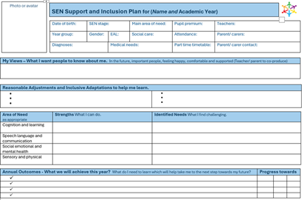 | The SSIP records: | SSIP holistic goals:
 | - Strengths  - Needs  - Outcomes  - Provision  - Adjustments  - Review arrangements | - Young person centred  - Co- Produced  - Preparing for adulthood led  - Inclusion and solution focussed
A one page profile followed by a page for each Assess Plan Do Review Cycle.

12. Ongoing Record of Action (ORA)
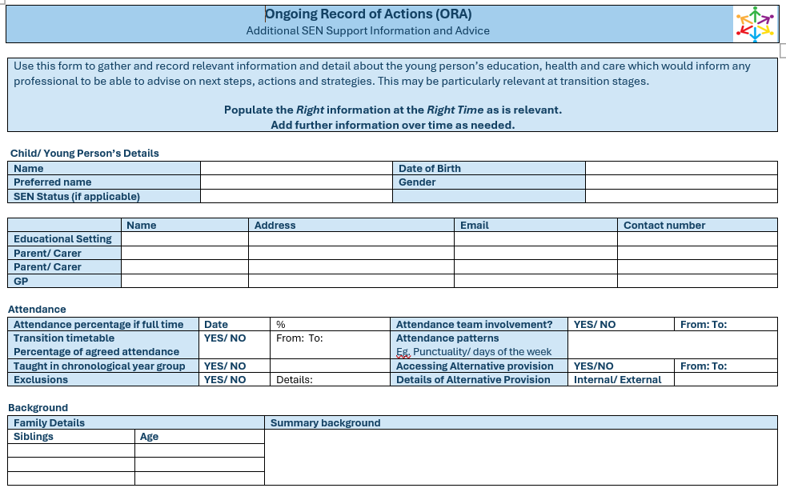 | The ORA provides evidence of:
- Assessment over time
- Provision over time
- Progress over time
- Reviews
- Expert at hand advice sought
- Impact
13. Co-production
Children and families are equal partners.
The school will:
- Collate and listen to pupil voice
- Value parent expertise
- Agree outcomes collaboratively
- Build on strengths
- Promote informed decision making

14. Neurodiversity-Affirming Practice
The school adopts a strengths-based approach. It recognises that neurodevelopmental differences do not require a formal diagnosis before support is implemented.
We recognise and celebrate differences in:
- Learning
- Communication
- Attention
- Sensory processing
- Social interaction
Support seeks to remove barriers rather than change identity.

15. Education, Health and Care Needs Assessments and EHCPs
Most pupils will have needs met through OAIP and SEN Support.
Support exists across a continuum:
- Universal
- Targeted
- Complex
Where appropriate the school, parents or young people may request an Education, Health and Care Needs Assessment.
Where an EHCP exists the school will:
- Deliver specified provision
- Monitor progress
- Convene annual reviews
- Support successful transitions
- Promote full inclusion

16. Attendance, Wellbeing and EBSNA
The school recognises that attendance difficulties may arise because of SEND.
The school follows Cheshire East guidance regarding Emotional Based School Non-Attendance (EBSNA).
We will:
- Seek to understand barriers
- Work collaboratively with families
- Promote belonging
- Implement graduated support
- Focus on inclusion rather than sanctions
17. Inclusion Priority Groups

In line with the Cheshire East Inclusion Strategy, particular attention is given to: | Support is coordinated through
- Pupils with SEND  - Neurodivergent pupils  - Pupils experiencing EBSNA  - Children in Care  - Previously Looked After Children  - Young Carers  - Pupils with SEMH needs  - Pupils supported through Family Help  - Pupils supported through Early Help  - Pupils at risk of suspension or exclusion | - The Graduated Approach  - Inclusive classroom practice  - Experts at hand collaboration  - Family partnership  - Early intervention

18. Early Help, Family Help and Families First
The school supports the Families First Partnership Programme.
Support may involve | We promote
- Early Help  - Family Help  - Family Hubs  - Education services  - Health services  - Social Care | - Prevention  - Early intervention  - Family partnership  - Child-centred practice  - Multi-agency working

19. Workforce Development
The school is committed to continuous professional development.
Training priorities include
- Inclusion  - OAIP  - Adaptive teaching  - Neurodiversity  - EBSN | - Families First  - Trauma-informed practice  - The Graduated Approach  - Reasonable Adjustments

20. Admissions
The school welcomes applications from all pupils including those with SEND.
The school complies with:
- Equality Act 2010
- School Admissions Code

The school will not discriminate against a child or young person because of disability or special educational needs and will make reasonable adjustments in accordance with the Equality Act 2010.

21. Supporting Pupils with Medical Conditions
Where SEND and medical needs coexist, support will be coordinated through:
- SEND Support
- Individual Healthcare Plans
- Multi-agency working

The school will comply with the statutory guidance Supporting Pupils at School with Medical Conditions and will ensure that pupils with medical needs have access to education, including through Individual Healthcare Plans where appropriate.

22. Roles and Responsibilities

Governing Body
The Governing Body will:  - Monitor SEND provision  - Ensure statutory compliance  - Appoint a SEND Governor  - Review pupil outcomes  - Ensure accessibility duties are fulfilled  - Monitor strategic inclusion priorities | Governors will monitor implementation of:  - SEND Code of Practice  - Equality Act 2010  - Cheshire East Inclusion Strategy  - Cheshire East SEND & AP One Plan  - Families First principles | Governors will receive reports relating to:  - Attainment  - Progress  - Attendance  - Persistent absence  - EBSNA  - Suspensions  - Exclusions  - Family engagement  - Belonging  - HAPI outcomes
School
Headteacher  The Headteacher will:  - Lead inclusion strategically  - Ensure implementation of this policy  - Monitor impact  - Deploy resources effectively  - Promote an inclusive culture | SENCO  The SENCO will:  - Coordinate SEND provision  - Liaise with families and agencies  - Support staff  - Maintain records  - Monitor outcomes  - Lead reviews  - Coordinate SSIPs and ORAs | Class Teachers  Teachers remain responsible for:  - Identification  - Adaptive teaching  - Delivery of provision  - Monitoring progress  - Working with families
Every teacher is a teacher of every child.

23. Educational Inclusion
The school seeks to ensure all pupils:
- Experience belonging
- Access a broad and balanced curriculum
- Participate fully in school life
- Access enrichment opportunities
- Develop independence

24. Transition Arrangements
The school recognises the importance of successful transitions.
Support may include:
- Transition visits
- Information sharing
- Multi-agency planning
- Additional familiarisation visits
- Enhanced transition programmes

25. Accessibility
The school maintains and publishes an Accessibility Plan which forms part of the school's Public Sector Equality Duty responsibilities.
The plan identifies actions to:
- Improve curriculum access
- Improve physical access
- Improve access to information
- Reduce barriers to participation

The Accessibility Plan is published on the school's website and reviewed annually by leaders and at least every three years by governors.
Progress is reported to governors and informs school improvement planning.

26. Complaints
The school seeks to resolve concerns quickly, fairly and collaboratively.
Parents should: | Independent support is available through:
- Speak with the Class Teacher  - Contact the SENCO  - Contact the Head Teacher  - Follow the School Complaints Procedure | - Cheshire East SENDIASS  - Cheshire East Local Offer  - Mediation Services  - Disagreement Resolution Services

Parents retain the right to appeal SEND decisions through the First-tier Tribunal (Special Educational Needs and Disability) where applicable.

Where appropriate, parents may contact the Local Government and Social Care Ombudsman.
The school is committed to resolving concerns at the earliest opportunity through open communication and co-production.
27. Monitoring and Evaluation

Provision will be evaluated through:
- Progress data
- Attendance information
- Pupil voice
- Parent voice
- Review meetings
- Provision audits
- Governor monitoring
- Inclusion self-evaluation
- SSIP and ORA reviews

The SENCO will report outcomes annually to governors.

28. Desired Outcomes

In line with Cheshire East's HAPI framework, we aim for children to be:

H – Happy and Healthy

A – Achieving their Potential

P – Part of their Communities

I – Independent as possible, making choices about their future

The school seeks to ensure every child experiences: | Success will be measured through:
- Belonging  - Achievement  - Participation  - Wellbeing  - Safety  - Positive relationships  - Inclusion  - Independence | - Academic progress  - Attendance  - Participation  - Wellbeing  - Engagement  - Independence  - Family engagement  - Successful transitions  - Pupil voice  - Parent voice

The school will monitor the extent to which pupils experience a genuine sense of belonging, inclusion and participation through surveys, reviews, attendance information and engagement in the wider life of the school. This reflects Cheshire East's vision that children should belong, achieve and thrive.

APPENDIX A

Governor SEND Compliance Checklist

Area | Yes | No | Evidence
SEND Policy reviewed annually | □ | □
SEND Information Report current and published on website | □ | □
Accessibility Plan published | □ | □
Local Offer link maintained | □ | □
OAIP embedded across school | □ | □
Graduated Approach embedded | □ | □
SSIPs used appropriately | □ | □
ORAs evidence support and impact | □ | □
Reasonable adjustments implemented | □ | □
SEND attendance monitored | □ | □
EBSNA guidance implemented | □ | □
Families First principles embedded | □ | □
Parent voice collected | □ | □
Pupil voice collected | □ | □
SEND outcomes improving | □ | □
Accessibility Plan reviewed | □ | □
SEND training delivered | □ | □
HAPI outcomes evaluated | □ | □

APPENDIX B

Key Reference Documents
- SEND Code of Practice 0-25 Years
- Children and Families Act 2014
- Equality Act 2010
- SEND Regulations 2014
- Keeping Children Safe in Education
- Supporting Pupils with Medical Conditions
- Working Together to Safeguard Children
- Cheshire East Inclusion Strategy 2025-2028
- Cheshire East SEND and AP One Plan 2025-2028
- Cheshire East Toolkit for Inclusion
- Cheshire East Local Offer
- Cheshire East Families First Partnership Programme
- SEND and Alternative Provision Improvement Plan
- SEND and Alternative Provision Roadmap
- Public Sector Equality Duty Guidance

APPENDIX C

Statutory and Strategic Reference Documents

National Legislation
- Children and Families Act 2014
- Equality Act 2010
- Education Act 1996
- SEND Regulations 2014
- Data Protection Act 2018

Statutory Guidance
- SEND Code of Practice 0-25 Years
Keeping Children Safe in Education
- Supporting Pupils at School with Medical Conditions
- School Admissions Code
Working Together to Safeguard Children

SEND Reform
- SEND Reform: putting children and young people first
- SEND and Alternative Provision Improvement Plan: Right Support, Right Place, Right Time
- Every child achieving and thriving
- Radical guidance in rights for children with SEND
- Solving the SEND crisis

Cheshire East Documents
- Cheshire East Inclusion Strategy 2025-2028
- Cheshire East SEND and AP One Plan 2025-2028
- Cheshire East Local Offer
- Cheshire East Toolkit for Inclusion
- Cheshire East Families First Partnership Programme
- Cheshire East Family Hubs
- Cheshire East SENDIASS

Additional Guidance
- Public Sector Equality Duty Guidance

GOVERNING BODY APPROVAL

Responsible person | Approval
Head teacher

SENCO

SEND Governor

Chair of Governors

Monitoring | Date
Date Ratified

Review Date | September 2027
Next Review

