St John the Evangelist CE Aided Primary School

SEND Information Report

Academic Year: 2026-2027



Welcome

At St John the Evangelist CE Aided Primary School, we believe every child is uniquely valued as a child of God and deserves to be welcomed, included, supported and enabled to flourish.
Our Christian vision underpins all aspects of our provision:

"Following Jesus' example, we seek to grow good people who are ready to make a difference to the world around them."
"The only thing that matters is faith expressing itself through love." (Galatians 5:6)

We are an inclusive mainstream primary school with an early years setting for children from age 2 to 11.

We encourage all pupils to develop independence, communication, self-advocacy, community participation and life skills appropriate to age. Preparing for adulthood begins in the early years and is embedded throughout school life.
In line with The Cheshire East Inclusion Strategy, we are committed to ensuring every child experiences
- Belonging  - Achievement  - Participation  - Wellbeing | - Safety  - Positive relationships  - Independence

This report explains how we support children and young people with Special Educational Needs and Disabilities (SEND) and how we work in partnership with families to ensure that all children belong, achieve and thrive.

- What are the Admission Arrangements for children who have special educational needs?
St John the Evangelist CE Aided Primary School admits pupils with SEND in accordance with the Equality Act 2010, School Admissions Code and Cheshire East admissions arrangements. No child will be refused admission on the basis of SEND where the school can reasonably meet need within mainstream provision

2. What kinds of SEND does the school provide for?
We cater for children with a wide range of needs who are able to access mainstream curriculum through ordinarily available inclusive provision and reasonable adjustments.
We support pupils across the four broad areas of need identified within the SEND Code of Practice:

Communication and Interaction
Including:
- Speech, Language and Communication Needs (SLCN)
- Autism

Cognition and Learning
Including:
- Dyslexia
- Dyscalculia
- Dyspraxia
- Moderate Learning Difficulties

Social, Emotional and Mental Health
Including:
- Anxiety
- Emotional regulation difficulties
- Attachment needs
- Trauma-related needs

Sensory and Physical Needs
Including:
- Hearing impairment
- Visual impairment
- Physical disabilities
- Medical conditions
We recognise that many children may experience needs across more than one area.
You can access the school SEND policy using the following link: 20219570_page_file.docx

1. How are pupils taught?
In accordance with the SEND Code of Practise, 2025 we believe every teacher is a teacher of every child. Including those with SEND.
At St John the Evangelist, we have a graduated approach to supporting the learners of our school community.
Universal Targeted Specialist
Universally, all pupils access ordinarily available inclusive teaching:
- High-quality teaching
- An ambitious curriculum
- Inclusive classroom practice
- Adaptive teaching strategies
Teachers remain responsible for:
- Planning learning
- Delivering support
- Monitoring progress
- Reviewing outcomes
The SENCO supports staff through advice, coaching and collaboration.

4. What is Ordinarily Available Inclusive Provision (OAIP)?
Ordinarily Available Inclusive Provision forms the foundation of support for all pupils.
Examples include:
- Adaptive teaching  - Visual supports  - Structured routines  - Flexible grouping  - Scaffolding  - Assistive technology | - Communication-friendly classrooms  - Sensory adaptations  - Reduced cognitive load  - Pre-teaching of vocabulary  - Additional models and worked examples  - Manipulatives and practical resources
These approaches are available before additional or different provision is considered.

2. What should I do if I think my child needs extra help?

If you have a concern about your child’s learning you should first discuss it with your child’s class teacher who will be able to support you with what to do next. A meeting with the school SENCO can be arranged and a plan put in place to address your concerns.

3. How does the school identify children who may have SEND?
Early identification is essential.
Concerns may be identified through:
- Teacher observations
- Assessment data
- Pupil progress meetings
- Attendance monitoring
- Wellbeing monitoring
- Parent concerns
- Pupil voice
- SENCO led Screening and assessment tools
- Advice from Experts at Hand
A formal diagnosis is not required before support is put in place.
We recognise that children may require support even when diagnosis pathways are ongoing.

3. How does the school assess and review SEND provision?
The school follows Cheshire East's Graduated Approach.
If we feel your child requires support additional to and different from the ordinarily available curriculum for a period of time, we may place them on the school’s special educational needs (SEN) register at SEN Support. This means we can closely monitor and review the progress your child is making in relation to intervention and support we may provide.
Support is reviewed through a continuous:
Assess → Plan → Do → Review cycle.
This includes:

Assess
- Gathering information from teachers, parents and pupils
- Reviewing assessment information
- Identifying strengths and barriers

Plan
- Agreeing outcomes
- Identifying strategies and support
- Recording adjustments and interventions

Do
- Delivering provision
- Implementing agreed adaptations
- Monitoring impact

Review
- Evaluating progress
- Gathering pupil and parent views
- Updating next steps
Progress is reviewed at least termly through SEN review meetings.
Once a child’s needs have been met and any gaps in learning have closed

5. How will you teach and support my child with SEND?
Here at St John the Evangelist, we teach pupils in accordance with Cheshire East’s Local Area wide offer. It is our aim that all children are given opportunity to access inclusive learning opportunities. Our priority is to provide high quality class teaching to all pupils. To achieve this we use a variety of approaches to scaffold learning so that every child has equal opportunity for learning.
Where a child requires support which is additional to or different from ordinarily available provision, targeted support is put into place and they may be placed at SEN Support for the period of time their difficulties are present.
The school has a wide range of intervention programmes available to support children who require support which goes beyond class based approaches.
Some of these intervention approaches are published or commercially available packages of support, such as IDL, Boxall Profile, Sensory Circuits, Nessy fingers, Motor Skills United.
Others are bespoke/personalised approaches based on best practice guidance, for example social skills groups, comic strip and social stories.
Wider support
In some cases, we may involve advice from specialist professionals as part of our Experts at Hand offer. Your child’s needs may be discussed at an inclusion forum meeting or related training may be accessed through a Specialist Inclusion cluster meeting. This advice and its impact will be recorded on a SEN Support & Inclusion Plan and also an Ongoing Record of Action document.
It may be necessary to refer your child to health care for specialist assessments. Our head teacher and SENCO will advise and work with you and support the processes involved.

SEN Support and Inclusion Plan (SSIP)
SSIPs are developed collaboratively with pupils and parents.
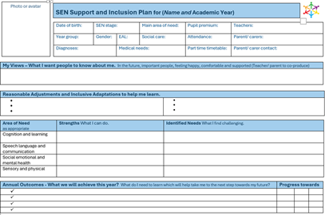 | The SSIP records: | SSIP holistic goals:
 | - Strengths  - Needs  - Outcomes  - Provision  - Adjustments  - Review arrangements | - Young person centred  - Co- Produced  - Preparing for adulthood led  - Inclusion and solution focussed
A one page profile followed by a page for each Assess Plan Do Review Cycle.
A fresh SEN Support plan is begun every three cycles or each year.

Ongoing Record of Action (ORA)
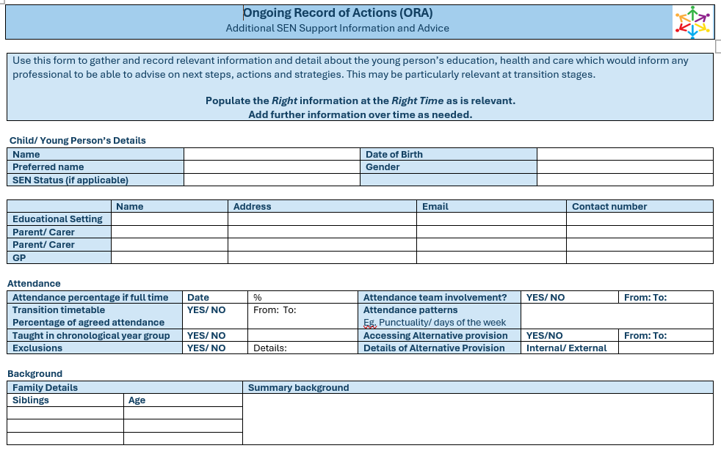 | The ORA provides evidence of:
- Assessment over time
- Provision over time
- Progress over time
- Reviews
- Expert at hand advice sought
- Impact
The Ongoing Record of Action tracks your child throughout their school career.
It is shared with each setting they attend.

6. How are parents involved?
We believe families are equal partners in education. We welcome communication from parents about children in all aspects of life skills development including strengths, needs, community involvement and achievements.
In relation to your child’s SEND journey, it is essential parents contribute through:
- Regular communication with staff
- Parent consultations
- Review meetings
- SEN Support reviews
- Annual reviews for EHCPs
- Family meetings
- Early Help processes where appropriate
Parents are encouraged to share their views throughout decision-making and planning as part of the assess, plan, do review process management of SEN Support plans.

7. How are pupils involved?
Pupil voice is central to our approach.
Children are encouraged to contribute through:
- One-page profiles
- SEND reviews
- Pupil discussions
- Surveys
- Draw-and-write activities
- My Support conversations
- Target setting discussions
We seek to understand:
- What is important to the child
- What helps them learn
- What barriers they experience
- Their aspirations and goals

9. What adaptations are made to the curriculum and learning environment?
Adaptations may include:
- Visual timetables
- Alternative ways of recording
- Assistive technology
- Additional processing time
- Chunked instructions
- Modified resources
- Quiet workspaces
- Sensory supports
- Flexible grouping
- Communication aids
- Structured playground support
Reasonable adjustments are implemented in accordance with the Equality Act 2010 and do not require a diagnosis to be in place.

10. What expertise and training do staff have?
Staff receive ongoing professional development relating to:
- SEND
- Inclusion
- Adaptive teaching
- Cognitive load
- Neurodiversity
- Autism
- Speech and language development
- SEMH needs
- Trauma-informed approaches
- Emotional Based School Non-Attendance (EBSNA)
- Families First
- Cheshire East Graduated Approach
The Head teacher and SENCO coordinates SEND provision and supports staff development across the school.

11. How does the school evaluate the effectiveness of provision?
We monitor:
- Academic progress
- Wellbeing
- Attendance
- Participation
- Pupil voice
- Parent voice
- Behaviour information
- Engagement in school life
- Successful transitions
Provision is evaluated through:
- SSIP reviews
- ORA reviews
- Provision mapping
- Learning walks
- Pupil progress meetings
- Governor monitoring

12. How are children enabled to participate in all aspects of school life?
We aim for every child to be fully included.
This includes:
- Educational visits
- Residential experiences
- Lunchtime activities
- Clubs
- Worship
- Sporting events
- Leadership opportunities
- Enrichment activities
Adjustments are made wherever necessary to remove barriers to participation.

13. What support is available for emotional wellbeing and mental health?
We recognise that emotional wellbeing supports learning. We have a designated Mental Health lead and a school Family Support Worker.
We nurture whole school emotions understanding and management through the Zones of Regulation programme and implement the Kapow PSHE programme which includes the mental health strand.
Additional wellbeing and mental health provision may include:
- Nurture approaches
- Trusted adults
- Emotional literacy support (ELSA)
- Pastoral support
- Regulation strategies
- Attendance support
- Early Help
- EBSNA support plans
- Family support
We work closely with families to understand barriers and build successful strategies.

14. What specialist services do we work with?
Where appropriate, the school may seek advice from a range of services:
Cheshire East Inclusion Specialists and experts at hand:
- Educational Psychology Service
- Cheshire East Autism Team
- Cheshire East Sensory Inclusion Team
- Inclusion Quality Team
- Inclusion Specialist Advisory Teachers
- Transition Officer
Cheshire East Health care services:
- Speech and Language Therapy
- Occupational Therapy
- Sensory Processing Occupational Therapy service
- Physiotherapy
- CAMHS – My Minds
- School Nursing Service
Cheshire East Family Care services
- Family Help Services
- Social Care
Under the Experts at Hand model, we work collaboratively with designated professionals to ensure joined-up support.

15. What arrangements exist for Education, Health and Care Plans (EHCPs)?
Most pupils have their needs successfully met through inclusive classroom practice and SEN Support.
Where a higher level of support is required, an Education, Health and Care Needs Assessment may be required. The decision to submit a request for a local authority needs assessment is collectively made through the SEN Support assess plan do review process. Needs and difficulties of a child will be ongoing and persistent despite adjustments and interventions which will have been put in place. The school will have demonstrated that it has used and reviewed the resources ordinarily available to meet a child's needs and sought specialist advice as part of the graduated approach.
EHCP Annual Review
Annual reviews seek the views of the child, parents and professionals and consider progress towards outcomes, continued appropriateness of provision and preparation for future transitions.

For pupils with an Educational Health and Care Plan, the school will:
- Deliver specified provision
- Monitor outcomes
- Hold annual reviews
- Work closely with families
- Coordinate professional involvement
- Support successful transitions
For local authority support around EHCPs and processes, take a look at the Education, Health and Care Assessment and Plans page on Livewell.

16. How do we support transitions?
When a child transitions, it may be they are starting school for the first time, beginning a new school within the school year, moving to a new key stage or transitioning to a whole new school phase.
We recognise that transitions can be challenging for some children. We work closely with Cheshire East’s Transition Officer and follow the graduated approach to transition so that each child’s journey is as supported and comfortable as your child needs it to be.
Support may include:

Starting School
- Enhanced transition visits
- Family meetings
- Information sharing with previous settings

Moving Between Year Groups
- Transition activities
- Staff handover meetings
- Pupil preparation work

Moving to Secondary School
- Additional visits
- Transition programmes
- SENCO liaison meetings
- Multi-agency planning where required
For more information about Transition take a look at Cheshire East Toolkit for Inclusion Section 14

17. How do we support attendance and EBSNA?
We understand that attendance difficulties can sometimes be linked to SEND.
In line with Cheshire East guidance, we support pupils experiencing Emotional Based School Non-Attendance (EBSNA) by:
- Seeking to understand barriers
- Working in partnership with families
- Providing graduated support
- Focusing on belonging and wellbeing
- Using reasonable adjustments where appropriate
Cheshire East Toolkit for Inclusion EBSNA page is not live at this moment

18. How accessible is the school?
As an inclusive school we seek to ensure that all pupils regardless of need are able to access and attend all enrichment activities and opportunities such as after school clubs, theatre visits, swimming, class trips including residential. We make every effort to provide reasonable adjustments to ensure that its facilities are accessible
Our buildings are fully wheelchair accessible and we have a disabled toilet with changing facilities. Our carpark has designated disabled parking bays for pick up and drop off. The school site is single story.
The school publishes an Accessibility Plan that outlines actions to:
- Improve access to the curriculum
- Improve access to information
- Improve physical access
- Remove barriers to participation
The Accessibility Plan is available on the school website.
Pupils with SEND are supported to access the facilities available to their peers, for example by providing large print text for those with visual impairments, providing additional adult support for sports sessions etc.
A range of resources are made available to those who need it to assist their learning. Equipment and facilities provided may include:
• sensory resources make a table of ideas
• assistive technology
• communication aids
• intervention spaces
• nurture provision

Where appropriate, pupils may access assessment arrangements such as additional time, readers, scribes, rest breaks or modified materials in accordance with national guidance.
Where required the school seeks to make reasonable adjustments to the auditory and visual environment for those learners with sensory impairments.
We aim to personalise communication to suit families. For those who find it difficult to access written documents we communicate in person, by phone or text.
Where pupils and their families require communication through languages other than English we seek to provide translation for key meetings / communications, and would discuss with those families their preferred means of communication.

19. How do we work with Early Help and Families First?
We support the Cheshire East Families First Partnership Programme.
Support may involve:
- Early Help
- Family Help
- Attendance at Family Hubs
- Health services
- Education services
- Social Care
Our approach focuses on:
- Prevention
- Early intervention
- Family partnership
- Child-centred practice
- Multi-agency working

20. Who can parents contact?

SENCO
Kay Hartley Clarke
Email: senco@sjsmacc.cheshire.sch.uk
Over 30 years SENCO experience teaching and working with SEND pupils. Almost a decade of Cheshire East specialist SENCO leadership

Headteacher
Mark Harrison
Email: head@sjsmacc.cheshire.sch.uk

SEND Governor
Louise Tweedie

School Office
admin@sjsmacc.cheshire.sch.uk

21. What is the Cheshire East Local Offer?
The Cheshire East Local Offer provides information about education, health and care services available for children and young people with SEND.
Cheshire East Local Offer: https://www.cheshireeast.gov.uk/livewell/local-offer-for-children-with-sen-and-disabilities
Cheshire East SENDIASS: https://www.ceias.cheshireeast.gov.uk
I would also include:
- EHCP page
- SENDIASS page
- Toolkit for Inclusion page
- Live Well SEND directory
The Local Offer is intended to help families access all available services and support.

22. How can concerns or complaints be raised?
We encourage concerns to be raised as early as possible.
Parents should:
- Speak to the class teacher.
- Contact the SENDCo.
- Contact the Headteacher.
- Follow the school's complaints procedure if concerns remain unresolved.
Independent advice is available through Cheshire East SENDIASS.

23. Additional Information

Neurodiversity-Affirming Practice
We recognise and value differences in:
- Communication
- Learning
- Attention
- Social interaction
- Sensory processing
Support focuses on removing barriers and promoting strengths.

Inclusion Priority Groups
Particular attention is given to:
- Pupils with SEND
- Neurodivergent pupils
- Children in Care
- Previously Looked After Children
- Young Carers
- Pupils experiencing EBSNA
- Pupils with SEMH needs
- Pupils supported through Early Help or Family Help

Desired Outcomes
In line with Cheshire East's HAPI framework, we aim for children to be:
- Happy and Healthy
- Achieving their Potential
- Part of their Communities
- Independent and prepared for the future
We evaluate our success through:
- Academic outcomes
- Attendance
- Participation
- Engagement
- Wellbeing
- Independence
- Parent voice
- Pupil voice
- Successful transitions

Review Date: September 2027
Approved by Governing Body: ___________________
SEND Governor: ___________________
Headteacher: ___________________
SENDCo: ___________________
This report should be published on the school website alongside the SEND Policy, Accessibility Plan and links to the Cheshire East Local Offer.

