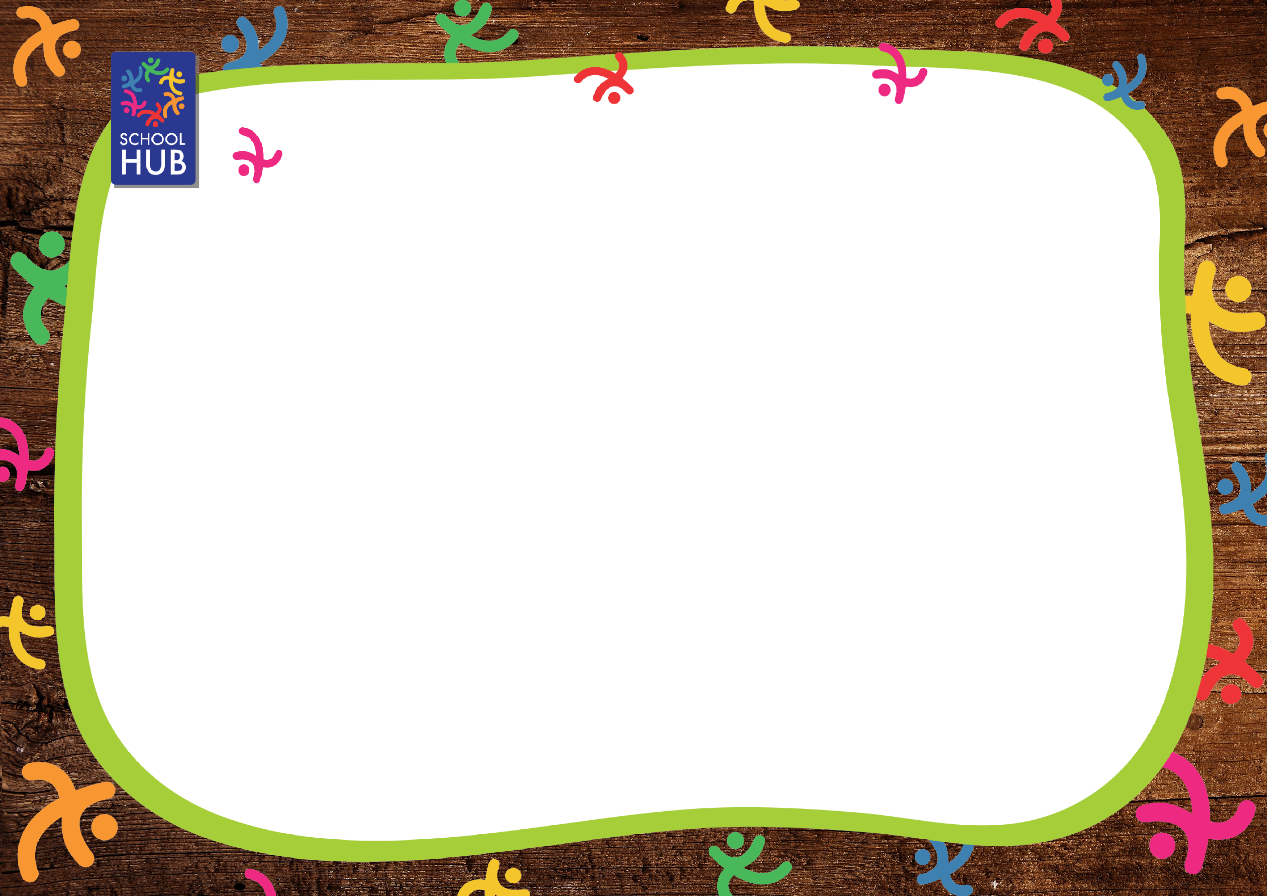
HALE PRIMARY SCHOOL WEEK ONE
CHOICE 1 |  | CHOICE 2 | CHOICE 3 | CHOICE 4 | SOMETHING SWEET
Monday | Cheese & Tomato Pizza  served with Herby Potatoes and Sweetcorn | Sweet Tomato Pasta  served with Garlic Bread and Sweetcorn | Jacket Potato  filled with Cheese, Tuna, Cheese & Beans or Beans served with Mixed Salad | Assorted Sandwiches  filled with Ham, Cheese or Tuna served with Crinkle Cut Sea Salted Crisps and Mixed Salad | Vanilla Ice Cream Tub  or Fresh Yoghurt  or Fruit Salad
Tuesday | Choice of Beefburger or Cheeseburger in a Bun  served with Crispy Potato Wedges and Baked Beans | Homemade Cheddar Cheese Flan  served with Crispy Potato Wedges and Baked Beans | Jacket Potato  filled with Cheese, Tuna, Cheese & Beans or Beans served with Mixed Salad | Assorted Sandwiches  filled with Ham, Cheese or Tuna served with Crinkle Cut Sea Salted Crisps and Mixed Salad | Chocolate Muffin  or Fresh Yoghurt  or Fruit Salad
Wednesday | Roast Chicken Breast  served with Yorkshire Pudding, Creamed Potatoes, Garden Pea & Carrot Medley and Gravy | Quorn Chicken Fillet  served with Yorkshire Pudding, Creamed Potatoes, Garden Pea & Carrot Medley and Gravy | Jacket Potato  filled with Cheese, Tuna, Cheese & Beans or Beans served with Mixed Salad | Assorted Sandwiches  filled with Ham, Cheese or Tuna served with Crinkle Cut Sea Salted Crisps and Mixed Salad | Chocolate Brownie  or Fresh Yoghurt  or Fruit Salad
Thursday | Chicken Korma  served with Rice, Naan Bread and Broccoli & Carrot Medley | Quorn Korma  served with Rice, Naan Bread and Broccoli & Carrot Medley | Jacket Potato  filled with Cheese, Tuna, Cheese & Beans or Beans served with Mixed Salad | Assorted Sandwiches  filled with Ham, Cheese or Tuna served with Crinkle Cut Sea Salted Crisps and Mixed Salad | Homemade Shortbread  or Fresh Yoghurt  or Fruit Salad
Friday | Fish Fingers  served with Skinny Fries, Garden Peas and Tomato Ketchup | Cheesy Pasta Bake  served with Garlic Bread and Garden peas | Jacket Potato  filled with Cheese, Tuna, Cheese & Beans or Beans served with Mixed Salad | Assorted Sandwiches  filled with Ham, Cheese or Tuna served with Crinkle Cut Sea Salted Crisps and Mixed Salad | Custard Cookie  or Fresh Yoghurt  or Fruit Salad

Available daily: Fresh Fruit, Salad and Bread Autumn/Winter 2026
If you have any questions about food allergens please speak to the kitchen team who will be happy to help.
Veg may change due to seasonality

HALE PRIMARY SCHOOL WEEK TWO
CHOICE 1 |  | CHOICE 2 | CHOICE 3 | CHOICE 4 | SOMETHING SWEET
Monday | Homemade Cheese & Tomato Pizza  served with Crispy Potato Wedges and Baked Beans | Veggie Nuggets  served with Crispy Potato Wedges and Baked Beans | Jacket Potato  filled with Cheese, Tuna, Cheese & Beans or Beans served with Mixed Salad | Assorted Wraps  filled with Ham, Cheese or Tuna served with Crinkle Cut Sea Salted Crisps and Mixed Salad | Strawberry Fruit Smoothie  or Fresh Yoghurt  or Fruit Salad
Tuesday | Sweet & Sour Chicken  served with Vegetable Spring Roll, Rice and Sweetcorn & Pea Medley | Homemade Cheddar Cheese & Bean Puff  served with Creamed Potato, Sweetcorn & Pea Medley and Gravy | Jacket Potato  filled with Cheese, Tuna, Cheese & Beans or Beans served with Mixed Salad | Assorted Wraps  filled with Ham, Cheese or Tuna served with Crinkle Cut Sea Salted Crisps and Mixed Salad | Banana Muffin  or Fresh Yoghurt  or Fruit Salad
Wednesday | All Day Breakfast  Bacon, Sausages, Hash Brown, Baked Beans and Muffin Omelette | Vegetarian All Day Breakfast  Vegan Sausage, Hash Brown, Baked Beans, Muffin Omelette | Jacket Potato  filled with Cheese, Tuna, Cheese & Beans or Beans served with Mixed Salad | Assorted Wraps  filled with Ham, Cheese or Tuna served with Crinkle Cut Sea Salted Crisps and Mixed Salad | Chocolate Cookie  or Fresh Yoghurt  or Fruit Salad
Thursday | Chicken & Tomato Pasta  served with Garlic Bread and Broccoli & Carrot Medley | Vegetarian Pasta Bolognaise  served with Garlic Bread and Broccoli & Carrot Medley | Jacket Potato  filled with Cheese, Tuna, Cheese & Beans or Beans served with Mixed Salad | Assorted Wraps  filled with Ham, Cheese or Tuna served with Crinkle Cut Sea Salted Crisps and Mixed Salad | Iced Sponge Cake  or Fresh Yoghurt  or Fruit Salad
Friday | Breaded Fish Fillet or Salmon Goujons  served with Skinny Fries and Garden Peas | Roasted Vegetable Pasta & Homemade Tomato Sauce  served with Garlic Bread and Garden Peas | Jacket Potato  filled with Cheese, Tuna, Cheese & Beans or Beans served with Mixed Salad | Assorted Wraps  filled with Ham, Cheese or Tuna served with Crinkle Cut Sea Salted Crisps and Mixed Salad | Raspberry Jelly  or Fresh Yoghurt  or Fruit Salad

Available daily: Fresh Fruit, Salad and Bread Autumn/Winter 2026
If you have any questions about food allergens please speak to the kitchen team who will be happy to help.
Veg may change due to seasonality

HALE PRIMARY SCHOOL WEEK THREE
CHOICE 1 |  | CHOICE 2 | CHOICE 3 | CHOICE 4 | SOMETHING SWEET
Monday | Homemade Cheese & Tomato Pizza  served with Herby Potatoes and Sweetcorn & Garden Pea Medley | Vegetarian Pasta Bolognaise  served with Garlic Bread and Sweetcorn & Garden Pea Medley | Jacket Potato  filled with Cheese, Tuna, Cheese & Beans or Beans served with Mixed Salad | Assorted Sandwiches  filled with Ham, Cheese or Tuna served with Crinkle Cut Sea Salted Crisps and Mixed Salad | Strawberry Ice Cream Roll  or Fresh Yoghurt  or Fruit Salad
Tuesday | Crispy Chicken Burger in a Bun  served with Crispy Potato Wedges and Baby Corn | Quorn Chicken Fillet  served with Crispy Potato Wedges and Baby Corn | Jacket Potato  filled with Cheese, Tuna, Cheese & Beans or Beans served with Mixed Salad | Assorted Sandwiches  filled with Ham, Cheese or Tuna served with Crinkle Cut Sea Salted Crisps and Mixed Salad | Melted Moment Biscuit  or Fresh Yoghurt  or Fruit Salad
Wednesday | Sliced Cooked Ham  served with Yorkshire Pudding, Creamed Potato, Broccoli & Carrot Medley and Gravy | Vegetable Sausage  served with Yorkshire Pudding, Creamed Potato, Broccoli & Carrot Medley and Gravy | Jacket Potato  filled with Cheese, Tuna, Cheese & Beans or Beans served with Mixed Salad | Assorted Sandwiches  filled with Ham, Cheese or Tuna served with Crinkle Cut Sea Salted Crisps and Mixed Salad | Flapjack  or Fresh Yoghurt  or Fruit Salad
Thursday | Chicken Tikka Masala  served with Rice, Naan Bread and Carrot & Cauliflower Medley | Quorn Tikka Masala  served with Rice, Naan Bread and Carrot & Cauliflower Medley | Jacket Potato  filled with Cheese, Tuna, Cheese & Beans or Beans served with Mixed Salad | Assorted Sandwiches  filled with Ham, Cheese or Tuna served with Crinkle Cut Sea Salted Crisps and Mixed Salad | Homemade Lemon Drizzle Cake  or Fresh Yoghurt  or Fruit Salad
Friday | Fish Fingers  served with Skinny Fries, Garden Peas and Tomato Ketchup | Sweet Tomato Pasta  served with Garlic Bread and Garden Peas | Jacket Potato  filled with Cheese, Tuna, Cheese & Beans or Beans served with Mixed Salad | Assorted Sandwiches  filled with Ham, Cheese or Tuna served with Crinkle Cut Sea Salted Crisps and Mixed Salad | Belgian Waffle and Cream  or Fresh Yoghurt  or Fruit Salad

Available daily: Fresh Fruit, Salad and Bread Autumn/Winter 2026
If you have any questions about food allergens please speak to the kitchen team who will be happy to help.
Veg may change due to seasonality

