

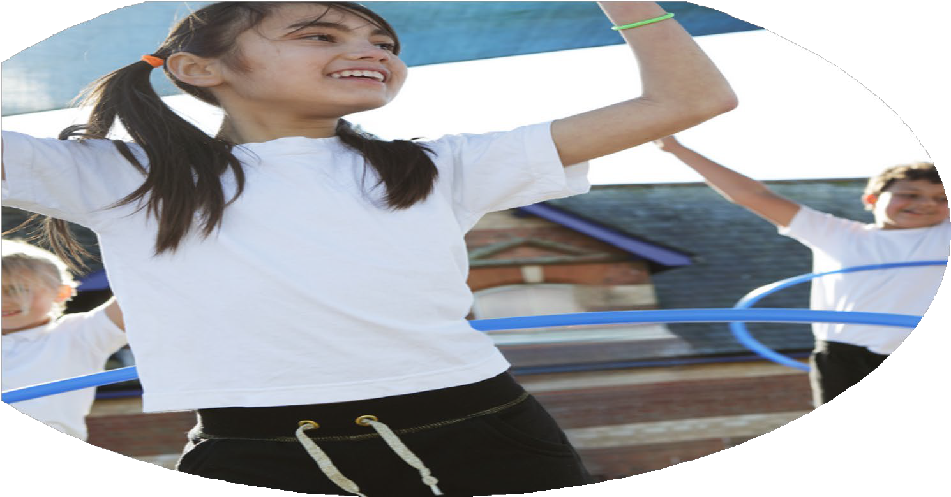
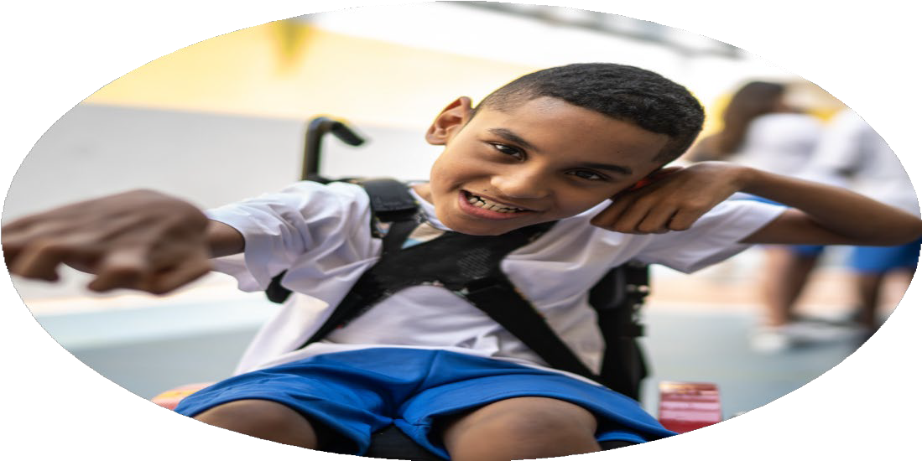
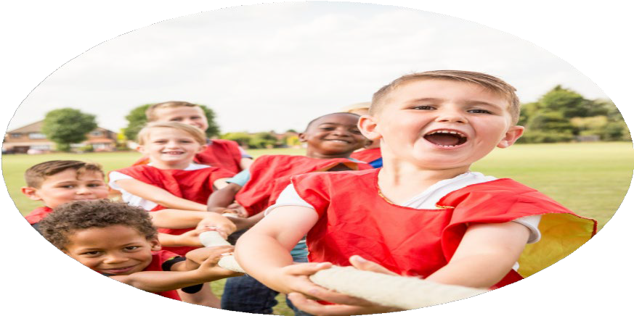



PE Funding

Evaluation Form

Commissioned by

Created by

Images courtesy of Youth Sport Trust

PE Funding Evaluation Form

It is intended that this template should be used as preparation for the completion of the statutory digital reporting tool being introduced this academic year. You can upload data (including swimming) from this template onto this platform once it becomes accessible.
Before you decide how you are going to use the funding for this academic year you should reflect and evaluate the impact of your use of the funding in 20242/25.
All spending of the funding must conform with the terms outlined in the Conditions of Grant document. The template is a working document that you can amend/update during the year.
Based on your evaluation of last year’s funding you should decide what you intend to do this academic year, how you will do it, and what impact you expect it to have.

It is important that the funding is used effectively and based on your school’s needs.
You must use the funding to make additional and sustainable improvements to the PE and sport in your school. You must develop and add to the PESSPA activities that your school already offers.

Summative digital reporting from June 2025 will continue to include swimming and water safety information therefore funding can be used to provide top-up lessons where necessary to ensure pupils meet national curriculum swimming requirements.

We recommend that you start by reflecting on the impact of current provision and reviewing your previous spend

What went well? | How do you know? | What didn’t go well? | How do you know?
To empower the children with the knowledge of what is a well-balanced diet and active / healthy lifestyle.  To develop staff CPD around dance and gymnastics.  To further develop staff knowledge, confidence and skills in teaching PE and sport (To allow a smooth exit strategy.  To run a variety of after school sports activities.  To access as many competitions as possible throughout the year.  Continue and expand the very successful LA sports challenges to keep increasing opportunities for all children to take part in inter LA competitions throughout the year. | • Empowering children with knowledge of a well-balanced diet and healthy lifestyle:  Pupils demonstrate increased understanding of nutrition and physical wellbeing, leading to healthier choices, improved engagement in physical activity, and positive attitudes towards lifelong health through our PSHE scheme and PE scheme as well as science lessons. Staff are more confident to use cross curricular links.  • Developing staff CPD around dance and gymnastics:  Staff confidence and subject knowledge in dance and gymnastics has improved, resulting in higher-quality teaching, greater pupil participation, and more consistent progression across year groups. Staff voice shows that staff are confident to teach now without the aid of the sports coach.  • Developing staff knowledge, confidence and skills in teaching PE and sport (exit strategy):  Staff are able to independently plan, deliver and assess high-quality PE lessons, ensuring sustainability and continuity of provision beyond external support.  • Running a variety of after-school sports activities:  Increased pupil participation in physical activity beyond the curriculum, with more children engaging in sport, developing skills, teamwork, and a positive attitude towards exercise.  • Accessing a wide range of competitions throughout the year:  Pupils have increased opportunities to compete, enhancing confidence, resilience and sportsmanship, while raising the profile of PE and sport across the school.  • Continuing and expanding LA sports challenges:  A greater number of pupils are able to represent the school in inclusive inter-LA competitions, increasing participation, motivation, and equal access to competitive sport throughout the year. | To start organising Federative ‘Matches’ aimed at all children regardless of ability. | The target to begin organising Federative “Matches” aimed at all children regardless of ability was not achieved within the planned timeframe. This was due to the need for additional planning and coordination to ensure the matches would be inclusive, accessible, and aligned with federation requirements. Factors such as limited resources, competing priorities, and the time required to engage stakeholders and establish appropriate formats delayed implementation. However, groundwork has been laid, and this target remains a priority moving forward.

What are your plans for 2024/25? | How are you going to action and achieve these plans?
Intent | Implementation
To increase awareness of the importance of an active and healthy lifestyle.  To empower the children with the knowledge of what is a well-balanced diet and active / healthy lifestyle.  To develop staff CPD around dance and gymnastics.  To further develop staff knowledge, confidence and skills in teaching PE and sport (To allow a smooth exit strategy.  To run a variety of after school sports activities.  To access as many competitions as possible throughout the year.  To start organising Federative ‘Matches’ aimed at all children regardless of ability.  Continue and expand the very successful LA sports challenges to keep increasing opportunities for all children to take part in inter LA competitions throughout the year. | - Healthy Me aspect of Jigsaw Programme to incorporate the active lifestyles element.  - Forest school sessions for pupils across the school to develop discussion and activities around healthy lifestyles.  Fitness sessions are an integral part of the PE scheme of work. HY to ensure these are incorporated and taught accordingly.  HY to contact Dance (Dream Big) Specialist to lead the unit of Dance.  Lessons to be taught by dance specialist along with an after-school club.  Teachers to attend and work alongside the sports coach and assistant  All staff to have access to updated schemes of work which have been written by the sports coach  To support staff CPD through Sport Dev / SSP training when needed.  To offer after school opportunities to all children in the school.  Free to all children  Arrange a schedule of events throughout the year – both in Sport and Chess.  Support all staff in leading their class team throughout the competitions  School sports day. (Celebration of sport)  Football tournament days KS1 and KS2.  To deliver healthy lifestyle lessons to children in KS1 and KS2 (Healthy Me)  Residential trips to Kingswood  Coaches to talk during lesson about how the children feel? What effect does exercise have?

What impact/intended impact/sustainability are you  expecting? | How will you know? What evidence do you have or  expect to have?
Through the implementation of these objectives, we aim to foster a culture of health, fitness, and well-being across our school community. By increasing awareness of the importance of an active and healthy lifestyle, children will develop lifelong habits that promote physical and mental well-being. Equipping students with knowledge about a well-balanced diet and the benefits of regular activity empowers them to make informed lifestyle choices.  Staff development in dance, gymnastics, and broader PE teaching will enhance confidence and skills, ensuring high-quality provision and a sustainable approach to physical education. The introduction of diverse after-school sports activities, inclusive federative matches, and participation in local authority competitions provides children of all abilities with opportunities to engage, compete, and build teamwork and resilience.  Overall, these initiatives are expected to increase student participation in physical activities, improve health outcomes, enhance staff expertise, and strengthen community engagement through sport, creating a lasting positive impact on both students and staff. | Staff feedback and staff voice  Pupil voice  Parent feedback  % of pupils working at ARE or above in PE according to tracking systems  Greater relationships with local schools and LA links with school competitive games  Greater uptake in children attending PE and sports clubs

What impact/sustainability have you seen? | What evidence do you have?
The initiatives implemented have had a measurable and lasting impact on both pupils and staff. Children have demonstrated increased awareness of the importance of an active and healthy lifestyle, with more pupils participating in regular physical activity and making healthier dietary choices. The introduction of varied after-school sports clubs and inclusive federative matches has enabled children of all abilities to engage, fostering teamwork, confidence, and resilience.  Staff development in dance, gymnastics, and broader PE teaching has significantly enhanced confidence, knowledge, and skills, ensuring high-quality PE delivery and a sustainable approach that can continue beyond external support.  Participation in local authority competitions and sports challenges has provided ongoing opportunities for children to test their skills, develop sportsmanship, and remain motivated throughout the year.  Overall, these initiatives have created a sustainable culture of physical activity and health within the school, embedding lifelong habits in children and ensuring that staff are well-equipped to maintain and build on these achievements. | All classes have taken part in cricket sessions with specialist teachers (photographs and pupil feedback).  All classes actively participated in a variety of exciting sporting events and tournaments, showcasing their skills and team spirit across multiple disciplines. Students competed enthusiastically in netball, demonstrating strategic passing and coordination, while others showcased their batting and bowling abilities in cricket matches.  Football tournaments saw fast-paced action and teamwork, with each class striving to score goals and defend vigorously. Additionally, orienteering challenged students’ navigation and problem-solving skills as they raced to locate checkpoints across the course. Overall, the events encouraged healthy competition, camaraderie, and a love for sports among all participants. (photographs, pupil feedback and staff voice).  Through targeted CPD sessions, staff gain new skills, teaching strategies, and up-to-date knowledge of dance techniques, enabling them to deliver engaging and effective lessons. The dance teacher (via online videos and tools linked to Getset4PE) can demonstrate creative choreography, model movement, and provide structured guidance, while staff learn to incorporate a variety of teaching methods, including visual demonstrations, step-by-step instructions, peer learning, and the use of music to develop rhythm and expression. This collaborative approach not only raises teaching confidence but also ensures that students experience high-quality, dynamic dance lessons that cater to different abilities and learning styles. Get set 4 PE provides video demonstrations and tutorials for staff to support with CPD.

